THE APPLICATION OF PREDICTIVE ANALYTICS IN WATER TREATMENT PROCESSES: MODELING CLARIFIER PERFORMANCE FOR

CHEMICAL FEED OPTIMIZATION

Presented to

The Faculty of the Department of Industrial Engineering

Lamar University

In Partial Fulfillment

Hof the Requirements for the Degree:

Bachelors of Science in Industrial Engineering

Report Prepared by:

Isaiah Gerald

April, 2018

© 2018 by Isaiah Gerald

No part of this work can be reproduced without permission except as indicated by the “Fair Use” clause of the copyright law. Passages, images, or ideas taken from this work must be properly credited in any written or published materials.

Not for Redistribution

Abstract

The following report details the scope and depth of methods, techniques, and tools used in the analysis and optimization of the polymer addition process at Dow’s Water Distribution (WD) Unit in Plaquemine, Louisiana. Specifically focusing on this as a subprocess in the context of WD’s remote clarifier system, it represents one of the most vital elements in proper water treatment and clarification. Throughout the progression of this optimization project multiple developments and functions were derived to ultimately achieve the goal of an improved method of managing cationic polymer usage. The key factor in determining necessary flow rates was considering the impact of different conditions seen in the quality of the Mississippi river water and the rate at which they changed. This led to the creation of several comprehensive design alternatives for better polymer management. However, accomplishing this while maintaining the clarifier's original purpose of reducing the concentration of solids in the river water presented the main limiting factor. This concentration of solids within the water, measured in nephelometric turbidity units (NTU), became the target function for this project as determining the explanatory variables that made up this response allowed for the upper limit of process set points to be maintained even in the face of constantly changing system dynamics. As seen throughout the report an iterative and meticulous process was applied to each phase to fully capture the characteristics of the system and yield the final solution set. The flow of this work will first examine methods relating to data collection, aggregation, and formatting. Then the analysis and exploration of the generated data-frames is discussed, followed up by the development of models and design alternatives for implementation.

Table of Contents

Introduction 1

Background 2

1.1 Process Description 2

1.2 Process Flow Diagram 3

1.3 Chemical Feed Adjustment Details 3

1.3 Procedural Flow Chart 4

1.5 Problem Statement 5

Literature Review 7

2.1 Water Chemistry 7

2.2 Water Treatment Mechanics 8

2.3 Modeling Techniques: Machine Learning 9

2.4 Modeling Techniques: Statistical Methods 19

2.5 Modeling Techniques: Time Series Analysis 23

Data Collection Methodology 27

3.1 Internal & External Data Sources 27

3.2 Sampling and Feature Identification 28

3.3 Initial Feature Selection and Relevance 32

Data Collection 37

4.1 Data Extraction and Formatting 37

4.2 Preprocessing of Raw Data 40

4.3 Data Cleaning and Reduction 43

Data Analysis 53

5.1 Exploratory Analysis 53

5.2 Feature Engineering 66

5.3 Transformation of Explanatory Variables 76

Modeling Assumptions Discussions 81

6.1 Physical Details of System 81

6.2 Constraints of the System 83

6.3 Noise and Environmental Factors 85

Design Alternatives 93

7.1 Component Alternatives 93

7.2 Comparison of Models 97

7.3 Description of System Designs 108

7.3.1 Procedural Based Design 108

7.3.2 Calculation Based Design 110

7.3.3 Automated Design Alternative 111

7.4 Design Matrix 116

7.5 Comparison of System Designs 116

7.5.1 The Cost Metric 117

7.5.2 The Savings Metric 117

7.5.3 The Safety Metric 118

7.5.4 The Upkeep Metric 119

7.5.5 The Accuracy Metric 119

7.6 Economic Analysis of Designs 120

7.7 Review of Other Design Alternatives 124

Conclusions 127

8.1 Comparison of Improvements over Baseline 127

8.2 Project Results 127

8.3 Potential Future Improvements 131

8.4 Beyond the project Description: A Short Description of the Appendix Content 134

References 135

Appendices 139

Appendix A: Data Analysis Code and Description (Python) 140

Appendix B: Calculation Tool Code and Description (Excel VBA) 214

Appendix C: Automated System Code and Description (Python) 220

Appendix D: Polymer Dosage Adjustment Procedure 223

Appendix E: Polymer Calculation Tool Procedure 226

Appendix F: Learning Curves for ML Algorithms 231

Appendix G: Terminology 235

*Page Intentionally Left Blank*

# Introduction

Predictive analytics and prognostics is an evolving field that is gaining significant traction in many areas including process control. In process control, it is often the case that unique and customized approaches are required to manage and control the system of interest. The nuances and caveats that drive system dynamics can lead to the creation of distinct trends within the system as well as varying system characteristics over time. These trends, patterns, and shifting descriptive statistics can arise from complex and intricate forces that can be difficult or nearly impossible to discretely identify and measure on an individual basis. Beyond this, those environmental factors which can be captured and used to describe system behavior can present the problem of being too expensive in terms of cost and time to measure when compared to the possible benefit that could be realized. However, due to the significant impact their aggregated effect can have on the performance of process systems the mitigation of these causal chains through alternative methods could at the very least provide the ability to better deliver on expected output and efficiency. By applying some of the most advanced modeling technologies and the compatibility of modern flexible software, various methods from the field of predictive analytics can be incorporated into archaic process control systems that haven’t changed in years due to limitations in their ability to be modified and the expense of possible retrofits. This can allow once unused streams of historical process data on system components to be transformed into a story that can be used as a process system’s owner’s manual to determine the current and future states of process parameters and take correct action before incidents arise.

# Background

## Process Description

At DOW’s EOP Water Distribution (EOWD) facility the up-flow clarifier represents the initial transition from raw water out of the Mississippi River to all its outgoing products. Up-flow clarifiers operate on a simple, robust, and reliable system that has changed little since their introduction in the late 1930’s. This system efficiently combines the techniques of coagulation, flocculation, sedimentation, filtration, sludge removal, and disinfection to produce process water which can be directly used for cooling process equipment and fire control, but also be further refined to yield potable, de-ionized, and demineralized water for different applications.

The clarification process in an up-flow system begins when raw water is taken from the collection sump and pumped through piping to clarifier basin. While being transferred, diluted cationic polymer and chlorine are injected in line where the turbulent stream quickly emulsifies the feed and influent. As the streams emulsify small particles and polymer begin to bond or coagulate and the chlorine disinfects the influent. The piping directs the influent stream towards the center well of the clarifier where it enters the primary mixing zone. In this area a mixer, refer to as the Accelator, pushes existing floc up and over the sides of the primary zone encountering the smaller particles from the influent and resulting in further flocculation. The flocculated stream then rides down the skirt covering the internal mixing zones and enters the settling zone. At this point the suspended particle have become dense enough that the upward velocity of the water doesn’t exert the force required to lift them into the launders where the finished effluent collects and is transferred to the clear well. The particles fall and begin to collect on the bottom where an internal rake (or the pitch of the walls on smaller clarifiers) creates a lifted bed consisting of the particles that slowly drifts back towards the bottom of the clarifier. Rolling under a small gap in the bottom of the skirt, the particle then reaches the secondary mixing zone where the bottom fans of the Accelator spin to encourage a higher number of collisions between the particles. Ones that still require further flocculation are sucked up through the small gap dividing the mixing zones while heavier ones fall and are dumped through sludge valves coming off of the clarifier’s basin.

## Process Flow Diagram

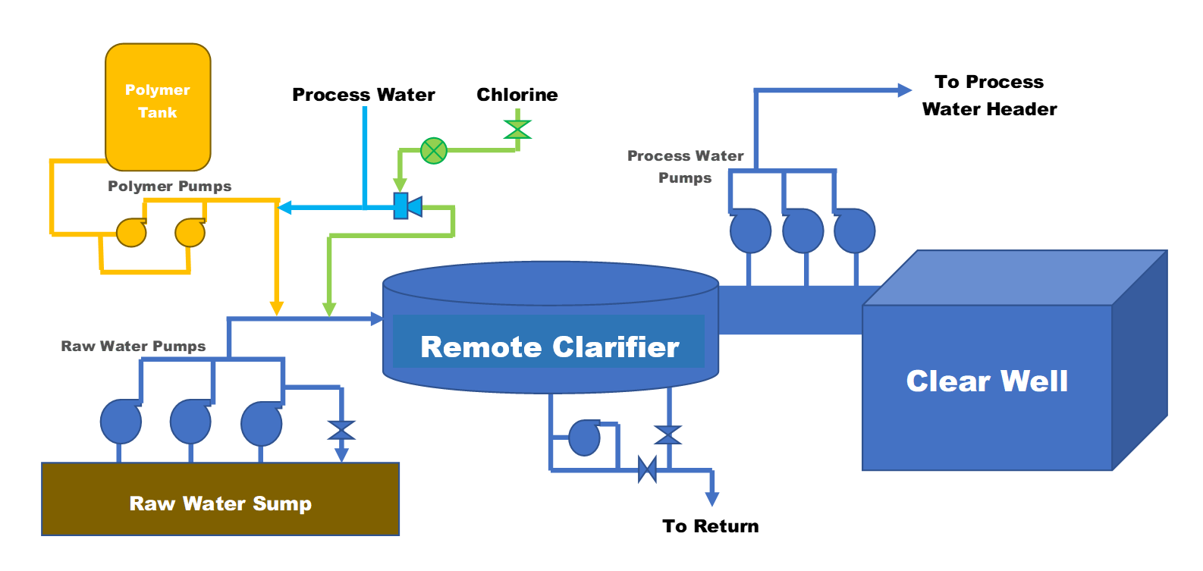

## 1.3 Chemical Feed Adjustment Details

The process of making chemical adjustments begins either by routine rounds made by operations personnel or by warnings built into the ▓▓▓▓ control scheme. Rounds made by operations personnel start every six hours (twice per shift) and include taking hand caught samples to measure the relative turbidity in the process and clarifier effluent and the slurry concentration in the clarifier mixing zone (see figure in appendix). If these samples indicate that the clarifier is out of operational set points, follow up samples are taken to ensure valid results and then action is taken if needed. The ▓▓▓▓ control system monitors the turbidity in the discharge flow of the forwarding pumps to the distribution header and the clarifier bed level with continuous meters. When these meters indicate that the process has exceeded set points action is taken immediately to correct the issue since these monitors usually lag samples directly caught from the clarifier. In either case, once the signal is given that adjustments to chemicals must be made operations personnel use personal knowledge gained through years of experience to estimate the proper amount of polymer that is necessary to reduce the level of suspended solids in the effluent leaving the clarifier and bring back within the desired set points. With no active metering device for the flow a repeated process of manually checking the polymer dosage is done via a draw down procedure on a sight glass. After making the proper adjustments and determining that the correct flow has been achieved the operator then continues with his daily task until the next instance when a chemical adjustment appears to be needed.

## Procedural Flow Chart

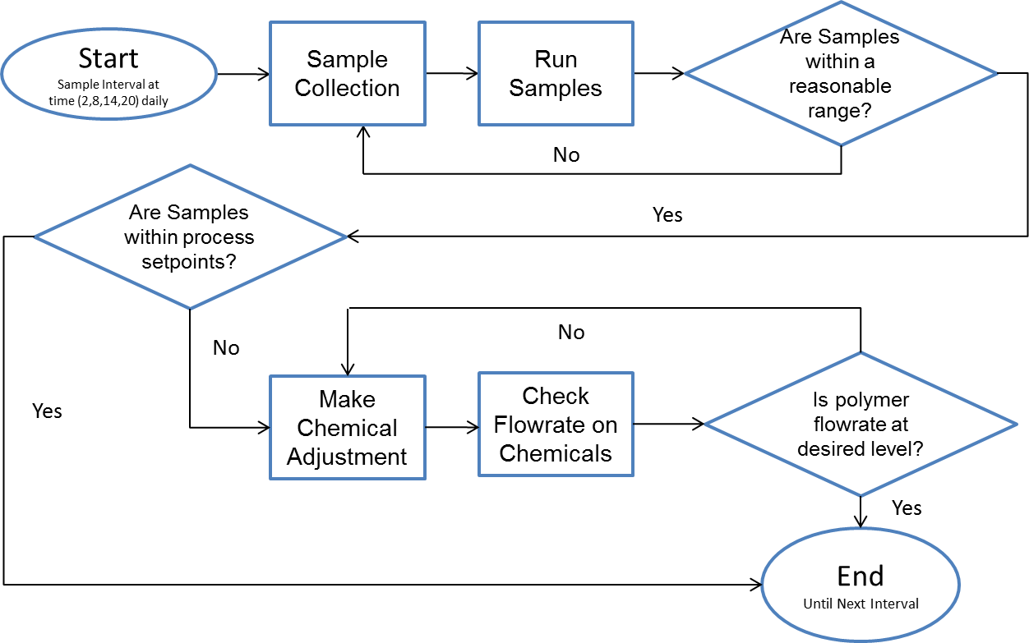

## 1.5 Problem Statement

The low average level of turbidity (seen in the figure below) in the process effluent being put into the distribution header points to the excess addition of polymer in the incoming raw water feed. The addition of excess polymer to raw water wastes this resource and adds unnecessary costs driving up the expense of production. Though, a simply solution of lowering the amount of polymer added to the influent would seem like a clear solution, the variability introduced by the random condition of the incoming Mississippi river water prevents this method from being effective as large swings in independent variables influencing the quality of water production could potential drive up the turbidity on short notice. Allowing the effluent leaving the clarifier to run at high levels of turbidity would present the opportunity for large deviations above the upper limit, thus exposing downstream equipment to situations that could accelerate degradation and possible cause unforeseen process upsets. This variability also presents the need to constantly adjust the polymer dosage to ensure the right amount is added with little guidance on what is adequate and no strict policy on what actions to take in the event of abnormal conditions.

*“Plot of Process Water Turbidity versus Set Point 2015-2018”*

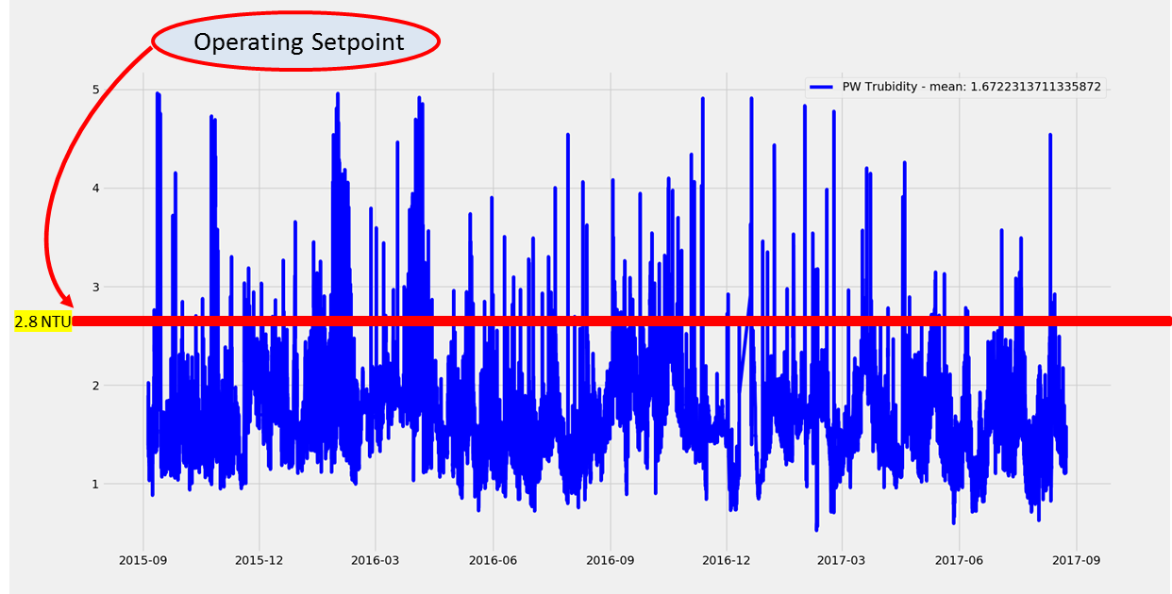

*Page Intentionally Left Blank*

# Literature Review

## 2.1 Water Chemistry

From first appearances “Water Chemistry” is a seemingly simple concept revolving around one-part oxygen and two-part hydrogen, but when considering effective water treatment practices this concept can become an exponential issue. Raw river water has a plethora of properties that can exhibit high variability at times and adversely affect the efficiency of a plants water treatment processes. Aside from the relative turbidity seen in river water, observable differences can be seen in its PH, conductivity, and temperature over time. These changes in overall water quality tend to interact in unique ways with coagulants used to bring solids together.

To better understand how these reactions can occur the chemicals used to perform this function and the process by which they remove solids must first be understood. Typically, two types of polymers are used to generate the coagulation of particles seen inside of clarifiers, cationic polymer, which is the primary and anionic polymer. The primary use of cationic polymer relates to its properties and the nature of particles in the water. These particles make up the colloidal influent general have a negative charge that exert a repulsive force against one another that, due to their small mass to surface area ratio, can overcome the effects of gravity for long enough durations to essential suspend them within the water. Being larger than atoms, but invisible to the naked eye, the smallest of these particles can take over 200 years to settle less than a meter in standing water. Cationic polymers are ideal for this as they consist of positive ions that neutralize the particles and bridge the gap between them increasing their mass. Anionic polymer performs a supportive role that aids the coagulation process. Their compounds consisting of negatively charge ions help clean up any remaining positively charged particles to achieve better water quality.

## 2.2 Water Treatment Mechanics

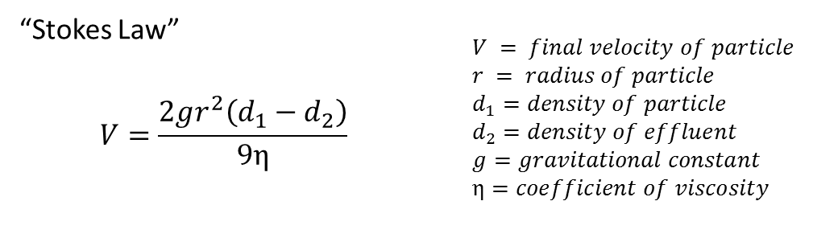 Up-flow clarifiers operate on fundamental principles relating to fluid dynamics and gravitational forces. Once the process of coagulation has bonded enough particles the increased distance between the remaining colloidal particles prevents electrical forces from suspending them in the water. At this point the only opposing element keeping gravity from bringing it back to earth is the drag force placed on it by water. This force increases with the increased upward flow of water and increased downward speed of the particle until the drag force originating from its motion equals the weight of the particle under water thus, reaching its terminal velocity. This concept must be carefully considered when determining the amount of flow that can be put through a clarifier to prevent the carry-over of excess particles that are not dense enough to overcome the drag force placed on its surface. As these particles fall the properties of the effluent their passing through can also play a critical role in determining the speed and direction they travel in the clarifier. Cooler, denser water combined with the particles density and surface area can all impact the dynamics of the particles path as seen in Stokes Law below and is a vital concern when selecting the proper polymer dosage to yield the correct size particles.

## 2.3 Modeling Techniques: Machine Learning

As a whole, the field of machine learning consist of numerous tools, techniques, and algorithms that are used to analyze and understand relationships amongst the massive amounts of data we collect. This scientific discipline seeks to untangle the complex structures stored away in this information to label seemingly ambiguous components and look into the future. Several branches of this broad field have emerged to solve problems having unique requirements. These branches differ in levels of ‘learning’ as well as desired output and lead to discrete and continuous distinctions. Learning variations are ranked by the amount of autonomy given to the algorithm and include supervised, semi-supervised, active, reinforcement, and unsupervised learning. Being given complete independence to sift through a database and return what it finds, unsupervised systems represent one extreme of this scale while supervised systems represent the other end, with the algorithm conforming itself to specific data points with known results. The desired output from these systems points to another separation beyond the learning level and includes classifications for discrete outcomes and regressions for continuous outcomes in supervised cases while consisting of clustering, density estimation, and dimensionality reduction in cases involving reinforced or unsupervised learning.

Modeling and forecasting water distribution’s clarification process presents the task of analyzing a relatively large dataset to yield an optimal polymer dosage for a distinct target turbidity. Since the objective consist of identifying a value base on a clear set point of 2.8 NTU the choice was made to focus on semi-supervised learning models to allow for flexibility and further improvement through guided direction while still placing importance on strong historical relationships between variables. Examining the desired output further it was determined that models yielding a continuous range would be needed since the final response should consist of a specific polymer dosage to counter random variations in other process inputs. The final decision was made to focus on several semi-supervised regression algorithms to properly identify the target value and better manage the process.

*“K-Nearest Neighbor (KNN)”*

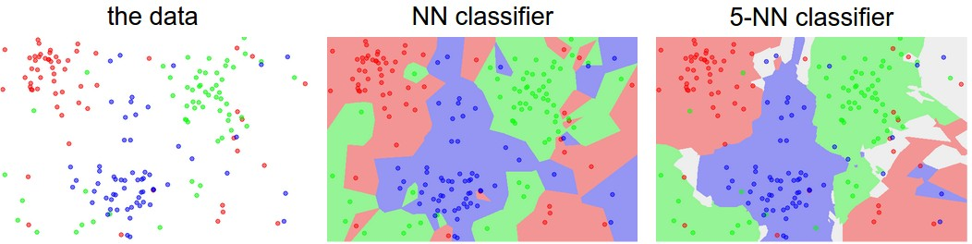

(Kemal 2016)

In comparison to some of the more prominent and flashy supervised learning regressors, K-nearest neighbors (KNN) represents a simple and robust approach that uses a desired metric’s neighbors to infer its’ possible value. To get this predicted value for continuous variables such as a polymer flow, a weight is calculated by running through stored data, recognizing closely associated instances of independent variables, and then passing these instances through a distance function. This distance function can take on one of several forms including Euclidean, Manhattan, and Minkowski functions depending on the application. Once these weights are derived, further processing incoming data and applying those weights to variables of similar values relative to each other is then done to yield a prediction. This application appears to be ideal for dependent time series data as past and current data typically plays an influential role in the future value of dependent variables.

*“Neural Networks (NN)”*

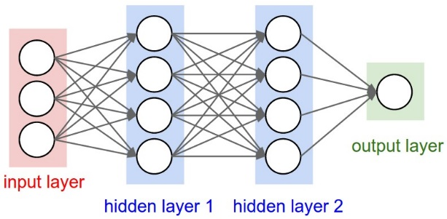

(Karpathy 2017)

Neural Networks (NN) are a class of learning algorithms that were originally inspired by the function of the human brain. These unique and sometimes confusing algorithms operate by first passing incoming vectors of information from datasets through a predetermined set of nodes known as the input layer. Each of these nodes act as “neurons” that apply simple mathematical operations to weight the value of each data point within the vector. The resulting values are then compared to a specific “activation” number for each node which is used to determine if it will “fire” and send its value to be used as an input for the next layer. The subsequent layer or layers, known as “hidden layers”, that comprise the body of the network then receives those values from the input layer or its previous hidden layer and uses them as parameters in a weighted function for each of its’ nodes. This function is used to adjust the resulting value to be within a desired range such as 0 to 1 in a sigmoid function. Nodes for this layer are then activated depending on the solution for its specific set of weights and their activation is then passed on to the next layer to be calculated again. Computing these sets of weights for each layer can be viewed as matrix multiplication were the set of weights form the matrix and the set of inputs from the previous layer form the vector for multiplication as seen below in the following expressions.

$$A^{1}= σ\left(W*A^{0}+B\right)→ \left[\begin{matrix}x \\ y \\ z\end{matrix}\right]= σ\left(\left[\begin{matrix}w_{0,0} & w_{0,1} & w_{0,2} \\ w_{1,0} & w_{1,1} & w_{1,2} \\ w_{2,0} & w_{2,1} & w_{2,2}\end{matrix}\right]\left[\begin{matrix}A_{0} \\ A_{1} \\ A_{2}\end{matrix}\right]+Bias\right)$$

$$Example:Sigmoid→ σ\left(x\right)=\frac{1}{1+e^{-x}}$$

Where $A^{1}$ is the resulting vector whose values correspond to a specific node and is used to determine if it will fire and send its activation to the next layer, σ represents the weighting function used to adjust the final value to a specific range, $A^{0}$ represents the vector containing activations from the previous layer, W represents the matrix of weights used to factor each of the incoming activations, and $B$ represents a biased applied to the resulting vector to control the activation of specific components in the incoming vector. This process is repeated throughout each layer until the output layer receives these values at which point the specific activations from this layer are usually processed through a function that yields the final output. Controlling the output received from these networks is done through the implementation of a cost function on the output of the network that compares the output to a known correct value. Depending on the deviation from this value the network is penalized and forced to make adjustment to its weights to close the gap. Due to the large number of calculation performed in these networks they are hard to interpret and understand.

*“Decision Trees”*

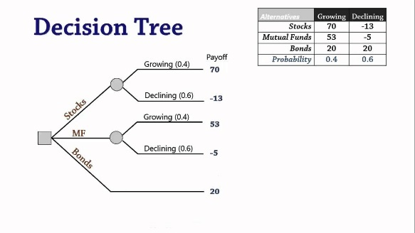

(Emmanuel 2015)

From a visual perspective, decision tree algorithms can be seen as an expanding set of choices stemming from a specific input condition with given attributes. These attributes determine the path taken along the branches of possible choices to lead to the final outcome. Another way to describe the function of these algorithms is that they repeatedly apply cuts to a solution plane to narrow the set of applicable results until certain criteria is satisfied. Decision trees can become complex with the addition of multiple decision layers but can generally present an easily understandable and repeatable solution that can be adjusted and manipulated manually by the user. Three important concepts to the theory behind decision trees include impurity, entropy, and information gain. Impurity is situation that arises in the structure of a tree when the nodes of two independent paths exhibit similarities of each other or repeated properties. This circumstance helps to identify when further expansion of the tree will not sub divide the solution space anymore and therefore not yield additional value to the solution. Entropy is a term used to represent the degree of randomness in the elements of nodes. This can also be thought of as a quantitative measure of the trees impurity. Information gain represents the amount of separation in the possible outcome gained from the separation of a particular node. The closer the division is to an equal split of the possible outcome the higher the amount of information gain.

*“Random Forest”*

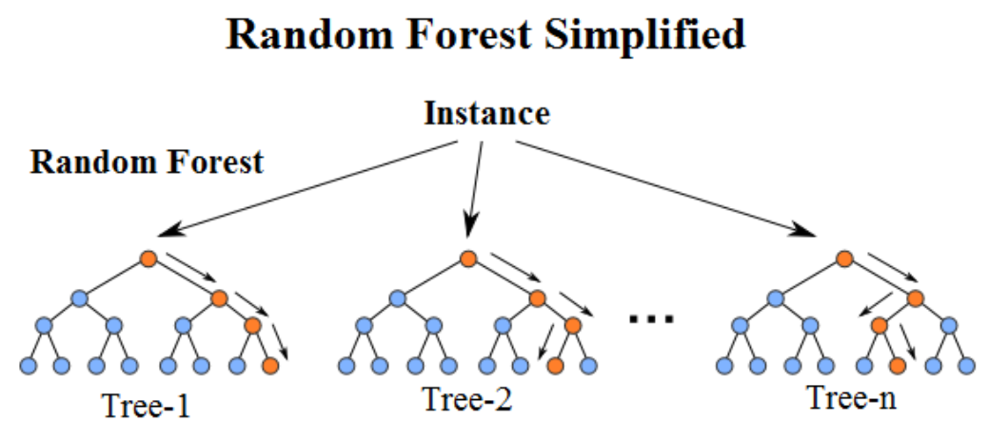

(Niraj Kumar 2016)

Known as one of the general ensemble methods, random forest algorithms are simple structures that build off the idea of decision trees. The general idea of these algorithms is to utilize a collection of, typically weaker, decision trees that work together to form the final outcome. By applying some simple weighting or averaging calculation to the results of these multiple trees the algorithms reasons which solution is best. This can be derived from the nature of the condition surrounding the input data or a type of voting structure where the majority wins.

*“Support Vector Machines (SVM)”*

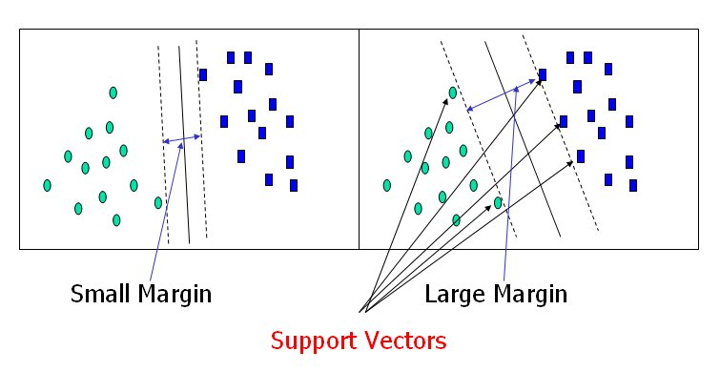

(Bajaj 2017)

Support Vector Machines (SVM) or a special kind of learning algorithm that selects the best result based on the location of a set of input values mapped to a two-dimensional plane. The way this model determines the outcome from a particular location of an input is by determining the best to separate previously evaluated data by the largest margin or distance. The resulting gap between these data points is commonly referred to as the hyperplane and the point that contact this hyperplane are known as support vectors. This calculated gap is used to serve as a level of certainty that any point determined to be on one side or the other will result in the expected outcome.

*“Ridge Regression”*

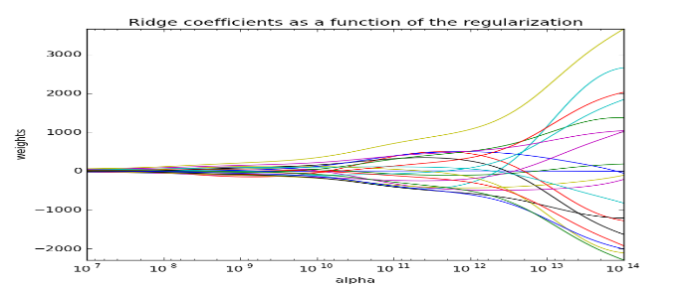

(fa.bianp.net 2011)

Many Machine Learning techniques are formed to solve problems seen with data sources that other modeling techniques fail account for. Ridge Regression is one such machine learning technique that accomplishes this. Design to mitigate the effect of large sets of explanatory variables and poorly designed target variables that yield highly inconsistent predictions as compared to the data with large deviations, this technique attempts to fix these condition by abandoning the requirement of an unbiased estimator. Removing the constant term in a least squares estimator by centering the explanatory and response variables, this algorithm then seeks to determine the necessary parameters to describe the given data by putting a constraint on the biased estimator $\left({\hat{β}}_{ridge}\right)$ which places penalties on individual coefficients $\left(β\right)$ of explanatory variables to minimize the penalized sum of squares. This leads to smaller coefficients that prevent the growth of these elements and restricts the overall variability in the output of the model to prevent large deviations.

*“RUNSAC”*

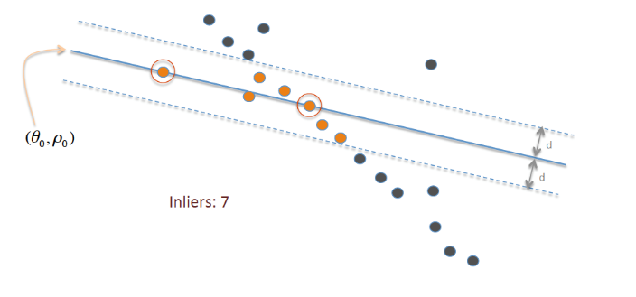

(Wikipedia 2018)

The Random Sample Consensus (RANSAC) Machine Learning Technique utilizes an iterative method to generate results. This method works by examining individual sample sets from the original data that contains outliers and then applying a regressive approach with least squares estimation where by it repeatedly estimates solutions from “inliers” within the sample set while ignoring what it defines as outliers. As the number steps is allowed to increase in this iterative process the resulting solutions are given with higher probabilities of certainty. Considered a non-deterministic approach the basic operation of this algorithm can be described in a stepwise manner. First a random sample is extracted from the target data, the algorithm then attempts to model this data’s behavior by drawing a best fit line of its run, calculating the distances between this line and the associated data points, and then slicing out those points with distances farther than a calculated threshold. After completing these steps, it then uses the linear least squares method of estimation to generate parameters for the final coefficients. There are several key limiting factors that must be determined to implement this technique which include setting the smallest sample size that can be extracted, the number of iteration that will be done, an abstract threshold to consider when determining outliers, and the number relative points that must be included in each sample set. This machine learning technique offer an improvement over basic least squares and typically provide more robust results for predictive algorithms. When considering the use of this algorithm the basic assumption of inliers being contained within the data must be satisfied. This means that together, sample sets and the data must be comprehensive enough to describe the process being examined.

*“Gradient Boosting”*

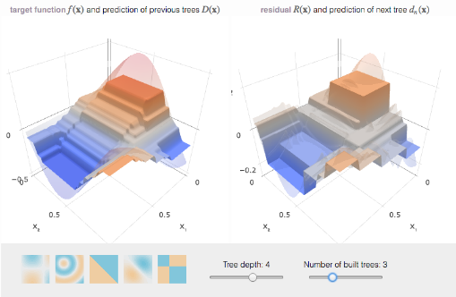

(Rogozhnikov 2016)

The idea of pushing a solution toward an optimum in a set of continuous values is applied in many types of algorithms including hill climbers and simulated annealing. Being an evolution of bagging techniques, gradient boosting is one of these types of algorithms. As an ensemble model it works by separating a dataset into training and test sets and then attempts to find the solution. It then looks at the best results from different methods applied and repeats the process until and optimal methodology is developed to derive the correct solution. This can be visualized as a hill placed over a two-dimensional plane were the algorithm starts at the top of the hill and then works its way down by identifying the best direction to travel. It develops an idea of which direction is best by applying some form of multivariate calculation which determine the area under any optional paths and selecting the minimum of this set of areas.

*“Adaptive Boosting”*

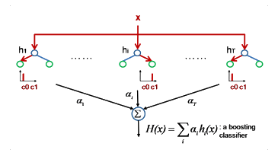

(JOGLEKAR 2016)

Adaptive Boosting is a Machine Learning technique that isn’t a standalone ML algorithm, but instead acts as a complementary boosting approach for other algorithm, primarily decision trees. This generates a meta-model that has improved accuracy and results in better predictive power. The way in which this boosting technique works is by evaluating the weaknesses present in the current model being implemented, applying different parameters, sample subsets, and estimators to it and then comparing the output of the altered model to the original one. By repeating this process in an iterative manner, it slowly develops a weak less accurate model into one that can perform at optimal levels. While not necessarily a hill climbing or simulated annealing approach it uses many of the same principles with altered allowance for error terms.

## 2.4 Modeling Techniques: Statistical Methods

“In simple terms, statistical modeling is a simplified, mathematically-formalized way to approximate reality” (XLSTAT 2017). This definition of statistical modeling captures the essence of the process by which large amounts of data recorded from a system can be manipulated and structured to allow for analysis and determination of future values. This type of modeling could be applicable to the current problem being analyzed as the massive amount of data can be quickly evaluated in programs such as python and excel and the results of statistical models are relatively simple to understand and interpret.

*“Ordinary Multiple Linear Least Squares Regression”*

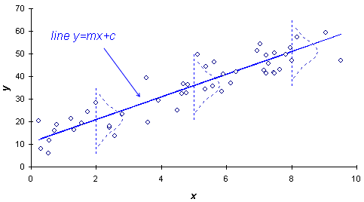

(EpiX Analytics LLC 2018)

Ordinary multiple linear least squares regression is a modeling technique that is designed to represent the relationship between a single response variable and two or more linearly related explanatory variables. This representation is generated in the form of a model that is comprised of linear combinations of the explanatory variable multiplied by predetermined coefficients. These coefficients are calculated by applying a penalty to the value of the sum of squared residual errors resulting from the models output compared to the target condition. This serves to minimize the residual sum of squares, therefore minimizing the errors overall, and effectively yielding an equation that can fit to the response variables data given the components of the explanatory variables.

*“Multiple Regression Equation”*

$$\left(y_{i}= β_{0}+ β_{1}*x_{i1}+ β_{2}*x_{i2}+ ... + β_{n}*x_{in}+ ε_{i}\right)$$

*“Target Function of Linear Least Squares: Residual Sum of Squares (RSS)”*

$$\left(RSS\left(β\right)= \sum_{i=1}^{n}{{\left(y_{i}-x_{in}*β_{n}\right)}^{2}}\right)$$

The following expression above for the multiple regression equation describes the multiple regression model used to describe the response variable. In this equation the beta terms (β) represents the coefficients of determination or intercept (constant) and slopes, (x) represents the value of the explanatory variable at any instance (i), and epsilon (ε) represents the error term for the overall dataset in relation to the calculated values for the response variable. When this model as well as the following two are applied for predictive purposes several assumptions must hold true. These assumptions include that the errors (εi) for each element must be independent, normally distributed when aggregated, and have equal variance (σ2) as a whole. An assumption that is particular to this instance of ordinary least squares is that the response variable must be a linear function of the explanatory variables thus having the ability to be modelled by a linear combination of them.

*“Multiple Nonlinear Least Squares Regression”*

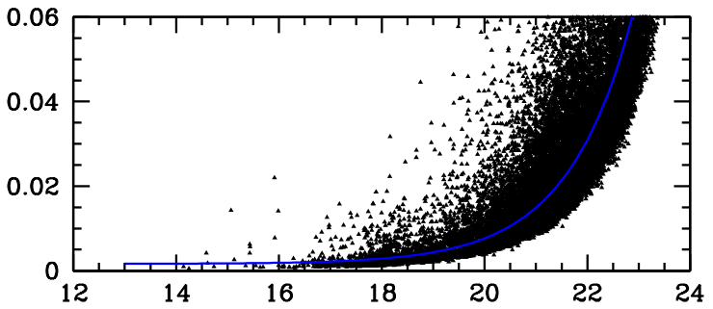

(Gabriel 2014)

Nonlinear least squares regression is an extension of the linear case that allows a response variable to be modeled by a host of nonlinear functions applied to the explanatory variables. With few constraints on the application of parameters in the functional part of the multiple regression equation many different relationships between the explanatory variables and the response variable can be explored. This includes exponential, trigonometric, root, and logarithmic relationships that can be the result of unique interactions in processes such as chemical reactions or other non-linear instances.

*“Nonlinear Regression Equation”*

$$\left(y_{i}=f\left(\vec{x_{in}};\vec{β_{ix}}\right)+ ε\right)$$

Circumstances that specifically fit well with this method of regression include situations where the response variable is smooth with respect to some unknown function and situations where the least squares requirement that is used to derive the parameters of the equation has a unique solution. Advantages over basic ordinary linear least squares that arise from this method of regression include the ability to apply a broad range functions to model the problem at hand and the fact that this method allow for relatively accurate results with limited amounts of data.

*“Weighted Least Squares Regression”*

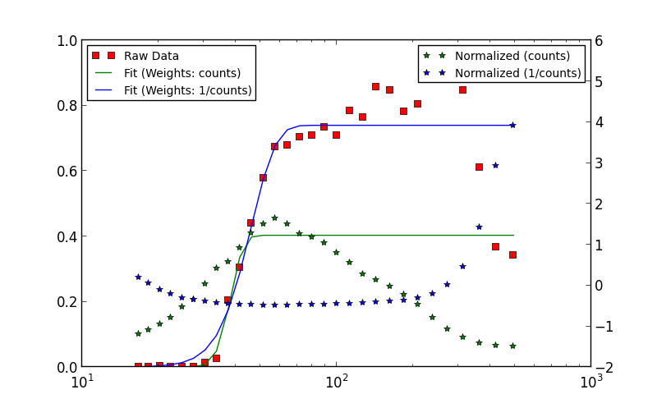

(Coming 2013)

Another extension of ordinary linear least squares regression that attempts to account for some of the short comings of its nature is weighted least squares regression. This approach applies a non-negative constant weight to each data point to account for errors that might be present within the data prior to developing the multiple regression model. Several conditions can signal the need for this type of meta-regression analysis and include that data collected for the response variable doesn’t conform to the assumption of homoscedasticity (meaning that the aggregation of these points doesn’t show similar variances), the goal of the regression analysis is to concentrate on specified areas within the data such as quartiles of the response variable, the regression procedure being used incorporates a logistic or nonlinear function, or any other situation where data points can’t be equally compared. This type of regression analysis also provides the additional benefit of extracting the maximum amount of information from a dataset regardless of the size, assuming there are at least the minimum number to fully explain the data. This leads to basic target function of weight least squares which seeks to reach an alternative conclusion where the goal is to minimize the weighted sum of squares instead of the residual sum of squares.

“Weighted Regression Equation”

$$\left(WSS\left(β,\vec{ω}\right)= \sum_{i=1}^{n}{W_{i}*{\left(y_{i}-x_{in}*β_{n}\right)}^{2}}\right)$$

Here the (Wi) component of the equation represents the weight used to modify the residual squared error term in the appropriate manner.

## 2.5 Modeling Techniques: Time Series Analysis

Time series analysis methods use a set of techniques and tools to dissect time series datasets and identify patterns, trends, and meaningful statistical results. These methods can be applied to continuous and discrete time series datasets and provide the benefit of considering the effects of past data on future values. By adapting models from these analysis techniques time series forecasting can be performed to predict the future value of specific variables based on past data and previously observed values. This form of analysis appears to ideal for finding a solution to the current problem of finding ideal polymer addition specifications as the process of water clarification usually involves a latency period from the initial onset of differing conditions to the experienced result in the clarifier effluent. By identifying the correct time series model a regression model could be derived from lagging variables to find the future expected turbidity level experienced in the outgoing product. Two time-series analysis techniques will be of interest during this project. These include the Auto Regressive Integrated Moving Average Exogenous Variable (ARIMAX) and Vector Autoregressive (VAR) methods which are two types that apply functions to incorporate exogenous explanatory variables into the model and expression.

*“ARIMAX / Box Jenkins”*

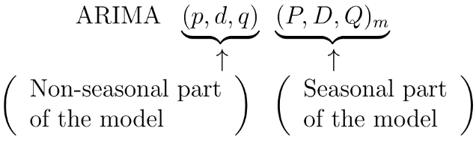

(N/A, ARIMA Forecasting n.d.)

An Auto Regressive Integrated Moving Average Exogenous Variable (ARIMAX) model is a technique used in time series analysis to forecast the future value of a specific variable based on some identifiable trend in its’ past data in conjunction with the time series of associated explanatory variables. The theory behind this model is that lagging data points in a variable historic trend contain some form of pattern or component that is a determinant of its future value. ARIMA models require three components to be defined in order to perform predictive analysis. These components include (p) which represents the number of lag observations considered within the model, (d) which represent the order of differencing steps performed on the data used in the model, and (q) which represents the size of the moving average window taken into account. In order to perform this analysis, the data must exhibit a stationary and linear mean. Differencing is done to achieve this stationary condition in datasets by removing trend and seasonal structures from the data that could adversely affect the regression model.

*“Vector Autoregressive (VAR) Model”*

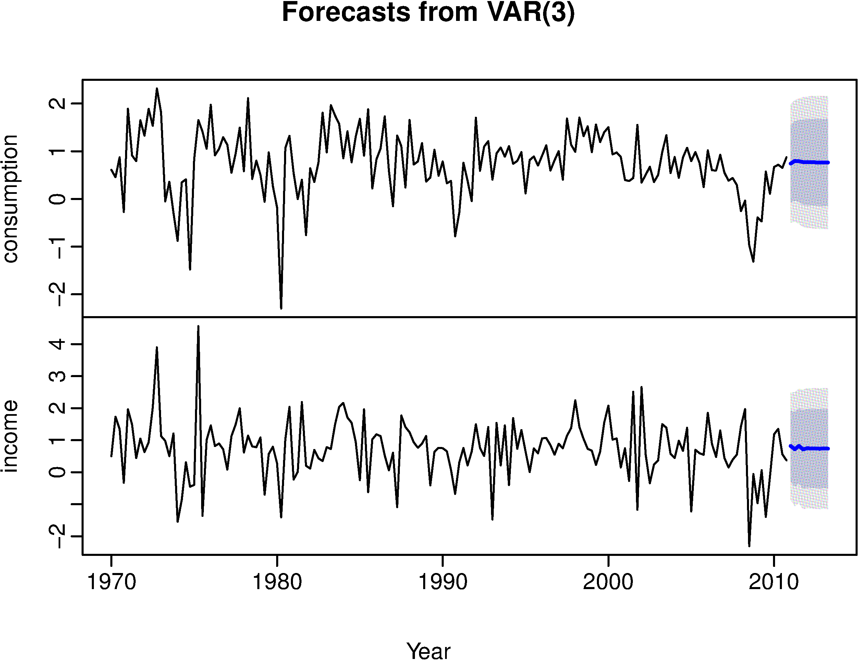

(N/A, VAR 3 lag Forecast n.d.)

Vector Autoregressive (VAR) models are a type of time series model that considers the idea of causality with regards to components among separate data series in a time series dataset. Though both intuitive and mathematical methods linear interdependencies can be found among multiple time series which in turn can be used to identify statistically significant independent variables. Then, regressing a specific number of lagging components from these predetermined independent variables it seeks to predict the future value of a specific dependent variable. This model seemed as though it could be a reasonable candidate for the final model as the data which is being used to determine the polymer dosage is time series data, but all attempts made with method did not fully explain the data of interest and failed to meet the necessary requirements for reversal and determination of values for explanatory variables.

*Page Intentionally Left Blank*

# Data Collection Methodology

## 3.1 Internal & External Data Sources

Although a simplistic and fairly straight forward process in terms of operation, up-flow water clarification systems are subject to many external factors and can be influenced by the method of control and condition of supporting equipment which create distinct nuances in the system’s predictive tendencies. To fully capture these elements in the models developed to forecast the future expected behavior of the clarification system at Dow’s Water Distribution unit, data was drawn from many sources to insure the integrity of the information and capture gaps present in the data collected from different sources due to alternative sampling frequencies and missing data. This resulted in the collection of records for a plethora of features that represented every possible facet of the system. This broad set of data was collected from several internal and external sources that included system information from the distributive control systems used to control the process, sampling databases used to store hand caught sample records, and public sites operated by government entities that posted current information on the quality of the Mississippi river water. Internal sources included Aspentech®, which was a user interface directly tied to Water Distribution’s ▓▓▓▓® control system that collected live streaming process data, and Samplemanager®, which was a sample database where operations personnel logged data on hand caught samples of process parameters. External sources included both USGS’s National Water Information System: Web Interface, which supplied hourly data points of different metrics associated with the Mississippi river’s water quality, and the Army Corp of Engineer’s website which supplied redundant information on the quality of the Mississippi River’s influent for verification and validation.

## 3.2 Sampling and Feature Identification

The databases selected for raw data extraction provided a large host of potential process variables for analysis and comparison. To sort and reduce these options to a set of features that was manageable given the time constraints, but still completely captured the major elements of the system an intuitive selection process supported by sampling and basic statistical analysis was done. Using classic probabilistic sampling techniques, the consistency and reliability of certain subsets from sourced databases were tested and verified with known and predetermined sample locations.

The first area where these techniques were applied was on hand caught samples by operations personnel. Specifically applying stratified sampling techniques, this served to ensure that independently caught samples on the clarifier effluent turbidity and proportional levels of concentrated solids or slurry in the clarifier basin across different shifts didn’t indicate any unusual trends developed from the relatively small, but still potentially impactful, differences in location and methodology that the current sampling procedures used by operation personnel allowed. Though, the training process and overall sample collection procedure was comprehensive and detailed in nature, these loose tolerances were evident and resulted from the system’s design which placed operators in the position to catch samples using dippers in a relatively wide area where the suspected levels of both turbidity and slurry could vary. After examining results from ten operators, labeled by an identifying number to omit their names, over a period of eight months the conclusions confirmed that the variation among operators was not enough for any individual to indicate strong deviations. The following chart details these results showing no signs of trends with consideration for standard error bars across each.

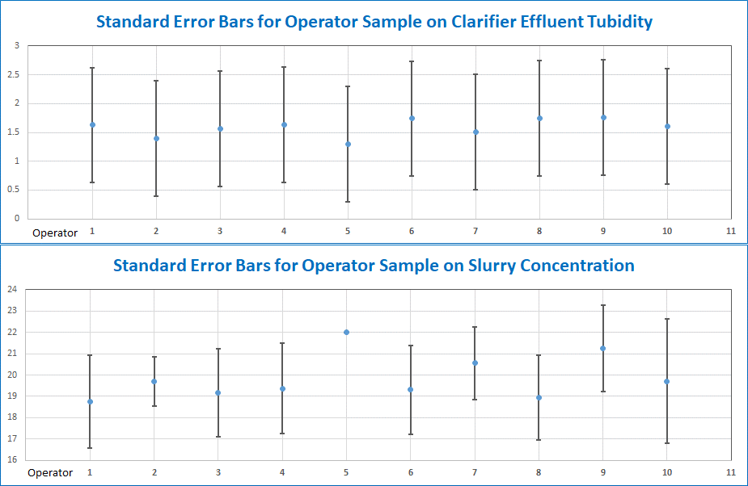

In addition, the descriptive statistics for the operators supported these conclusions as seen from the data below.



Next, due to the construction of the intake canal system used to deliver raw water to the clarifier’s location and the relative position of this location to the sampling location of the raw water turbidity at Water Distribution’s main block sampling of the raw water clarity was done at different locations within the site to insure that no significant variations were seen throughout the system. The construction of the canal generated the need for this test due to the long run and turns that the raw water took on its way to the remote clarifier, downstream of the main block, which could have potentially allowed for heavier elements to fall out of the water essentially clarifying the water to some degree or for downstream elements within the system to create more turbulence, potentially increasing the relative concentration of solids. This was done by applying clustered sampling techniques at three locations that captured the raw water turbidity at the main inlet where the intake pumps initially fed the river, the primary sample location for the raw water turbidity at the main block, and the turbidity at the inlet for the main feed sump at the remote clarifier. The results of this exercise showed that the raw displayed a consistent clarity throughout the canal system despite the distance and external factors. This can be seen below in the analysis of these sample points through the month of August in 2017.

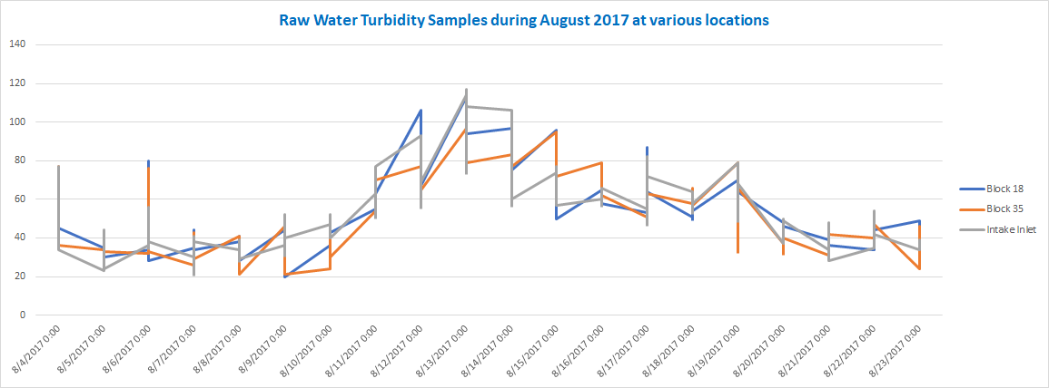

Supporting these results, the graphical representation of a linear regression analysis run on these samples is shown in the following diagram.

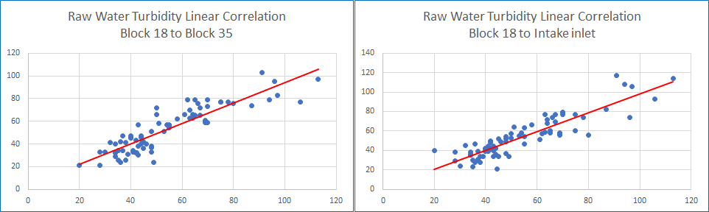

Raw Water Turbidity Linear Correlation

Main Block to Intake Inlet

Raw Water Turbidity Linear Correlation

Main Block to Remote Block

Expanding on this analysis of the raw water turbidity, the potential correlation between samples caught at the main block and USGS’s data collected on the turbidity of the Mississippi River on hourly basis was compared to see if this source could be used as a good representation of the expected turbidity levels seen at Dow’s site. This statistical testing proved to be a crucial part of the project as the benefits of opening this data source to the possibility of being a true indicator of the anticipated turbidity seen by Water Distribution’s system were substantial. The primary benefits of verifying this source included being able to supplement this hourly data in combination with the hourly data supplied by Water Distribution’s distributive control system to vastly expand the number of data points for model development and creation as well as utilizing this data as a component in any final model generated to allow for use at any time with accuracy since raw water samples were only caught at six hour intervals internally. The results of this analysis showed a strong correlation between the two sample sets with the best spearman R correlation coming at a 2-hour lead for the USGS data in comparison to the the main block samples. The resulting correlation revealed that 92% of the variance could be explained between the two datasets. Further support of this analysis was done by examining graphical information which can be seen below.

*“Comparison of WD’s Main Block RW Turbidity to USGS Turbidity Data on the MSR”*

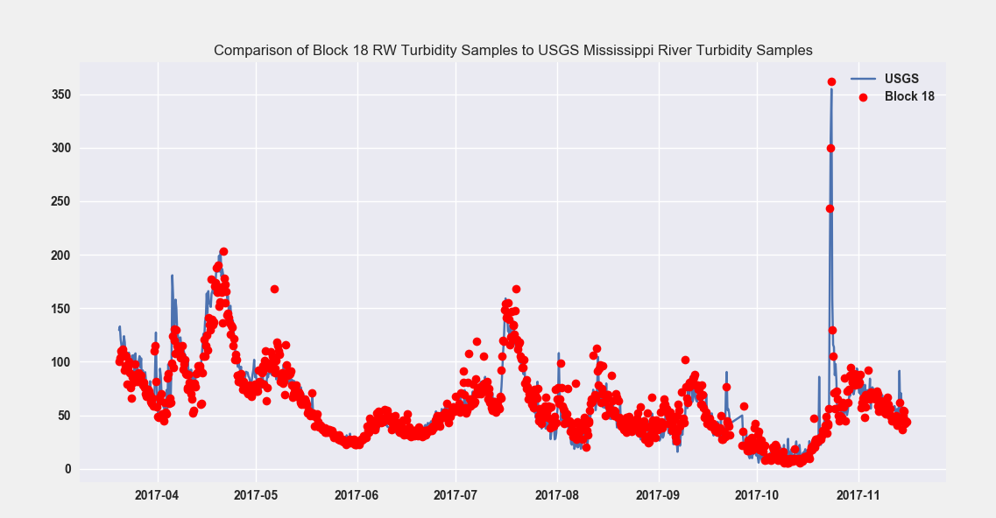

*“Linear Regression of WD’s Main Block Data to USGS Samples”*

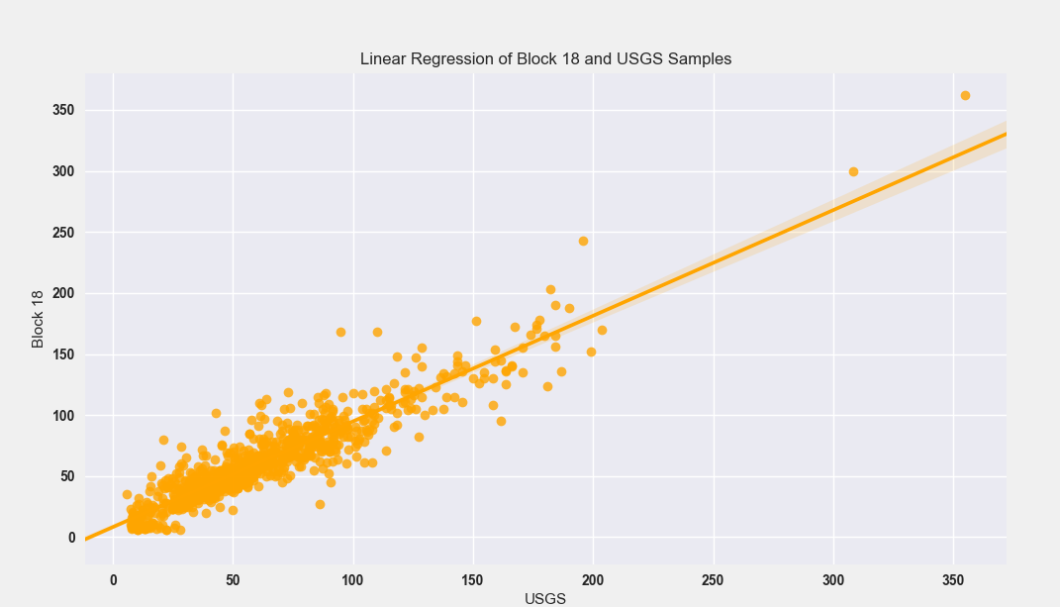

## 3.3 Initial Feature Selection and Relevance

After conducting extensive research and performing additional minor testing and sampling a comprehensive list of features that accounted for all possible influential metrics was derived. Knowing that most of these features would be eliminated quickly once the analysis began, all process variables associated with the remote clarifier’s system were collected from ▓▓▓▓ through Aspentech®. The time period this data covered was from January 2015 to March 2018 which yielded over 27,000 hourly data points per feature. This large number of points was collected to account for some variation and errors that were seen throughout data due to instrument and communication failures within the system over that period. To complement this large dataset, data taken from Samplemanager® included eight-month intervals for samples caught on the clarifier turbidity, process water turbidity, slurry concentration, and raw water turbidity as well as three years of data collected on polymer dosage levels. Combined with these features, USGS and the Corp or Engineers supplied data on several metrics associated with the Mississippi River influent which are listed in the complete initial feature list below.

|  |  |  |  |
| --- | --- | --- | --- |
| **Feature Name** | **Source** | **Unit** | **Monitor ID** |
| Mississippi River Stage | The Corps of Engineers | ft. | - |
| Ambient Water Temperature | ▓▓▓▓ (AspenTech®) | F° | AI-128 |
| Intake Level | ▓▓▓▓ (AspenTech®) | ft. | AI-219 |
| Intake Flow Rate | ▓▓▓▓ (AspenTech®) | GPM | AC-1244 |
| Process Water Header Pressure | ▓▓▓▓ (AspenTech®) | PSIG | AI-261 |
| Process Water Header Flow Rate | ▓▓▓▓ (AspenTech®) | GPM | AI-245 |
| Polymer Tank Level | ▓▓▓▓ (AspenTech®) | % | AI-248 |
| Clarifier Clear Well Level (Primary) | ▓▓▓▓ (AspenTech®) | % | AI-240 |
| Clarifier Clear Well Level (Backup) | ▓▓▓▓ (AspenTech®) | % | AI-242 |
| Raw Water Conductivity | ▓▓▓▓ (AspenTech®) | µS/cm | AI-345 |
| **Feature Name** | **Source** | **Unit** | **Monitor ID** |
| Clarifier Bed Depth Meter | ▓▓▓▓ (AspenTech®) | in. | AI-255 |
| Chlorine Feed Temperature | ▓▓▓▓ (AspenTech®) | F° | AI-259 |
| Chlorine Feed Flow Rate | ▓▓▓▓ (AspenTech®) | lbs./m | AI-257 |
| Raw Water Turbidity (DOW site) | Samplemanager® | NTU | - |
| Raw Water Turbidity (Baton Rouge) | USGS | NTU | 63680 |
| Raw Water PH (Baton Rouge) | USGS | PH | 00400 |
| Raw Water Salinity (Baton Rouge) | USGS | ppt | 00480 |
| Raw Water Dissolved O2 (Baton Rouge) | USGS | mg/L | 00300 |
| Raw Water Conductivity (Baton Rouge) | USGS | µS/cm | 00095 |
| Raw Water Nitrates (Baton Rouge) | USGS | mg/L | 99133 |
| Mississippi River Height (Baton Rouge) | USGS | ft | 00065 |
| Raw Water Pump Discharge Pressure | ▓▓▓▓ (AspenTech®) | PSIG | AI-262 |
| Raw Water Pump Discharge Temperature | ▓▓▓▓ (AspenTech®) | F° | AI-263 |
| Raw Water Pump # 3 Amps | ▓▓▓▓ (AspenTech®) | Amps | AI-216 |
| Raw Water Pump # 2 Amps | ▓▓▓▓ (AspenTech®) | Amps | AI-226 |
| Polymer Addition Rate | Samplemanager® | ml/min | - |
| Average Process Water Turbidity (Meter) | ▓▓▓▓ (AspenTech®) | NTU | AI-246 |
| Max Process Water Turbidity (Meter) | ▓▓▓▓ (AspenTech®) | NTU | AI-246 |
| **Feature Name** | **Source** | **Unit** | **Monitor ID** |
| Min Process Water Turbidity (Meter) | ▓▓▓▓ (AspenTech®) | NTU | AI-246 |
| Process Water Turbidity | Samplemanager® | NTU | - |
| Clarifier Effluent Turbidity | Samplemanager® | NTU | - |
| Slurry Concentration in Mixing Zone | Samplemanager® | % | - |
| Chlorine Addition Rate | Samplemanager® | ml/min | - |
| Raw Water Pump # 3 VFD Amps | ▓▓▓▓ (AspenTech®) | Amps | AI-236 |
| West Desludge Valve Indication | ▓▓▓▓ (AspenTech®) | Binary | DO-228 |
| East Desludge Valve Indication | ▓▓▓▓ (AspenTech®) | Binary | DO-238 |
| RW Pump # 3 VFD Percent Ramp | ▓▓▓▓ (AspenTech®) | % | AO-205 |

In total this yielded 37 individual features for examination and formed an aggregate data-frame that overcame many deficiencies from missing and poor-quality data. These variables were carefully selected through the initial analysis steps and with the assistance of qualitative data collected through interviews conducted with operations personnel. The data collected through interviews also served to aid in understanding the decision-making process currently used to determine necessary chemical adjustments and why certain actions were avoided when process parameters were outside of optimal limits. By incorporating this additional qualitative data into the feature selection process, datasets were better defined to create a framework of how a simulated process should interact with the current system setup.

*Page Intentionally Left Blank*

# Data Collection

## 4.1 Data Extraction and Formatting

Obtaining raw data from each of the selected sources for analysis through Python’s various data analysis and modeling libraries brought unique challenges with every instance. In order to import data into the integrated development environment (IDE) used to interpret Python code a specific structure was required prior to execution. To maintain uniformity in code structure and syntax, all datasets retrieved from sample sources were converted into excel and then formatted to allow them to be easily transformed into indexed data-frames utilizing Pandas, Python’s best-known data analysis library. A clear and concise process was developed for data conversion from each source and generally consisted of two phases, data extraction and data formatting.

Samplemanager® was the easiest to extract data from. The program allowed for up to eight months of prior data to be uploaded from the system in a convenient excel spreadsheet. Once uploaded, the only major conversions that needed to be done were formatting the data-time fields and re-aligning the data to remove redundant date-time entries. This was accomplished with built in functions for excel which allowed for the quick selection of columns and blank fields between rows. After selecting these elements, they were quickly altered to create convertible data structures. Other minor changes needed to be made to column headers which contained large amounts of unnecessary data on each feature and its status, but this was done with little effort to yield the following conversion.

*“Conversion of Samplemanager® Data”*

|  |
| --- |
| BEFORE |
|  |
| AFTER |
|  |

The next source of data to be drawn from was internally from Apsentech® which provided continuous data directly from Water Distribution’s distributed control system (DCS), ▓▓▓▓. Data extracted from Aspentech® was accomplished through its add-in for excel, *“Aspen Process Data”*. For proper collection and transfer of the raw data in the appropriate format, it had to be immediately relocated to a separate file upon generation. This action had to be taken to break the values away from formulas used to draw information with direct access to servers. Without the immediate processing of this data, converting it into python could not be done since the initial dataset was directly reliant on connections to DCS servers and would default to an error value upon a discontinuity in communication. Despite this, the data collected from Aspentech® was relatively easy to work with once placed in a secure local file and came in an excel format that perfectly converted into Pandas’ data-frame structure.

*“Example Code to Extract Data from Aspentech®”*

|  |
| --- |
|  |

Data drawn from external sources presented its own set of challenges. Data from USGS and the Corp. of Engineers had to be extracted directly from their respective websites by accessing the HTML code. A script had to be written for both which incorporated elements from Python and the Pandas library. Executing this script automatically opened the site homepage, enter metrics for the desired range and scope of data to be collected (utilizing tag names for objects in page), generated the specified dataset on their site, imported the entire page of data, and then systematically stripped elements from the page structure until only a clean data-frame was remaining. Even though this scheme proved to be difficult to build, once setup, the code could quickly be modified to capture different aspects of the data and return new data-frames completely formatted and ready for analysis. This was especially advantageous when different facets from these datasets were required for the comparison and analysis of system components. The final functions that were designed to perform this task also allow for portability with conditional variables in place to recognize specific changes in the system and adjust accordingly. The following is an example of the construction of one these modules used to extract data from USGS’s web interface.

*“USGS Data Extraction”*

|  |
| --- |
|  |

## 4.2 Preprocessing of Raw Data

After developing methods to obtain data from all selected sources and bringing the fully formatted data-frames into the development platform, data aggregation was required to bring specific elements from individual datasets into more comprehensive and uniquely structured data-frames for analysis. This was done by utilizing various functions available through Python’s Pandas and Sklearn libraries as well as native functions written specifically to preprocess and manipulate these datasets. Once the final data-frames were conceived and constructed additional functions were built within the primary data analysis module to quickly store the them in easily accessible “pickle” files.

Comprehensive data-frames took on several permutations from the original raw datasets. These included sets with both hourly and six-hour index intervals that were truncated and trimmed from various portions of the data to examine the effects of certain features. For some of these data-frames missing data became an issue as offsets in sample times and omitted data created mismatches and gaps throughout the time series. Though some of these gaps were too large to bridge through built-in methods or interpolation, minor breaks were handled according to the underlying assumptions of their associated feature characteristics and the type of gap that was present.

Pandas provided the best option for most of these instances. The Pandas’ *“.fillna(_)”* function employing the *“ffill”* or fill forward method was applied across the six hour intervals between data points of the polymer dosage to expand this information to an hourly basis. This function essentially extended the current value forward in the series to all null points until next relevant value was reach. This was applicable in the case of polymer flows under the assumption that minimal variation in pump output would be experienced over those spans. Pandas’ *“.resample(_)”* function was applied on many features at various points of the different data-frames to correct small errors and adjust timing issues with samples that only appeared to be several minutes off of the hourly basis. This was especially helpful in data-frames constructed on the six-hour interval basis that corresponding to the four sample rounds taken daily at 02:00, 08:00, 14:00, and 20:00. Some data points within these sets were recorded at odd times such 08:02 or 19:00 despite the system specifically outlining predetermined time intervals for recording samples. Mitigating these issues through the *“.resample(_)”* call function was easily done when performed in conjunction with Pandas’ *“.shift(periods=’’)”* function.

For values that were omitted from the time series data of continuous features, Pandas’ failed to provide an adequate method of alteration to gradual replace missing values with interpolated ones. These types of gaps were present in many parts of the data including recorded values from USGS and the Aspentech® system and required at least some degree of mitigation due to the number of these points and their location within the data-frames. The solution to this issue came from two sources which included personal developments and Sklearn’s *“Imputer”* method. Personal developments were programmed for instances such as the raw water turbidity and employed a smoothing method which applied an averaging technique across previous and future values to smooth out the gaps within the data. This worked well for many instances where large deviation between small gaps between data points appeared unlikely. As seen below, this simple function was built to efficiently accomplish this task while preserving the overall structure of the feature’s time series.

*“Smoothing Function”*

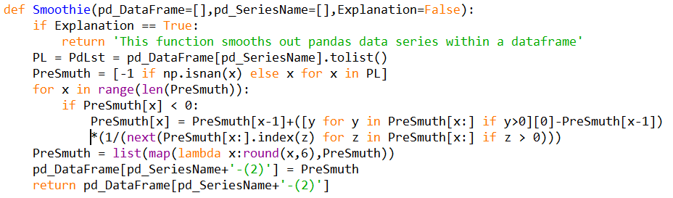

Sklearn’s *“Imputer”* method provided an alternative means to accomplish this task and allowed for the replacement of missing values by applying one of three different strategies. These strategies included replacement by examining the mean, median, or mode of the total data series and enabled target values to be defined for replacement instead of missing elements as well. This method worked well over data with little variance such as the Mississippi River’s PH and proved to be very reliable across larger segments of missing data. Utilizing these preprocessing steps was essential to preserve as much of the data as possible since many values were truly offset from one another and hindered the use of large sections in these data-frames.

## 4.3 Data Cleaning and Reduction

Even with the successful attempts at data preservation accomplished through preprocessing, blocks of missing data as well as other deficiencies of recorded data still appeared rampant in many sections of the comprehensive data-frames. These deficiencies, inherent from the data’s source, were extremely impactful in some instances, to the point where time series analysis techniques were incompatible despite data-frames being formatted in a structured ideal for this. The first issue to be resolved involved the exemption data segments containing features with large sequences of missing data points. After completing preprocessing steps many of the smaller gaps had been resolved meaning that the elimination of the larger gaps would have a limited impact on the integrity of the data-frames. As seen below, these gaps were primarily isolated to data collect from USGS and the elimination of these points only impacted earlier sections of the time series. This allowed for their removal without critically depreciating the data-frames. (Missing data represented by spaces in the vertical series.)

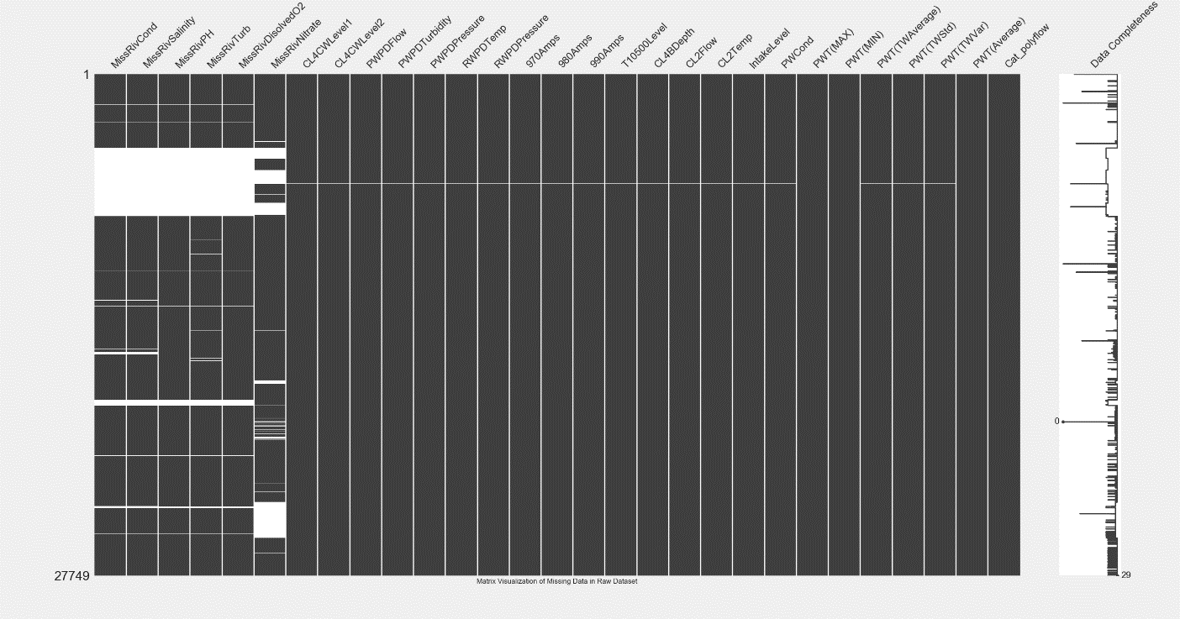

Further examination of the missing data through a dendrogram show the extent to which these gaps were isolated to the USGS data.

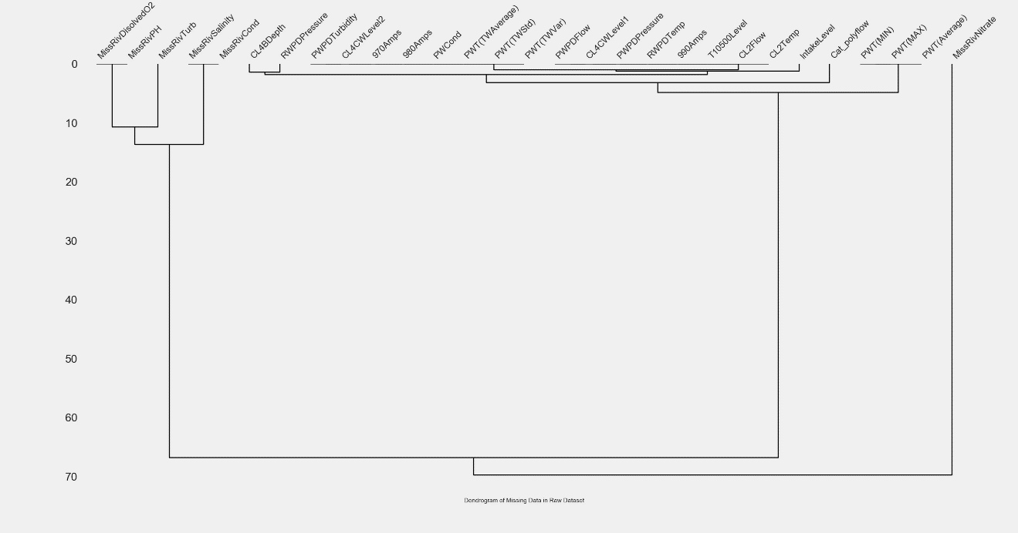

The removal of these gaps was done in manner that yielded multiple permutations of the original data-frames. These multiple variations omitted the missing data in some instances while in others the most incomplete features were entirely removed. This was done under the premise that if those incomplete features were found to be statistically insignificant to determining the future behavior of the system the frames could easily be swapped gaining the omitted points while sacrificing the insignificant feature.

Following the elimination of these gaps from the alternative datasets, attention was given to identifying bad data and outliers for mitigation or removal. These elements were chosen and examined based on several criteria in a procedural manner that insured their removal was not be erasing any true readings which might be critical to capturing a complete picture of the process in motion. By intuitively examining parameters and their variability those features which appeared to contain bad data were first collected into a list of possible targets. These targets were then considered based on the likelihood that they could truly experience these extreme values, the frequency at which these values were reached, and the rate at which these features scaled to the values in question. In addition to analyzing the nature of the data, information on possible causes for these events was investigated by searching through equipment records and operations personnel were questioned to determine if any of these instances could be dealt with expressly. Upon concluding the evaluation of these targets, eight features were found to have removable points and noisy outliers that could be tied to some external factor not related to the system. The following shows the name and descriptive statistics for each.





The external influence for all, but one of these was attributable to signal blockage within the process, instrument failure, or communication failure within the DCS. The process water turbidity reading captured from the discharge of the process water pumps at the remote clarifier was the only feature that contained problematic data with an alternative source. This features deviation was due to the daily cleaning of the meter which caused it to spike sharply to its maximum value as the cleaning process involved flushed all solids built-up in the sample line through the meter. In addition to these extreme values, segments of the data where the clarifier was out of service was removed due to the zero or null value feature data that was collected during these periods. By comparing graphical representations of several targeted variables from their initial state to after cleaning, the effects of bad data can be clearly conveyed.

*“Plot of Polymer Tank Level Standard Deviation: Removal of Inaccurate Readings”*

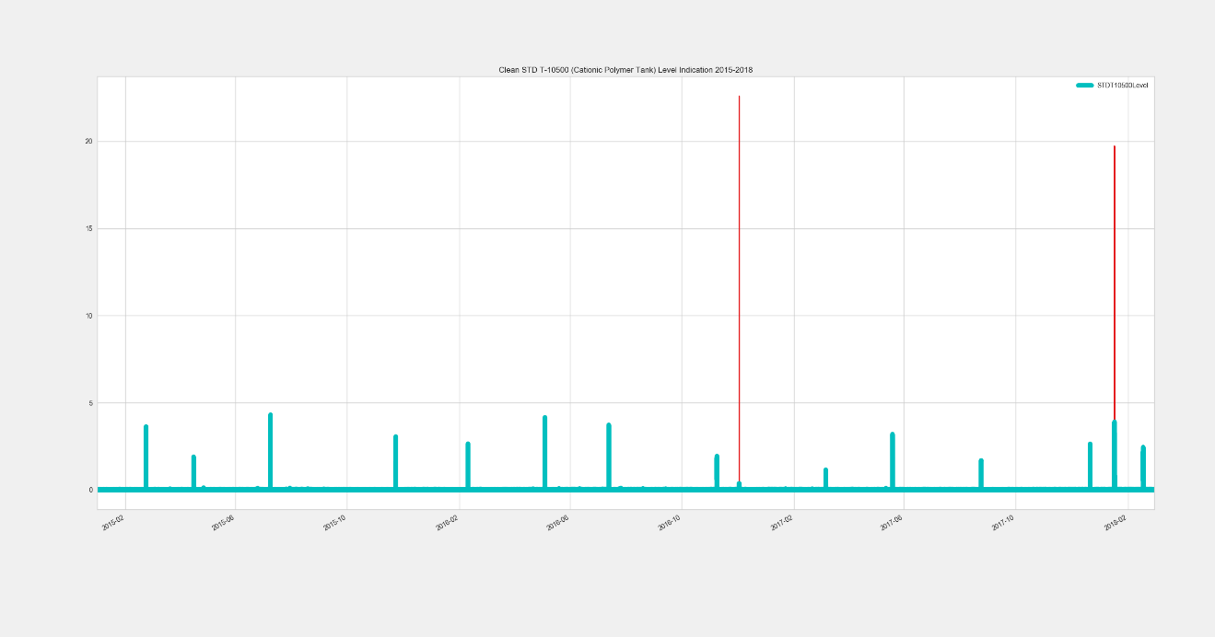

In this graph, red represents the elements that were removed. The time of these spikes in the standard deviation did not correspond to any relevant events such as a polymer delivery and off load. The clarifier bed depth was the next element to review. While there did appear to be some false readings only values below zero were removed at this step due to the stratification of the data. Other issues would be appropriately address in the data analysis portion of the project.

*“Plot of The remote clarifier Bed Depth: Removal of Negative Values”*

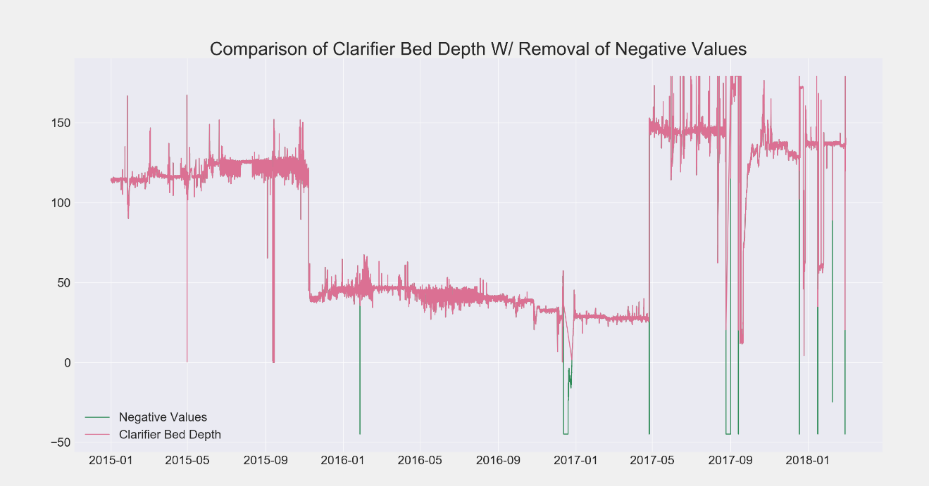

Examining the standard deviation of the raw water pump discharge pressure effectively helped identify a long segment of time were the meter was out of service and did not return a signal. This rendered the feature completely unusable for considerations in later analysis.

*“Plot of Raw Water Pump Discharge Pressure Standard Deviation”*

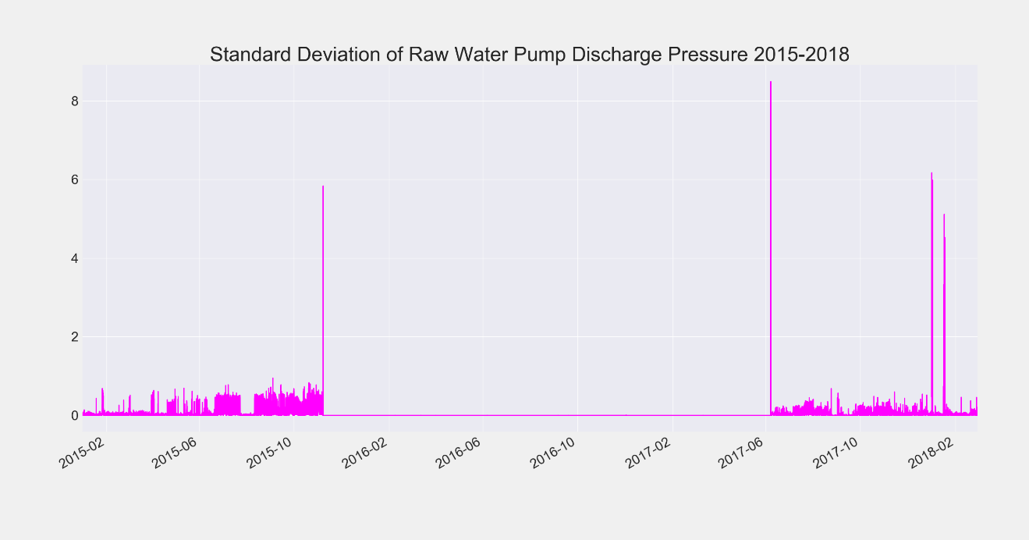

The trend of the process water discharge flow was another area where some of the recorded values were clearly outside of the physical capabilities of the system. To resolve these issues the change in standard deviation was used as an identifying factor.

*“Plot of Process Water Discharge Flow 2015-2018”*

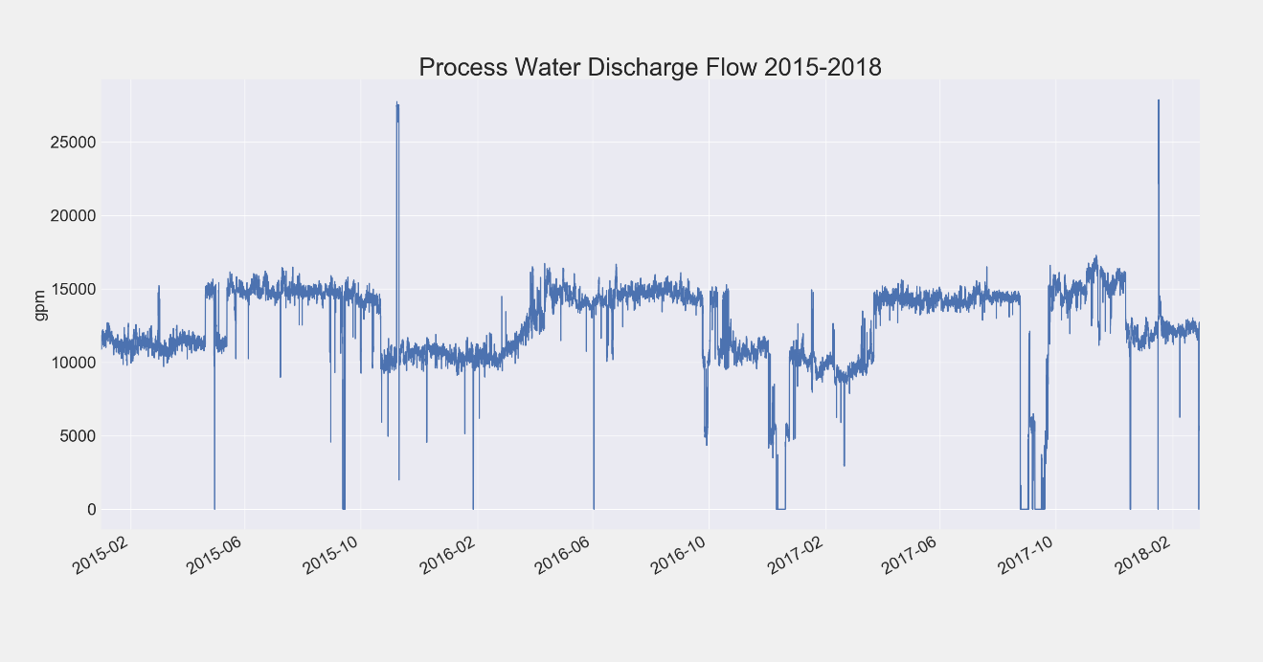

Using the 95% interval of the standard deviation many extreme values were removed. This range of the feature’s standard deviation was chosen by examining its descriptive statistics which revealed that some changes in the gallons per minute observed at points from the time series of the discharge flow were greater than the maximum output of the combined pumps.

*“Descriptive Statistics of the Standard Deviation for the Process Water Discharge Flow”*

|  |
| --- |
| count 27726.000000  mean 151.141842  std 339.800752  min 0.000000  5% 3.813579  50% 86.348515  95% 417.006778  99% 1410.587660  max 15290.757448 |

This small segment of the standard deviation only removed around 400 of the 27,700 data points from the data-frame, but as seen the from changes in the plot of the standard deviation from before to after removal this had a large impact on many extreme values.

*“Plot of Standard Deviation for the Process Water Discharge Flow: W/ Removed Values”*

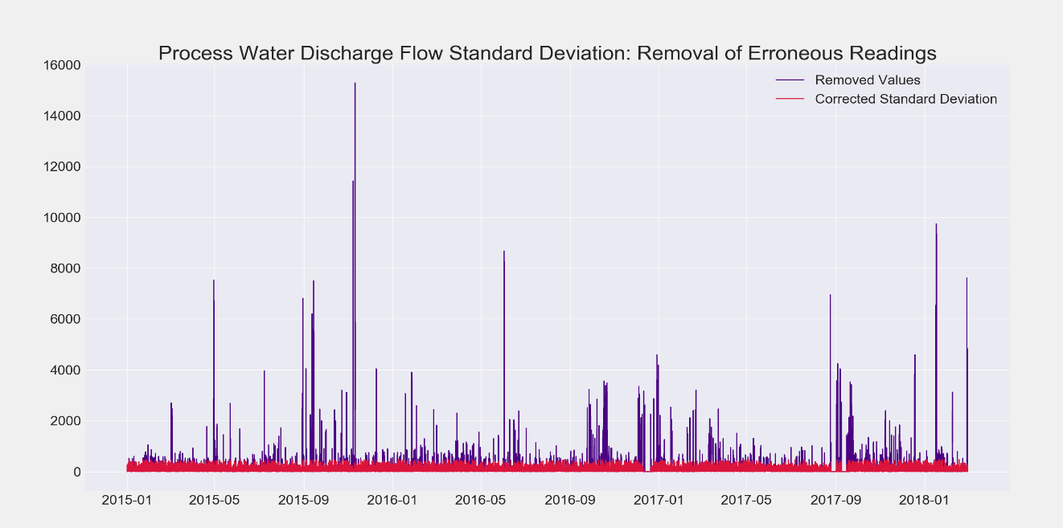

The removal of these values resulted in much cleaner trend on the process water discharge flow which served to produce improved results during the modeling phase of the project.

*“Plot of Corrected Process Water Discharge Flow 2015-2018”*

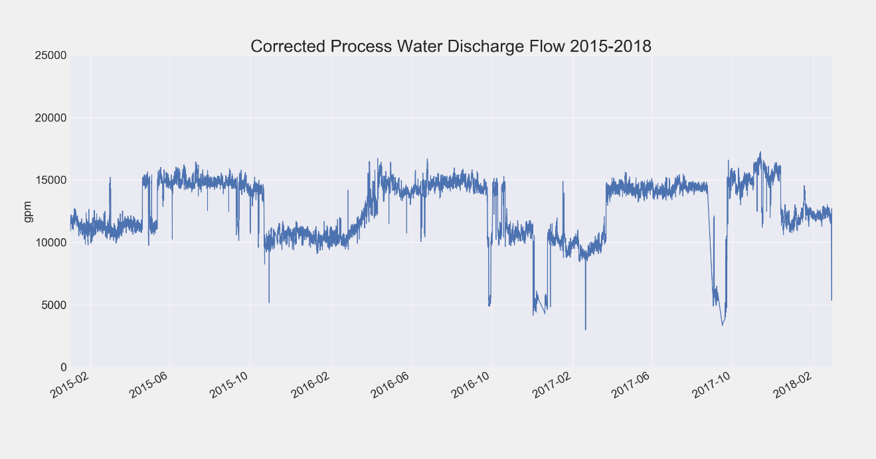

Analyses like the one performed on the process water discharge flow was repeated for the remaining elements including the process water turbidity, raw water temperature, primary clear well level indication, and backup clear well level indication. Though additional adjustments and modifications would be done in the data analysis phase of the project due to new facts revealed through exploratory data analysis, the initial steps to identify and remove false readings helped to quickly improve the overall structure of the data and streamline phases in the latter portion of the project. The following charts show these last four features and there before and after correction plots. As seen from the charts, trimming minor sections from the data easily produced results that were more realistic and cleaner for visualization and analysis.

*“Plot of Process Water Turbidity: Before and After Corrections”*

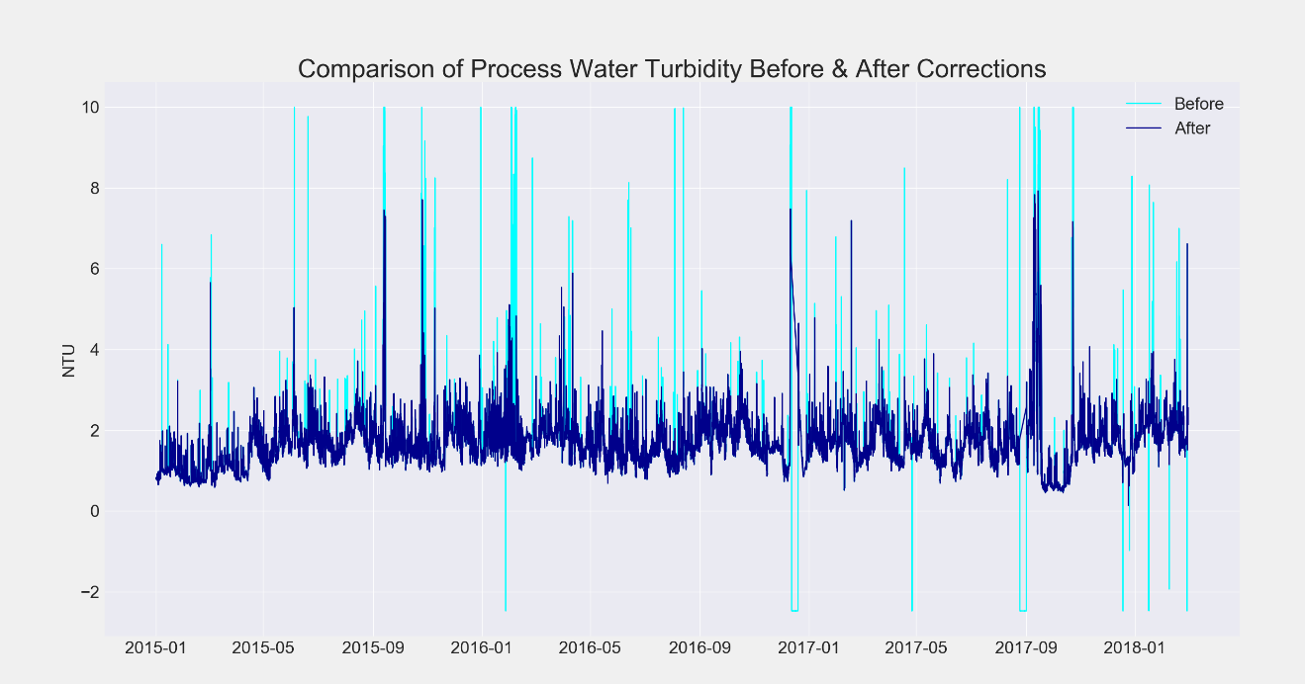

*“Plot of Raw Water Temperature: Before and After Corrections”*

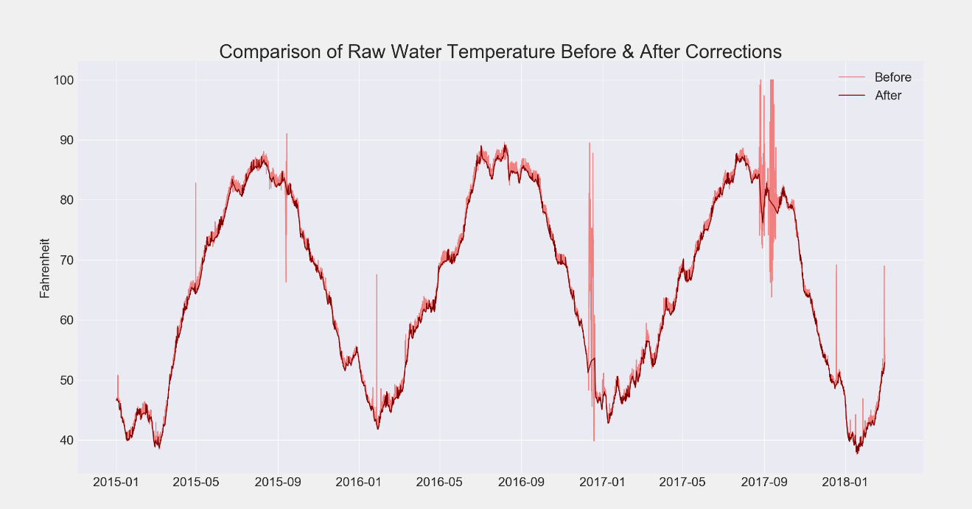

*“Plot of Primary Clear Well Level: Before and After Corrections”*

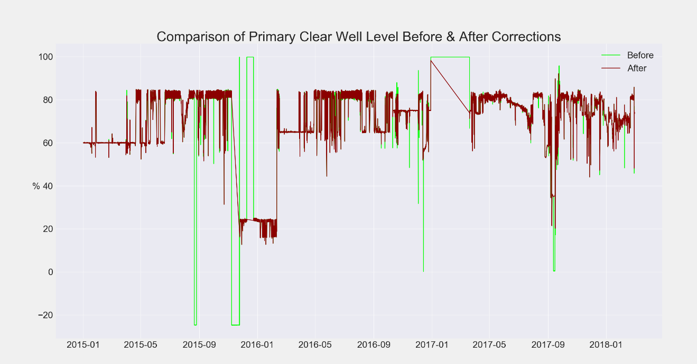

*“Plot of Backup Clear Well Level: Before and After Corrections”*

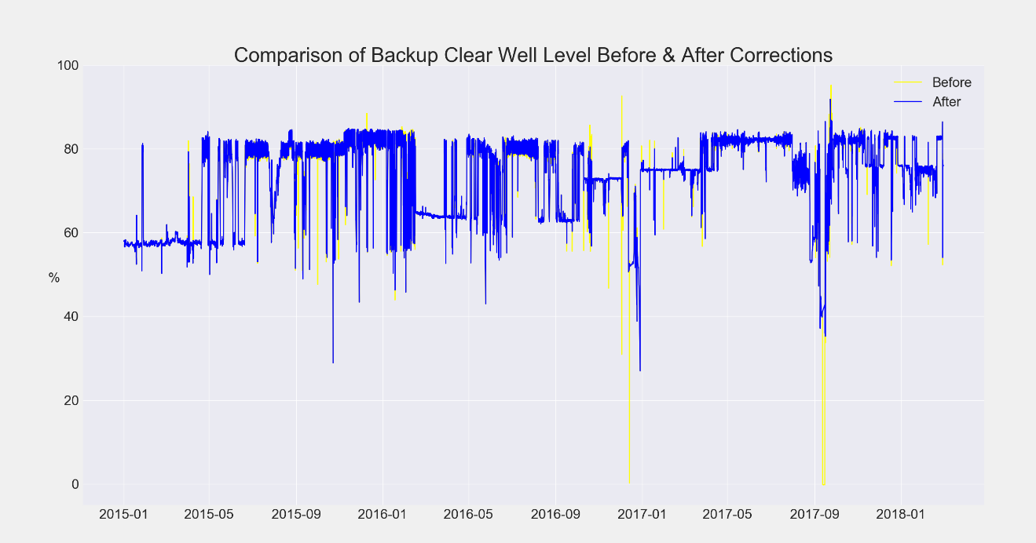

After the cleaning process was complete further reduction steps were performed on the data prior to initial exploratory analysis. This involved the quick assessment of suspect features that were already questionable in terms of relevance. By eliminating them through the examination of correlated relationships, fifteen of the thirty-seven variables were dropped from the data-frames and not considered in further analysis phases.

# Data Analysis

## 5.1 Exploratory Analysis

After completion of the collection, preprocessing, and cleaning phases to aggregate the raw data into data-frames and performing basic analysis techniques to develop some central themes concerning underlying assumptions associated with data, the process of refining the selected feature and clarifying the data structure began with exploratory data analysis (EDA). By utilizing a combination graphical approaches, statistical indicators, correlations, and system knowledge new process details were revealed and relationships among features were defined. Testing of data initially centered on confirming seasonal trends and other patterns within the data to identify what features might need to be adjusted or transformed to account for possible autocorrelations with the lagging instances of each. Focusing on parameters obtained from naturally occurring processes such as those associated with the Mississippi River influent, several techniques were applied to ensure that any findings would have strong support.

Examining the Turbidity of the incoming river influent was the first of these features to exhibit signs of serial correlation. Running autocorrelation (ACF) and partial autocorrelation functions (PACF) on the data revealed that there was a high level of correlation among lagging components within this data series as seen on the following page.

*“ACF Plot for Mississippi River Turbidity”*

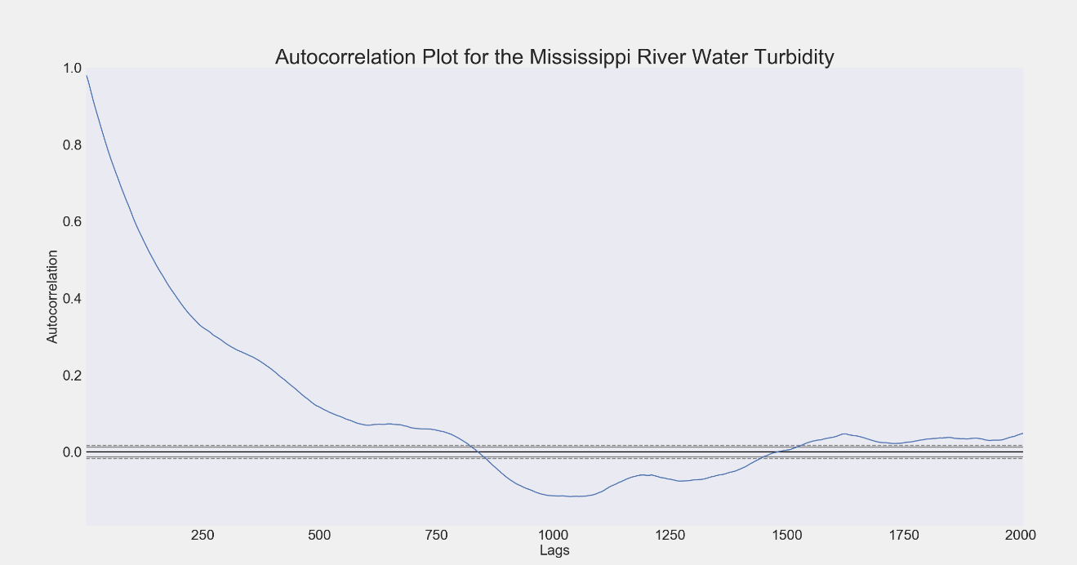

*“PACF Plot for Mississippi River Turbidity”*

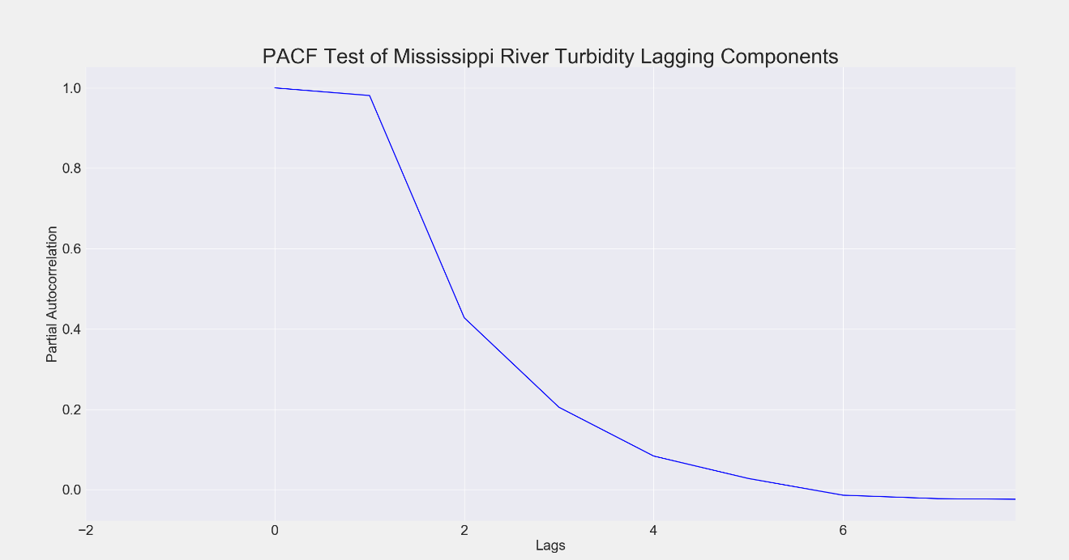

An additional inspection of the lag plots associated with this feature further confirmed the suspect autocorrelation.

*“Lag Plot for Mississippi River Turbidity”*

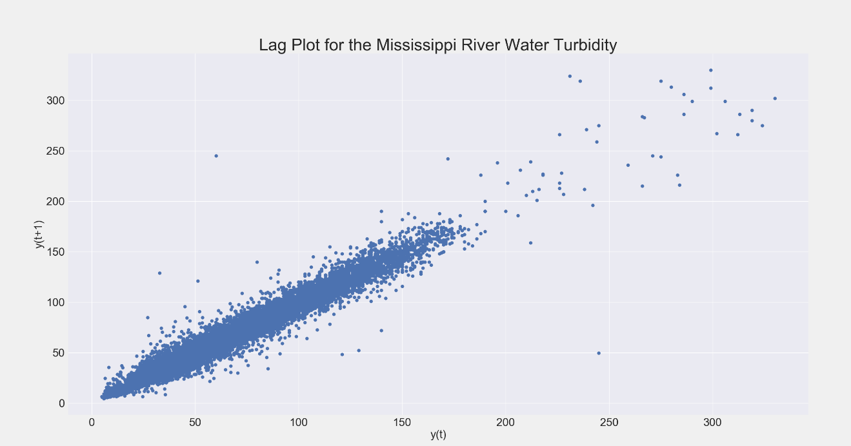

As a result of these tests, the stationarity of this time series component was tested to ensure that its statistical properties remained constant over time and would be useful in any modeling application. Running an Augmented Dickey-Fuller test served to determine this property and resulted in the rejection of the null hypothesis of the existence of a unit root in the time series sample, therefore proving it was stationary as seen in the following output.

|  |
| --- |
| --Mississippi River Turbidity--  adf = -6.99175219587  p_value = 7.71294718299e-10  Critical Values = {'1%': -3.4306314365478272,  '5%': -2.8616643860175452,  '10%': -2.5668362071124706}  Time Series is Stationary |

Despite the proof of stationarity, resolving the issue of serial correlation was still necessary for the application of this sample data in most modeling and analysis techniques. To accomplish this a one lag differencing was done on the raw water turbidity time series which immediately resolved the issue as seen in the following autocorrelation chart created after this procedure.

*“ACF Plot for Mississippi River Turbidity W/ Differencing”*

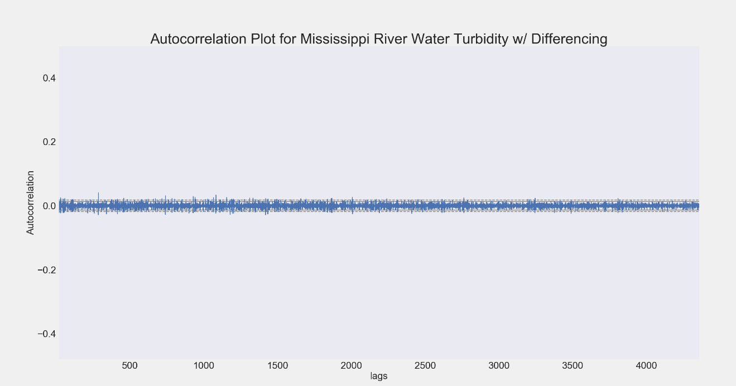

The next feature which displayed symptoms of autocorrelation was the temperature of the raw water influent. This time series showed a clear seasonal pattern with two autoregressive components. These components were easy to identify from examining the ACF and PACF chart patterns. This was determined from the sine wave form in the following autocorrelation plot and one spike lag in the partial autocorrelation chart.

*“ACF Plot for Raw Water Temperature”*

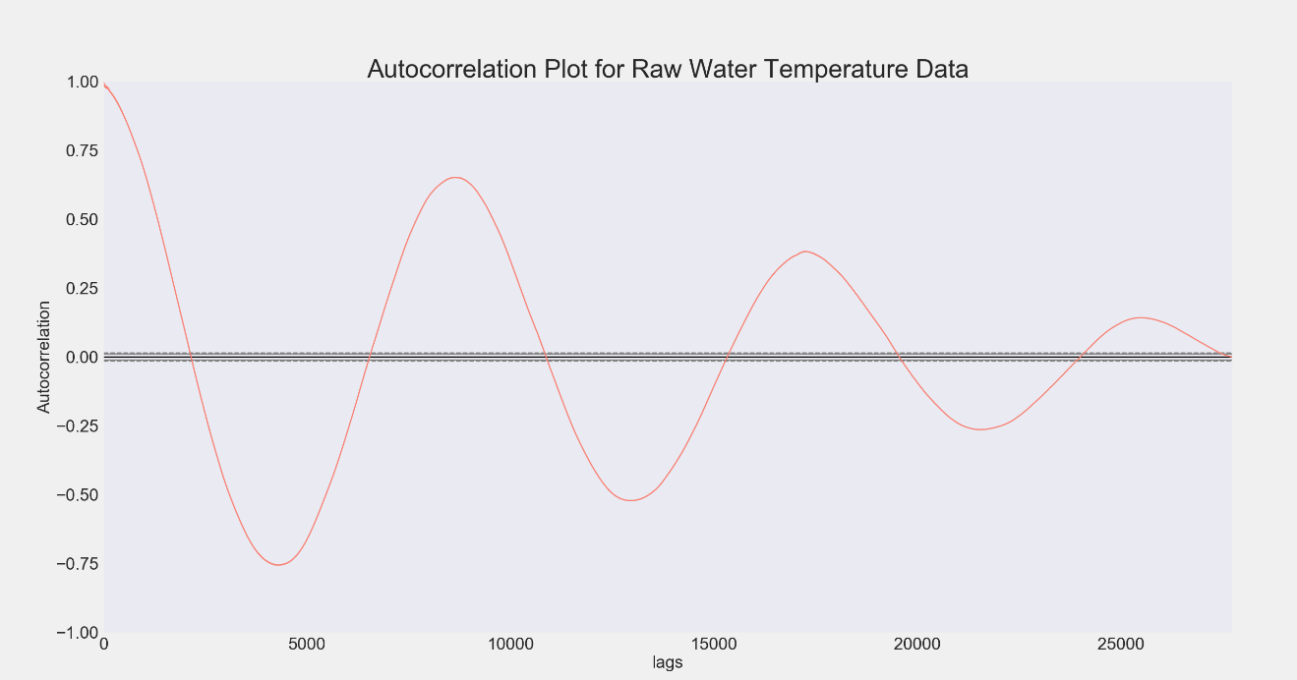

*“PACF Plot for Raw Water Temperature”*

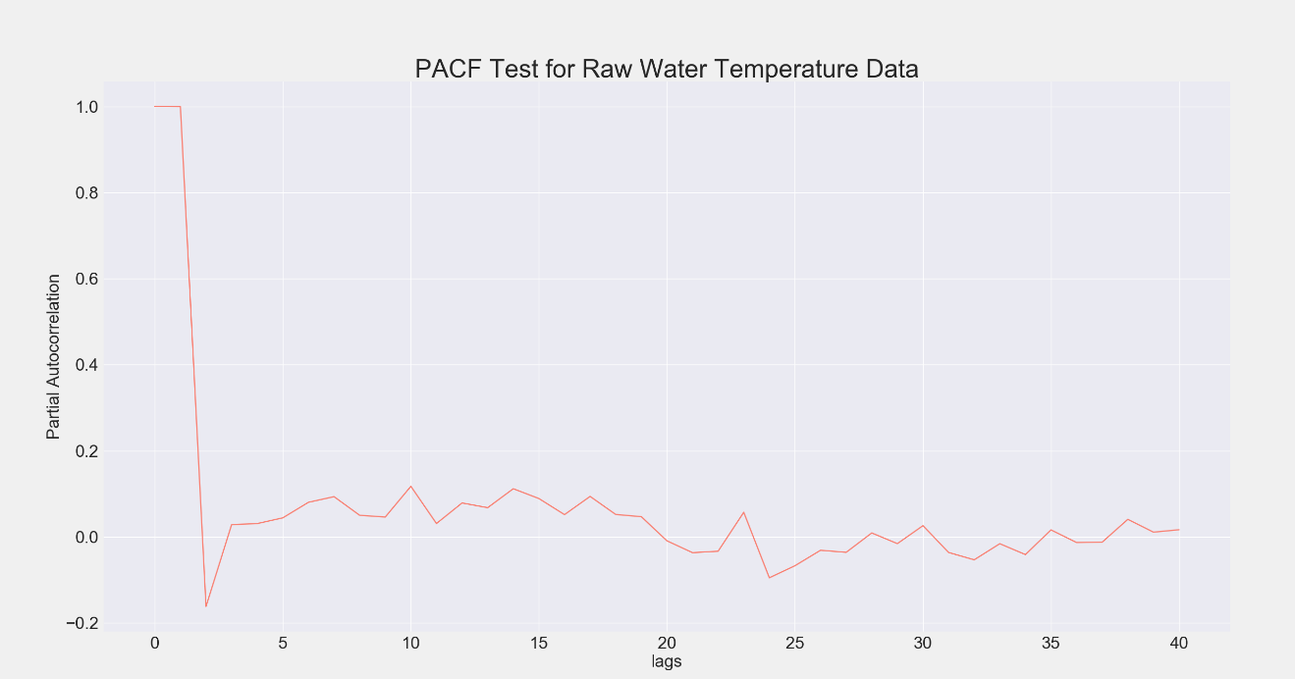

Once again examining the lag plot for this time series further confirmed the strong seasonality of this data.

*“Lag Plot for Raw Water Temperature”*

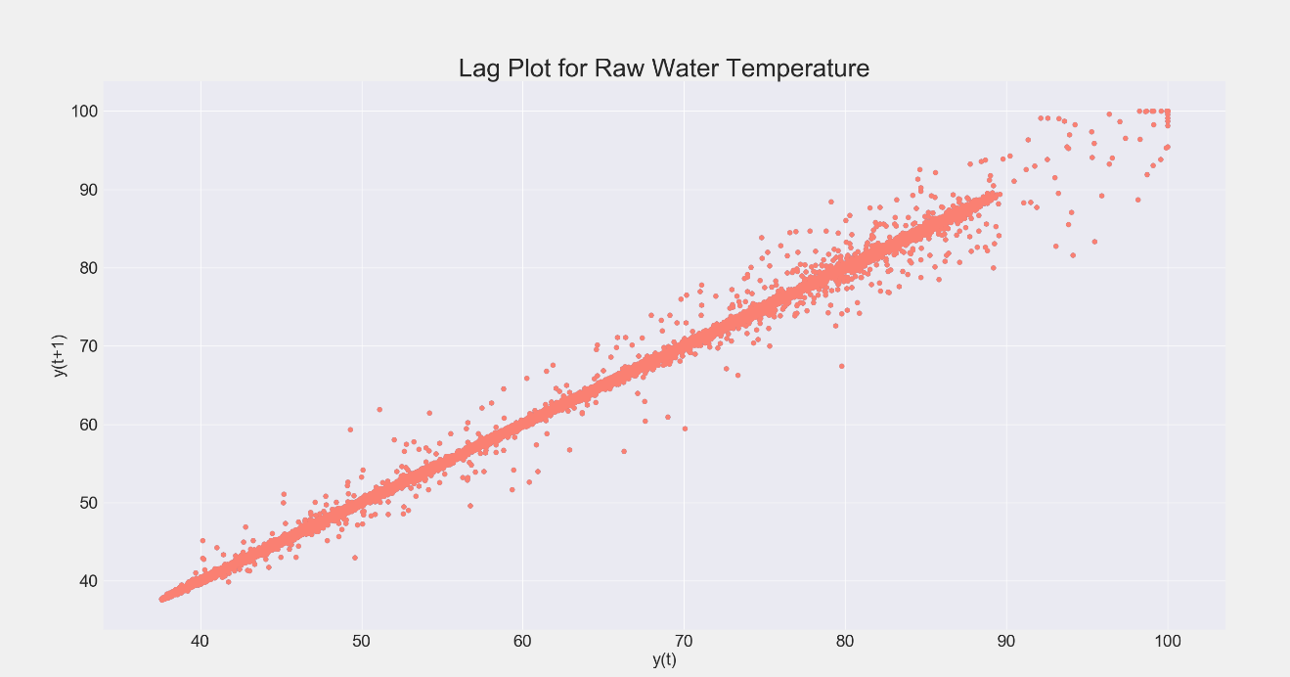

Continuing the same process with this time series an Augmented Dickey-Fuller test was run again on this time series. The results of this test failed to reject the null hypothesis of a unit root. This led to the conclusion that this time series had non-stationarity with changing statistical properties such as mean and variance over time. The results of the test seen below show the resulting statistic was well above both 5% and 10% confidence levels.

|  |
| --- |
| --Raw Water Temperature--  adf = -1.49522227572  p_value = 0.535873472897  Critical Values = {'1%': -3.4305862085592853,  '5%': -2.8616443974780941,  '10%': -2.5668255676474718}  Time Series is NOT Stationary |

Examining the trend of this feature over time it is easy to see these characteristics which had to be corrected for in order to incorporate it into any modeling applications. Steps were taken to do this as the research had shown that temperature plays a critical role in the effectiveness of polymer addition and performance of the solids removal process in clarification mechanics.

*“Raw Water Temperature over Time”*

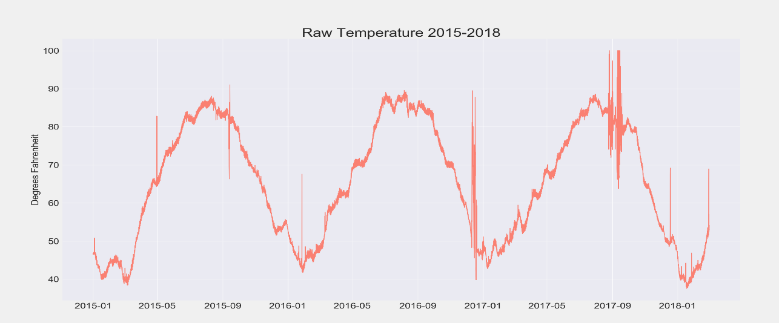

To fix these issues, seasonal differencing was first applied on an annual basis. This slightly corrected the problem of both serial correlations and non-stationarity but did not completely fix the issue. Next, a second one-order lag differencing technique was applied which created a stationary series but failed to eliminate the autocorrelation. Finally, applying a natural log transformation corrected the autocorrelation issue generating temperature data in a convertible and useable format as seen in the following results.

*“Corrected Raw Water Temperature Over time”*

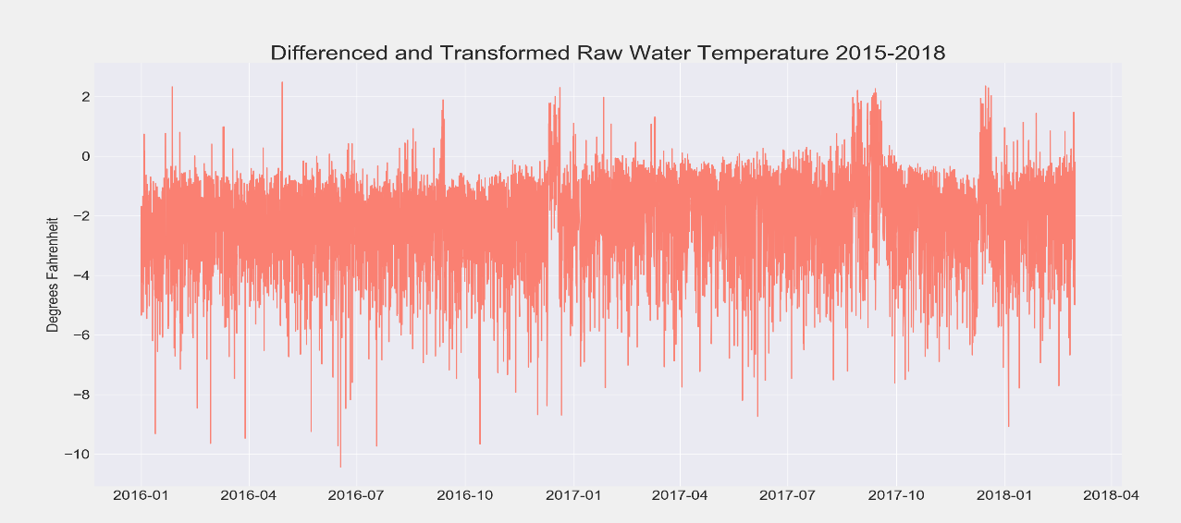

*“Autocorrelation Plot for Corrected Raw Water Temperature*

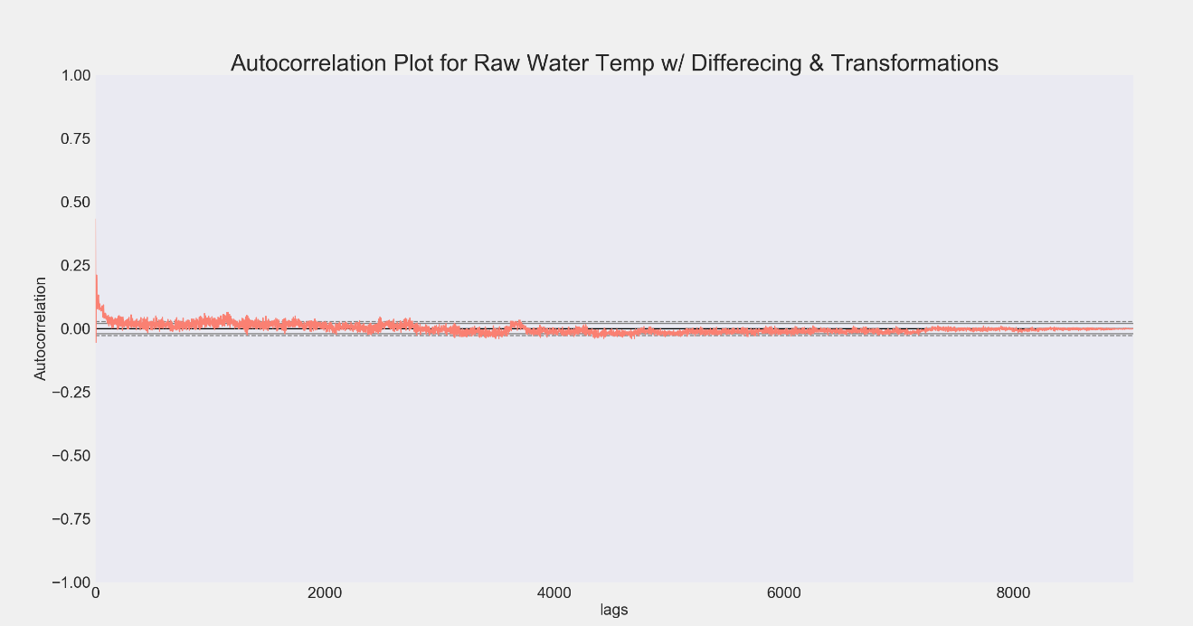

After these adjustments the Augmented Dickey-Fuller Test also proved stationarity.

|  |
| --- |
| --Corrected Raw Water Temperature--  adf = -8.50077191863  p_value = 1.24008553388e-13  Critical Values = {'1%': -3.4310759893473408,  '5%': -2.8618608402236996,  '10%': -2.5669407782202782}  Time Series is Stationary |

Further examination of other features that were assumed to potentially carry these traits did not show any evidence of trends, patterns, or seasonality.

The next steps in the EDA phase of the project involved examining the characteristics and properties of the target variable. Looking at the raw distribution of the process water turbidity it was clear that the extreme values taken out in the cleaning phases could have potentially caused problems due to the high concentration of these erroneous values in the tails of the distribution.

*“Distribution of Raw Process Water Turbidity Data”*

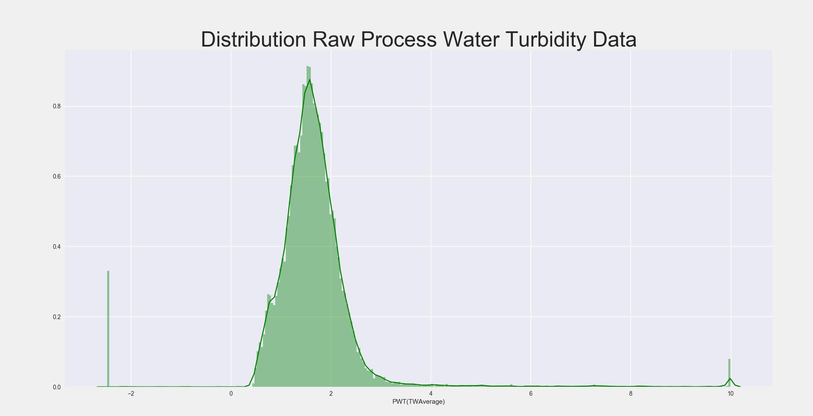

At this step further data reduction was done with the help of time series data collected on the maximum values of the process turbidity on an hourly basis. Since the removal of the initial false outliers was done by a process of identifying unusual spikes in the standard deviation of the target series and cleaning the meter typical only caused the recorded values to stay at maximum levels for around 45 minutes, instances where the meter was cleaned between hourly intervals only inflated the level of the recorded time weighted average of the turbidity for these two data points. Using a looping function, the maximum values were examined to identify sharp spikes to the upper limit of the scale for only two consecutive readings with a return to a normal maximum value that was well below these. The result of this reduction eliminated any remaining outlying elements and removed the leptokurtic shape of the process water turbidity distribution. This removed a large portion of the data reducing the largest comprehensive data-frames by around 2,000 data points.

*“Distribution of final Process Water Turbidity Data”*

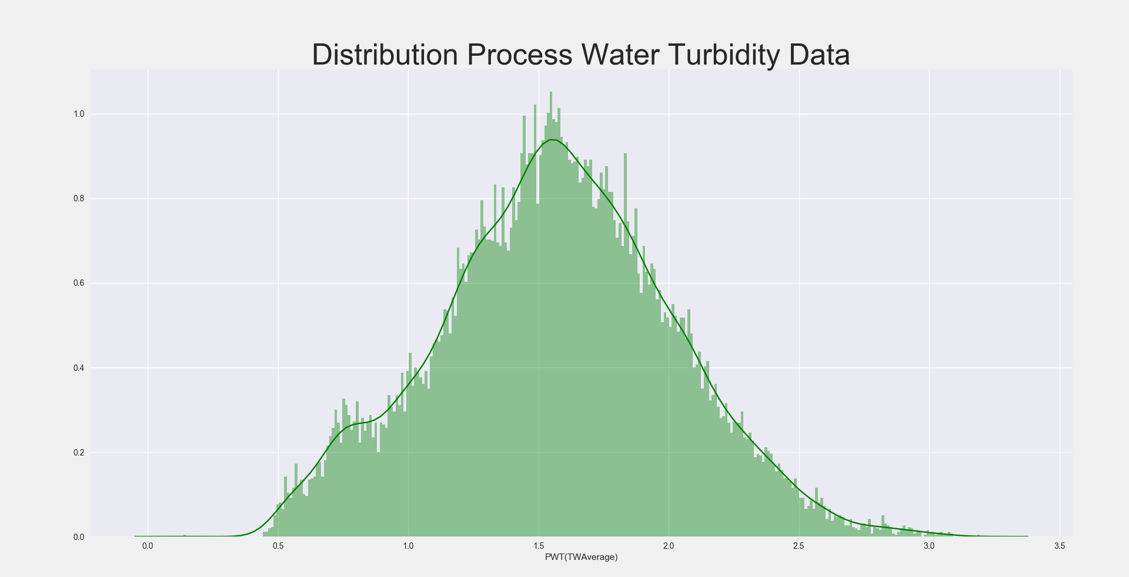

The distribution of this final data series also displayed characteristics of normality in its shape holding true to the central limit theorem. However, testing the normality of the data resulted in a p-value that suggested the null hypothesis of normally distributed data should be rejected. Despite this, the modeling techniques selected were robust to the failure of this assumption and it was not a major factor in any models’ performance.

|  |
| --- |
| --Normal Test Result--  Statistic = 41.553529904585965  P-value = 9.4790677957241691e-10)  Reject the null with P<alpha = 0.05 |

At this point comparison of process water turbidity data captured through online metering was compared to hand caught samples. The results of this analysis showed that there was a significant average deviation between the two of around -0.43 NTU which was 15% of the target set point for this value. Attributing this deviation to be a result of sampling location and system construction, the consistent difference was utilized as an adjustment measure to realign the set point to better represent the results of hand caught samples. The reversion to samples caught by operations personnel was done under the assumption that these samples were more accurate. The accuracy of these appeared to be a better basis due to two factors. The first was the fact that the bench top meter used to read these samples was calibrated on a regular 90-day interval as opposed to the meter that was only calibrated when necessary. The second was that the way in which the meter capture turbidity values meant that it could potentially lose flow yielding lower than expected NTU levels. After adjusting this value, the new target set point for the final system was determined to be 2.4 NTU.

*“Comparison of Turbidity values for operations personnel and the online meter”*

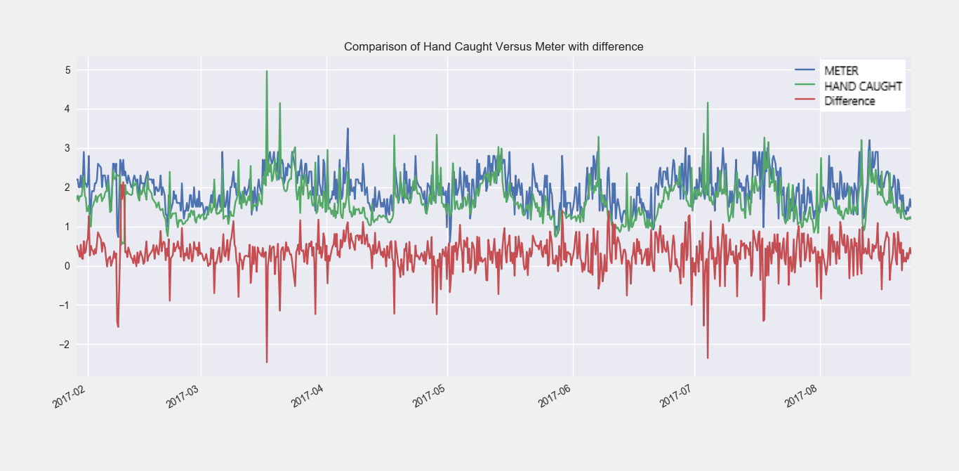

Extending from this analysis, the next area of examination related to the relationship of the remaining features in the set to the target variable. This analysis was done to eliminate additional feature from the final analysis sets for quicker and more accurate model development. Correlations were examined using correlation matrices develop through Pandas in Python. These matrices increased the efficiency of this step immensely and allowed for the fast determination of significant variables.

*“Complete Correlation Matrix”*



*“Process Water Turbidity Column in Matrix”*



With no highly correlated features expected, since the nature of this system puts features significant to the process in adverse relation to each other causing a dampening effect, only those variables which showed weak correlations (0.1 – 0.5) or who were determined to be critical factors through research were selected for future analysis. Those features who were already suspect to have little influence on the process were cut from the list.

*“Process Water Turbidity Column in Matrix with variables for further analysis”*



This process was then repeated again on a shifted version of the Process Water Turbidity data series which took it from a one-hour lag compared to the entire dataset to a six-hour lag to develop a feature list for use in models purposed for use with current sampling intervals.

*“6-hour Shift PW Turbidity Column in Matrix with variables for further analysis”*



These two feature sets would be the basis for future transformation and adjustment to formalize models. However, several variables were revisited to account for in accuracy in this base set. Weak correlations were over looked for several reasons. The most prominent of these included the fact that many feature such as the raw water turbidity and the cationic polymer dosage counteracted each other, effectively neutralizing their impact, and that despite these weak correlations the need to consider suspect features kept them significant in terms of model develop such as the process water discharge flow from the clarifier which was clearly an impact feature as the concentration of polymer in the water went down as the amount of water flowing through the clarifier increased.

## 5.2 Feature Engineering

EDA led to the next phase of the data analysis portion of the project, feature engineering. This phase involved applying proven techniques to modify features so that their relationship to the response variable, process water turbidity, could be clearly defined, alternative feature sets could be evaluated to possibly find better explanatory variables for more reliable models, and to correct deficiencies in features containing poor or bad data. Feature engineering was useful in many ways and help to develop some critical metrics for future evaluation.

Examining features for deficiency was the priority entering this phase and several features clearly displayed some poor qualities. The clarifier bed depth was one of these. Upon initial inspection of the time series data captured on this feature it appeared that there was a significant shift in the mean for a period of nearly two years. This was ultimately attributed to instrument failure resulting from lighting striking the field meter. Failure to correct this problem for a two-year period was due to low priority. Since the meter only experienced a shift in mean and didn’t completely fail, it still properly controlled the cascaded desludge valves used to manage the clarifier bed depth within desired levels. Without the high priority, the repair of the instrumentation experienced several push backs before finally being repaired. Since that time though, several more instances have occurred which caused the meter to either be at its maximum or minimum level for some time despite the bed being well within it normal operating range. Ultimately several steps had to be taken to shift portions of the data and remove false values which were not picked up during the data cleaning phase of the project.

*“Plot of Raw Data from Clarifier Bed Depth over the Period 2015-2018”*

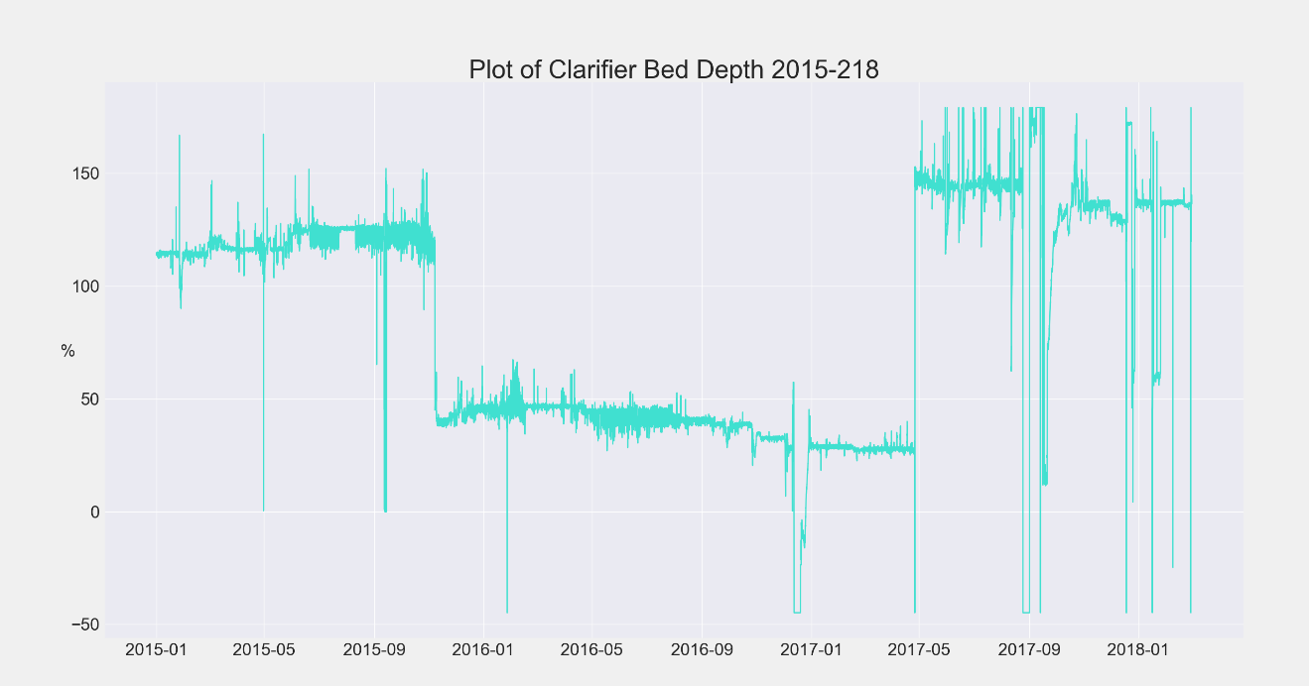

First, the time series was split into three segments representing the three stratified portions of the series. Each segment was then scrubbed and searched through for false readings and outliers by applying functions to find sharp percent changes, values outside of realistic ranges, and inconsistent trends. After removing these values, the mean, maximum, and minimum values were extracted and compared. Using simple regression analysis, equations were derived from the rank order of the values in each segment. The resulting equations were used to shift the values of each data point in the separate segments which generated the final modified clarifier bed depth time series.

*“Equations for transformation”*

|  |
| --- |
| ## 1st segment of data from Clarifier Bed Depth Time Series ##  clbd1 = ModelData().CL4BDepth[:7446]  -- Final Equation = “NV = New_Value = -93.0449+(clbd1[x])*5.4122  ## 2nd segment of data from Clarifier Bed Depth Time Series ##  clbd2 = ModelData().CL4BDepth[7446:20346]  -- Final Equation = “NV = New_Value = -316.4483+(clbd2[x])*3.8517  ## 3rd segment of data from Clarifier Bed Depth Time Series ##  ## Used as Basis for Transformation of other two portions ##  clbd3 = ModelData().CL4BDepth[20346:] |

The use of an equation instead of simply shifting the mean was done because the data appeared to indicate both a shift in fixed quantity as well as the presence of a scaling factor.

*“Plot of Modified Data from Clarifier Bed Depth over the Period 2015-2018”*

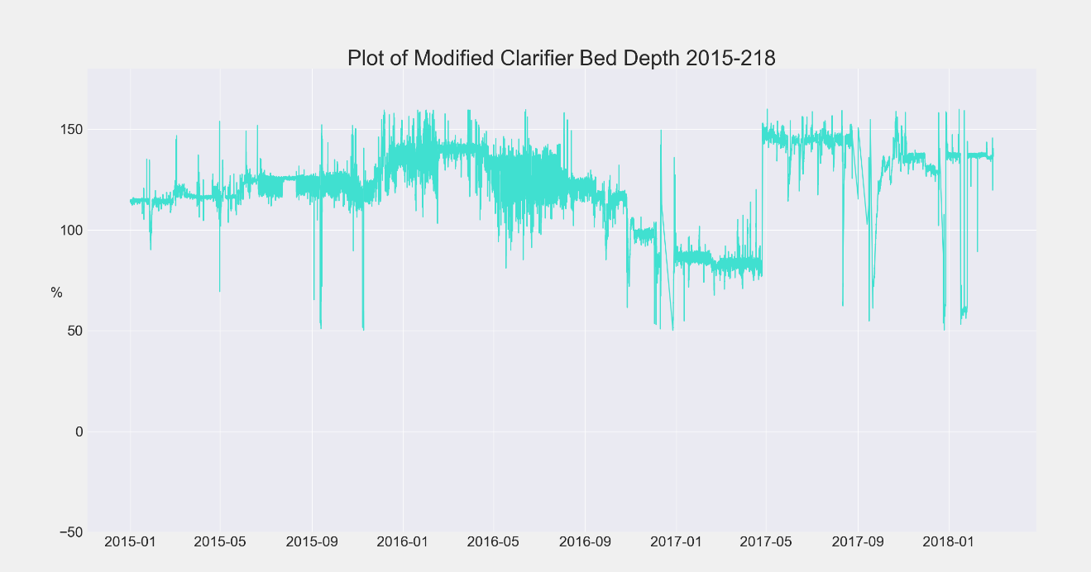

Other feature deficiencies were relatively minor in comparison to the clarifier bed depth, only representing small daily or hourly intervals within the time series. These were handle in a straight forward manner either by elimination from the data-frame, application of an additional factor, or by built in functions such as Sklearn’s Imputer Function.

After correcting for any complications in the data, the next step of feature engineering was to develop alternative features for analysis. This step presented some unique problems resulting from feature explosion and management. To mitigate these issues many procedures used to develop features were automated and sorted through using loops and defined metrics to eliminate irrelevant feature creations. Starting with basic alterations, Pandas’ functions such as *“.resample(_)”* and *“.shift(period=_)”* were revisited in combination with more advanced functions such as *“.pct_change(_)”, “.rolling(_)[.mean(_), .std(_), .var(_)]”,* and *“pd.rolling_’* *multiple options *‘(_)”*. This resulted in several interesting results. The Mississippi River data was found to have a higher correlation when considerations were taken for rolling components of between 12 to 14 hours. Different features coming from the Mississippi River data were also found to have higher correlations when their shifted values were offset in time, suggesting that the levels of these qualities in the water were propagating downstream at different rates. This was attributed to how they were affected by different conditions in the overall flow of the river. It was also discovered that some of the highest correlations between the target variable and the explanatory features were reach when there was a six-hour lag between them. To find this each entire data-frame was sliced according to the quartiles of different features including those that were not under consideration. This essentially controlled for certain variables allowing for some of strongest correlations to be revealed and helped to identify possible issues with multicollinearity among explanatory variables in the data-frames.

*“Example Returned Correlations for the 6-hour lag: PW Turbidity and Polymer Flow”*

|  |
| --- |
| 6 hour shift PWT  [ 'Correlation', 'Feature', 'Condition', 'Size of Section']  [-0.4716064922388753, 'MissRivNitrate', '1.22>df1', 4242]  [-0.44219760323616253, 'MissRivSalinity','0.2>df1', 1133]  [-0.43133773524252955, 'MissRivTurb', 'df5>89.0', 4319]  [-0.35310793434449383, 'MissRivTurb', '89.0>df4>65.2', 4315]  [-0.33885818358880881, 'ModifCL4BDepth', '119.315>df2>110.876', 5180] |

The ultimate cause of this has been difficult to decide on, but two theories are still being considered. The first is that this amount of time is what’s required for the clarifier to fully experience effects from changes in input parameters. The other thought behind this is that the largest impact is seen at these points because of changes that are made during rounds by operations personnel which are done every six hours.

Binary features were then created to determine if features could be used as classification objects during the regression analysis. Using value ranges within the time series as indicators, dummy variables were generated through pandas and tested with initial multiple regression tests and decision tree functions to see if any of these features could play a crucial role in modeling the system. Very few of these features were considered for further analysis, but those that were include binary features for the run indication of the third raw water pump based on amp values greater than zero, the open or closed condition for both desludge valves, the high or low value of the Mississippi River Turbidity, and an indicator for if the discharge flow from the clarifier was above or below 13300 gpm.

|  |  |  |
| --- | --- | --- |
| BINARY FEATURE | 0 – CONDITION | 1-CONDITION |
| MP-970 | Amps <= 0 | Amps > 0 |
| Desludge Valves | Both Closed | One Open |
| Miss. River Turbidity | MRT <= 150 | MRT > 150 |
| PW Discharge Flow | PWDF <= 13300 | PWDF > 13300 |

Of these, the discharge flow was the only one considered due to the condition of the data. Examining the distribution of data points related to this feature showed a bimodal spread. The cause of this condition was due to the amount of flow ultimately being determined by a fixed number of pumps that could be run. Without a Variable Frequency Drive (VFD) to perform incremental flow adjustments of the outgoing effluent the only variation in flow outside of the pump capacity was a direct result of changing header pressure placing back pressure on the output of the pumps.

*“Distribution of Process Water Discharge Flow Data 2015-2018”*

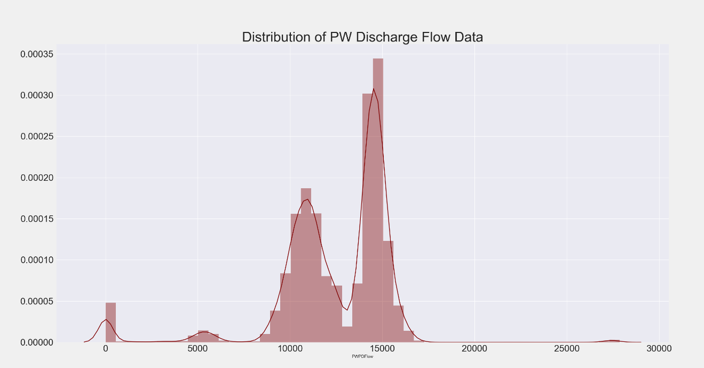

Other transformations were experimented with beyond this point including the roots, exponents, and natural logarithms of features, but none yielded any improvement in their relationship to the response variable. Interaction terms were also tested with the thought that combinations of features would neutralize their dampening effect. These terms were created by multiplied pairs of features to get their combined value. Utilizing SKlearn’s preprocessing function *“PolynomialFeatures”* in a self-developed function named *“Interaction Terms”* these elements were sent to a correlation matrix and evaluated in a similar fashion to how the original set of features were examined. With over 50 terms created few of them performed better than the base set of features and none considered in the final model development phase.

*“Correlation Matrix for Interaction Terms”*



The only positive result from feature combinations came from what was ultimately termed the *“Poly-Turb Ratio”* or polymer to turbidity ratio. This feature was developed by a division of the cationic polymer flowed by the inverse value of response variable plus its maximum value and one.

$$\left(Poly-Turb Ratio=PTR=\frac{Cationic Polymer Flow}{\left(Max\left(PWT\right)-PWT\right)+1}\right)$$

While not directly involved in the overall model development phase of the project, this term did help to better understand relationships and verify features that would play central role in model creation and was used to generate target values for some more basic models. It created an intuitive sense of how variables impacted how much polymer was needed to reach certain turbidity levels in the outgoing effluent under certain conditions. This truly became apparent when discrete values, talked about in the future sections, were generated from the primary explanatory variables. This can be seen in the following heat map showing an increased polymer requirement with lowering temperatures and rising raw water turbidity.

*“Heatmap – RW Temp, RW Turb, Poly-Turb Ratio”*

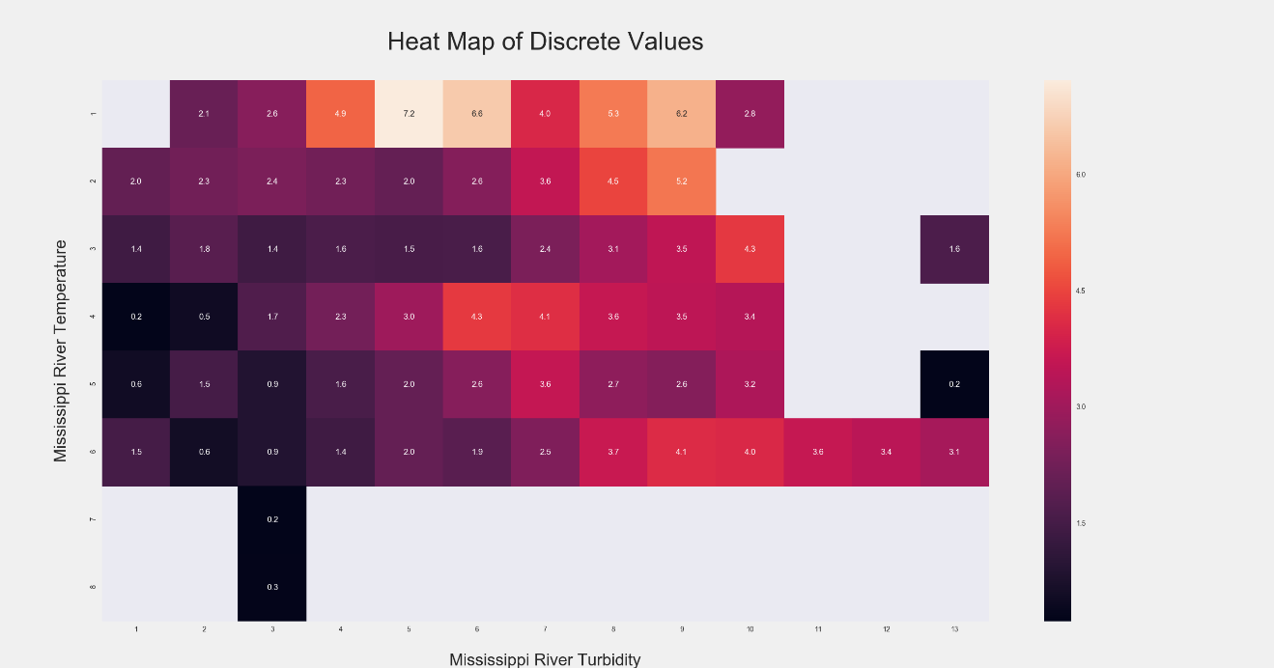

Several more modified features were generated through other means that showed some promise. The best of these were a combination of the raw water pump amps and the smoothing of the clear well level indication. The thought behind the creation of a combine raw water pump amp feature was that the process water discharge flow didn’t properly account for the changes in flow going into the clarifier due to incremental changes in the VFD of the first raw pump and on/off cycle of the third raw water pump to maintain the clear well level. In addition to this there was an offset in the time that these elements operated due to the control logic being directly tied to the clear well level and not the outgoing flow. This meant that the pumps on the inlet and outlet of this process would be adjusted to increase and decrease flows at different times. Expanding on this idea, attempts where made to correlate outgoing flow rates to amp readings of the raw water pumps by utilizing relative percent changes in the clear well, but skewed segments in several large sections of data collected from ▓▓▓▓ prevented this from being reliable enough to use.

*“Plot of Raw Water Pump Amp Combination 2015-2018”*

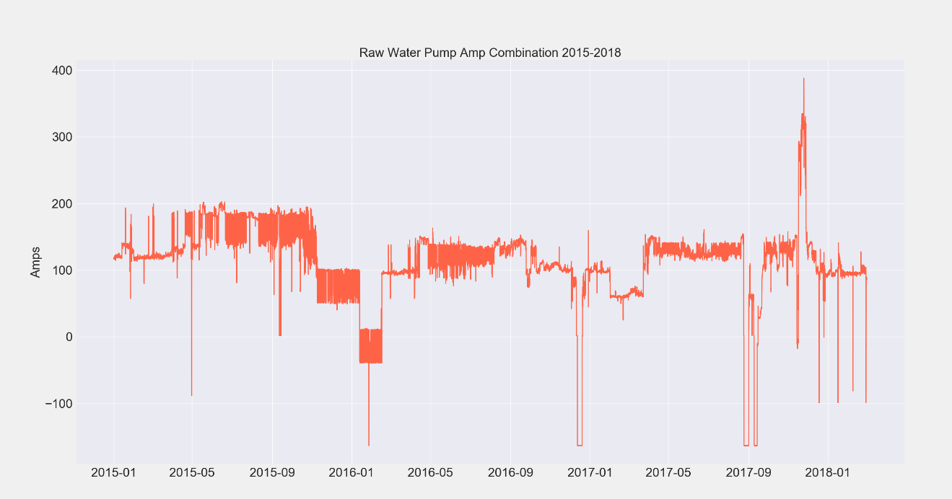

The smoothed clear well level indication served to combined the primary and back-up level meters to account for periods of bad data seen in both during the first steps in this phase. Although the primary level indicator did run at somewhat higher levels than the back-up, their correlated output allowed for a regression equation to be developed to map the back-up meters output onto the primary’s when it failed to provide accurate data. As shown in the following charts the times that the primary was out of service represented some large section of data that couldn’t be ignored. The modified time series provided a consistent picture of how the level within the clear well changed over time. This provided crucial information and input for models developed in the later stages and also helped to identify what metrics would better serve describing the process in some of the final models chosen

*“Regression Equation for Clearwell Conversion”*

$$\left(Clear Well Level 1 Reading=19.68+\left(Clear Well Level 2 Reading\right)*0.7182\right)$$

*“Plot of Individual Clear Well Level Indicators 2015-2018”*

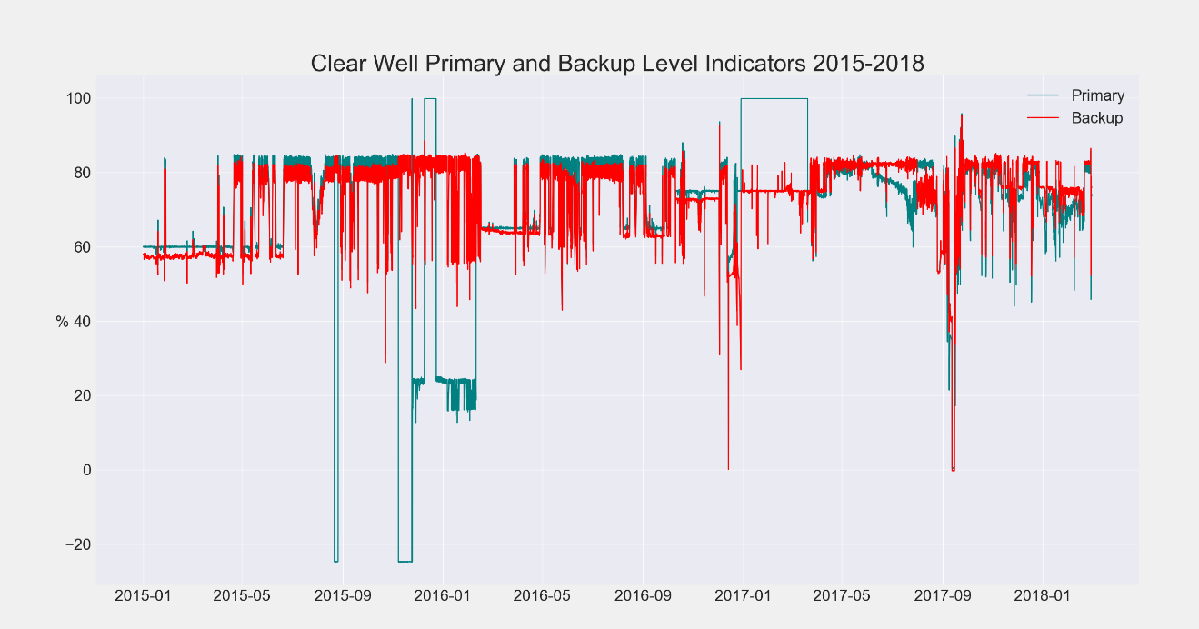

*“Plot of Combined Clear Well Level Indication 2015-2018”*

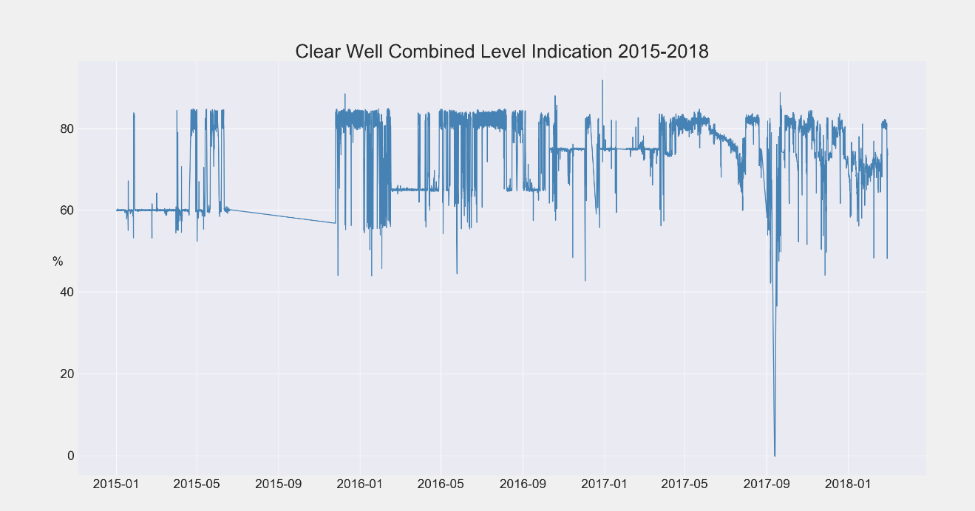

## 5.3 Transformation of Explanatory Variables

After Feature Engineering a select set of explanatory variables was created to be applied to different modeling techniques. This short list, in comparison to the original feature set, represented those components which not only showed some statistical relation to the two targeted response variables, but also were supported by research and intuition. The careful evaluation of these metrics helped to better refine how the model development phase would flow and decreased the amount of time that it took to complete steps of that portion of the project.

*“Explanatory Variables”*

|  |  |  |
| --- | --- | --- |
| Features Applicable for Modelling | | |
| Mississippi River Turbidity | Mississippi River PH | Miss. River Conductivity |
| PW Discharge Flow | Clear Well Level | Raw Water Temperature |
| Polymer Flow | Desludge Boolean | Combine RW Pump Amps |
| MP-970 Amp Boolean | Lagged PW Turbidity | Modified Bed Depth |

*“Response Variables”*

|  |  |
| --- | --- |
| Target Features for Model Definition | |
| 1 hour leading PW Turbidity | 6 hour leading PW Turbidity |

The first attempts to model the data resulted in extremely poor performance. Most models struggled to explain much of the target variables variance with the best models only having an R2 of 0.37 with an extremely high mean squared error in the residuals. After cycling through all possible combinations of feature sets with several different models and tuning their parameters to determine if any changes would improve these results, the next adjustments that were made involved simply rounding the data. This provided some improvement which led to redefining all of the features involved from continuous values to simplified discrete values. These transformations proved to be the turning point of the modeling process. Once these values were defined the models immediately performed better and fit the target time series with limited deviations. Using the data-frames *“sdf”* (Stripped-Data-Frame) and *“sdfc”* (Comprehensive-Stripped-Data-Frame)these features were created through list comprehension and the application of simple functions. The *“sdf”* data-frame represented a slightly more refined and reduced dataset that removed some components and time intervals that were suspect to exhibit high levels of noise, while the *“sdfc”* data-frame was a comprehensive cleaned dataset that capture nearly the entire period from 2015 to 2018 omitting only known periods of deficiency. A table containing the description of these features along with the basic code is shown below.

*“Discrete Features”*

|  |  |  |
| --- | --- | --- |
| Name | Description | Interval |
| ComboRWPBool | Run indication for raw water pump | (1-3) |
| CPFD | Cationic Polymer Flow Discrete | (1-27) |
| MRTD_26 | Mississippi River Turbidity Discrete | (1-26) |
| RWTD_12 | Raw Water Temperature Discrete | (1-12) |
| MRPHD | Mississippi River PH Discrete | (1-10) |
| CL4CWlevel | Clear Well Level Cleaned | Continuous |
| CL4CWLD | Clear Well Level Cleaned Discrete | (1-3) |
| PWPDFD | PW Pump Discharge Flow Discrete | (0.0-6.5) |
| *PWTD ‘_#’ | Multiple PW Turbidity Discrete Features | Multiple Ranges |
| PWTCPRC | Poly-Turb Ratio Continuous | Continuous |
| PWTCPRD | Poly-Turb Ratio Discrete | (0.0 – 15.0) |
| DDLV | Desludge Boolean Series | (1-2) |

*“Code for Discrete Features”*

|  |
| --- |
| 1. ## Indicator of number of pumps running ## 2. sdf['980AmpsBool'] = [1 **if** x>0 **else** 0 **for** x **in** sdf['980Amps']] 3. sdf['990AmpsBool'] = [1 **if** x>0 **else** 0 **for** x **in** sdf['990Amps']] 4. sdf['ComboRWPBool'] = sdf['970AmpsBool']+sdf['980AmpsBool']+sdf['990AmpsBool'] 6. ## Cat_Poly_Flow_Discrete (CPFD) = cationic polymer discrete values (1-27) ## 7. sdf['CPFD'] = [(x-100)/10 **for** x **in** sdf['Cat_polyflow']] 8. sdf['CPFD'] = [1 **if** x<1 **else** divmod(x,1)[0]+1 **if** x<26 **else** 27 **for** x **in** sdf['CPFD']] 10. ## Miss_Riv_Turb_Discrete (MRTD_26) = Mississippi River Turbidity discrete values (1-26) ## 11. sdf['MRTD_26'] = [x/10 **for** x **in** sdf['MissRivTurb']] 12. sdf['MRTD_26'] = [int(divmod(x,1)[0]+1) **if** x<=25 **else** 26 **for** x **in** sdf['MRTD_26']] 14. ## Raw_Water_Temp_Discrete (RWTD_12) = Raw water temperature discrete values (1-12) ## 15. sdf['RWTD_12'] = [int(divmod((x-30)/5,1)[0]+1) **for** x **in** sdf['RWPDTemp']] 17. ## Miss_Riv_PH_Discrete (MRPHD) = Mississippi River PH discrete values (1-11) ## 18. sdf['MRPHD'] = [int((x-7.2)*10) **if** **not** np.isnan(x) **else** x **for** x **in** sdf['MissRivPH']] 20. ## Clear_Well_Level_Discrete (CL4CWLD) = Clear Well Level Discrete Values ## 21. sdf['CL4CWLevel'] = [o **if** (one<95) **and** (one>40) **else** t **for** o,t **in** list(zip(sdf.CL4CWLevel1,sdf.CL4CWLevel2))] 22. sdf['CL4CWLD'] = [1 **if** z < 65 **else** 2 **if** z < 75 **else** 3 **for** z **in** sdf.CL4CWLevel] 24. ## Process_Water_Discharge_Flow (PWPDFD) = Process Water Flow Discrete Values 25. sdf['PWPDFD'] = [round((pf-9000)/1000,1) **for** pf **in** sdf.PWPDFlow] 27. ## Process_Water_Turb_Discrete (PWTD) = Current process water turbidity discrete values (1-8) ## 28. sdf['PWTD2'] = [int(divmod((x-0.3)*(7/2.9),1)[0]+1) **for** x **in** sdf['PWT(TWAverage)']] 29. sdf['PWTD'] = [round((x-0.3)*(7/2.9),1)+1 **for** x **in** sdf['PWT(TWAverage)']] 31. ## Process_Water_Turb_Discrete_Shift-6 (PWTD6) = 6 hour leading process water turbidity discrete values (1-8) ## 32. sdf['PWTD62'] = [int(divmod((x-0.3)*(7/2.9),1)[0]+1) **for** x **in** sdf['PWT(TWAverage)S_6']] 33. sdf['PWTD6'] = [round((x-0.3)*(7/2.9),1)+1 **for** x **in** sdf['PWT(TWAverage)S_6']] 35. ## Process_Water_Turb_Discrete_40 (PWTD_40) = Current process water turbidity discrete values (1-40) ## 36. sdf['PWTD_40'] = [int(divmod((x)*(10),1)[0]) **for** x **in** sdf['PWT(TWAverage)']] 38. ## Pro_Water_Turb_Cat_Poly_Ratio_"Contiuous/Discrete" (PWTCPRC)/(PWTCPRD) = ratio of cationic polymer to PWT used ## 39. pwtmc = sdf.describe()['PWT(TWAverage)S-6']['max'] 40. pwtmd = sdf.describe()['PWTD6']['max'] 41. sdf['PWTMCDiff'] = (pwtmc+1) - sdf['PWT(TWAverage)S-6'] 42. sdf['PWTMDDiff'] = (pwtmd+1) - sdf['PWTD6'] 43. sdf['PWTCPRC'] = [u/z **for** (u,z) in list(zip(sdf['Cat_polyflow'],sdf['PWTMCDiff']))] 44. sdf['PWTCPRD'] = [u/z **for** (u,z) in list(zip(sdf['CPFD'],sdf['PWTMDDiff']))] 46. ## Binary Desluge Valve Indication ## 47. sdf['DumDesludge1'] = [1 **if** (x!='SHUT') **or** (y!='SHUT') **else** 0 **for** x,y **in** list(zip(sdf.DsvalveE,sdf.DsvalveW))] 48. sdf['DumDesludge2'],sdf['DumDesludge3'] = pd.get_dummies(sdf['DumDesludge1']) 49. sdf['DumDesludge2'] = ~sdf.DumDesludge1 50. sdf['DDLV'] = tdf.DumDesludge1 |

Alternative limits were placed on some of these values to exclude ranges that could not be properly model. These include a cap on high and low side of the polymer flow from 100 to 370 ml/min being represented by 1 to 27, raw water temperature only above 30° which is represented by 1, and the PH scale being redefined for values from 7.2-8.2 by 0.1 increments multiplied by 10 to create a range from 1 to 10. These limits were placed on the features to eliminate ranges that were either not normally seen or that could not be accurately measured. Detailed reasoning behind why these limits were chosen is explained later in the modeling assumptions chapter.

While in the modeling phase, several more minor transformations were experimented with to try and possibly account for the issue of differences in scale between the explanatory and the response variables. These included mean centering, normalization, and standardization. Attempts to incorporate all of these methods were driven by research which supported the application of these techniques when differences of scale were seen. All of the mentioned techniques centered the features around zero so that when all of their values were equal to their specific mean the response would be equivalent to the constant in the equation. The actual implementation of these methods did not appear to have any significant impact on model output, actually reducing performance in some situations. In the final models developed these techniques were left out, since centering these features on zero seemed to suggest the individual components had both positive and negative influences on the final response output when in reality most of these relationships were unilateral, for example, as the raw water turbidity goes up and down the clarity of effluent will always react proportionally.

*Page Intentionally Left Blank*

# Modeling Assumptions Discussions

## 6.1 Physical Details of System

Water Distribution’s (WD) remote clarification system is a rather complex unit with many intricate working parts. While the operation of this system rarely requires any advanced knowledge of the underlying dynamics, several key pieces of information about the construction of the equipment were useful during analysis steps performed in the project. The average turnover rate of the clarifier was determined by the capacity of the clarifier basin and the average process water pump discharge flow. With the basin having a capacity of 1 million gallons and the average output being 12,417 gallons per minute, the total detention time for water through the clarifier came out to be roughly 80 minutes.

*“Turnover Rate Calculation”*

$$\left(80 minutes=detention time=\frac{Clarifier Capacity}{Average Flow Out}=\frac{1000000 gallons}{12417 gpm}\right)$$

Using a first order differential mixing equation, the time for a 10 ml/min change in cationic polymer flow to completely saturate the clarifier was also calculated. This was found by utilizing the average flow to the header of 12417 gallons per minute and the average cationic polymer flow of 140 ml/min as a baseline with the clarifier volume at its capacity of 1,000,000 gallons. The results showed that this change would take around 280 minutes or roughly 5 hours to take effect, nearly 4 times the turnover rate. The following shows the solution derived with the resulting concentration in parts per million (ppm).

*“Solution for Mixing Differential Equation”*

$$\left(Concentration \left(ppm\right)=3.3221-0.2215*e^{-0.012417*t}\right)$$

Other physical parameters were useful in outlining the constraints of the system, the possible deviations that could be experienced within the system, and the impact of environmental factor. Understanding these factor were necessary to develop a model that could both accurately describe the system and be flexible enough to handle extreme conditions. The clarifier system at Water Distribution’s remote block location consisted of 3 raw water pumps that delivered water to the clarifier basin. Each of these were rated for roughly 8,000 gallons per minute. The clarifier clear well had a capacity around the same size as the clarifier at about 1 million gallons. Three pumps supplied water from the pump basin to the process header each with a rated capacity of 7,500 gallons per minute. All together these components along with the instrumentation and other equipment shown below balanced one another to maintain the clarifier in a steady state of operation.

*“Diagram of Clarifier Systems and Instrumentation”*

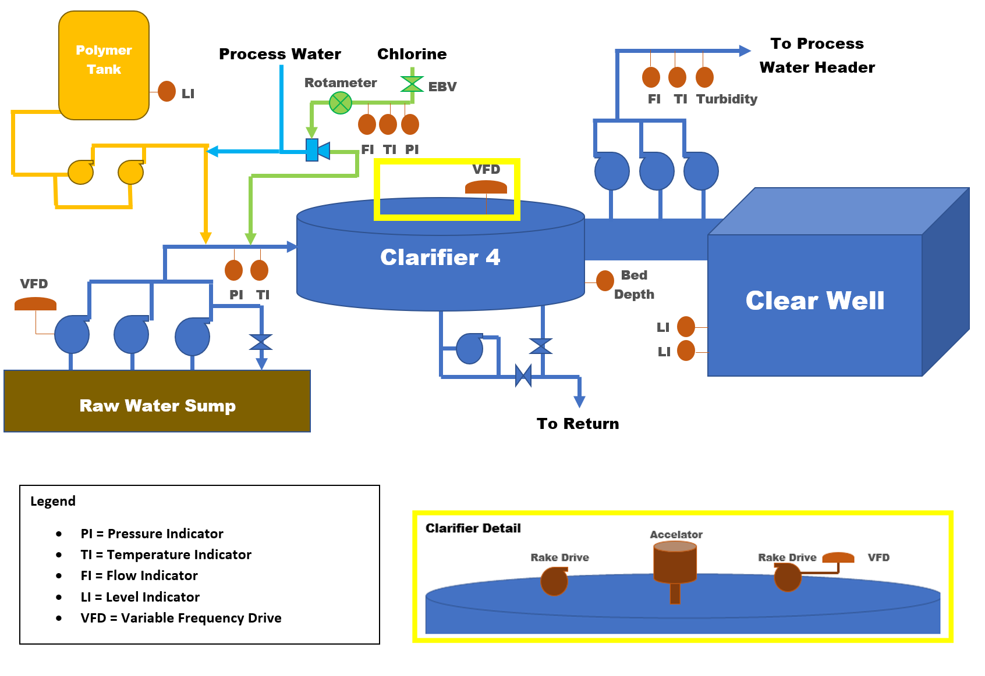

Remote Clarifier

## 6.2 Constraints of the System

With any process system there are limitations to the extent to which parameters can reach. WD’s clarification process at its remote location was not exception to this rule. The modeling techniques applied were only as good as the instrumentation and in many situations the maximum and minimum ranges of these process components limited the amount of information that could be obtain. The following table presents the maximum values for each Analog Input (AI) reading examined as features for modeling the process water turbidity.

*“Table of Instrumentation Limitation”*

|  |  |  |
| --- | --- | --- |
| AI | Parameter | Max |
| AI-240 | Clear Well Level (Primary) | 100 |
| AI-242 | Clear Well Level (Backup) | 100 |
| AI-245 | PW Pump Discharge Flow | 27890 |
| AI-246 | PW Pump Discharge Turbidity | 10 |
| AI-261 | PW Pump Discharge Pressure | 200 |
| AI-263 | RW Pump Discharge Temperature | 100 |
| AI-262 | RW Pump Discharge Pressure | 10 |
| AI-216 | RW Pump # 3 Amps | 150 |
| AI-226 | RW Pump # 2 Amps | 150 |
| AI-236 | RW Pump # 1 Amps | 100 |
| AI-248 | Polymer Tank Level | 100 |
| AI-255 | The remote clarifier Bed Depth | 180 |
| AI-257 | Chlorine Flow Rate | 54.670 |
| AI-259 | Chlorine Temperature | 150 |
| AI | Parameter | Max |
| AI - 219 | Intake Level | 8.199 |
| AI – 340 | PW Conductivity | 1000 |

Separate limitations were placed on the discrete values created for model development based on personal observations and expectations of ranges for certain features. The polymer flow discrete value feature was designed with a lower limit of 100 ml/min and an upper limit of 370 ml/min. This resulted in the upper and lower limits being the maximum extent of coverage for the models which represented over 80% of the data points in that respective time series. When models return these limits they only show the requirement that the flow must be above or below this level, but the flow can vary anywhere beyond those points. This was done due to high variability in pump performance once these levels were reach. Interviews and experience revealed that the flow rates can shift drastically due to small changes in the downstream pressure of the process water used to emulsify the polymer prior to injection. With shifts of nearly 30 ml/min seen in the data, the ability to fully project the necessary flow rates at these levels was not possible. Other limitation included a lower limit on the raw water temperature which was placed at 30° Fahrenheit since this temperature should never be reached at the site’s location, a lower limit placed on the process water discharge flow which was placed at 9000 gallons per minute since levels below this were only seen during startup, shut down, and upset conditions, and an upper and lower limit placed on the raw water PH which was set with a high side of 9 and a low side of 5 since the river water should rarely deviate from this range.

## 6.3 Noise and Environmental Factors

While conducting different phases of this optimization project several major factors were discovered that heavily impacted the process of water clarification independently of chemical addition. These factors introduced a severe amount of noise into this system and made it extremely difficult to properly model its behavior. Only touching on them in this project, the failure to mitigate these issues in the future will cause poor clarifier performance regardless of the robustness of systems put in place to manage chemical addition and will lead to continual process upsets in the future.

The first of these factors that became apparent related to the clear well level indication. After examining initial sliced sections of the data based on different percentiles of the clear well level data, a slight difference in the mean of the process water turbidity was seen. By looking at the descriptive statistics of the process water turbidity in cleaned data-frames the difference was exacerbated and clearly identifiable.

*“Descriptive Statistics for the PW Turbidity: Upper and Lower 50% of Clear Well”*

|  |  |
| --- | --- |
| Upper 50% of Clear Well Level  mean 1.614697  std 0.504515  min 0.444430  25% 1.293818  50% 1.606470  75% 1.900922  max 4.961467 | Lower 50% of Clear Well Level  mean 1.320571  std 0.590878  min 0.492333  25% 0.880690  50% 1.132426  75% 1.636568  max 4.918378 |

Relying on the robust two-sample T-test to determine if this deviation represented a significant statistical difference showed that there was difference in mean based on the resulting values.

*“Two Sample T-Test Results Clear Well Levels”*

|  |
| --- |
| --Ttest_indResult--  statistic=26.18710774228402  p_value=8.2779221350646219e-146 |

The resulting P-value was well below the 1% confidence value for alpha which led to the conclusion that these two sample means represented the effect of two separate conditions that impacted clarification process, high and low clear well levels. Further research on this issue revealed that this impact resulted from the design and relative location of the clarifier to the clear well and their location to the process water discharge pump basin.

*“Relative Location of Clarifier to Clear Well”*

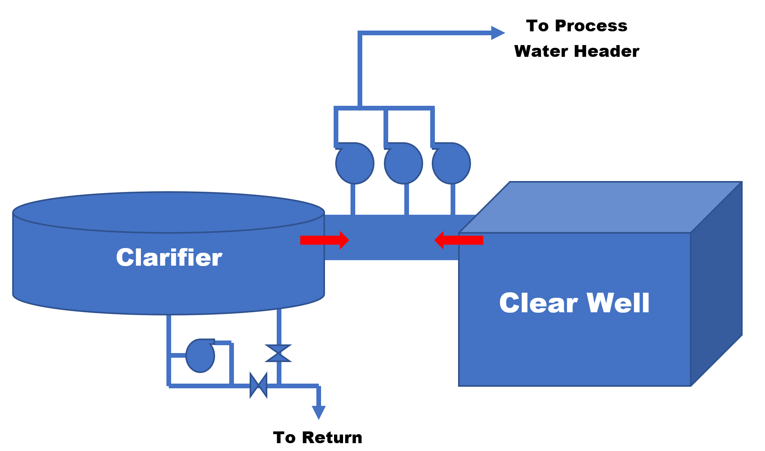

The layout of this system caused the the amount of effluent seen straight from the clarifier to be determined by the level of the clear well. When the clear well level was elevated less water was pumped out from effluent leaving the clarifier’s launders into the pump basin and the primary source of water came from the clear well. In contrast when the clear well was at lower levels the primary source of effluent being pumped out came from the clarifier. Examining the condition of the clear well helped to further explain why water from the clarifier consistently produced cleaner water with a lower concentrations of solids. The clear well has an open air design with relatively little turbulence. This stagnant pool of water leads to significant algae growth which can contaminate the clean water as parts of the growth break away. Thus when flow is mainly sourced from the clear well higher levels of turbidity will are seen in the discharge flow and ultimately in the recorded turbidity values.

The next factor that was observed to have a significant impact on water quality centered on the clarifier bed depth. Attempting similar techniques on the upper and lower halves of the data relating to clarifier bed depth yielded similar results to that of the clear well level. Upon completing the two-sample T-test on this set of data, the difference between means suggested by the test was even greater than that of the clear well level.

*“Two Sample T-Test Results Clarifier Bed Depth”*

|  |
| --- |
| --Ttest_indResult--  statistic=34.230277255209039  pvalue=4.0204096318044382e-235 |

This significantly low P-value indicated a more impactful effect as compared to the clear well level with much higher turbidity levels being experienced on the high side of the clarifier bed depth. Investigation of this phenomena revealed some interesting details of how the bed depth directly relates to effluent quality. The bed within the clarifier basin consist of the coagulated solids stripped from the influent entering the clarifier. Under normal operating conditions this bed acts as a filter floating above the clarifier floor where all water circulated through the clarifier passes. The height of this bed is determined by two factors which are the thickness or amount of solids in the bed and the relative up flow velocity of the water compared to the strength of the polymer matrix formed within the bed to generate its structure. When the clarifier is functioning as it is intended too, the bed depth meter continuously blows the bed down to thin out and remove excess solids with desludge values that run from take offs on floor of the clarifier. However, when the bed is not properly managed an excess of solids essentially leads to the bed becoming saturated and its level begins to rise. Since the bed cannot properly filter the exiting effluent, solids known as pin floc develop above the bed and are eventual carried over into the launders leading to higher concentrations of solids within the effluent. This condition becomes aggravated when the bed rises in conjunction with this saturation. The rising bed pushes the pin floc suspended above it closer to the launder to flow out with the effluent. This led to the conclusion that bed management was a critical part to any successful chemical addition system.

The next factor observed actually stemmed from the investigation of the bed depth’s impact on the process water turbidity. The effect this factor had on the process water turbidity was due to its underlying influence on the bed depth during binary states. This indirect factor related to system logic and how the ▓▓▓▓ system attempted to control the clear well level utilizing the raw water pumps. Under typical system logic, the clear well is managed by making incremental adjustments to 1st RW pump’s VFD which slowly raises and lowers its output to avoid sharp changes in flow through the clarifier. Although this logic appears to operate in an efficient manner, failures in the system logic have periodically caused it to switch between this primary method of control and the failsafe method. The failsafe method used to manage the clear level ignores VFD output and instead, utilizes the third raw water pump. By starting and stopping this pump in response to high and low levels in the clear well, the flow through the clarifier swings drastically causing erratic bed depths and effluent quality. As seen in the following graph this method of control is detrimental to the clarifiers operation and prevents any sound method of chemical management from producing positive results.

*“Impact of third raw water pump On/Off Service on Bed Depth”*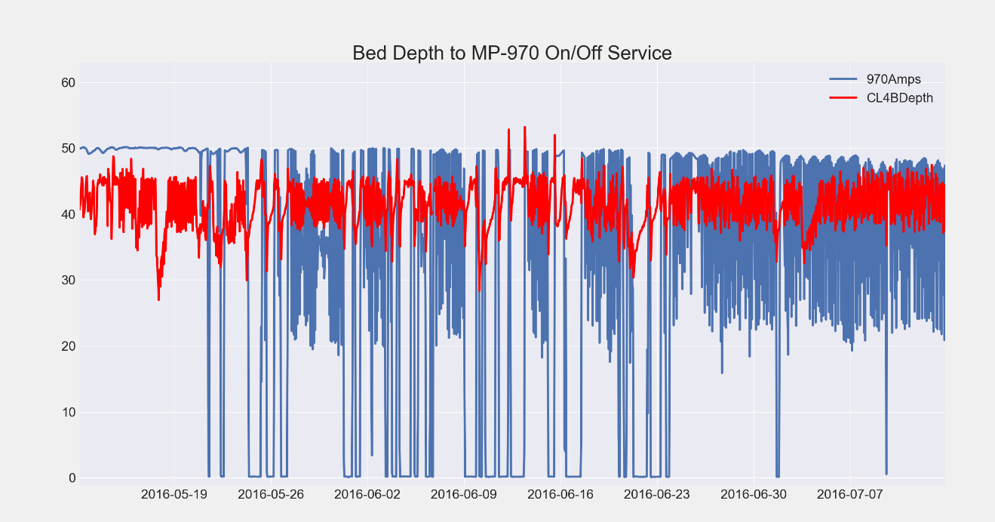

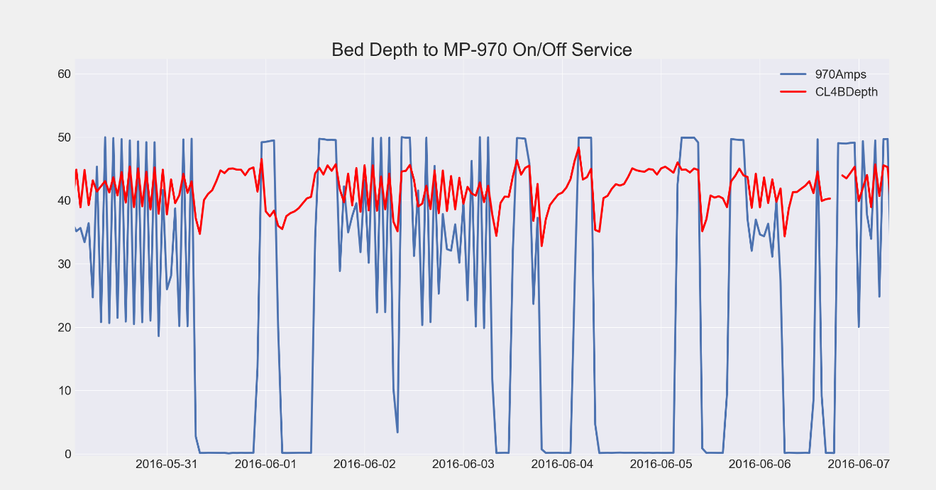

The last factor that presented issues in properly managing the process water turbidity came from apparent differences in polymer quality. By examining the time between polymer deliveries, average polymer flow, relative polymer to process water turbidity ratios, and relative polymer to raw water turbidity ratios across each time period significant differences were observed. Removing the possibility of seasonal trends from being the root cause of these differences the only clear unique quality of these independent results is polymer deliveries. Future experimentation and testing will most likely need to be done in order to verify these results, but if true this issue will need to be resolved before any set system is put in place for chemical addition control. In the interim continuous revision of systems put in place may serve as a buffer against this apparent change in polymer quality across loads. Below are details of findings to show how these conclusions were found.

*“Bar Chart of Time between Polymer Deliveries”*



*“Details on Time between Polymer Delivery Intervals”*



*“Average Polymer Flow between Deliveries”*

|  |
| --- |
| Delivery 2-2015 mean Poly-Flow = 170.791081751  Delivery 5-2015 mean Poly-Flow = 229.419410745  Delivery 7-2015 mean Poly-Flow = 167.62572759  Delivery 11-2015 mean Poly-Flow = 88.6447494414  Delivery 2-2016 mean Poly-Flow = 173.073833432  Delivery 5-2016 mean Poly-Flow = 158.350830209  Delivery 7-2016 mean Poly-Flow = 152.320265781  Delivery 11-2016 mean Poly-Flow = 99.6054158607  Delivery 3-2017 mean Poly-Flow = 144.805448964  Delivery 5-2017 mean Poly-Flow = 187.840236686  Delivery 8-2017 mean Poly-Flow = 116.044977511  Delivery 12-2017 mean Poly-Flow = 158.641584878  Delivery 2-2018 mean Poly-Flow = 287.649595687 |

*“Average Poly-Turb Ratio per Delivery”*

|  |
| --- |
| Delivery 2-2015 mean Poly-Turb Ratio = 16.8952226299  Delivery 5-2015 mean Poly-Turb Ratio = 23.0718956542  Delivery 7-2015 mean Poly-Turb Ratio = 18.0328716262  Delivery 11-2015 mean Poly-Turb Ratio = 9.53725436565  Delivery 2-2016 mean Poly-Turb Ratio = 18.7888444642  Delivery 5-2016 mean Poly-Turb Ratio = 17.0570915243  Delivery 7-2016 mean Poly-Turb Ratio = 15.9824948776  Delivery 11-2016 mean Poly-Turb Ratio = 10.8252217374  Delivery 3-2017 mean Poly-Turb Ratio = 15.5118206402  Delivery 5-2017 mean Poly-Turb Ratio = 19.9105985874  Delivery 8-2017 mean Poly-Turb Ratio = 12.249819382  Delivery 12-2017 mean Poly-Turb Ratio = 17.1385782514  Delivery 2-2018 mean Poly-Turb Ratio = 31.5852247202 |

*“Bar Chart of* *Average Poly-Turb Ratio per Delivery”*

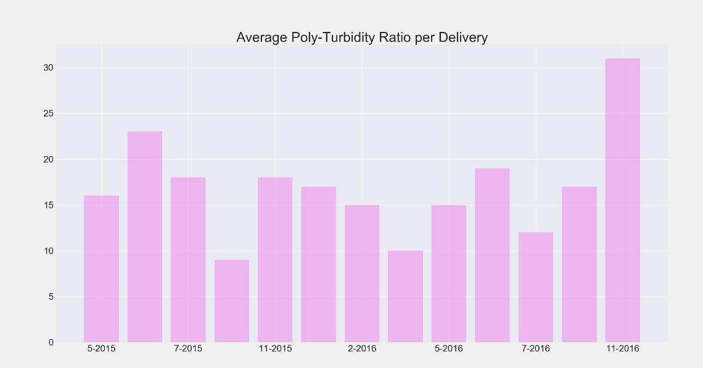

*“Average Polymer to Raw Water Turbidity per Delivery”*

|  |
| --- |
| Delivery 2-2015 mean Poly Ratio = 4.73226398614  Delivery 5-2015 mean Poly Ratio = 3.70789728592  Delivery 7-2015 mean Poly Ratio = 2.27637587408  Delivery 11-2015 mean Poly Ratio = 1.21999898156  Delivery 2-2016 mean Poly Ratio = 2.67760358199  Delivery 5-2016 mean Poly Ratio = 2.62585904551  Delivery 7-2016 mean Poly Ratio = 2.50641282379  Delivery 11-2016 mean Poly Ratio = 2.20569931156  Delivery 3-2017 mean Poly Ratio = 2.18362434106  Delivery 5-2017 mean Poly Ratio = 3.79909709027  Delivery 8-2017 mean Poly Ratio = 3.71973311923  Delivery 12-2017 mean Poly Ratio = 3.56159426673  Delivery 2-2018 mean Poly Ratio = 2.11011351223 |

# Design Alternatives

## 7.1 Component Alternatives

While several comprehensive design plans were created to optimize the polymer addition process, independent alternatives for general process improvement were develop to take advantage of the knowledge gained throughout this project and aid in the steady state operation of the clarifier as a whole. These include alternative logic components within the run code, additional instrumentation in the field, and new treatment options. These options are meant to be considered as future improvements that will drive continuous improvement and help re-engineering the way in which clarifier operation is done at WD’s remote block systems.

Alternatives relating to system logic mainly focused on the incorporation early warning alarms that could facilitate the mitigation of adverse conditions that could be seen up river on the Mississippi. Situations that might lead to such warnings would be severe spikes in the raw water turbidity, large shifts in PH, or any other variable that might impact clarifier performance. By taking advantage hourly data collected from USGS on the condition of Mississippi at its Baton Rouge location these warnings could provide a significant advantage to operation personnel. The method of delivery is the main detail that will need to be determined for this alternative. While email notifications or accessible tools built into typically used applications such as excel provide the easiest and most non-intrusive way of relaying these messages, warnings built directly into the DCS would allow for guaranteed acknowledgement of these messages. This might be a necessity as any automated systems would need to be monitored during these types of events to prevent loss of control with regards to the process. An additional alternative for logic considerations is related to the timing of the relief line off of the discharge of the raw water pumps. In its current state while controlling clear well level with the use of the third raw water pump the line only temporarily opens to provide a diversion for the excess flow. For a cheaper solution to the VFD issues presented by first raw water pump, the valve could be replace with a throttling valve for incremental control while starting and stopping the third raw water pump. This valve could be tied to future instrumentation to monitor flow from the raw water pumps, discussed below, and throttle appropriately to smooth out the rapid increase in flow seen from the sudden change in the number of pumps running. This implementation could prevent the extreme swings that are experienced in the clarifier bed depth and result in the better overall performance of the clarifier.

Alternatives relating to additional instrumentation include several areas. Suggestions on alternative redundant instrumentation consist of two monitor locations at the clarifier. Redundant monitors that might increase the efficiency of operation include a secondary monitor for the process water turbidity off of the process water pump discharge and a backup clarifier bed depth monitor. A secondary process water turbidity meter would insure that readings coming from these meters could be relied on a higher percentage of the time and implementing policies such as an alternating flushing schedule for these meters would create a more complete and continuous picture of the processes performance over time. The backup bed depth monitor would drastically increase the reliability of this system and result in better bed depth management, a crucial factor in chemical optimization. Performing basic calculations on the reliability of this equipment it was found that out of 27,749 hourly data points, it was out of range or out of service 5547 times. This yielded a reliability rate of 0.8 or 80%. Assuming this rate holds, applying the reliability of a parallel system would yield a reliability rate of 96% which would represent a significant increase in clarifier performance and effluent quality.

*“Reliability Calculation”*

$$R\left(t\right)=0.96=1-{\left(1-\frac{5,547}{27,749}\right)}^{2}$$

Other alternatives for new instrumentation include a pressure sensor for the process water used during polymer injection, a turbidity meter located off of the clarifier launders, and a flow meter for discharge of the raw water pumps. A pressure sensor on process water line tied into the polymer pump discharge would help to better understand how this pressure can impact polymer pump performance and then help monitor it for better control. Placing a turbidity meter on the clarifier to collect readings on the effluent quality directly from the launders would allow for better process management. This would be accomplished due to the more realistic data of the effluent quality being produced by the clarifier from the elimination of noise produced by variations of the clear well level.

*“Clarifier Turbidity Meter Alternative”*

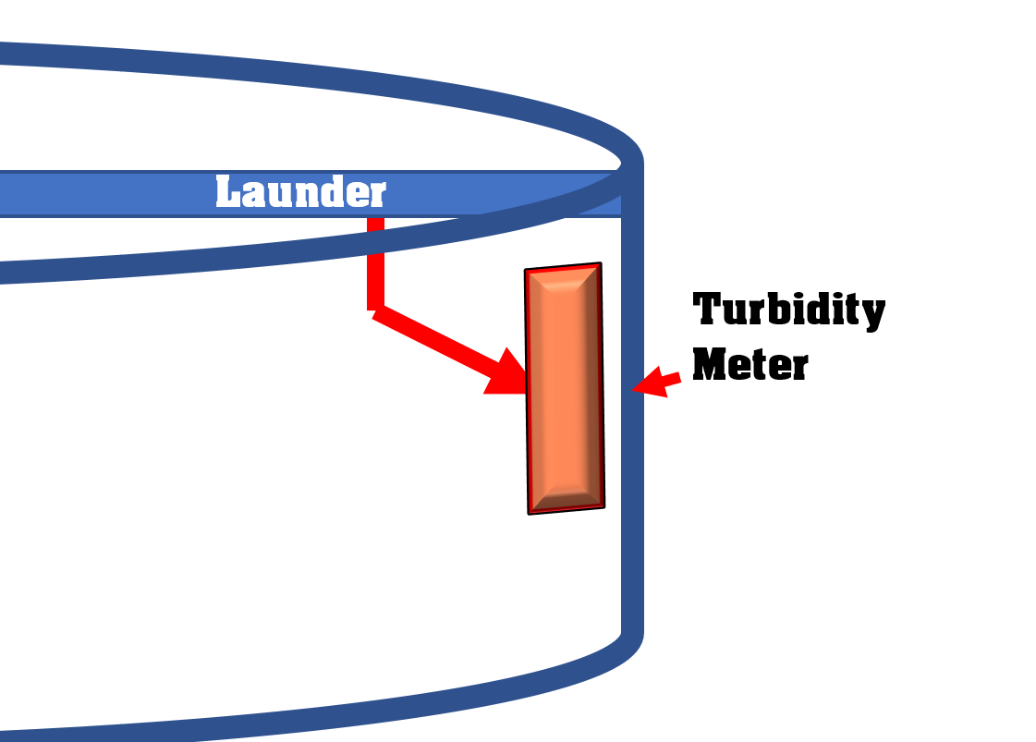

The installation of a flow meter on the discharge of the raw water pumps would have immediate positive impacts. This meter would allow for better bed depth management by more complete knowledge of the flow through the clarifier, allow the DCS logic to maintain tighter tolerance on the level of the clear well by being able to determine exactly what is needed to support specific levels, and give operation personnel improved capabilities to monitor the variability that is experienced within the system. Altogether, these alternatives used in conjunction with a fully developed strategy for clarifier management could greatly improve clarifier performance and output, reduce maintenance cost, and stabilize the clarification process at WD’s remote block. Below is a diagram displaying the proposed location of all new instrumentation as well as polymer pump VFDs and a downstream flow meter which would be installed if an automated design were implemented.

*“Clarifier Diagram with Proposed Instrumentation”*

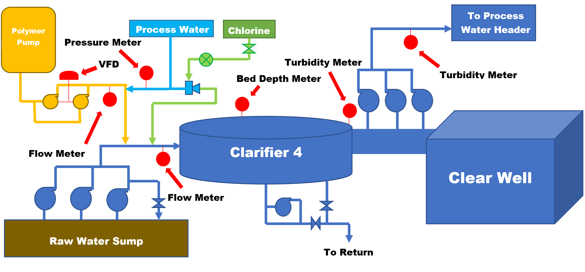

Alternative treatment options were explored as well and include several synthetic polymers which could grant more efficient solids removal. These polymers are cationic in nature and very similar to the one currently being used, but with slightly different structures to cope in different environments. Further research on the quality of the Mississippi River water will have to be conducted to determine if any of these alternative might provide a better alternative. Qualities of interest will revolve around the alkalinity, turbidity, PH, and hardness of water being pumped in from the Mississippi River which will ultimately determine if any of these treatments are an improvement over the current benchmark.

## 7.2 Comparison of Models

The modeling phase of the project consisted of two sections. Each of these sections were defined by the models overall structure and method of use, proposed design alternative for implementation, and the target variable. For the automated design alternative several machine learning techniques where developed with the one hour leading process water turbidity as a target. These techniques were tested aggregately using several different feature combinations to determine the best mix for the final set while individual models were tuned by utilizing one of SKlearn’s most powerful functions, *“GridSearchCV”.* Grid search allowed for multiple parameters and depths of each algorithm to be tested against incoming data to determine the optimal mix to tune it appropriately. While not completely automated and somewhat computationally expensive, this function still allow for an individual with general knowledge of the algorithms to develop a neighborhood of parameters that should meet the objectives and then find the right choices without running the individual models, saving a large amount of time and effort in the coding process. Machine learning algorithms (ML) that were implemented in this portion of the model development phase included many of SKlearn’s regressor models. These ML models included Ridge Regression (RR), K-nearest Neighbor (KNN), Support Vector Machine (SVM), Nu-Support Vector Machine (NSVM), Neural Networks (NN), Random Sample Consensus (RANSAC), Gradient Booster (GB), and Random Forest (RF) models. The selection of these ML models was done by evaluating their effectiveness for the given application through researching related applications and by examining how they interact with datasets possessing a similar structure to the data-frames developed over the course of this project. Models were first tested utilizing feature combinations that contained a lagged process water turbidity variable with the thought that these element would have previous process data essentially baked into it. As seen from the best combinations in the next table, these models performed well, but due to the extremely biased nature of this predictor its effect caused many other variables to experience high variability from their actual values when attempts were made to infer their current state through back propagation. The table on the following page details these results showing the Mean Absolute Error (MAE), Mean Squared Error (MSE), and R-Squared (R2) for each model after tuning on each run. The variables for each run are discrete and were as follows. Details for each can be found in section 5.3.

* 1st Run - ['CPFD', 'MRTD', 'RWTD', 'MRPHD', 'PWTD']
* 2nd Run - ['ComboRWPBool', 'CPFD', 'MRTD', 'RWTD', 'MRPHD', 'PWTD']
* 3rd Run - ['ComboRWPBool', 'CPFD', 'MRTD', 'RWTD', 'MRPHD', 'PWTD', 'MRTDpct']

*“Model Performance with Lagged Process Water Variable”*

|  |  |  |  |
| --- | --- | --- | --- |
| MODEL | 1st RUN | 2nd RUN | 3rd RUN |
| RR | MAE: -0.391  MSE: -0.317  R2: 0.755 | MAE: -0.391  MSE: -0.317  R2: 0.755 | MAE: -0.391  MSE: -0.317 R2: 0.755 |
| KNN | MAE: -0.348  MSE: -0.266  R2: 0.795 | MAE: -0.348  MSE: -0.267  R2: 0.794 | MAE: -0.338  MSE: -0.259  R2: 0.800 |
| SVM | MAE: -0.331  MSE: -0.259  R2: 0.800 | MAE: -0.331  MSE: -0.257  R2: 0.808 | MAE: -0.330  MSE: -0.257  R2: 0.802 |
| NSVM | MAE: -0.323  MSE: -0.262  R2: 0.798 | MAE: -0.326  MSE: -0.259  R2: 0.800 | MAE: -0.327  MSE: -0.258  R2: 0.801 |
| NN | MAE: -0.382  MSE: -0.300  R2: 0.766 | MAE: -0.381  MSE: -0.302  R2: 0.766 | MAE: -0.385  MSE: -0.300  R2: 0.769 |
| RANSAC | MAE: -0.413  MSE: -0.339  R2: 0.732 | MAE: -0.407  MSE: -0.342  R2: 0.736 | MAE: -0.413  MSE: -0.332  R2: 0.738 |
| GB | MAE: -0.361  MSE: -0.278  R2: 0.791 | MAE: -0.360  MSE: -0.279  R2: 0.785 | MAE: -0.363  MSE: -0.285  R2: 0.780 |
| RF | MAE: -0.339  MSE: -0.260  R2: 0.807 | MAE: -0.339  MSE: -0.260  R2: 0.799 | MAE: -0.372 MSE: -0.311  R2: 0.803 |

Since these model failed to provide the utility that was desired they were discarded despite their good performance. After several more tests a final feature set was created for training the models. This set was comprised of many of the critical features from the original set, but without the lagged process water turbidity variable the performance of some models faltered, yielding limited predictive power and large errors. Those models that did perform well were picked out of this group and selected to be used in a script that would be implemented under the automated design alternative. Implementing a consensus type method these models will work together to find the optimal polymer dosage given the current environmental condition. The following details are setup in the same manner as the previously displayed results.

*“Final Feature Set for Training”*

['ComboRWPBool', 'CPFD', 'MRTD', 'RWTD', 'MRPHD', 'DDLV', 'PWPDFD']

*“Model Performance for Final Training Set”*

|  |  |
| --- | --- |
| MODEL | RESULT |
| RR | MAE: -0.697 (0.025)  MSE: -0.772 (0.062)  R2: 0.405 (0.038) |
| KNN | MAE: -0.410 (0.018)  MSE: -0.337 (0.034)  R2: 0.740 (0.027) |
| SVM | MAE: -0.410 (0.027)  MSE: -0.360 (0.038)  R2: 0.722 (0.029) |
| NSVM | MAE: -0.461 (0.020)  MSE: -0.366 (0.033)  R2: 0.718 (0.025) |
| NN | MAE: -0.557 (0.026)  MSE: -0.525 (0.045)  R2: 0.598 (0.032) |
| RANSAC | MAE: -0.745 (0.041)  MSE: -0.975 (0.117)  R2: 0.255 (0.092) |
| GB | MAE: -0.485 (0.021)  MSE: -0.420 (0.024)  R2: 0.675 (0.027) |
| RF | MAE: -0.415 (0.013)  MSE: -0.373 (0.030)  R2: 0.711 (0.035) |

The second half of the modeling phase focused on developing models targeting the six hour leading process water turbidity time weighted average. These models were developed with the specific intent of being implemented through the other two design alternatives which included the procedural design and the calculation based design. The models that were used during this develop cycle included several from each of the different major categories including machine learning, statistical, and time series models. Many attempts were made to successfully generate models that could accurately predict this target. Just as in the previous portion an attempt was made to incorporate a lagged process water variable into the feature set, but the same results were experienced with extremely high variability being experienced in the reversal of the models to generate polymer dosage values.

*“Result of reversing OLS Multiple Regression Equation W/ Lagged PW Variable”*

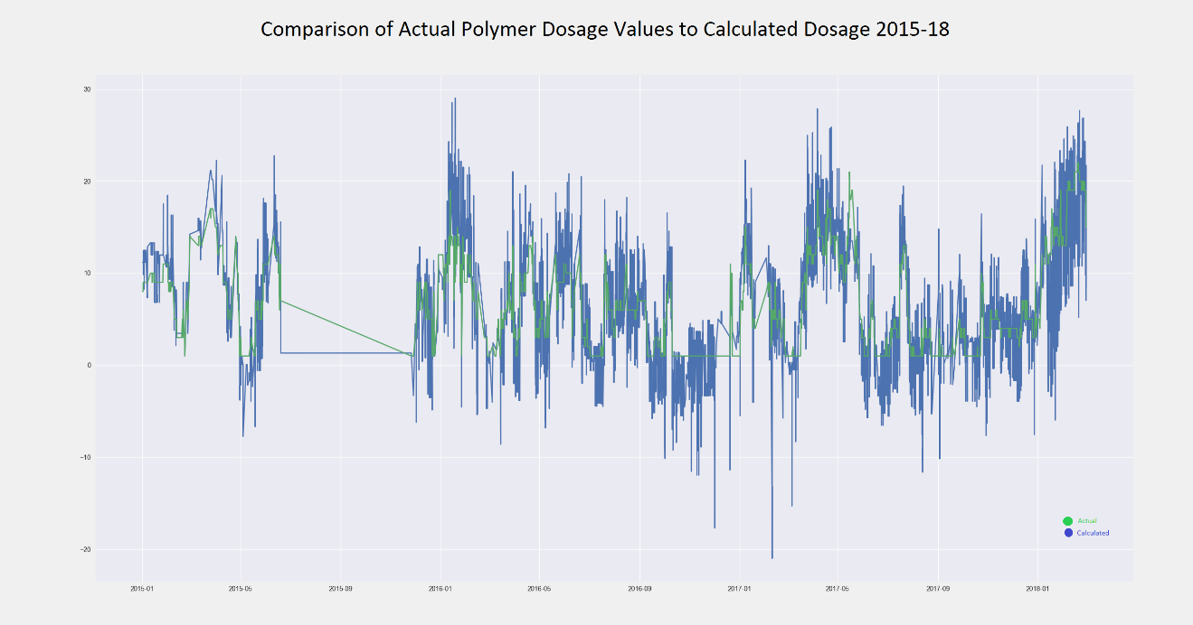

The chart above clearly shows this dilemma with the actual polymer value being in green and the calculated value being in blue. This resulted in many models with extremely strong metrics being discarded due to the failure to produce useable results.

*“Example of Weighted OLS Results from Discarded Model”*

|  |
| --- |
| WLS Regression Results  ==============================================================================  Dep. Variable: PWT(TWAverage)S-1 R-squared: 0.991  Model: WLS Adj. R-squared: 0.991  Method: Least Squares F-statistic: 3.822e+05  Date: Thu, 08 Mar 2018 Prob (F-statistic): 0.00  Time: 14:20:56 Log-Likelihood: 15881.  No. Observations: 13895 AIC: -3.175e+04  Df Residuals: 13890 BIC: -3.171e+04  Df Model: 4  Covariance Type: nonrobust  ====================================================================================  coef std err t P>|t| [0.025 0.975]  ------------------------------------------------------------------------------------  const -0.5786 0.013 -44.137 0.000 -0.604 -0.553  MRTSRoll^3 0.0404 0.001 60.644 0.000 0.039 0.042  MissRivPH -0.0568 0.002 -37.141 0.000 -0.060 -0.054  PWT(TWAverage)^2 2.0573 0.002 1018.469 0.000 2.053 2.061  Cat_polyflow^3 -0.0256 0.000 -52.858 0.000 -0.027 -0.025  ==============================================================================  Omnibus: 152.988 Durbin-Watson: 1.645  Prob(Omnibus): 0.000 Jarque-Bera (JB): 102.375  Skew: -0.076 Prob(JB): 5.88e-23  Kurtosis: 2.608 Cond. No. 454.  ============================================================================== |

After many more attempts to find the right mix of features, three final models were developed for different applications. A multiple regression and ARIMAX model was developed for the calculation based design and a decision tree model was developed for the procedural design. The multiple regression model was based on a multi-factor feature set that sought to incorporate elements to represent the entire process.

*“Feature Set for Multiple Regression Model”*

['CPFD', 'MRTD_26', 'RWTD_12', 'MRPHD', 'DDLV', 'PWPDFD']

This included all discrete values and a Boolean object representing the open or closed state for both desludge values which served as an indicator for the state of the clarifier bed depth. This model seemed to be well rounded and robust against extreme values. On the following page the model equation shows that all features have signs consistent with their expected impact on clarifier performance.

*“Final Multiple Regression Equation”*

$$PWTD6= 3.8118 -0.1162*CPFD+0.3086*MRTD_{26}-0.1603*RWTD_{12}-0.2112*MRPHD-0.5355*DDLV+0.2503*PWPDFD$$

The prediction interval for this model had tight tolerances and most points falling outside of this interval did stray far as seen in the following chart.

*“Prediction Interval for Multiple Regression Model”*

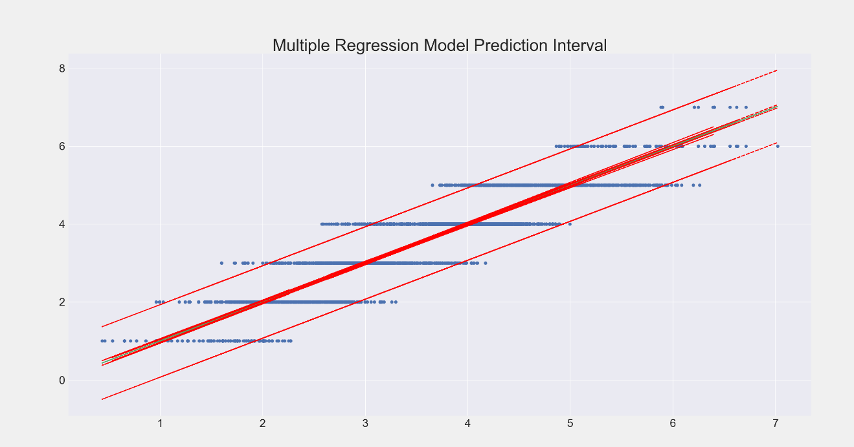

In addition to this, the reversal of the model to determine required polymer flow seemed to be very robust against extreme values in the broader comprehensive data-frame. As seen in the chart on the following page. This expected performance was what was ultimately required of the model to make it a feasible option for design implementation.

*“Calculated Polymer Flow from OLS Regression Vs. Actual”*

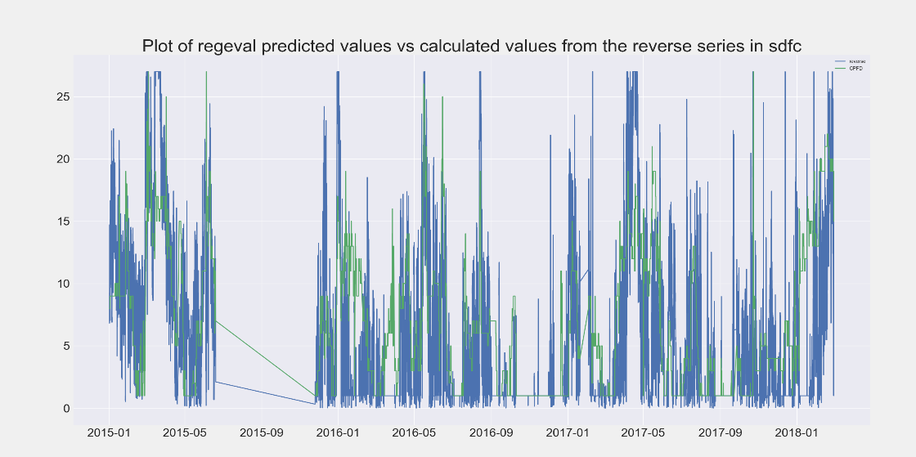

The final metrics of this model were also surprisingly good with an R2 of around 80%. By attaining this level of predictive power the model created a very useful tool for application. As seen from the following table all of the metrics associated with this model provided extremely strong results.

“OLS Multiple Regression Results of Final Model”

|  |
| --- |
| OLS Regression Results  ==============================================================================  Dep. Variable: PWTD6 R-squared: 0.805  Model: OLS Adj. R-squared: 0.805  Method: Least Squares F-statistic: 6814.  Date: Mon, 19 Mar 2018 Prob (F-statistic): 0.00  Time: 13:25:27 Log-Likelihood: -6663.6  No. Observations: 9922 AIC: 1.334e+04  Df Residuals: 9915 BIC: 1.339e+04  Df Model: 6  Covariance Type: nonrobust  ==============================================================================  coef std err t P>|t| [0.025 0.975]  ------------------------------------------------------------------------------  Intercept 3.8118 0.028 137.676 0.000 3.758 3.866  CPFD -0.1162 0.001 -106.289 0.000 -0.118 -0.114  MRTD_26 0.3086 0.002 179.393 0.000 0.305 0.312  RWTD_12 -0.1603 0.002 -64.966 0.000 -0.165 -0.155  MRPHD -0.2112 0.003 -82.806 0.000 -0.216 -0.206  DDLV -0.5355 0.010 -52.008 0.000 -0.556 -0.515  PWPDFD 0.2503 0.003 87.470 0.000 0.245 0.256  ==============================================================================  Omnibus: 76.144 Durbin-Watson: 0.550  Prob(Omnibus): 0.000 Jarque-Bera (JB): 64.697  Skew: 0.138 Prob(JB): 8.94e-15  Kurtosis: 2.718 Cond. No. 84.5  ============================================================================== |

Finally applying this model to predict the entire data set including all values stripped away in the initial analysis phases showed just how good the model was.

*“Predicted PW Turbidity by Multiple Regression Model Vs. Actual”*

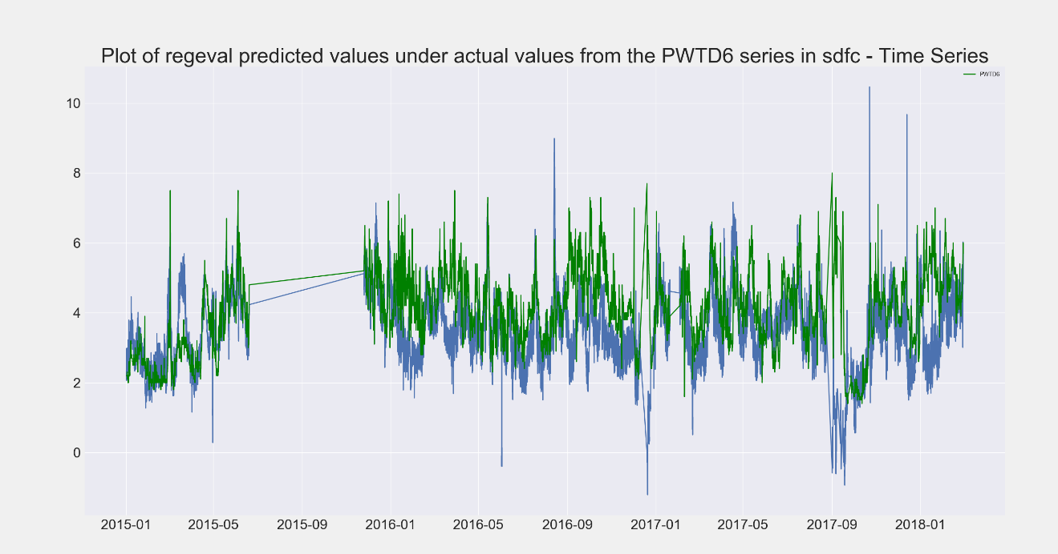

The ARIMAX Model produced similar results with the final version containing two autoregressive components and two moving average components as seen in the summary of results on the following page.

*“Results of ARIMAX Model”*

|  |
| --- |
| ARIMA Model Results  ==============================================================================  Dep. Variable: D.PWTD6 No. Observations: 18999  Model: ARIMA(2, 1, 2) Log Likelihood -2882.709  Method: css-mle S.D. of innovations 0.282  Date: Wed, 21 Mar 2018 AIC 5785.418  Time: 08:54:00 BIC 5863.939  Sample: 01-01-2015 HQIC 5811.171  - 12-23-2017  =================================================================================  coef std err z P>|z| [0.025 0.975]  ---------------------------------------------------------------------------------  const 0.0017 0.003 0.651 0.015 -0.003 0.007  CPFD -0.0011 0.000 -6.212 0.000 -0.001 -0.001  MRTD_26 0.0011 0.000 4.040 0.000 0.001 0.002  RWTD_12 -0.0006 0.000 -2.215 0.027 -0.001 -7.46e-05  PWPDFD 0.0008 0.000 2.439 0.015 0.000 0.002  ar.L1.D.PWTD6 0.5460 0.140 3.900 0.000 0.272 0.820  ar.L2.D.PWTD6 0.2504 0.114 2.190 0.029 0.026 0.475  ma.L1.D.PWTD6 -0.6880 0.141 -4.881 0.000 -0.964 -0.412  ma.L2.D.PWTD6 -0.2453 0.132 -1.858 0.043 -0.504 0.013  Roots  =============================================================================  Real Imaginary Modulus Frequency  -----------------------------------------------------------------------------  AR.1 1.1862 +0.0000j 1.1862 0.0000  AR.2 -3.3669 +0.0000j 3.3669 0.5000  MA.1 1.0559 +0.0000j 1.0559 0.0000  MA.2 -3.8601 +0.0000j 3.8601 0.5000  ----------------------------------------------------------------------------- |

This resulted in a model with an R-squared of 0.84, making an excellent model to be used in conjunction with the multiple regression model. The final model that was develop for implementation in the procedural based design alternative was the decision tree. Three trees were ultimately made by using the basic decision tree classifier algorithm, decision tree regressor algorithm, and then by applying an adaptive boosting algorithm over the original regressor tree, though this third model didn’t show any substantial improvement and was not considered in the final design development. The classifier and regressor both performed well with the classifier having an R-squared value of 0.72 and the regressor having and R-squared of 0.80. The ultimate decision was made to go with the regressor due to better performance an easier interpretability.

*“Actual Values Plotted Against Predicted by Decision Tree Regressor”*

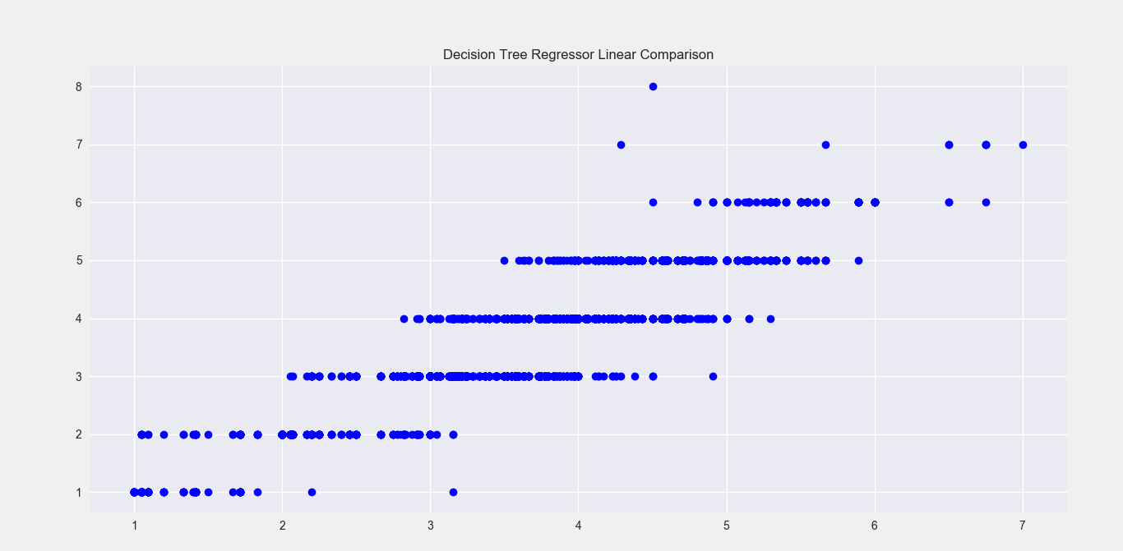

*“Adaboost Decision Tree Performance Vs Basic Decision Tree Regressor (DTR)”*

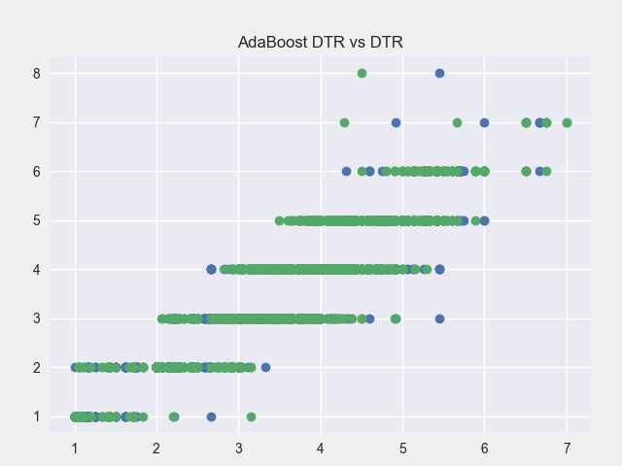

*“Plot of Predicted Values from Decision Tree (Red) Vs. Actual”*

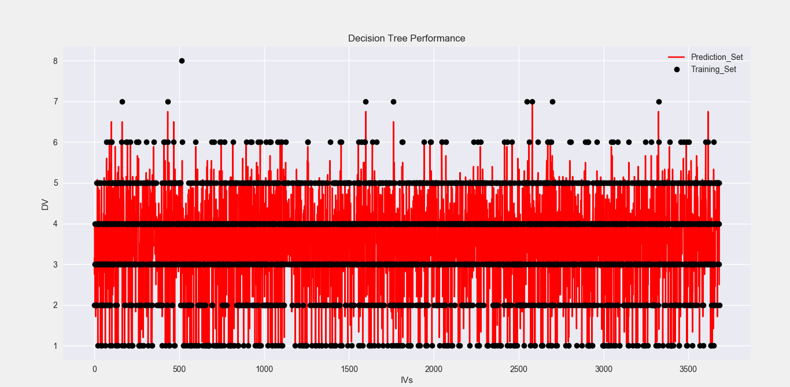

## 7.3 Description of System Designs

Three comprehensive design alternatives were developed for application in the polymer feed chemical adjustment process. These were designed with increasing complexity, cost, and impact in relation to the process system and served to provide multiple options for WD’s management to decide from. This allowed them the freedom and flexibility to devote the amount of resources they felt comfortable with to any design chosen while still providing reliable and robust guidelines on how to conduct the process of chemical adjustments at the remote clarifier.

### 7.3.1 Procedural Based Design

The first and most basic of these design alternatives is the procedural based design. This design is based on a simple decision tree model put to paper that outlines the process of chemical adjustments based on intervals for the features used. Features utilized in this decision tree include only three primary impact factors that carry the highest weight of determining the future process water turbidity. These include the raw water turbidity, raw water temperature, and process water discharge flow. The intervals represent somewhat broader ranges that these features can fall into and split them into 46 different combinations that correlate to different conditions that could be experienced within this system. While the resulting polymer dosage intervals that correspond to these combination sets don't hold the requirements on polymer flow as tightly as the other two designs, it still provides coverage for a wide array of possible situations that could be seen based on past data. In order to use this procedure the user will have to manually look up values for the required features which make up the tree. To aid in this, a light version of the calculation tool developed for the second design alternative may be modified to only return the necessary values from there sources. The procedure will only be used when applicable, which means only when the turbidity at the remote clarifier or turbidity in the raw water suggests this. While not the most proactive design, this implementation would at least provide some guidance on how this task should be completed and potentially help newer operators gain a sense of how the clarifier works in shorter time frames, reducing the learning curve.

*“Ranges for Key Impact Features”*

|  |  |  |  |
| --- | --- | --- | --- |
| Feature | Raw Water Turbidity | Raw Water Temperature | Process Water Discharge Flow |
| Ranges | 0 – 50 | 35 – 55 | X < 11,000 |
| 51 – 100 | 56 – 75 | 11,001 - 12,000 |
| 101 – 150 | X > 76 | 12,001 – 13,000 |
| 151 – 200 |  | X > 13,000 |
| 201-250 |  |  |
| X > 250 |  |  |

### 7.3.2 Calculation Based Design

The next design alternative is the calculation based design which utilizes a tool developed in Microsoft’s Excel VBA. Being the focal point of this design, this tool is highly customizable with expanded functionality to allow for specific model selection and manual data entry. The tool extracts updated information from the various feature sources used throughout the project by accessing web queries and automatically synchronized Aspentech® data entries. Combining this data with the multiple regression or ARIMAX models, the required polymer dosage is calculated and returned to the user given the current conditions. In addition to the options to only utilize the multiple regression or ARIMAX models the tool allows for the use of a consensus model that weights each individual model appropriately given their success rate with regards to the target variable and then uses this value in unison a parts per million calculation. This parts per million calculation is value that must be determined by running jar test, but is very useful for verifying the river water’s condition during start up situation and when the clarifier exhibits highly uncertain behavior. For instances when instrumentation is known to have communication issues the tool allows for manual data entry which will supplement and replace the deficient data. To support this tool the design will incorporate a procedure for guidance and several other resources on process background information to give operations a higher level of understanding with regards to the systems design and its underlying dynamics. Continued maintenance and updates on the tool have been simplified to allow for other technical personnel to continuously adjust and improve the models as new data is collected. This is accomplished by incorporating the main calculations and conversions into an excel sheet the code accesses instead of building the model directly into the code. By integrating these components into the final tool, this design can facilitate multiple modes of operation and can be left to automatically control the polymer addition process or be controlled on a finite level if necessary.

*“Polymer Calculation Tool”*

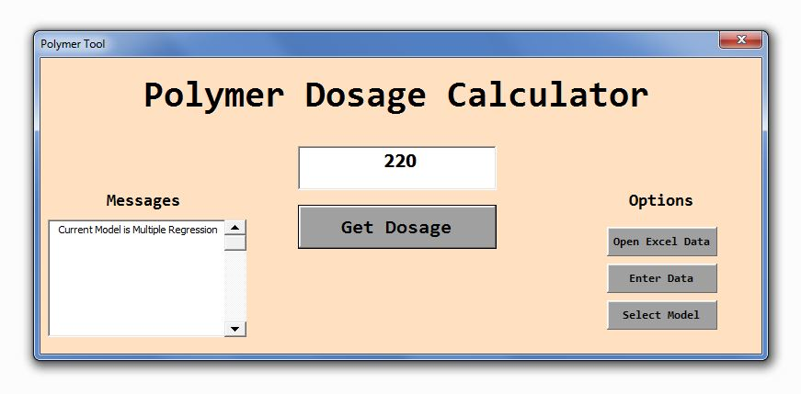

*“Calculation Tool Model Selection and Manual Data Entry”*

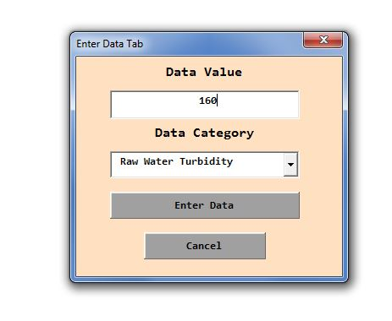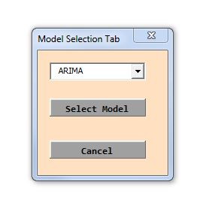

### 7.3.3 Automated Design Alternative

The final design alternative presents the most costly and time consuming option in terms of required upfront investment, but also consist of a design that could provide the largest long term benefit and ability for continuous improvement. This is the automated design alternative which consist of a completely redesigned polymer control system including new process logic, equipment, meters, and sensors. This comprehensive redesign of the system will serve to facilitate the hourly adjustment of polymer flows in order to conform to the calculated clarifier turnover rates and expected feature values. This will help better manage the outgoing clarifier effluent quality and polymer usage rate. The primary component of interest in this design is the method of polymer flow control. A positive displacement metering pump utilizing a remotely controlled variable frequency drive will be the key to this system’s success and several models have been examined. The best of these pumps that have been reviewed is the Proteus™ by Milton Roy which meets all the requirements for the system including compatibility with most DCS, SCADA, and PLC systems, the ability for extremely accurate flow rates even with fluctuations in discharge pressure, and a wide range of flow set points that could extend the range with which polymer could be controlled at.

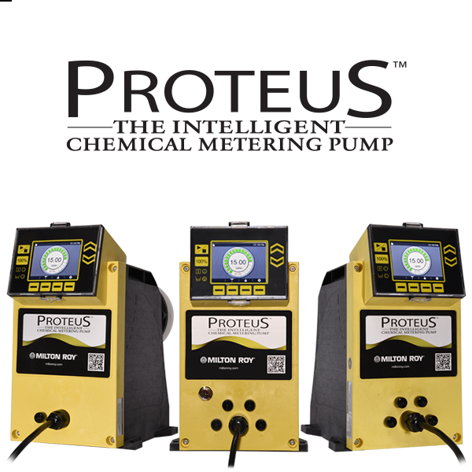

(Milton Roy 2018)

The application of this pump could eliminate the need for flow meters to insure pump efficiency as well, but due to the high flexibility and capability of this pump this also represents the most expensive pump option. Other pumps that have been explored include additional Milton Roy mROY® metering pumps, Madden Manufacturing JN Series Metering Pumps, and ProMinent® Delta Series diaphragm pumps which all offer remote VFD capabilities. Flow meters for service with high viscosity fluids have also been examined in the event that this becomes necessary. Though no specific manufacturer designs have been singled out as primary contenders the final meter type that will be selected will be a Coriolis mass flow meter. These meter utilize a slight deflection in the design of the metering tube which acts in a similar way to an orifice plate causing a minor pressure drop in the fluid passing through it. By combining this with a highly sensitive meter this design captures the pressure drop and converts the resulting reading into a relatable flow measurement. The controlling force behind these process equipment upgrades will be an application programmed in Python and accessible by WD’s ▓▓▓▓® control system. This application applies several function which access excel files that draw information on the necessary features from their sources and selected models from *“Pickle”* formats which are pre-trained on process data to calculated the necessary flow for the polymer addition process. The models selected for this module include only those ML algorithms which displayed the best performance during the modeling phase of the project and include K-nearest Neighbors, Neural Network, Support Vector Machine, Gradient Boosting, and Random Forest models. By taking weighted averages from the past performance of these models the module will calculate the necessary flow to set the polymer pumps at and relay this information to the ▓▓▓▓® control system which will in turn make the necessary adjustments to the system to provide for optimal control and chemical usage. Policies and Operating Disciplines will be defined to manage adverse situations seen in the system and to give operations personnel guidance on how and when to make adjustments.

*“Automated Design Alternative Process Flow Diagram”*



## 7.4 Design Matrix

These three comprehensive design alternatives each have their pros and cons. These are compared to the baseline and each other below in the following weighted design decision matrix which gives each design a score from 0 meaning no improvement to 5 which represents the maximum amount of improvement. The weights given to these metrics relate to the emphasis of the project, which is savings, representing 40% of the decision criteria while other factors were equally weighted to account for the impact that these designs could have on those factors within the overall systems. The following summarized design matrix is expanded upon and explained in section 7.5 the comparison of system designs.



## 7.5 Comparison of System Designs

As seen from the design decision matrix the baseline, do nothing option, is comparable to the procedural based design, while the calculation and automated designs appear to be relatively equal given the scores, but when examining the details behind these scores this becomes more of an issue related to desired level of investment and the short term time frame of reference. By reviewing how these scores were derived the true value of each can be easily discerned and a proper evaluation of each alternative can be made.

### 7.5.1 The Cost Metric

For cost, both the amount of capital required and training involved or human capital was considered. Both the procedural and calculation based designs scored relatively well and close to the do nothing approach which would have no cost. This was due to the only major cost being the learning curve for the designs application and to account for any cost incurred during the implementation phase from wasted polymer, which would be a result of having to make model adjustments. The automated design had an extremely poor score in this region due to the high initial set up cost associated with the purchase and installation of new equipment and the additional training of system logic. However, these would only represent upfront investments with an immediate drop in the cost of system function after implementation which is capture in other metrics.

### 7.5.2 The Savings Metric

Savings, the metrics representing the heaviest weight, reveals that each of these designs has an increasing return on investment after implementation excluding the null option. Minimal savings seen in the procedural based design result from calculations made on the cleaned data collected from the process system. These were made by only applying changes in the system when needed to determine the resulting polymer addition rate and then examining the resulting average flow rate of the polymer. This showed that only a 6.5% decrease in polymer usage would be seen from the implementation of this design. Calculations made with the calculation based design implementation represented changes made on the rate of polymer addition every 6 hours on sample rounds. This showed substantial improvement over both the baseline and procedural based design with a reduction in polymer usage of nearly 17%. Finally, the automated design showed the most improvement through implementing the consensus model from the different ML models on an hourly basis. This would most likely improve with the installation of pumps that could provide more accuracy and better flow management. The total expected savings resulting from this design implementation were estimated at nearly 33% over the baseline which would easily compensate any cost incurred by WD’s due to initial investments. Below is a table showing the average flow rates and the reduction based on design implementation from the cleaned data-frame.

|  |  |  |  |  |
| --- | --- | --- | --- | --- |
| Design | Baseline | Procedural Design | Calculation Design | Automated Design |
| Average Flow | 156 ml/min | 146 ml/min | 130 ml/min | 104 ml/min |
| Savings | - | 6.5% | 16.7% | 32.7% |

### 7.5.3 The Safety Metric

Safety metrics took into consideration the impact of being required to change the polymer rates in both normal and rushed conditions and the complications introduced into the process environment from the associated design. Both the baseline and procedural option scored equally since these changes would mostly be reactionary and possibly cause the operator performing these changes to rush. The calculation based design scored marginally better than these despite not putting the operator in an adverse situations due to the higher frequency of changing polymer flow rates exposing them to the slip and trip hazards associated with this task. The automated system score much higher than the other options since operators would rarely be exposed to these hazards and ergonomic concerns thus eliminating the possibility of injury.

### 7.5.4 The Upkeep Metric

Upkeep considered several factors that included maintenance, updates to code, and physical management of the system. The baseline, procedural, and calculation based designs were relatively similar in this manner since they would not increase the required amount of preventive maintenance required on the system and most updates would only consist of minor changes to values within the documents and models. The automated design scored poorly in comparison to these due to the nature of the design and the increased amount of necessary maintenance that would have to be performed on the system. Maintenance and updates would have to be performed routinely on the additions this design would bring which include the new equipment such as pumps which require oil changes, instrumentation requiring calibration, and significant updates to logic which would require the alteration of code in both the ▓▓▓▓® system and the associate Python syntax.

### 7.5.5 The Accuracy Metric

Accuracy was a metric that encompassed how well the system would continuously achieve target values in parameters and the overall accuracy of the models involved. The procedural based design score in this category was relatively average due to only being able to broadly define ranges for operator guidance. The calculation based design attained a higher score despite the less than perfect model accuracy due to the increased proactive adjustment of polymer flow rates. The automated system had a perfect score in this metric which resulted from its ability to make hourly changes to polymer flow rates in accordance to clarifier turnover rates and feature values. Altogether these metrics resulted in clear advantage being given to the calculation based and automated designs which provided the largest improvement over the base line do nothing approach.

## 7.6 Economic Analysis of Designs

While the evaluation of these designs based on comprehensive measures can provide for a good indicator of the overall impact to the system, sometimes design selection can come down to a monetary issue. To satisfy this, a look at the economics behind each design was done to label them with a physical value. Using the baseline, do nothing option, as an effective indicator cost of $0, since no implementation cost or savings are associated with it, the value of other designs could be quantified. This design value was determined by considering the cost of installing components, potential losses due to over feeding chemical during the initial rough in period, and savings extended over a 5 year time horizon. These metrics were chosen over return on investment from the outgoing product due to the lack of any quantifiable profit per gallon based on water quality. The unidentifiable profit margin results from the nature of the system. Since four clarifiers feed the same process water header the ability trend the quality of water that any plant gets within the site to a single clarifier is nearly impossible. In addition to this, the risk of sending out poor quality water as a result of any model is extremely low as relatively quick turnover rates in the clarifier influent means that any deviation from process set points can be quickly adjusted and accounted for by operations personnel. The cost of polymer was considered based on the average annual expenditure on this feed chemical for the years 2016 and 2017 divided by the amount used in those years. Taking the average of these years helped to mitigate the effect of delayed or early billing which may have pushed cost for a polymer delivery into the next year or set it back to the prior year. The values shown below detail these key metrics.

*“Annual Polymer Cost and Usage Details”*

|  |  |  |  |
| --- | --- | --- | --- |
| Year | 2016 | 2017 | Average |
| Cost | $277,746.39 | $194,827.30 | $236,286.85 |
| Amount | 19167 gallons | 19608 gallons | 19388 gallons |
| Cost Per Gallon | $14.49 gallon | $9.94 gallon | $12.21 gallon |

The first design evaluated against these metrics was the procedural based design. Due to the somewhat broad ranges defined for polymer flows within this design, over feeding could be a potentially large problem with its initial implementation as operations personnel will most likely tend to aim for the high side of the proposed ranges. The implementation of this procedure did not require any upfront cost for equipment making the initial investment -$0. Assuming that over feeding will diminish over time as more data is collected and the ranges are narrowed, tests were run to identify points in time where more than necessary amounts of polymer may be added. The test consisted of calculating the sum of the worst case overfeed rates for the first year. This was derived from examining the maximum flow set points described in the procedure and comparing those to actual average feed rates seen during those conditions described in the document. Taking the percentage of time that the proposed maximum flow rate exceeded the average actual flow rate and then applying that to the average difference in these situations the worst case, total additional cost came out to around -$45,110 for the first year of implementation. Countering this by calculating the reversal of this situation over the next 5 years with the annually average reduction in polymer usage estimated at 6.5%, the total savings came out to +$76,532. Not accounting for inflation or any other time related adjustments resulted in the actual implementation of this design yielding an estimated net positive of $31,421.

*“Calculations for Procedural Design”*

|  |  |
| --- | --- |
| Number of unique conditions identified in the procedure. | 46 |
| Number of times maximum flow exceed average flow under these conditions. | 34 |
| Percentage of time max flow exceeded average | 73% |
| Calculation for number hour in one year this covers | $$6474 hours=365*24*\left(\frac{34}{46}\right)$$ |
| Average overfeed in these conditions | 36 ml/min |
| Conversion to gallons per hour (gph) | 0.57 gph = 36*0.000264*60 |
| Amount of first year overfeed (worst case) | 3694 gallons = 6474*0.57 |
| Cost of first year overfeed (from average cost) | $45,110 = 3694*$12.21 |
| Annual amount saved base on estimation (6.5%) | 1253 gallons = 19288*0.065 |
| Total amount saved over 5 years | 6265 gallons = 5*1253 |
| Total savings over 5 years based on average cost | $76,495 = 6265*$12.21 |
| Total gain from implementation over 5 years | +$31,421 = $76,495-$45,110 |

The economic estimate for the calculation based design was performed using a different methodology. To quantify this value the models used were run against historical data to determine the number of times that the calculated feed rate exceeded the actual feed rate by more than its standard deviation. This revealed that the model only exceeded this threshold 4% of the time. Further analysis to calculate the net loss resulting from over feeding during these periods was done by applying the average amount over fed which was 8 ml/min. Making similar calculation to the last design alternative the total over feed cost came to -$533 dollars annually. Assuming this cost carried over into the 5 year horizon due to minimal model improvement resulted in a net loss of -$2,668. With no other cost involved in the implementation of this design, this represented a major improvement over the procedural design.

*“Net Loss Calculations”*

$$\left(Lost gallons=0.1248 per hour=\frac{8 ml}{min}*\frac{0.00026 gallons}{ml}*\frac{60 min}{hour}\right)$$

$$\left(Annual hours loss occurs=350 hours=365 days*\frac{24 hours}{days}*4\%\left(0.04\right)\right)$$

$$\left(Total gallons lost=43.7 gallons=0.1248 gallons per hour*350 hours\right)$$

$$\left(Net loss=\$2668=5 years*\$533.58=43.7 gallons*\$12.21 per gallon\right)$$

Next the gain from this design was calculated by utilizing the estimated savings in terms of the percent reduction of polymer used from the data collected on the necessary polymer flow found for the target value. This percentage applied to the average amount used annually resulted in a calculated reduction of 3,221 gallons per year. Extending this over the five year horizon and then applying the average cost per gallon resulted in a total gain of +$196,642 for this design resulting in a net positive of $193,974 for the next five years or $38,790 annually.

Performing many of the same calculation on the automated design was done with the additional consideration of cost of equipment and installation. First the savings were calculated in the same manner as the previous two analysis. This resulted in the annual reduction of polymer used being 6,307 gallons. Stretching this over five years and then applying the average cost per gallon led to a gain of $385,000. With the accuracy of this system being even greater, the cost of over feeding polymer was considered negligible, but the cost of equipment and installation impacted the final net positive. Considering the maximum cost of equipment, the polymer pump cost was estimated at $7,500 while the estimated cost of a flow meter came out to around $2,000. Combining this with the total cost of installation which was estimated to be $2,100 the investment cost related to this design resulted in an estimated total of $13,000. These small amounts in comparison to the potential savings led to the final net positive for the automated design alternative being $372,000 over the five year time frame considered or roughly $74,000 annually.

*“Review of Economic Analysis”*

|  |  |  |  |
| --- | --- | --- | --- |
| Estimated Loss, Gain, and Net Positive | | | |
| Design | Procedural Based | Calculation Based | Automated |
| Net loss (Annually) | $9,000 | $530 | $13,000 Upfront |
| Net Gain (Annually) | $15,300 | $39,200 | $77,000 |
| Net Positive (Annually) | $6,300 | $38,790 | $74,000 |

## 7.7 Review of Other Design Alternatives

While developing the final three design alternatives several other ideas were developed which proved to either be infeasible or not provide sufficient benefit to outweigh their cost. The most prominent of these included sample adjustment designs, control valve designs, and policy based designs. All of these designs were fully evaluated given the system limitations and failed to meet the necessary criteria.

Sample adjustment designs focused on increased sampling and polymer flow rate adjustment frequencies to cope with changing dynamics within the system. While this was thought to possibly provide a solution for the polymer addition process due to the high clarifier bed turnover rate several issues created problems. The first was that those factors which held the most weight in determining the necessary polymer flow rate didn’t change at fast enough rates to warrant this type of change. In addition to this the increased number of times operations personnel would be required to visit the clarifier took them away from other necessary task which they were required to do. In conjunction with these problems, events that did cause clarifier upsets could rarely be predicted and subsequently would not be properly mitigated with higher sampling and adjustment frequencies.

Control valve based designs were considered as an alternative automated design. These designs involve the installation of a valve downstream of the polymer pumps to throttle the flow as necessary from the ▓▓▓▓ control system. However, due to the high viscosity of the polymer, centrifugal pumps could not be used and the application of a control valve downstream of the currently used positive displacement pumps could have introduced the potential for component failures within the pump from over pressure. This could have led to instances where pump failure led to major process upsets, thus disqualifying these designs as an option.

Policy based designs were essentially a step below the procedural based design which was meant to provide an extremely passive option in the case that major system changes did not want to be implemented. Reviewing some of the currently used policies it was found that this was not an effect treatment for the polymer addition process. While a policy may have provided guidance for operations personnel when making adjustments to the clarification system, the lack of any solid foundation to base changes on would have resulted in an almost net neutral effect from such a design. Due to these short coming and the possible confusion that could have resulted, these design alternative were abandoned.

*Page Intentionally Left Blank*

# Conclusions

## 8.1 Comparison of Improvements over Baseline

After reviewing the fully developed design alternatives it was clearly shown that these options could provide at least some benefit with their implementation. Though, further testing, experimentation, and monitoring will need to done to determine the extent to which they actually benefit the entire system and reduce feed consumption, examining the scores and values developed through this project demonstrates that any alternative could be successful. In total the procedural, calculation, and automated design options all decreased the average rate of polymer usage, increased system accuracy, and aided operations personnel by creating a safer working environment. In addition to those immediate improvements, these designs also presented the opportunity for future improvements within the specific system of study and possible expanded coverage of other systems around Water Distribution. With these better metrics and increased possibilities the implementation of such a system is undoubtedly a positive application of resources which will further the goals of Water Distribution’s business unit.

## 8.2 Project Results

Upon wrapping up the major components of this project a review was done to compare how the overall progression of the work flow went as opposed to the original project plan. This was an interesting exercise as it allowed for the reconciliation of different aspects of the project which were once thought to carry different amounts of importance. In addition, the evaluation of how well the original project plan, developed to guide the project’s progression, was formed with respect to the ultimate goals showed areas for improvement. As seen from the following synopsis of the Gantt chart created during the initial project proposal period, several areas of the project changed and required adaption over time.

*“Initial Gantt Chart Calendar”*

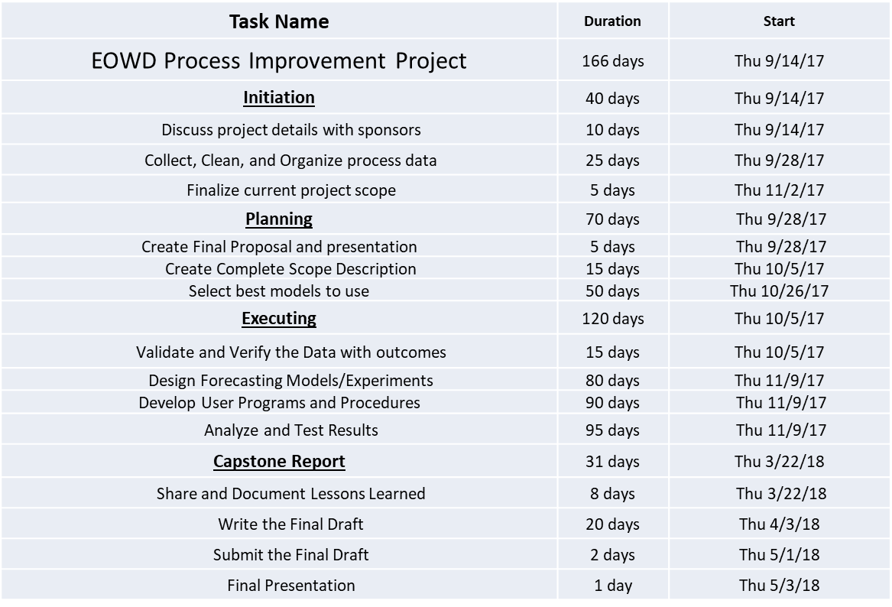

Both the planning and execution phases required more time that what was initially proposed and many of the time frames given for the elements within these project components were adjusted to facilitate the changing dynamics of the project. Some phases within the scope of the project were severely altered while others were combined. Additional sections were added over time, such as advanced feature engineering and data exploration phases, to cope with adverse events and unique conditions that were examined in the collected datasets. Data cleaning also became its own distinct segment of the project flow and evolved into the complete restructuring of collected data to account for gaps and missing elements as well as a detour into data aggregation methods which led to generation of entire modules to satisfy the requirements of later sections such as the model development and generation phase. The modeling phase was another area within the execution portion that experienced a large amount of change. Model selection became wrapped up in the model design phase and then expanded to include the forecasting and experimentation phases. The overall length of the proposed calendar resulted in yet another issue as defined dates did not line up exactly with what was expected over this time. Necessary adjustments to these time frames to account for deviations from proposed deadlines had to be made in order to satisfy requirements from both the ultimate end user and for the educational aspects of the project. Other minor differences in the actual flow of the project can be seen throughout the work describe in this report and show that the original project timeline had some major deficiencies when compared to the actual flow of work that took place. Despite these apparent major changes to the proposed project flow suggested at the onset of this project, clear deficiencies in project scope, and inconsistent deadlines that were determined during the projects formation, the major elements created within this period helped to guide the flow of work and assist in time management which was necessary to complete the project in timely manner.

The result of this comprehensive project management plan led to develop of 3 design alternatives. These complete design alternative represent well rounded and robust processes that fully capture all aspects of the clarification system used at WD’s remote location and allow for advanced and optimized control of the chemical addition process used to manage cationic polymer usage for proper water treatment. In addition to these deliverables, other endeavors that arose from the phases within the project yielded several useful items including comprehensive Python modules for data analysis with features and impact variables specific to WD’s systems, functions developed in Python for advanced data-frame manipulations and data aggregation, and a well formed data analysis processes to handle the unique conditions that surround systems in chemical plants.

*“Final Project Flow”*

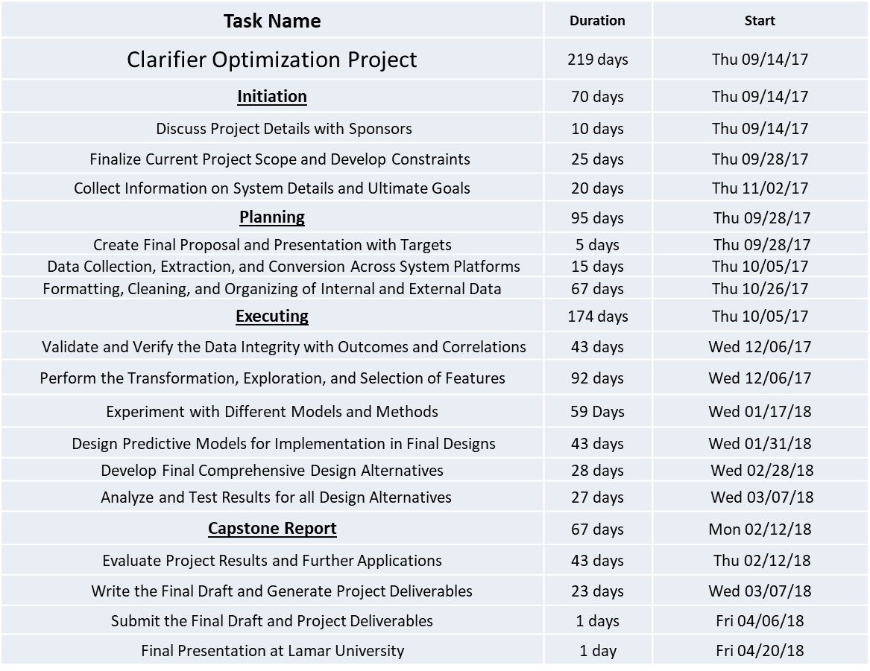

The final flow of the project described in the timeline above shows the increased attention to details during the most critical phases of the model and design development phases which expanded to cover a much broader set of analysis and testing procedures. Through this expanded definition some of the best results from work on the project were realized. While the addition of the techniques and ideas did not always find their way into the final comprehensive design alternative they led to two positive outcomes. The first, came from being able to utilize these alternative methods to verify other results leading to critical design components during the analysis process while the second was the increased knowledge that will lead to better and more thorough analyses in the future, hopefully producing even better results.

## 8.3 Potential Future Improvements

At the conclusion of this project the ultimate goal was attained, but potential future improvements were identified at several phases within the project that extended beyond the scope of optimizing the addition of cationic polymer at the remote clarifier. One of these that remained within the context of the overall system at the remote clarifier related to the method with which chlorine flow rates were set at this clarifier. Throughout the research process many significant correlations were seen with this feature leading to the assumption that it could be modeled by means of a linear equation. By applying some of the same techniques used to model the process water turbidity this idea was explored with immediate success. A multiple regression model generated with the a quick set of correlated and unaltered features led to an R-squared value of 0.62 with a low Mean Squared Error of 3.4 compared to the complete range of value for the chlorine flow. this seemed to indicate relatively strong predictive capability from the data. Applying design alternatives similar to the calculation based or automated system created for the polymer addition system could result in large savings for this chemical feed. Described on the following page are details from this quick analysis which showed positive results and should clearly convey the potential of such a system for this element of the clarification system at WD’s remote location.

*“Correlation Table of Chlorine Flow: Significant Relationships Highlighted”*



*“OLS Regression for the Resulting Chlorine Residual at the Clarifier”*

|  |
| --- |
| OLS Regression Results  ==============================================================================  Dep. Variable: EVMD['CL2Flow'] R-squared: 0.617  Model: OLS Adj. R-squared: 0.617  Method: Least Squares F-statistic: 3921.  Date: Tue, 27 Mar 2018 Prob (F-statistic): 0.00  Time: 14:28:12 Log-Likelihood: -54390.  No. Observations: 17038 AIC: 1.088e+05  Df Residuals: 17030 BIC: 1.089e+05  Df Model: 7  Covariance Type: nonrobust  =============================================================================================  coef std err t P>|t| [0.025 0.975]  ---------------------------------------------------------------------------------------------  Intercept 32.7295 2.361 13.860 0.000 28.101 37.358  EVMD['MissRivPH'] -13.6392 0.372 -36.668 0.000 -14.368 -12.910  EVMD['MissRivTurb'] 0.0509 0.001 34.037 0.000 0.048 0.054  EVMD['PWPDFlow'] 0.0015 2.72e-05 56.578 0.000 0.001 0.002  EVMD['MissRivDisolvedO2'] 3.1891 0.089 35.972 0.000 3.015 3.363  EVMD['970Amps'] 0.0003 0.002 0.159 0.873 -0.003 0.004  EVMD['RWPDTemp'] 0.6369 0.011 56.525 0.000 0.615 0.659  EVMD['CL4CWLevel2'] 0.1589 0.005 30.948 0.000 0.149 0.169  ============================================================================== |

*“Prediction Interval for Chlorine Residual from Regression Analysis”*

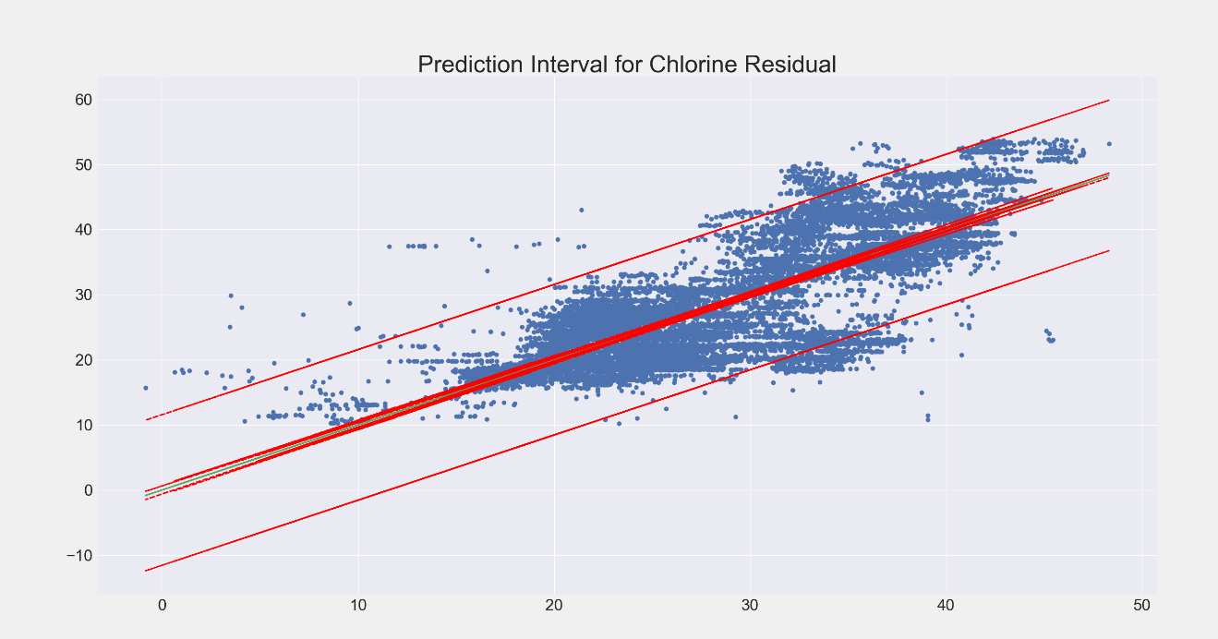

Prediction Interval Half Width = 11.5

*“Calculated Necessary Chlorine Flow Rates Vs. Actual”*

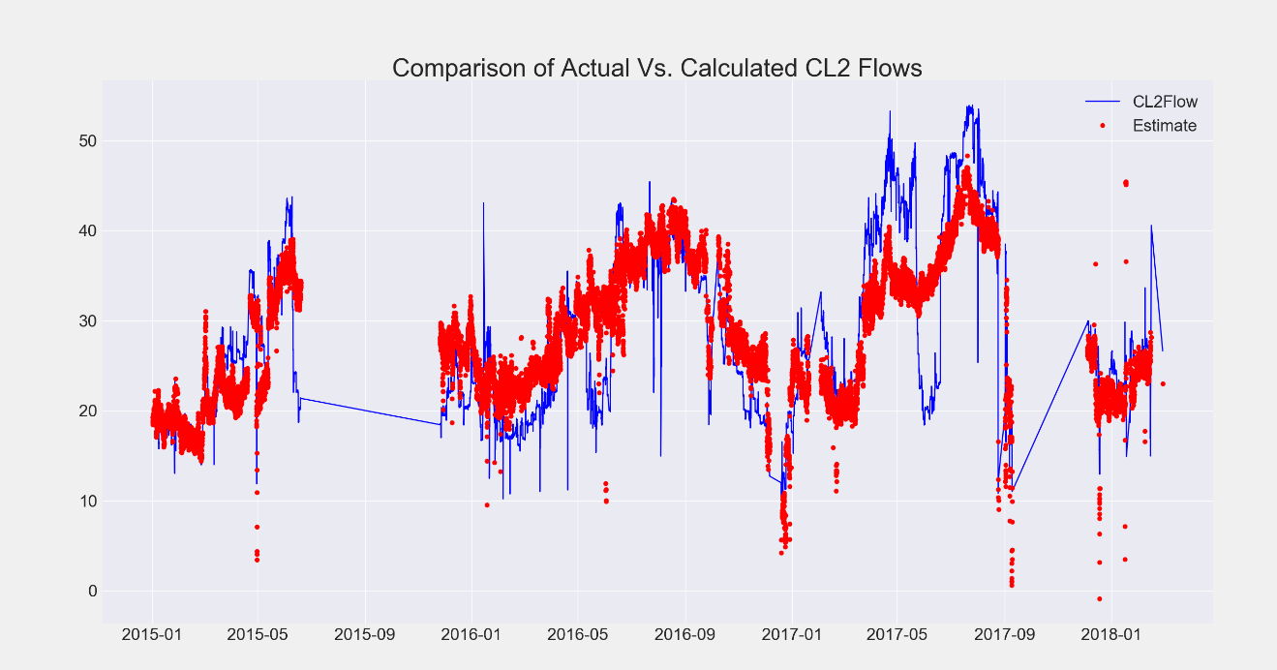

For other areas of future improvement outside of the clarification system at WD’s remote location, application of these techniques could be adapted, after they fully evaluated at the remote clarifier, to be utilized with the three other clarifiers located at Water Distributions main block. These systems could reduce the rate of polymer addition and also serve to maintain necessary turbidity levels for these systems which is critical since the effluent leaving the two smallest ones are used as feed for the potable water system at Dow’s Plaquemine location. Further applications of these techniques can be used at other plants and even other sites if the designs presented in the project prove to be successful and could even go beyond water treatment to be utilized in other chemical processes for larger savings, better product quality, and improve process management.

## 8.4 Beyond the project Description: A Short Description of the Appendix Content

Beyond these main sections describing the overall work conducted over the course of the project, the appendix will serve to show the details and calculations behind these results as well as show other details which could not be fully talked about in the report. The appendix contains several sections that will include the code written for project analysis, other charts of information showing model performance, calculations, and terminology with definitions. I hope that this will easily convey the magnitude of the work completed and the potential for the design alternatives developed.

# References

Bajaj, Ekant. 2017. "What are Support Vectors?" Linkedin. *How Support Vector Machines works.* https://www.linkedin.com/pulse/how-support-vector-machine-works-ekant-bajaj/.

Coming, Thursday. 2013. *Interpretation of weight in non-linear least squares regression.* July 24. https://stats.stackexchange.com/questions/65484/interpretation-of-weights-in-non-linear-least-squares-regression.

Emmanuel, Joshua. 2015. "Decision Tree." N/A. *Decision Analysis 3: Decision Trees.* N/A. https://www.youtube.com/watch?v=ydvnVw80I_8.

EpiX Analytics LLC. 2018. *Least Squares Linear Regression.* 3 27. http://www.epixanalytics.com/modelassist/AtRisk/Model_Assist.htm#Probability_theory_and_statistics/The_basics/Probability_theorems/Useful_concepts/Least_Squares_Linear_Regression.htm.

fa.bianp.net. 2011. "Ridge coefficients as a function of the regularization." *Ridge Regression Path.* July 12. http://fa.bianp.net/blog/2011/ridge-regression-path/.

Gabriel. 2014. *N-sigma curves for a non-linear least square curve fit.* 7 5. https://stats.stackexchange.com/questions/105851/n-sigma-curves-for-a-non-linear-least-square-curve-fit.

JOGLEKAR, SACHIN. 2016. *A (Small) Introduction to Boosting.* 3 6. https://codesachin.wordpress.com/2016/03/06/a-small-introduction-to-boosting/.

Karpathy, Andrej. 2017. "3-layer neural network." Stanford's Department of Computer Science. *CS231n Convolutional Neural Networks for Visual Recognition.* Stanford. https://cs231n.github.io/neural-networks-1/#summary.

Kemal, Enes. 2016. "K-Nearest Neighbor." NAU-ACM. *Classification with Nearest Neighbors.* http://nauacmrocks.azurewebsites.net/ai_lab.html.

Milton Roy. 2018. *PROTEUS Series Metering Pumps.* https://www.miltonroy.com/products/metering-pumps/proteus-metering-pumps/#downloads.

N/A. n.d. "ARIMA Forecasting." *8.9 Seasonal ARIMA models.* https://www.otexts.org/fpp/8/9.

—. n.d. "VAR 3 lag Forecast." *9.2 Vector autoregressions.* OTexts. https://www.otexts.org/fpp/9/2.

Niraj Kumar, Ph.D. 2016. "Random Forest Simplified." International Institute of Information Technology. *Random Forest Algorithm, An Interactive Discussion.* Hyderabad. https://www.linkedin.com/pulse/random-forest-algorithm-interactive-discussion-niraj-kumar/.

Rogozhnikov, Alex. 2016. "Gradient Boosting Visualized." Github. *Gradient Boosting Explained [Demonstration].* Accessed November 8, 2017. http://arogozhnikov.github.io/2016/06/24/gradient_boosting_explained.html.

Wikipedia. 2018. *Random Sample Consensus.* https://en.wikipedia.org/wiki/Random_sample_consensus.

XLSTAT. 2017. *What is statistical modeling?* July 25. Accessed November 14, 2017. https://help.xlstat.com/customer/en/portal/articles/2062460-what-is-statistical-modeling-?b_id=9283.

*Page Intentionally Left Blank*

# Appendices

Appendix A: Data Analysis Code and Description (Python)

Appendix B: Calculation Tool Code and Description (Excel VBA)

Appendix C: Automated System Code and Description (Python)

Appendix D: Polymer Dosage Adjustment Procedure

Appendix E: Polymer Calculation Tool Procedure

Appendix F: Learning Curves for ML Algorithms

Appendix G: Terminology

## Appendix A: Data Analysis Code and Description (Python)

NOTE: Refer to comments in code for further explanations shown between (## ##)

The following sections show the initial data extraction, import, formatting steps that took place during the data analysis portion of the project.

*“Setup and Configuration”*

|  |
| --- |
| 1. ## Imported Modules ## 2. **from** __future__ **import** print_function 3. **import** os 4. **import** dask 5. **import** pickle 6. **import** scipy as sp 7. **import** numpy as np 8. **import** pandas as pd 9. **import** seaborn as sns 10. **import** statsmodels.api as sm 11. **import** matplotlib.pyplot as plt 12. **import** matplotlib.colors as colors 13. **import** matplotlib.patches as patches 14. **from** matplotlib **import** style 15. **from** statsmodels.compat **import** lzip 16. **from** scipy **import** stats,polyval,polyfit 17. **from** statsmodels.formula.api **import** OLS,ols 18. **from** pandas.plotting **import** lag_plot as lgplt 19. **from** pandas.plotting **import** autocorrelation_plot as autoplt 20. **from** statsmodels.sandbox.regression.predstd **import** wls_prediction_std 21. **from** statsmodels.stats.outliers_influence **import** summary_table 22. style.use('fivethirtyeight') 24. ## New Libraries for Expanded Capabilities ## 25. **import** Dora 26. **import** ftfy 27. **import** arrow 28. **import** tabulate 29. **import** beautifier 30. **import** datacleaner 32. ## Suppress Warnings for Clean Readouts ## 33. **def** warn(*args, **kargs): **pass** 34. **import** warnings 35. warnings.warn = warn 37. ## Suppress Pandas Futures Warning ## 38. warnings.simplefilter(action='ignore', category=FutureWarning) 40. ## OS DIRECTORY VARIABLES ## 41. HomePathMSI = 'C:\\Python36\\' 42. AFSMSI = AlternativeFileSourceMSI = 'C:\\Python36\\SPData\\CSPD' 43. HomePathAsus = 'C:\\Users\\bandit\\AppData\\Local\\Programs\\Python\\Python36-32\\lib\\ntpath.py' 44. HomePath2Asus = 'C:\\Users\\bandit\\AppData\\Local\\Programs\\Python\\Python36-32\\' 45. FSAsus = FileSource1Asus = 'E:\INEN - 4385\Final Report (In Progress)\Python Files\SPData\CSPD' 46. FSMSI = FileSourceMSI = 'H:\INEN - 4385\Final Report (In Progress)\Python Files\SPData\CSPD' 47. FSAsus2 = FileSource1Asus = 'E:\INEN - 4385\Final Report (In Progress)\Python Files\SPData' 48. FSMSI2 = FileSourceMSI = 'H:\INEN - 4385\Final Report (In Progress)\Python Files\SPData' 49. HP = HomePath = HomePath2Asus **if** 'bandit' **in** str(os.environ) **else** HomePathMSI 50. FS = FileSource = FSAsus **if** "bandit" **in** str(os.environ) **else** FSMSI 51. FS2 = FileSorceTwo = FSAsus2 **if** "bandit" **in** str(os.environ) **else** FSMSI2 53. ## Redefined Terms ## 54. pdxl = pd.read_excel 55. pdXL = pd.ExcelFile 56. pdp = pd.read_pickle 58. ## Redefined Extension and Other Variables ## 59. xl, xlm, pic = '.xlsx', '.xlsm', '.pickle' 60. Tophold = 2 |

*“Data Imports, Initial Analysis, and Data-Frame Configuration”*

|  |
| --- |
| 1. ## Main Importer for Raw Datasets ## 2. **class** MasterDataAggregator(): 4. ## Declared Variables ## 5. DirLst = None 7. ## Variables Given to Class is Initialization ## 8. **def** __init__(self,data): 9. self.data = data 11. ## Function to Change the Directory ## 12. **def** changeDir(): 13. **global** DirLst 14. os.chdir(FSMSI **if** 'bandit' **not** **in** str(os.environ) **else** FSAsus) 15. DirLst = list(os.listdir()) 16. **return** None 18. ## Function to Import Data from Excel Files ## 19. **def** importDataXL(imports=''): 20. **global** ▓▓▓▓x,cost16x,cost17x,poly15x,clar3x,polyindx,allDatahrx,allData6hrx,RWLimsx,Clar4Limsx 21. polyindx,poly15x,clar3x,Clar4Limsx,cost16x,cost17x,▓▓▓▓x,RWLimsx = [FN **for** FN **in** DirLst **if** '.pickle' **not** **in** FN] 22. DataNames = [▓▓▓▓x,cost16x,cost17x,poly15x,clar3x,polyindx,RWLimsx,Clar4Limsx] 23. **if** imports == True: 24. **for** x **in** DataNames: 25. xD = pdXL(x).parse(pdXL(x).sheet_names[-1]) 26. xD.to_pickle(x.split('.')[0]+'.pickle') 27. **return** None 28. **else**: 29. **return** DirLst 31. ## Function to Import Pickle Data ## 32. **def** ImportData(): 33. **global** ▓▓▓▓,cost16,cost17,poly15,clar3,polyind,allDatahr,allData6hr,RWLims,Clar4Lims,usgs,PWT,IDV 34. polyind,poly15,allDatahr,allData6hr,clar3,Clar4Lims,cost16,cost17,▓▓▓▓,RWLims,usgs,PWT,IDV = [pdp(PN) **for** PN **in** MasterDataAggregator.importDataXL() **if** '.pickle' **in** PN] 35. **return** None 37. ## Call to Generate Class Instance and Run Class Functions ## 38. MDA = MasterDataAggregator 39. MDA.changeDir() 40. MDA.ImportData() 42. ## First Function for Raw Comparison Between USGS and Dow Site Sample Data ## 43. **def** RWComp(): 44. **global** CompData 45. **def** RSam(): 46. **for** u **in** range(0,8,2): 47. colname = 'RSam'+str(8-u) 48. usgs[colname] = usgs[usgs.columns[0]].resample(str(8-u)+'H', label='right',closed='right').sum()/(8-u) 49. RSam() 50. CompData = pd.DataFrame(index=RWLims.index) 51. CompData['Samples'] = RWLims[RWLims.columns[0]] 52. **for** w **in** usgs.columns: 53. CompData = CompData.join(usgs[w]) 54. plt.plot(CompData['RSam2']) 55. plt.plot(CompData['Samples']) 56. plt.clf() 57. CompData = CompData.drop(['RSam8', 'RSam6', 'RSam4'],axis=1) 58. CompData.dropna(inplace=True) 59. CompData = CompData[240:] 60. **for** i **in** range(6): 61. CompData['RSam2shift'+str(i)] = CompData['RSam2'].shift(periods=i) 62. CompData.dropna(inplace=True) 63. x = CompData['RSam2shift'+str(i)] 64. y = CompData["Samples"] 65. x1 = polyfit(x,y,1) 66. plt.plot(x,y,'o') 67. plt.plot(x,polyval(x1,x),'r-') 68. plt.clf() 70. ## Second Function for Raw Comparison Between USGS and Dow Site Sample Data ## 71. **def** RWComp2(): 72. **import** matplotlib as mplb 73. RWComp() 74. **global** CompData2 75. CompData2 = CompData[['RSam2shift2','Samples']] 76. CompData2['MSRT'] = CompData['MissRivTurb'] 77. CompData2['MSRTShift'] = CompData['MissRivTurb'].shift(periods=2) 78. CompData2.dropna(inplace=True) 79. CompData2['MSRTScaled'] = CompData2['MSRTShift']*(61.462/54.05) 80. x1 = CompData2['MSRT'] 81. x2 = CompData2['RSam2shift2'] 82. x3 = CompData2['MSRTShift'] 83. x4 = CompData2['MSRTScaled'] 84. y = CompData2['Samples'] 85. fontsize = {'family':'normal','weight':'bold','size':72} 86. mplb.rc('font',**fontsize) 87. sns.set() 89. ## Comparison Plot of Raw Water Turbidity USGS Scaled vs Dow ## 90. fig = plt.figure() 91. plt.subplot(1,1,1) 92. plt.plot(CompData2['MSRTScaled'], label='USGS') 93. plt.subplot(1,1,1) 94. plt.plot(CompData2['Samples'], 'or', label='The main block') 95. plt.title('Comparison of The main block RW Turbidity Samples to USGS Mississippi River Turbidity Samples') 96. plt.legend() 97. plt.show() 98. plt.clf() 100. ## Comparison Plot of Raw Water Turbidity USGS vs Dow ## 101. fig = plt.figure() 102. plt.subplot(1,1,1) 103. plt.plot(CompData2['MSRT'], label='USGS') 104. plt.subplot(1,1,1) 105. plt.plot(CompData2['Samples'], 'or', label='The main block') 106. plt.title('Comparison of The main block RW Turbidity Samples to USGS Mississippi River Turbidity Samples') 107. plt.legend() 108. plt.show() 109. plt.clf() 111. ## Regression Plot of Raw Water Turbidity at Dow and USGS sites ## 112. g = sns.regplot(CompData2['MSRTScaled'],CompData2['Samples'],color='orange') 113. plt.title('Linear Regression of The main block and USGS Samples') 114. plt.xlabel('USGS') 115. plt.ylabel('The main block') 116. plt.show() 117. plt.clf() 119. **print**(stats.spearmanr(CompData2['MSRTShift'],CompData2['Samples'])) 121. ## Import Additional Data on Clarifier 3 for Comparison and Evaluation ## 122. **def** bringin3(intitial=False): 123. **global** cl317 124. os.chdir(HomePath) 125. cl317 = pd.ExcelFile('Clarifier 3-17.xlsx').parse(pd.ExcelFile('Clarifier 3-17.xlsx').sheet_names[-1]) 126. **if** intitial == True: 127. cl317.to_pickle("cl317.pickle") 128. **else**: 129. cl317 = pd.read_pickle('cl317.pickle') 130. os.chdir(AFSMSI **if** 'bandit' **not** **in** str(os.environ) **else** FSAsus) 132. ## Import Additional Data on Clarifier 3 Polymer Flow Rates for Comparison and Evaluation ## 133. **def** DataBuilder(): 134. **global** Clar315,TotPoly 135. Clar315 = poly15[['Cat_Poly3','Cat_Poly4','Ani_Poly3']][:730] 136. Clar315.index = poly15[0.25][:730] 137. **del** Clar315.index.name 138. Clar315.fillna(method='ffill',inplace=True) 139. Clar315.dropna(inplace=True) 140. Clar315 = Clar315[Clar315['Ani_Poly3']>0] 141. TotPoly = poly15['Cat_Poly4'] 142. TotPoly.index = poly15[0.25] 143. **del** TotPoly.index.name 144. TotPoly.fillna(method='ffill',inplace=True) 145. TotPoly = pd.concat([TotPoly,Clar4Lims['CATION-Polymer Drawdown']]) 146. TotPoly.dropna(inplace=True) 147. DataBuilder() 149. ## Function to Aggregate USGS and ▓▓▓▓ Data into Single DataFrame ## 150. **def** CorAnalysis(): 151. **global** AllData15 152. AllData15 = ▓▓▓▓.join(usgs['MissRivTurb']) 154. ## Additional Function to Bring a More Comprehensive USGS Dataset ## 155. **def** USGSTotImport(info=''): 156. os.chdir(HomePath) 157. **import** USGSDFBuilder2 as UG 158. USGSTot = UG.DFBuilderUSGS() 159. **if** info == 'yes': 160. **print**(USGSTot.describe()) 161. os.chdir(AFSMSI **if** 'bandit' **not** **in** str(os.environ) **else** FSAsus) 162. **return** USGSTot 164. ## Third Function for Raw Comparison Between USGS and Dow Site Sample Data ## 165. **def** RWComp3(): 166. m = pd.DataFrame(MData15['CleanMissRivTurb']) 167. m = m.join(RWLims[RWLims.columns[0]]) 168. m.dropna(inplace=True) 169. **print**(stats.pearsonr(m['CleanMissRivTurb'],m['RWTurbidity'])) 170. CorrelationRW = 0.92915 |

*"Data Cleaning and Initial Exploration"*

|  |
| --- |
| 1. ## Function to Perform Data Cleaning and Some Exploration Steps ## 2. **def** ModelData(graph=False,var='yes',TotMD='yes',PWCond=False,old=False): 3. **global** MData15, MData 4. pd.options.mode.chained_assignment = None 5. **if** old == True: 6. MData15 = ▓▓▓▓[['A_AI_0246(Value)','A_AI_0255(Value)','A_AI_0263(Value)','A_AI_0242(Value)', 7. 'A_AI_0261(Value)','A_AO_0205(Value)','A_AI_0216(Value)', 'A_AI_0226(Value)', 8. 'A_AI_0236(Value)','A_AI_0257(Value)','A_AI_0245(Value)']] 9. MData15.columns = ['PWTurbidity', 'CBDepth', 'RWTemperature', 'PCWLevel', 'PWDPressure', 10. '990VFD', '970Amps','980Amps', '990Amps', 'CL2Flow', 'PWDFlow'] 11. AsusCol = ['Conductivity','Salinity', 'PH', 'Turbidity', 'Dissolvedoxygen', 'Nitrate'] 12. **else**: 13. MData15 = IDV[['CL4CWLevel1', 'CL4CWLevel2', 'PWPDFlow', 'PWPDTurbidity','PWPDPressure', 14. 'RWPDTemp', 'RWPDPressure', '970Amps', '980Amps','990Amps', 'T10500Level', 15. 'CL4BDepth', 'CL2Flow', 'CL2Temp','IntakeLevel', 'PWCond']] 16. MData15 = MData15.join(PWT) 17. MData15['Cat_polyflow'] = TotPoly 18. MData15['Cat_polyflow'] = MData15['Cat_polyflow'].fillna(method='ffill') 19. **try**: 20. **if** PWCond == True: 21. os.chdir(HomePath) 22. PWCond = pd.ExcelFile('PWCond2.xlsx').parse(pd.ExcelFile('PWCond2.xlsx').sheet_names[-1]) 23. os.chdir(AFSMSI **if** 'bandit' **not** **in** str(os.environ) **else** FSAsus) 24. MData15 = AllData15.join(PWCond) 25. **except** FileNotFoundError: **pass** 26. os.chdir(FS2) 27. usgs2 = pd.read_pickle('USGSData2.pickle') 28. os.chdir(AFSMSI **if** 'bandit' **not** **in** str(os.environ) **else** FSAsus) 29. MData15 = usgs2.join(MData15) 30. **if** graph == 'data': 31. **print**(MData15.describe()) 32. **print**(MData15.columns) 33. **print**(MData15.describe()) 34. **print**(MData15.corr()) 36. ## Plot All Feature Time Series for Analysis of Basic Plots ## 37. **if** var == 'no': 38. **for** x **in** MData15.columns: 39. fig2 = plt.figure(figsize=(30,20)) 40. plt.plot(MData15[x]) 41. plt.legend() 42. plt.savefig(x) 43. plt.clf() 45. ## Function to Clean Datasets for Better Analysis ## 46. **def** DatClean(): 47. **global** MData15, graph 48. **if** graph == False: 49. **print**(MData15.describe()['PWT(TWAverage)']['count']) 51. ## Setup Some Rolling Data Series ## 52. MData15['CRWTempSTD'] = MData15['RWPDTemp'].rolling(window=2,center=True).std() 53. CRWT_std = MData15.describe()['RWPDTemp']['std'] 54. MData15 = MData15[MData15['CRWTempSTD'] <= 0.01*CRWT_std] 55. **if** graph == False: 56. **print**(MData15.describe()['PWT(TWAverage)']['count']) 58. # Clean Data Regarding Bed Depth ## 59. **if** var == 'yes': 60. MData15['CBDepthSTD'] = MData15['ModifCL4BDepth'].rolling(window=2,center=True).std() 61. CBD_std = MData15.describe()['ModifCL4BDepth']['std'] 62. MData15 = MData15[MData15['CBDepthSTD'] <= CBD_std*.7] 63. MData15 = MData15[MData15['ModifCL4BDepth']>80] 64. MData15 = MData15[MData15['ModifCL4BDepth']<175] 65. **elif** var == 'no': 66. MData15 = MData15[MData15['ModifCL4BDepth']>50] 67. MData15 = MData15[MData15['ModifCL4BDepth']<175] 68. **if** graph == False: 69. **print**(MData15.describe()['PWT(TWAverage)']['count']) 71. # Clean Data Regarding Process Water Discharge Flow ## 72. MData15 = MData15[MData15['PWPDFlow']>7000] 73. **if** graph == False: 74. **print**(MData15.describe()['PWT(TWAverage)']['count']) 76. # Clean Data Regarding Process Water Turbidity ## 77. MData15 = MData15[MData15['PWT(TWAverage)'] < 3.2] 78. MData15 = MData15[MData15['PWT(TWAverage)'] > .4] 79. **if** graph == False: 80. **print**(MData15.describe()['PWT(TWAverage)']['count']) 82. # Clean Data Regarding Cationic Polymer Flow (Remove Values When Clarifier was Shutdown) ## 83. MData15 = MData15[MData15['Cat_polyflow']>0] 84. **if** graph == False: 85. **print**(MData15.describe()['PWT(TWAverage)']['count']) 86. **if** graph == 'data': 87. MData15['PWT(TWAverage)'] = MData15['PWT(TWAverage)'].round(decimals=2) 89. ## Function to Perform Initial Feature Engineering Steps ## 90. **def** FeatEng(): 91. **global** bdstart,bdcore,bdend,P970,P980,P990 93. ## Clarifier Bed Depth Monitor Read Out Modification ## 94. ctl = cutlist = MData15['CL4BDepth'].tolist() 95. bdstart,bdcore,bdend = ctl[:7500],ctl[7500:20320],ctl[20320:] 96. **def** BedDepthAnalysis(): 97. bd1 = pd.Series(bdcore) 98. bdo1 = pd.Series(bdstart+bdend) 99. bdt1 = pd.Series([x+99.975 **for** x **in** bdcore]) 100. bdt2 = pd.Series([x+99.975 **for** x **in** bdcore **if** x>0]) 101. bdt3 = pd.Series([x*3 **for** x **in** bdcore]) 102. bdt4 = pd.Series([x*3 **for** x **in** bdcore **if** x>0]) 103. bdo2 = pd.Series([i **for** i **in** bdstart+bdend **if** i>0]) 104. bdtdf = pd.concat([bd1,bdo1,bdo2,bdt1,bdt2,bdt3,bdt4],axis=1) 105. bdtdf.columns = ['bd1', 'bdo1', 'bdo2', 'bdt1', 'bdt2', 'bdt3', 'bdt4'] 106. **print**(bdtdf.describe) 107. MData15['ModifCL4BDepth'] = bdstart+[bd*3 **for** bd **in** bdcore]+bdend 109. ## Aggregation of Pump Amps to generate a measure for flow ## 110. MData15['CombRWPumAmps'] = MData15['970Amps']+MData15['980Amps']+MData15['990Amps'] 112. ## Shifting Raw Water Turbidity 9hrs ## 113. MData15['MissRivTurbShift9'] = MData15['MissRivTurb'].shift(periods=9) 115. ## Mississippi River PH Rolling Statistic ## 116. MData15['MRPHSRoll'] = MData15['MissRivPH'].rolling(window=12).mean() 118. ## Rolling Average Turbidity for Regressive Factor ## 119. Var = MData15['PWT(TWVar)'] 120. Std = MData15['PWT(TWStd)'] 121. **def** PWTAnalysis(): 122. jk = MData15 123. **for** x **in** range(1,20): 124. jk['PWT(TWAverage)R']=jk['PWT(TWAverage)'].rolling(window=x).mean() 125. jk['PWT(TWAverage)Rp'] = jk['PWT(TWAverage)R'].pct_change() 126. jk['PWT(TWAverage)R'+str(x)] = jk['PWT(TWAverage)R'].shift(periods=2) 127. num2 = jk['PWT(TWAverage)'].corr(jk['PWT(TWAverage)Rp']) 128. num1 = jk['PWT(TWAverage)'].corr(jk['PWT(TWAverage)R'+str(x)]) 129. **print**(num1) 130. MData15['PWT(TWA)Roll'] = MData15['PWT(TWAverage)'].rolling(window=2).mean() 131. MData15['PWT(TWA)Roll'] = MData15['PWT(TWA)Roll'].shift(periods=2) 133. ## Rolling Statistics on raw water Turbidity ## 134. **def** RWAnalysis(): 135. jk = MData15 136. **for** x **in** range(1,13): 137. jk['MRTSRoll'] = jk['MissRivTurb'].rolling(window=x).mean() 138. jk['MRTSRolls'] = jk['MissRivTurbShift9'].rolling(window=x).mean() 139. numrw = jk['PWT(TWAverage)'].corr(jk['MRTSRoll']) 140. numrw1 = jk['PWT(TWAverage)'].corr(jk['MRTSRolls']) 141. **print**(numrw) 142. **print**(numrw1) 143. MData15['MRTSRoll'] = MData15['MissRivTurb'].rolling(window=12).mean() 145. ## 970 Amp Boolean column for on/off notice ## 146. AmpsBool = [1 **if** x>0 **else** 0 **for** x **in** MData15['970Amps'].tolist()] 147. MData15['970AmpsBool'] = AmpsBool 149. ## Shifted values for regression ## 150. MData15['PWT(TWAverage)S-1'] = MData15['PWT(TWAverage)'].shift(periods=-1) 151. MData15['PWT(TWAverage)S-2'] = MData15['PWT(TWAverage)'].shift(periods=-2) 152. MData15['PWT(TWAverage)S-3'] = MData15['PWT(TWAverage)'].shift(periods=-3) 153. MData15['PWT(TWAverage)S-4'] = MData15['PWT(TWAverage)'].shift(periods=-4) 154. MData15['PWT(TWAverage)S-5'] = MData15['PWT(TWAverage)'].shift(periods=-5) 155. MData15['PWT(TWAverage)S-6'] = MData15['PWT(TWAverage)'].shift(periods=-6) 156. MData15['PWT(TWAverage)S-7'] = MData15['PWT(TWAverage)'].shift(periods=-7) 157. MData15['PWT(TWAverage)S-8'] = MData15['PWT(TWAverage)'].shift(periods=-8) 158. MData15['PWT(TWAverage)S-9'] = MData15['PWT(TWAverage)'].shift(periods=-9) 159. MData15['PWT(TWAverage)S-10'] = MData15['PWT(TWAverage)'].shift(periods=-10) 160. MData15['PWT(MAX)S-1'] = MData15['PWT(MAX)'].shift(periods=-1) 161. MData15['PWT(MAX)S-2'] = MData15['PWT(MAX)'].shift(periods=-2) 162. MData15['PWT(MAX)S-3'] = MData15['PWT(MAX)'].shift(periods=-3) 163. MData15['PWT(MAX)S-4'] = MData15['PWT(MAX)'].shift(periods=-4) 164. MData15['PWT(MAX)S-5'] = MData15['PWT(MAX)'].shift(periods=-5) 165. MData15['PWT(MAX)S-6'] = MData15['PWT(MAX)'].shift(periods=-6) 166. MData15['PWT(MAX)S-7'] = MData15['PWT(MAX)'].shift(periods=-7) 167. MData15['PWT(MAX)S-8'] = MData15['PWT(MAX)'].shift(periods=-8) 168. MData15['PWT(MAX)S-9'] = MData15['PWT(MAX)'].shift(periods=-9) 169. MData15['PWT(MAX)S-10'] = MData15['PWT(MAX)'].shift(periods=-10) 170. MData15['PWT(MIN)S-1'] = MData15['PWT(MIN)'].shift(periods=-1)  173. ## Rolling Mississippi River Conductivity ## 174. MData15['MRCSRoll'] = MData15['MissRivCond'].rolling(window=12).mean() 176. ## Mississippi River Classified Values ## 177. **if** 1==2: 178. x=[] 179. **for** y **in** range(0,100,10): 180. x.append(str(y)+'%') 181. **print**("','".join(x)) 182. x1,x2,x3,x4,x5,x6,x7,x8,x9 = MData15.describe(percentiles=[0.1,0.2,0.3,0.4,0.5,0.6,0.7,0.8,0.9])['MissRivTurb'][['10%','20%','30%','40%','50%','60%','70%','80%','90%']] 183. MData15['MRTBool'] = [1 **if** yz<x1 **else** 2 **if** (x1<yz) **and** (yz<x2) **else** 3 **if** (x2<yz) **and** (yz<x3) **else** 4 **if** (x3<yz) **and** (yz<x4) **else** 5 **if**  (x4<yz) **and** (yz<x5) **else** 6 **if**  (x5<yz) **and** (yz<x6) **else** 7 **if** (x6<yz) **and** (yz<x7) **else** 8 **if** (x7<yz) **and** (yz<x8) **else** 9 **if**  (x8<yz) **and** (yz<x9) **else** 10 **for** yz **in** MData15['MissRivTurb'].tolist()] 185. ## Process Water Discharge Flow Transformation ## 186. MData15['PWPDBiMod'] = [1 **if** zy<13300 **else** 2 **for** zy **in** MData15['PWPDFlow'].tolist()] 188. ## First Function to Compare Different Correlations Within the Data ## 189. **def** corrComp(): 190. **global** added,corrDf,resultDF 191. added,corrDF,resultDF = 0,MData15[['MissRivCond', 'MissRivSalinity', 'MissRivPH', 'MissRivTurb', 'ModifCL4BDepth', 'PWPDFlow', 'RWPDTemp', 'CL2Flow', 'Cat_polyflow', '980Amps', 'PWT(TWAverage)']],pd.DataFrame(MData15['PWT(Average)']) 192. **for** x,y **in** [(x,y) **for** x **in** range(1,50) **for** y **in** [u **for** u **in** corrDF.columns **if** u!='PWT(TWAverage)']]: 193. basis = corrDF['PWT(TWAverage)'].corr(corrDF[y]) 194. corrDF[y+str(x)] = corrDF[y].shift(periods=x) 195. newB1 = corrDF['PWT(TWAverage)'].corr(corrDF[y+str(x)]) 196. corrDF[y+'-'+str(x)] = corrDF[y].shift(periods=-x) 197. newB2 = corrDF['PWT(TWAverage)'].corr(corrDF[y+'-'+str(x)]) 198. **if** abs(newB1) > abs(1.4*basis): 199. resultDF[y+str(x)] = corrDF[y+str(x)] 200. added+=1 201. **if** newB1 > 2*basis: 202. **print**('one was added '+str(basis)+' was replaced with new corr = '+str(newB1)) 203. **elif** abs(newB1) < abs(1.4*basis): 204. **del** corrDF[y+str(x)] 205. **else**: 206. **print**('newB=basis or some other error has occurred') 207. **if** abs(newB2) > abs(2*basis): 208. resultDF[y+'-'+str(x)] = corrDF[y+'-'+str(x)] 209. added+=1 210. **if** newB2 > 2*basis: 211. **print**('one was added '+str(basis)+' was replaced with new corr = '+str(newB2)) 212. **elif** abs(newB2) < abs(2*basis): 213. **del** corrDF[y+'-'+str(x)] 214. **else**: 215. **print**('newB=basis or some other error has occurred') 216. os.chdir('..') 217. writer = pd.ExcelWriter('NewCorr5.xlsx') 218. corrDF.corr().to_excel(writer,'sheet1') 219. resultDF.corr().to_excel(writer,'sheet2') 220. writer.save() 221. os.chdir(AFSMSI **if** 'bandit' **not** **in** str(os.environ) **else** FSAsus) 222. **return** None 224. ## Second Function to Compare Different Correlations Within the Data ## 225. **def** corrComp2(): 226. **global** added,corrDf,resultDF 227. added,corrDF,resultDF = 0,MData15[['MissRivCond', 'MissRivSalinity', 'MissRivPH', 'MissRivTurb', 'ModifCL4BDepth', 'PWPDFlow', 'RWPDTemp', 'CL2Flow', 'Cat_polyflow', '980Amps', 'PWT(TWAverage)']],pd.DataFrame(MData15['PWT(Average)']) 228. **for** x,y **in** [(x,y) **for** x **in** range(1,50) **for** y **in** [u **for** u **in** corrDF.columns **if** u!='Cat_polyflow']]: 229. basis = corrDF['Cat_polyflow'].corr(corrDF[y]) 230. corrDF[y+str(x)] = corrDF[y].shift(periods=x) 231. newB1 = corrDF['Cat_polyflow'].corr(corrDF[y+str(x)]) 232. corrDF[y+'-'+str(x)] = corrDF[y].shift(periods=-x) 233. newB2 = corrDF['Cat_polyflow'].corr(corrDF[y+'-'+str(x)]) 234. **if** abs(newB1) > abs(1.4*basis): 235. resultDF[y+str(x)] = corrDF[y+str(x)] 236. added+=1 237. **if** newB1 > 2*basis: 238. **print**('one was added '+str(basis)+' was replaced with new corr = '+str(newB1)) 239. **elif** abs(newB1) < abs(1.4*basis): 240. **del** corrDF[y+str(x)] 241. **else**: 242. **print**('newB=basis or some other error has occurred') 243. **if** abs(newB2) > abs(2*basis): 244. resultDF[y+'-'+str(x)] = corrDF[y+'-'+str(x)] 245. added+=1 246. **if** newB2 > 2*basis: 247. **print**('one was added '+str(basis)+' was replaced with new corr = '+str(newB2)) 248. **elif** abs(newB2) < abs(2*basis): 249. **del** corrDF[y+'-'+str(x)] 250. **else**: 251. **print**('newB=basis or some other error has occurred') 252. os.chdir('..') 253. writer = pd.ExcelWriter('NewCorr6.xlsx') 254. corrDF.corr().to_excel(writer,'sheet1') 255. resultDF.corr().to_excel(writer,'sheet2') 256. writer.save() 257. os.chdir(AFSMSI **if** 'bandit' **not** **in** str(os.environ) **else** FSAsus) 258. **return** None 260. ## Run Function for DataCleaning and Correlation Analysis Functions ## 261. **def** RunAnalysisFunctions(): 262. corrComp() 263. corrComp2() 264. DatClean() 265. FeatEng() 267. ## Conditional Statement to Determine the Returned DataFrame ## 268. **if** TotMD == 'yes': 269. MData = MData15[MData15.columns] 270. **elif** TotMD == 'no': 271. MData = MData15[['MissRivCond', 'MissRivSalinity', 'MissRivPH', 'MissRivTurb', 272. 'ModifCL4BDepth', 'PWPDFlow', 'RWPDTemp', 'CL2Flow', 'Cat_polyflow', 273. '980Amps', 'PWT(TWAverage)','PWT(TWA)Roll']] 274. **else**: 275. MData = MData15[['CleanCBDepth2', 'PWDFlow', 'CleanPWTurbidity', 'CleanRWTemperature', 276. 'MRTS','MissRivDisolvedO2', 'MissRivNitrate', 'MissRivCond', 'Cat_polyflow', 277. '990VFD', '970AmpsBool', 'CL2Flow', '980Amps', '990Amps']] 279. ## Conditional Statement to Plot all Feature in Freshly Cleaned DataFrame ## 280. **if** graph=='data': 281. **for** x **in** MData.columns: 282. plt.plot(MData15[x]) 283. plt.legend() 284. plt.show() 285. plt.clf() 286. **return** MData 288. ## Graphing Function to Graph All Data in MData15 DataFrame ## 289. **def** g(graph='yes'): 290. **if** graph=='yes': 291. **print**(MData15.columns) 292. plots = input('put cols hear: ') 293. **for** x **in** plots.split(','): 294. plt.plot(MData15[x]) 295. plt.legend() 296. plt.show() |

*"Initial Modeling Attempts to Evaluate Feature Relationships"*

|  |
| --- |
| 1. ## Initial Modeling Function to Evaluate Relationships and set a Baseline Performance Metric ## 2. **def** Regress(factor='',export='yes',sheet=2): 3. **global** MD,MDCol,MDIVar,MDDVar 4. pd.options.mode.chained_assignment = None 5. MD = ModelData() 6. **if** export == 'yes': 7. os.chdir(HomePath) 8. writer = pd.ExcelWriter('CorAnalysis.xlsx') 9. MD.corr().to_excel(writer,'sheet'+str(sheet)) 10. writer.save() 11. os.chdir(AFSMSI **if** 'bandit' **not** **in** str(os.environ) **else** FSAsus) 12. **if** factor == 'plotall': 13. **for** x **in** MD.columns: 14. plt.plot(MD[x]) 15. plt.legend() 16. plt.show() 17. plt.clf() 18. MDCol = list(MD.columns) 19. MDIVar = [z **for** z **in** MDCol **if** 'Turbidity' **not** **in** z] 20. MDDVar = [z **for** z **in** MDCol **if** 'Turbidity' **in** z][0] 21. y, x1, x2, x3, x4, x5, x6, x7 = MD[MDDVar], MD[MDIVar[1]], MD[MDIVar[2]], MD[MDIVar[3]], MD[MDIVar[4]], MD[MDIVar[5]], MD[MDIVar[6]],MD[MDIVar[7]] 22. equation = ''.join(['y~']+['x'+str(VN)+'+' **for** VN **in** range(1,8)])[:-1] 23. regtest = ols(formula = equation,data=MD).fit() 24. **print**(regtest.summary()) 25. **print**(regtest.rsquared) 26. C = Coefficents = list(regtest.params) 27. **print**(C) 28. xl1,xl2,xl3,xl4,xl5,xl6,xl7 = x1.tolist(), x2.tolist(), x3.tolist(), x4.tolist(), x5.tolist(), x6.tolist(), x7.tolist() 29. estimate = [c*C[1] + v*C[2] + b*C[3] + n*C[4] + m*C[5] + l*C[6] + k*C[7] **for** c,v,b,n,m,l,k **in** list(zip(xl1,xl2,xl3,xl4,xl5,xl6,xl7))] 30. MD['estimate'] =  estimate 31. plt.plot(MD['estimate']) 32. plt.plot(y) 33. plt.legend() 34. plt.show() 35. plt.clf() 36. **return** None 38. ## Second Modeling Function to Evaluate Relationships and Continue Basic Evaluation ## 39. **def** Regress2(factor=''): 40. **global** MD,MDCol,MDIVar,MDDVar 41. pd.options.mode.chained_assignment = None 42. MD = ModelData() 43. **print**(MD.corr()) 44. MDCol = list(MD.columns) 45. MDIVar = [z **for** z **in** MDCol **if** 'Cat_' **not** **in** z] 46. MDDVar = [z **for** z **in** MDCol **if** 'Cat_' **in** z][0] 47. y, x1, x2 = MD[MDDVar], MD['MRTS'],MD['CleanPWTurbidity'] 48. regtest = ols(formula = "y~x1+x2",data=MD).fit() 49. **print**(regtest.summary()) 50. **print**(regtest.rsquared) 51. C = Coefficents = list(regtest.params) 52. **print**(C) 53. MD['estimate'] =  x1*C[1]+x2*C[2] 54. plt.plot(MD['estimate']) 55. plt.plot(y) 56. plt.legend() 57. plt.show() 58. plt.clf() 59. **return** None 61. ## Looping Function to Check how Well Different Feature Sets can Model the Behavior of the System ## 62. **def** MultiRegress(factor='',export='yes'): 63. **from** itertools **import** combinations as cb 64. **global** MD,cnl,ccnl,HighLst 65. pd.options.mode.chained_assignment = None 66. MD = ModelData() 67. HighLst = [] 68. DVar = 'Cat_' 70. ## Conditional Statement to Send Correlation Matrix to Excel File for Evaluation ## 71. **if** export == 'yes': 72. os.chdir(HomePath) 73. writer = pd.ExcelWriter('CorAnalysis.xlsx') 74. MD.corr().to_excel(writer,'sheet'+str(3)) 75. writer.save() 76. os.chdir(AFSMSI **if** 'bandit' **not** **in** str(os.environ) **else** FSAsus) 78. ## Feature Combination List Genenrator ## 79. cnl = ColumnNameList = list(MD.columns) 80. ccnl = CombinationsColumnList = [] 81. **for** t **in** range(2,len(cnl)): 82. ccnl += list(cb(cnl,t)) 84. ## Looping Function to Test Different Feature Sets and their Linear Relation to the Target ## 85. **for** combination **in** ccnl: 86. y = MD[[o **for** o **in** MD.columns **if** DVar **in** o][0]] 87. equation2 = 'y~' + '+'.join(["MD['"+z+"']" **for** z **in** combination **if** DVar **not** **in** z]) 88. regtest = ols(formula = equation2,data=MD).fit() 89. **if** regtest.rsquared>.35: 90. **print**(combination) 91. **print**(regtest.rsquared) 92. C = Coefficents = list(regtest.params) 93. **print**(C) 94. HighLst.append([regtest.rsquared,combination,C]) 95. HighLst = sorted(HighLst,key=**lambda** x:x[0]) 96. **print**('\n'.join(['\n'.join([str(i) **for** i **in** u]) **for** u **in** HighLst[-10:]])) 97. **return** None 99. ## First Function to Test the Application of Regression Analysis for Possible Model Development ## 100. **def** modelEval(plot=False): 101. **global** EVMD,st,data,ss2,regEval,prstd, iv_l, iv_u,prstdm, iv_lm, iv_um,EVMDT 102. pd.options.mode.chained_assignment = None 103. EVMD = ModelData() 104. EVMD = EVMD[['CleanCBDepth2', 'CleanRWTemperature', 'MRTS', 'Cat_polyflow', 'MissRivPH','CleanPWTurbidity','CPWTShift+1','PCWLevel']] 105. equation3 = "EVMD['CleanPWTurbidity']~"+'+'.join(["EVMD['"+x+"']" **for** x **in** EVMD.columns **if** 'Turbidity' **not** **in** x]) 107. ## Setup Critical Information for Further Analysis and Comparison ## 108. regEval = ols(formula=equation3,data=EVMD).fit() 109. prstd, iv_l, iv_u = wls_prediction_std(regEval) 110. st,data,ss2 = summary_table(regEval,alpha=0.05) 111. **print**(round(regEval.rsquared,5)) 112. **print**(regEval.summary()) 113. prstdm = np.mean(prstd) 114. iv_lm = np.mean(iv_l) 115. iv_um = np.mean(iv_u) 116. C = list(regEval.params) 118. ## Reverse Regression Model to Generate Time Series for Comparison ## 119. x1,x2,x3,x4,x5,x6,x7 = EVMD['CleanCBDepth2'], EVMD['CleanRWTemperature'], EVMD['MRTS'], EVMD['Cat_polyflow'], EVMD['MissRivPH'], EVMD['CPWTShift+1'], EVMD['PCWLevel'] 120. EVMD['Estimate'] = C[0]+x1*C[1]+x2*C[2]+x3*C[3]+x4*C[4]+x5*C[5]+x6*C[6]+x7*C[7] 121. x = EVMD['Estimate'] 122. y = EVMD['CleanPWTurbidity'] 124. ## Setup Additional Information for Analysis ## 125. fittedvalues = data[:,2] 126. predict_mean_se  = data[:,3] 127. predict_mean_ci_low, predict_mean_ci_upp = data[:,4:6].T 128. predict_ci_low, predict_ci_upp = data[:,6:8].T 130. ## check we got the right things ## 131. **print**(np.max(np.abs(regEval.fittedvalues - fittedvalues))) 132. **print**(np.max(np.abs(iv_l - predict_ci_low))) 133. **print**( np.max(np.abs(iv_u - predict_ci_upp))) 135. ## Plot Prediction Interval ## 136. plt.plot(x, y, 'o') 137. plt.plot(x, fittedvalues, '-', lw=2) 138. plt.plot(x, predict_ci_low, 'r--', lw=2) 139. plt.plot(x, predict_ci_upp, 'r--', lw=2) 140. plt.plot(x, predict_mean_ci_low, 'r--', lw=2) 141. plt.plot(x, predict_mean_ci_upp, 'r--', lw=2) 142. **if** plot == True: 143. plt.show() 145. ## Print Results and Other Information ## 146. **print**(EVMD.describe()['CleanPWTurbidity']['count']) 147. EVMD['LL'] = iv_l 148. EVMD['UL'] = iv_u 149. EVMDT = EVMD 150. EVMDT = EVMDT[(EVMDT['CleanPWTurbidity']<(EVMDT['LL']+0.21)) | (EVMDT['CleanPWTurbidity']>(EVMDT['UL']-0.21))] 151. **print**(EVMDT.describe()['CleanPWTurbidity']['count']) 152. **print**(str(((EVMD.describe()['CleanPWTurbidity']['count']-EVMDT.describe()['CleanPWTurbidity']['count'])/EVMD.describe()['CleanPWTurbidity']['count'])*100)+'%') 154. ## Print Information Relating to Prediction Interval ## 155. EVMD['IntervalWidth'] = EVMD['UL']-EVMD['LL'] 156. **print**(EVMD.describe()['IntervalWidth']['mean']) 157. **print**(EVMD.describe()['CleanPWTurbidity']['mean']) 158. **print**(EVMD.describe()['Estimate']['mean']) 160. ## Run DataFrame Building Function for Use in Data Analysis Function ## 161. **def** run(): 162. **print**(allDatahr.corr()) 163. modelEval() 164. ModelData() |

*"Advanced Data Analysis for Outlier Detection and Verification of Assumptions"*

|  |
| --- |
| 1. ## Data Analysis Function to Build Comprehensive Feature Set for Model Development ## 2. **def** DAT(plottype=30,RX='yes',upper=False): 3. **global** mdat,MaxIV,MinIV,miv,mav,pwts,mdats,pwttnorm1,pwttnorm2,pwttnorm3,pwttnorm4,pwttnorm5,pwttnorm6,pwttnorm7,pwttnorm8,pwttnorm9,ptn6ase,mdati1,mdati2,mdati3,mdati4,Tophold 4. pd.set_option('display.max_columns',35) 5. mdat = ModelData() 6. PWTS1 = 'PWT(TWAverage)S-6' 7. mdat = mdat[['MissRivCond', 'MissRivSalinity', 'MissRivPH', 'MissRivTurb', 'CL4CWLevel2','PWPDFlow', 'PWPDTurbidity', 'PWPDPressure', 'RWPDTemp', 'RWPDPressure', 8. '970Amps', '980Amps', '990Amps', 'T10500Level', 'CL4BDepth', 'CL2Flow',  'CL2Temp', 'PWCond', 'PWT(MAX)', 'PWT(MIN)', 'PWT(TWAverage)', 'PWT(TWStd)', 9. 'PWT(TWVar)', 'PWT(Average)','Cat_polyflow', 'ModifCL4BDepth', 'CombRWPumAmps', 'PWT(TWA)Roll', 'MRTSRoll', '970AmpsBool', 'PWT(TWAverage)S-1', 10. 'PWT(TWAverage)S-2', 'PWT(TWAverage)S-3', 'PWT(TWAverage)S-4','PWT(TWAverage)S-5', 'PWT(TWAverage)S-6', 'MRCSRoll','PWT(MIN)S-1','PWT(MAX)S-6']].dropna() 12. ## Setup and Partial Scrub DataFrame ## 13. mdat[PWTS1] = mdat[PWTS1].round(decimals=3) 14. SNT = stats.normaltest 15. mdat = mdat[mdat[PWTS1]>0] 16. **print**(str(mdat.shape)+'\n'+str(mdat['PWT(TWAverage)S-1'].isnull().sum())) 18. ## Function to Bring in Maximum and Minimum Values for All Feature to Determine Outliers and Influence ## 19. **def** ImpIVMinMax(): 20. os.chdir(HP) 21. MaxIV = pd.ExcelFile('IDVar.xlsx').parse('MAX') 22. MinIV = pd.ExcelFile('IDVar.xlsx').parse('MIN') 23. **print**(str(type(MaxIV))+'/n'+str(type(MinIV))) 24. os.chdir(FS) 25. os.chdir('..') 26. MaxIV.to_pickle('MaxIV.pickle') 27. MinIV.to_pickle('MinIV.pickle') 28. **return** 'Pickle Complete' 30. ## Command to Run and Store Information Regarding ImpIVMinMax() Function ## 31. os.chdir(FS) 32. os.chdir('..') 33. **if** ('MaxIV' **not** **in** str(os.listdir())) **and** ('MinIV' **not** **in** str(os.listdir())): 34. **print**(ImpIVMinMax()) 35. **else**: 36. miv = pd.read_pickle('MinIV.pickle') 37. mav = pd.read_pickle('MaxIV.pickle') 38. sns.set() 39. **if** 1 > Tophold: 40. **print**(mdat.describe(percentiles=[0.05,0.95])) 42. ## First Function to Remove Outliers By Examining Exterior Points of Feature Series ## 43. **def** DFslim(upper=False): 44. **from** openpyxl **import** load_workbook as lowork 45. **global** Z,NORM,countofframesize,shnum,mdat 47. ## Setup Variables and Examine Effects of Distribution Tail Removal in Loop ## 48. Z,NORM = ['CL4CWLevel1', 'CL4CWLevel2', 'PWPDFlow', 'PWPDTurbidity', 'PWPDPressure', 49. 'RWPDTemp', 'RWPDPressure', '970Amps', '980Amps', '990Amps', 'CL4BDepth', 50. 'CL2Flow','CL2Temp',  'PWCond', 'PWT(MAX)', 'PWT(MIN)', 'PWT(TWAverage)', 51. 'PWT(Average)', 'ModifCL4BDepth'],[] 52. **for** colnam **in** Z: 53. countofframesize = [] 54. **if** upper==True: 55. mdat = mdat[mdat[colnam]<mdat.describe(percentiles=[0.95])[colnam]['95%']] 56. **else**: 57. mdat = mdat[(mdat[colnam]<mdat.describe(percentiles=[0.95])[colnam]['95%']) & (mdat[colnam]>-1)] 58. **for** md **in** mdat.columns: 59. countofframesize.append(mdat.describe()[md]['count']) 60. **print**(max(countofframesize)) 61. NORM.append(stats.normaltest(mdat['PWT(TWAverage)'])) 62. removedFrames = {'sheet1-2':['IntakeLevel','T10500Level']} 63. **print**(max(NORM,key=**lambda** x:x[1])) 65. ## Record Values From Loop ## 66. os.chdir(FS) 67. os.chdir('..') 68. **if** 'ProgressiveDescriptionOfMdatDF' **not** **in** os.listdir(): 69. shnum = [1,2] 70. writer = pd.ExcelWriter('ProgressiveDescriptionOfMdatDF.xlsx',engine='openpyxl') 71. mdat.describe().to_excel(writer,'sheet'+str(shnum[0])) 72. mdat.corr().to_excel(writer,'sheet'+str(shnum[1])) 73. writer.save() 74. os.chdir(FS) 75. **else**: 76. shnum = [int(pd.ExcelFile('ProgressiveDescriptionOfMdatDF.xlsx').sheet_names[-2][-1])+1,int(pd.ExcelFile('ProgressiveDescriptionOfMdatDF.xlsx').sheet_names[-1][-1])+1] 77. book = lowork('ProgressiveDescriptionOfMdatDF.xlsx') 78. writer = pd.ExcelWriter('ProgressiveDescriptionOfMdatDF.xlsx',engine='openpyxl') 79. writer.book = book 80. writer.sheets = dict((ws.title, ws) **for** ws **in** book.worksheets) 81. mdat.describe().to_excel(writer,'sheet'+str(shnum[0])) 82. mdat.corr().to_excel(writer,'sheet'+str(shnum[1])) 83. writer.save() 84. os.chdir(FS) 85. **return** None 87. ## Second Function to Remove Outliers By Examining Exterior Points of Feature Series ## 88. **def** DFslim2(printer=False): 89. **from** openpyxl **import** load_workbook as lowork 90. **from** itertools **import** permutations as pm 91. **from** itertools **import** combinations as cb 92. **from** sklearn **import** preprocessing as pp 93. **global** W,X,Y,Z,NORM,countofframesize,shnum,mdati,cter,colnamMs,colnamCH,Test,hold,colflow,colflow2,PWTS1,md 95. ## Setup DataFrames and Variables for Analysis with Trimming Functions ## 96. mdati = mdat 97. **print**('original mdati shape = '+str(mdati.shape)) 98. mdati = mdati[mdati['PWT(TWAverage)S-6']<6] 99. mdati = mdati[mdati['PWT(MAX)S-6']<mdati.describe(percentiles=[0.95])['PWT(MAX)S-6']['95%']] 100. mdati = mdati[mdati['Cat_polyflow']>0] 101. mdati['Cat_Turb'] = mdati['Cat_polyflow']*mdati['PWT(TWAverage)S-1'] 102. md = mdati 103. **print**('new mdati shape = '+str(mdati.shape)) 104. PWTS1 = 'Cat_polyflow' 105. Z = ['CL4CWLevel2', 'PWPDFlow', 'RWPDTemp','CombRWPumAmps','CL2Flow', 'PWCond', PWTS1, 'PWT(MIN)S-1','PWT(MAX)S-6','ModifCL4BDepth'] 106. W,X,Y,NORM,cter,countofframesize,alpha,colnamMs,colnamCH,pcount,pval = 0,[],0,[],0,[],0.05,[],[],0,stats.normaltest(mdati[PWTS1])[1] 107. X2,Test,hold,colflow,colflow2 = [],[],[],[],[] 109. ## best two sets for reaching normalization ## 110. Z2 = ['CL4CWLevel2', 'Cat_Turb'] 111. Z3 = ['RWPDTemp', 'Cat_Turb'] 112. Z4 = ['980Amps', 'Cat_Turb'] 113. Z5 = ['Cat_Turb', 'CL4CWLevel2'] 114. Z6 = ['CL4CWLevel2', 'PWT(MAX)S-1'] 115. Z7 = ['RWPDTemp', 'PWT(MAX)S-1'] 116. Z8 = ['PWT(MAX)S-1', 'CL4CWLevel2'] 118. ## Setup Additional Feature Combinations for Further Trimming ## 119. **for** j **in** [Z2, Z3, Z4, Z5, Z6, Z7]: 120. X2 += [j+list(n) **for** n **in** list(pm([t **for** t **in** Z **if** t **not** **in** j],3))] 121. X += list(pm(Z,2)) 122. X3 = list(cb(['PWPDFlow', 'PWPDTurbidity', 'RWPDTemp', '970Amps', '980Amps', '990Amps', 'CL4BDepth', 'CL2Flow', 'PWT(MIN)', 'PWT(TWAverage)', 'PWT(Average)', 'ModifCL4BDepth'],12)) 123. X4 = ['PWT(MAX)', 'RWPDPressure', 'CL4CWLevel2', 'CL4CWLevel1', 'PWCond'] 124. X5 = list(pm(['PWPDFlow', 'PWPDTurbidity', 'RWPDTemp', '970Amps', '980Amps', '990Amps', 'CL4BDepth', 'CL2Flow', 'PWT(MIN)', 'PWT(TWAverage)', 'PWT(Average)', 'ModifCL4BDepth'],2)) 125. X6 = ['PWT(MAX)', 'RWPDPressure', 'CL4CWLevel2', 'CL4CWLevel1', 'PWCond', 'ModifCL4BDepth', 'PWT(MIN)'] 126. X7 = ['PWT(MAX)', 'RWPDPressure', 'CL4CWLevel2', 'CL4CWLevel1', 'PWCond', 'ModifCL4BDepth', 'PWT(TWAverage)'] 127. X8 = ['PWT(MAX)', 'RWPDPressure', 'CL4CWLevel2', 'CL4CWLevel1', 'PWCond', 'ModifCL4BDepth', 'PWT(Average)'] 128. X9 =  list(pm(['PWPDFlow', 'PWPDTurbidity', 'RWPDTemp', '970Amps', '980Amps', '990Amps', 'CL4BDepth', 'CL2Flow', 'PWT(MIN)', 'PWT(Average)'],2)) 130. ## Define Variable for Normality Test ## 131. SNT = stats.normaltest 133. ## Second to Last Test to Determine Effect of Trimming ## 134. **def** NewTest(): 135. **global** Z,W,X,Y,NORM,countofframesize,shnum,mdati,cter,colnamMs,colnamCH,Test,hold,colflow,colflow2,PWTS1,md 136. nbot,ntop,nbs,nts = 0,1,'','' 137. Y = SNT(mdati[PWTS1])[1] 138. colflow2.append(Y) 139. X10 = [['Cat_Turb']+list(x) **for** x **in** list(pm([y **for** y **in** Z **if** y **not** **in** ['Cat_Turb','RWPDPressure']],3))] 140. **while** ntop != 0.95: 141. nbot += 0.01 142. ntop -= 0.01 143. nbs,nts = str(int(nbot*100))+'%',str(int(ntop*100))+'%' 144. **for** listCols **in** X10: 145. **for** colnam **in** listCols: 146. indicator = 0 147. **if** SNT(mdati[mdati[colnam]<mdati.describe(percentiles=[ntop])[colnam][nts]][PWTS1])[1]>=Y: 148. mdati = mdati[mdati[colnam]<mdati.describe(percentiles=[ntop])[colnam][nts]] 149. hold.append(nts+' of '+colnam+' taken at this point\n') 150. **if** SNT(mdati[PWTS1])[1] > 0.05: 151. **print**('pval above threshold and is: '+str(SNT(mdati[PWTS1])[1])) 152. **break** 153. **if** SNT(mdati[mdati[colnam]>mdati.describe(percentiles=[nbot])[colnam][nbs]][PWTS1])[1]>=SNT(mdati[PWTS1])[1]: 154. mdati = mdati[mdati[colnam]>mdati.describe(percentiles=[nbot])[colnam][nbs]] 155. hold.append(nbs+' of '+colnam+' taken at this point\n') 156. **if** SNT(mdati[PWTS1])[1] > 0.05: 157. **print**('pval above threshold and is: '+str(SNT(mdati[PWTS1])[1])) 158. **break** 159. **if** (hold != []) **and** (SNT(mdati[PWTS1])[1] > max(colflow2)): 160. colnamCH.append([mdati,SNT(mdati[PWTS1])[1],mdati.shape[0],colnam,''.join(hold)]) 161. colnamMs.append([SNT(mdati[PWTS1])[1],colnam]) 162. colflow2.append(SNT(mdati[PWTS1])[1]) 163. **print**(listCols) 164. **print**('Shape of mdati is: '+str(mdati.shape)) 165. **print**('Pval is: '+str(SNT(mdati[PWTS1])[1])) 166. **print**(''.join(hold)) 167. hold = [] 168. mdati = md 169. **print**('Finished') 170. **return** None 172. ## Last Test to Determine Effect of Trimming ## 173. **def** NewTest2(start=False): 174. **global** Z,W,X,Y,NORM,countofframesize,shnum,mdati,cter,colnamMs,colnamCH,Test,hold,colflow,colflow2,PWTS1,md,indicator,mds,new1,new2,new3,new4 175. Y = SNT(mdati[PWTS1])[1] 176. colflow2.append(Y) 177. Z = [x **for** x **in** Z **if** x!='RWPDPressure'] 178. **if** start == True: 179. X10 = list(pm(Z,2)) 180. **elif** start == 'secondrun': 181. pn = 2 182. X10 = [['CL2Flow', 'Cat_polyflow', 'CombRWPumAmps', 'ModifCL4BDepth']+list(x) **for** x **in** list(pm([y **for** y **in** Z **if** y **not** **in** ['CL2Flow', 'Cat_polyflow', 'CombRWPumAmps', 'ModifCL4BDepth']],pn))] 183. X10 = X10+[['CL2Flow', 'Cat_polyflow', 'CombRWPumAmps', 'PWT(MAX)S-6']+list(x) **for** x **in** list(pm([y **for** y **in** Z **if** y **not** **in** ['CL2Flow', 'Cat_polyflow', 'CombRWPumAmps', 'PWT(MAX)S-6']],pn))] 184. X10 = X10+[['Cat_polyflow', 'PWCond', 'RWPDTemp', 'PWT(MAX)S-6']+list(x) **for** x **in** list(pm([y **for** y **in** Z **if** y **not** **in** ['Cat_polyflow', 'PWCond', 'RWPDTemp', 'PWT(MAX)S-6']],pn))] 185. X10 = X10+[['Cat_polyflow', 'PWCond', 'RWPDTemp', 'PWT(MIN)S-1']+list(x) **for** x **in** list(pm([y **for** y **in** Z **if** y **not** **in** ['Cat_polyflow', 'PWCond', 'RWPDTemp', 'PWT(MIN)S-1']],pn))] 186. X10 = X10+[['CL2Flow', 'Cat_polyflow', 'ModifCL4BDepth', 'CombRWPumAmps']+list(x) **for** x **in** list(pm([y **for** y **in** Z **if** y **not** **in** ['CL2Flow', 'Cat_polyflow', 'ModifCL4BDepth', 'CombRWPumAmps']],pn))] 187. **elif** start == 'Test': 188. X10 = [['CL4CWLevel2', 'Cat_Turb', 'PWCond', 'CL2Flow', 'PWCond', 'PWT(TWAverage)S-1', 189. 'ModifCL4BDepth', 'CL4CWLevel2', 'RWPDTemp', 'PWT(MIN)S-1', 'CL2Flow']+[x] **for** x **in** ['PWPDFlow', 'RWPDTemp','CL4BDepth','CombRWPumAmps','CL2Flow', 'PWCond', PWTS1, 'PWT(MIN)S-1', 190. 'PWT(MAX)S-1','Cat_Turb','PWT(TWAverage)S-1','ModifCL4BDepth']] 191. X11 = list(pm(['CL4CWLevel2', 'PWPDFlow','CombRWPumAmps','CL2Flow', PWTS1, 'PWT(MIN)S-1','PWT(MAX)S-1','PWT(TWAverage)S-1','ModifCL4BDepth'],3)) 192. **elif** start == 'hello': 193. pn = 2 194. X10 = [['Cat_Turb', 'PWCond', 'CL4BDepth']+list(x) **for** x **in** list(pm([y **for** y **in** Z **if** y **not** **in** ['CL4BDepth','Cat_Turb','PWCond']],pn))] 195. X10 = [['PWCond', 'Cat_Turb', 'ModifCL4BDepth']+list(x) **for** x **in** list(pm([y **for** y **in** Z **if** y **not** **in** ['CL4BDepth','Cat_Turb','PWCond']],pn))] 196. X10 = X10+[['CL4CWLevel2', 'PWT(MAX)S-1']+list(x) **for** x **in** list(pm([y **for** y **in** Z **if** y **not** **in** ['CL4CWLevel2', 'PWT(MAX)S-1']],pn))] 197. X10 = X10+[['Cat_Turb', 'PWCond', 'CL2Flow']+list(x) **for** x **in** list(pm([y **for** y **in** Z **if** y **not** **in** ['Cat_Turb', 'PWCond', 'CL2Flow']],pn))] 198. **print**(len(X10)) 199. **for** listCols **in** X10: 200. **if** cter%10==0: 201. **print**(str(cter)+' lists have been completed') 202. **for** colnam **in** listCols: 203. nbot,ntop,nbs,nts = 0,1,'','' 204. nbot += 0.01 205. ntop -= 0.01 206. nbs,nts = str(int(nbot*100))+'%',str(int(ntop*100))+'%' 207. indicator = SNT(mdati[PWTS1])[1] 208. mds = mdati 209. new1,new2,new3,new4 = 0,0,0,0 211. ## Function to Cycle through Trimming Top of Data Series with Conditional to Make Changes ## 212. **def** rollnumTop(n1,n2,colnam,ind,df=''): 213. **global** mdati,newdf,mds,new1,new2 214. mdati=mds 215. **if** SNT(mdati[mdati[colnam]<mdati.describe(percentiles=[n1])[colnam][n2]][PWTS1])[1]>=ind: 216. mdati = mdati[mdati[colnam]<mdati.describe(percentiles=[n1])[colnam][n2]] 217. new1,new2 = n1,n2 218. ind = SNT(mdati[PWTS1])[1] **if** SNT(mdati[PWTS1])[1]>ind **else** ind 219. mds = mdati 220. n1 -= 0.01 221. n2 = str(int(n1*100))+'%' 222. **return** rollnumTop(n1,n2,colnam,ind,mds) **if** n1 > 0.94 **else** [mdati,new1,new2] 224. ## Command to Run and Print Results from rollnumTop() ## 225. mdati,new1,new2 = rollnumTop(ntop,nts,colnam,indicator,mds) 226. **if** new1!=0: 227. hold.append(new2+' of '+colnam+' taken at this point\n') 229. ## Function to Cycle through Trimming Bottom of Data Series with Conditional to Make Changes ## 230. **def** rollnumBot(n3,n4,colnam,ind,df=''): 231. **global** mdati,newdf,mds,new3,new4 232. mdati=mds 233. **if** SNT(mdati[mdati[colnam]>mdati.describe(percentiles=[n3])[colnam][n4]][PWTS1])[1]>=ind: 234. mdati = mdati[mdati[colnam]>mdati.describe(percentiles=[n3])[colnam][n4]] 235. new3,new4 = n3,n4 236. ind = SNT(mdati[PWTS1])[1] **if** SNT(mdati[PWTS1])[1]>ind **else** ind 237. mdati = mds 238. n3 += 0.01 239. n4 = str(int(n3*100))+'%' 240. **return** rollnumBot(n3,n4,colnam,ind,mds) **if** n3 != 0.05 **else** [mdati,new3,new4] 242. ## Command to Run and Print Results from rollnumBot() ## 243. mdati,new3,new4 = rollnumBot(nbot,nbs,colnam,indicator,mds) 244. **if** new3!=0: 245. hold.append(new4+' of '+colnam+' taken at this point\n') 246. **if** hold == []: 247. **break** 249. ## Command to Record Statistically Significant Values From Analysis ## 250. **if** (hold != []) **and** (SNT(mdati[PWTS1])[1] > max(colflow2)): 251. colnamCH.append([mdati,SNT(mdati[PWTS1])[1],mdati.shape[0],colnam,''.join(hold)]) 252. colflow2.append(SNT(mdati[PWTS1])[1]) 253. **print**(listCols) 254. **print**('Shape of mdati is: '+str(mdati.shape)) 255. **print**('Pval is: '+str(SNT(mdati[PWTS1])[1])) 256. **print**(''.join(hold)) 257. **elif** (SNT(mdati[PWTS1])[1] > min(colflow2)) **and** (SNT(mdati[PWTS1])[1] **not** **in** colflow2): 258. colflow2.append(SNT(mdati[PWTS1])[1]) 259. colflow2 = sorted(colflow2)[1:] 260. colnamMs.append([SNT(mdati[PWTS1])[1],listCols]) 261. **print**('The new Minimum value of colflow2 is '+str(min(colflow2))+' with a shape of '+str(mdati.shape[0])) 262. **print**('columns of new minimum are '+str(listCols)+'\n') 263. hold = [] 264. mdati = md 265. cter +=1 266. **print**('Finished') 267. **return** None 269. ## Command to Run Last Function for Determining the Effect of Trimming ## 270. NewTest2('secondrun') 272. ## First Test to Determine Effect of Trimming ## 273. **def** oldtest(): 274. **global** cter,mdati,hold,Test,colflow,colflow2,PWTS1,md 275. **for** u **in** X: 276. **if** cter%10==0: 277. **print**('number done = '+str(cter)) 278. **elif**  mdati.shape[0] < countofframesize: 279. **print**(mdati.shape[0]) 280. countofframesize = int(mdati.shape[0]) 281. cter +=1 282. **for** colnam **in** u: 283. mdati = mdati[mdati[colnam]<mdati.describe(percentiles=[0.95])[colnam]['95%']] **if** SNT(mdati[mdati[colnam]<mdati.describe(percentiles=[0.95])[colnam]['95%']][PWTS1].dropna())[1]>=SNT(mdati[PWTS1])[1] **else** mdati 284. hold.append('95% of '+colnam+' taken at this point\n') 285. mdati = mdati[mdati[colnam]>mdati.describe(percentiles=[0.05])[colnam]['5%']] **if** SNT(mdati[mdati[colnam]>mdati.describe(percentiles=[0.05])[colnam]['5%']][PWTS1].dropna())[1]>=SNT(mdati[PWTS1])[1] **else** mdati 286. hold.append('5% of '+colnam+' taken at this point\n') 287. **if** mdati.shape[0] == countofframesize: 288. mdati = mdati[mdati[colnam]>mdati.describe(percentiles=[0.01])[colnam]['1%']] **if** SNT(mdati[mdati[colnam]>mdati.describe(percentiles=[0.01])[colnam]['1%']][PWTS1].dropna())[1]>=SNT(mdati[PWTS1])[1] **else** mdati 289. hold.append('1% of '+colnam+' taken at this point\n') 290. mdati = mdati[mdati[colnam]<mdati.describe(percentiles=[0.99])[colnam]['99%']] **if** SNT(mdati[mdati[colnam]<mdati.describe(percentiles=[0.99])[colnam]['99%']][PWTS1].dropna())[1]>=SNT(mdati[PWTS1])[1] **else** mdati 291. hold.append('99% of '+colnam+' taken at this point\n') 292. **if** mdati.shape[0] != countofframesize: 293. NORM.append(SNT(mdati[PWTS1].dropna())) 294. Y = SNT(mdati[PWTS1])[1] 295. **if** Test == []: 296. Test.append(Y) 297. **elif** Y>max(Test): 298. **print**(Y) 299. Test.append(Y) 300. **print**(str(u) + ' this set yield a test val of ' + str(Y) + ' and mdati shape is now ' + str(mdati.shape)) 301. **if** colnam == u[-1]: 302. **print**(''.join(hold)) 303. colflow.append([u,Y]) 304. **elif** Y>min(Test): 305. Test.append(Y) 306. Test = Test[1:] 307. hold = [] 308. mdati = md 310. ## Fifth Test to Determine Effect of Trimming ## 311. **def** oldtest5(): 312. **global** cter,mdati,hold,Test,colflow,colflow2,md 313. **for** q **in** [Z2,Z3,Z4,Z5,Z6,Z7,Z8]: 314. **for** alcn **in** [y **for** y **in** Z **if** y **not** **in** q]: 315. u = q+[alcn] 316. **for** colnam **in** u: 317. r = mdati.shape[0] 318. **if** SNT(mdati[mdati[colnam]<mdati.describe(percentiles=[0.95])[colnam]['95%']][PWTS1])[1]>=SNT(mdati[PWTS1])[1]: 319. mdati = mdati[mdati[colnam]<mdati.describe(percentiles=[0.95])[colnam]['95%']] 320. hold.append('95% of '+colnam+' taken at this point\n') 321. **if** SNT(mdati[mdati[colnam]>mdati.describe(percentiles=[0.05])[colnam]['5%']][PWTS1])[1]>=SNT(mdati[PWTS1])[1]: 322. mdati = mdati[mdati[colnam]>mdati.describe(percentiles=[0.05])[colnam]['5%']] 323. hold.append('5% of '+colnam+' taken at this point\n') 324. **if** mdati.shape[0] == r: 325. **pass** 326. **if** SNT(mdati[mdati[colnam]>mdati.describe(percentiles=[0.01])[colnam]['1%']][PWTS1])[1]>=SNT(mdati[PWTS1])[1]: 327. mdati = mdati[mdati[colnam]>mdati.describe(percentiles=[0.01])[colnam]['1%']] 328. hold.append('1% of '+colnam+' taken at this point\n') 329. **if** SNT(mdati[mdati[colnam]<mdati.describe(percentiles=[0.99])[colnam]['99%']][PWTS1])[1]>=SNT(mdati[PWTS1])[1]: 330. mdati = mdati[mdati[colnam]<mdati.describe(percentiles=[0.99])[colnam]['99%']] 331. hold.append('99% of '+colnam+' taken at this point\n') 332. **if** mdati.shape[0] != countofframesize: 333. NORM.append(SNT(mdati[PWTS1].dropna())) 334. Y = SNT(mdati[PWTS1])[1] 335. **if** Test == []: 336. Test.append(Y) 337. **elif** Y>max(Test): 338. **print**(Y) 339. Test.append(Y) 340. **print**(str(u) + ' this set yield a test val of ' + str(Y) + ' and mdati shape is now ' + str(mdati.shape)) 341. **if** colnam == u[-1]: 342. **print**(''.join(hold)) 343. colflow.append([u,Y]) 344. **elif** Y>min(Test): 345. Test.append(Y) 346. Test = Test[1:] 347. hold = [] 348. mdati = md 349. **def** repeat(lis): 350. **global** cter,mdati,hold,Test,colflow,colflow2 351. **for** q **in** lis: 352. **for** alcn **in** [y **for** y **in** Z **if** y **not** **in** q[0]]: 353. u = list(q[0])+[alcn] 354. **for** colnam **in** u: 355. r = mdati.shape[0] 356. **if** SNT(mdati[mdati[colnam]<mdati.describe(percentiles=[0.95])[colnam]['95%']][PWTS1])[1]>=SNT(mdati[PWTS1])[1]: 357. mdati = mdati[mdati[colnam]<mdati.describe(percentiles=[0.95])[colnam]['95%']] 358. hold.append('95% of '+colnam+' taken at this point\n') 359. **if** SNT(mdati[mdati[colnam]>mdati.describe(percentiles=[0.05])[colnam]['5%']][PWTS1])[1]>=SNT(mdati[PWTS1])[1]: 360. mdati = mdati[mdati[colnam]>mdati.describe(percentiles=[0.05])[colnam]['5%']] 361. hold.append('5% of '+colnam+' taken at this point\n') 362. **if** mdati.shape[0] == r: 363. **pass** 364. **if** SNT(mdati[mdati[colnam]>mdati.describe(percentiles=[0.01])[colnam]['1%']][PWTS1])[1]>=SNT(mdati[PWTS1])[1]: 365. mdati = mdati[mdati[colnam]>mdati.describe(percentiles=[0.01])[colnam]['1%']] 366. hold.append('1% of '+colnam+' taken at this point\n') 367. **if** SNT(mdati[mdati[colnam]<mdati.describe(percentiles=[0.99])[colnam]['99%']][PWTS1])[1]>=SNT(mdati[PWTS1])[1]: 368. mdati = mdati[mdati[colnam]<mdati.describe(percentiles=[0.99])[colnam]['99%']] 369. hold.append('99% of '+colnam+' taken at this point\n') 370. **if** mdati.shape[0] != countofframesize: 371. NORM.append(SNT(mdati[PWTS1].dropna())) 372. Y = SNT(mdati[PWTS1])[1] 373. **if** Test == []: 374. Test.append(Y) 375. **elif** Y>max(Test): 376. **print**(Y) 377. Test.append(Y) 378. **print**(str(u) + ' this set yield a test val of ' + str(Y) + ' and mdati shape is now ' + str(mdati.shape)) 379. **if** colnam == u[-1]: 380. **print**(''.join(hold)) 381. colflow.append([u,Y,mdati.shape[0]]) 382. **elif** Y>min(Test): 383. Test.append(Y) 384. Test = sorted(Test)[1:] 385. **if** Y>0.05: 386. colflow2.append([mdati,u,Y,mdati.shape[0],''.join(hold)]) 387. hold = [] 388. mdati = md 389. colflow = [x **for** x **in** colflow **if** len(x[0]) == len(max(colflow,key=**lambda** x: len(x[0])[0]))] 390. **return** repeat(colflow) 391. repeat(colflow)  394. ## Second Test to Determine Effect of Trimming ## 395. **def** oldtest2(): 396. **global** cter,mdati,hold,Test 397. **for** u **in** X2: 398. **if** cter%10==0: 399. **print**('number done = '+str(cter)) 400. countofframesize = int(mdati.shape[0]) 401. cter +=1 402. Y = SNT(mdati[PWTS1])[1] 403. pval,pcount=0,0 404. **for** colnam **in** u: 405. mdati = mdati[mdati[colnam]<mdati.describe(percentiles=[0.95])[colnam]['95%']] **if** SNT(mdati[mdati[colnam]<mdati.describe(percentiles=[0.95])[colnam]['95%']][PWTS1].dropna())[1]>=SNT(mdati[PWTS1])[1] **else** mdati 406. mdati = mdati[mdati[colnam]>mdati.describe(percentiles=[0.05])[colnam]['5%']] **if** SNT(mdati[mdati[colnam]>mdati.describe(percentiles=[0.05])[colnam]['5%']][PWTS1].dropna())[1]>=SNT(mdati[PWTS1])[1] **else** mdati 407. **if** mdati.shape[0] == countofframesize: 408. mdati = mdati[mdati[colnam]>mdati.describe(percentiles=[0.01])[colnam]['1%']] **if** SNT(mdati[mdati[colnam]>mdati.describe(percentiles=[0.01])[colnam]['1%']][PWTS1].dropna())[1]>=SNT(mdati[PWTS1])[1] **else** mdati 409. mdati = mdati[mdati[colnam]<mdati.describe(percentiles=[0.99])[colnam]['99%']] **if** SNT(mdati[mdati[colnam]<mdati.describe(percentiles=[0.99])[colnam]['99%']][PWTS1].dropna())[1]>=SNT(mdati[PWTS1])[1] **else** mdati 410. **if** mdati.shape[0] != countofframesize: 411. NORM.append(SNT(mdati[PWTS1].dropna())) 412. countofframesize = int(mdati.shape[0]) 413. **if** SNT(mdati[PWTS1].dropna())[1]>pval: 414. pval = SNT(mdati[PWTS1].dropna())[1] 415. pcount+=1 416. **if** (pcount == 4) **and** (pval>0.000005): 417. **print**(format(pval,'.8f')) 418. **print**(str(u)+' is the list of column names and the set is '+str(mdati.shape[0])+' long') 419. colnamCH.append([u,pval]) 420. **if** SNT(mdati[PWTS1])[1] > 0.05: 421. colnamCH.append([u,colnam]) 422. **print**(mdati.shape[0]) 423. **continue** 424. mdati = mdat 426. ## Fourth Test to Determine Effect of Trimming ## 427. **def** oldtest4(): 428. **global** cter,mdati,hold,Test 429. **for** u **in** X9: 430. **if** cter%10==0: 431. **print**('number done = '+str(cter)) 432. countofframesize = int(mdati.shape[0]) 433. cter +=1 434. Y = SNT(mdati[PWTS1].dropna())[1] 435. pval,pcount=0,0 436. **for** colnam **in** X7+list(u): 437. mdati = mdati[mdati[colnam]<mdati.describe(percentiles=[0.95])[colnam]['95%']] **if** SNT(mdati[mdati[colnam]<mdati.describe(percentiles=[0.95])[colnam]['95%']][PWTS1].dropna())[1]>=Y **else** mdati 438. mdati = mdati[mdati[colnam]>mdati.describe(percentiles=[0.05])[colnam]['5%']] **if** SNT(mdati[mdati[colnam]>mdati.describe(percentiles=[0.05])[colnam]['5%']][PWTS1].dropna())[1]>=Y **else** mdati 439. **if** mdati.shape[0] == countofframesize: 440. mdati = mdati[mdati[colnam]>mdati.describe(percentiles=[0.01])[colnam]['1%']] **if** SNT(mdati[mdati[colnam]>mdati.describe(percentiles=[0.01])[colnam]['1%']][PWTS1].dropna())[1]>=Y **else** mdati 441. mdati = mdati[mdati[colnam]<mdati.describe(percentiles=[0.99])[colnam]['99%']] **if** SNT(mdati[mdati[colnam]<mdati.describe(percentiles=[0.99])[colnam]['99%']][PWTS1].dropna())[1]>=Y **else** mdati 442. **if** mdati.shape[0] != countofframesize: 443. NORM.append(SNT(mdati[PWTS1].dropna())) 444. countofframesize = int(mdati.shape[0]) 445. **if** SNT(mdati[PWTS1].dropna())[1]>pval: 446. pval = SNT(mdati[PWTS1].dropna())[1] 447. pcount+=1 448. **if** (pcount == 7) **and** (pval>0.01): 449. **print**(format(pval,'.8f')) 450. **print**(str(colnam)+' is the list of column names and the set is '+str(mdati.shape[0])+' long') 451. colnamCH.append([u,pval]) 452. **if** SNT(mdati[PWTS1].dropna())[1] > 0.05: 453. colnamCH.append([u,colnam]) 454. **print**(mdati.shape[0]) 455. **continue** 457. ## Export DataFrames Generated from Function Runs ## 458. **def** exportpickldat(): 459. cl1 = colflow2[0:20] 460. cl2 = colflow2[20:50] 461. cl3 = colflow2[50:80] 462. cl4 = colflow2[80:110] 463. cl5 = colflow2[110:140] 464. cl6 = colflow2[140:170] 465. cl7 = colflow2[170:200] 466. cl8 = colflow2[200:] 467. z = 3 468. **for** x **in** [cl3,cl4,cl5,cl6,cl7,cl8]: 469. with open('datalist-colflow'+str(z)+'.pickle', "wb") as f: 470. pickle.dump(x, f) 471. z+=1 472. cl = sorted(colflow2,key=**lambda** x:x[2]) 473. cl2 = sorted(colflow2,key=**lambda** x:x[3]) 475. ## Test Assumption of Normality in DataFrame Features ## 476. removedFrames = {'sheet1-2':['IntakeLevel','T10500Level']} 477. **if** Y == True: 478. **print**(max(NORM,key=**lambda** x:x[1])) 480. ## Send Data and Discriptive Statistices from Trimming Exercises to Excel for Analysis ## 481. os.chdir(FS) 482. os.chdir('..') 483. **if** 'ProgressiveDescriptionOfMdatDF1' **not** **in** os.listdir(): 484. shnum = [1,2] 485. writer = pd.ExcelWriter('ProgressiveDescriptionOfMdatDF1.xlsx',engine='openpyxl') 486. mdati.describe().to_excel(writer,'sheet'+str(shnum[0])) 487. mdati.corr().to_excel(writer,'sheet'+str(shnum[1])) 488. writer.save() 489. os.chdir(FS) 490. **else**: 491. shnum = [int(pd.ExcelFile('ProgressiveDescriptionOfMdatDF1.xlsx').sheet_names[-2][-1])+1,int(pd.ExcelFile('ProgressiveDescriptionOfMdatDF1.xlsx').sheet_names[-1][-1])+1] 492. book = lowork('ProgressiveDescriptionOfMdatDF1.xlsx') 493. writer = pd.ExcelWriter('ProgressiveDescriptionOfMdatDF1.xlsx',engine='openpyxl') 494. writer.book = book 495. writer.sheets = dict((ws.title, ws) **for** ws **in** book.worksheets) 496. mdati.describe().to_excel(writer,'sheet'+str(shnum[0])) 497. mdati.corr().to_excel(writer,'sheet'+str(shnum[1])) 498. writer.save() 499. os.chdir(FS) 501. ## Command to Run Second Function to Remove Outliers By Examining Exterior Points of Feature Series ## 502. DFslim2() 504. ## Import Selected Trimmed DataFrames Possessing the Most Ideal Conditions ## 505. os.chdir(FS2) 506. mdati1=pd.read_pickle('mdatj1.pickle') 507. mdati2=pd.read_pickle('mdatj2.pickl') 508. mdati3=pd.read_pickle('mdati3.pickle') 509. mdati4=pd.read_pickle('mdati4.pickle') 510. os.chdir(FS) 512. ## Generate New DataFrame From Imported Pickle Files Above ## 513. pwt = mdat[[PWTS1,'PWT(MIN)','PWT(MAX)']].dropna() 515. ## Large Conditional Statement with Nested Conditionals to Run Different Plots and View for Analysis ## 516. **if** plottype<5: 517. **for** u **in** pwt.columns: 518. **if** plottype == 1: 519. sns.kdeplot(pwt[u],shade=True) 520. **elif** plottype == 2: 521. sns.distplot(pwt[u]) 522. **elif** plottype == 3: 523. sns.kdeplot(pwt) 524. **elif** plottype == 4: 525. sns.pairplot(pwt,size =2.5) 526. **elif** plottype == 'all': 527. **for** x **in** pwts.columns: 528. plt.plot(pwts[x],label='pwts - ' + str(x)) 529. plt.legend() 530. plt.show() 531. os.chdir('..') 532. plt.savefig('pwts - ' + str(x)) 533. plt.show() 534. **else**: 535. **if** plottype == 5: 536. mdats = mdat 537. **if** RX=='yes': 538. mdats = mdats[(mdats['CL4CWLevel2']>40) & (mdats['CL4CWLevel2']<100)] 539. mdats = mdats[(mdats['ModifCL4BDepth']>60) & (mdats['ModifCL4BDepth']<175)] 540. a,b,c = mdats.describe()['CL4CWLevel2'][['25%','50%','75%']] 541. CLlist = mdats['CL4CWLevel2'].tolist() 542. **if** 1 > Tophold: 543. mdats['cwlh'] = ['CWL<'+str(a) **if** x<a **else** str(a)+' < CWL < '+str(b) **if** (x>a) **and** (x<b) **else** str(b)+' < CWL < '+str(c) **if** (x>b) **and** (x<c) **else** 'CWL>'+str(c) **for** x **in** CLlist] 544. mdats['cwlh'] = [1 **if** x<a **else** 2 **if** (x>a) **and** (x<b) **else** 3 **if** (x>b) **and** (x<c) **else** 4 **for** x **in** CLlist] 545. pwts = pwt.join(mdats[['970AmpsBool','cwlh']]) 546. **if** RX=='yes': 547. pwts = pwts[pwts[PWTS1]<pwts.describe(percentiles=[0.95])[PWTS1]['95%']] 548. pwts = pwts[pwts[PWTS1]>pwts.describe(percentiles=[0.05])[PWTS1]['5%']] 549. sns.violinplot(x='cwlh',y=PWTS1,hue='970AmpsBool',data=pwts,palette='muted',split=True) 550. plt.show() 551. **elif** plottype == 6: 552. g = sns.JointGrid(x='PWCond',y='Cat_polyflow',data = mdat) 553. g.plot_joint(sns.regplot,order=1) 554. g.plot_marginals(sns.distplot) 555. plt.show() 556. **elif** plottype == 7: 557. pw = pwt[PWTS1].tolist() 558. pw = [i **for** i **in** pw **if** (i<2.9) **and** (i>0.7)] 559. sns.distplot(pw) 560. plt.show() 561. **elif** plottype == 8: 562. mdats = mdat 563. **if** RX=='yes': 564. mdats = mdats[(mdats['CL4CWLevel2']>40) & (mdats['CL4CWLevel2']<100)] 565. mdats = mdats[(mdats['ModifCL4BDepth']>60) & (mdats['ModifCL4BDepth']<175)] 566. a,b,c = mdats.describe()['ModifCL4BDepth'][['25%','50%','75%']] 567. CLlist = mdats['ModifCL4BDepth'].tolist() 568. **if** 1 > Tophold: 569. mdats['cbdh'] = ['CBD <'+str(a) **if** x<a **else** str(a)+' < CBD < '+str(b) **if** (x>a) **and** (x<b) **else** str(b)+' < CBD < '+str(c) **if** (x>b) **and** (x<c) **else** 'CBD >'+str(c) **for** x **in** CLlist] 570. mdats['cbdh'] = [1 **if** x<a **else** 2 **if** (x>a) **and** (x<b) **else** 3 **if** (x>b) **and** (x<c) **else** 4 **for** x **in** CLlist] 571. pwts = pwt.join(mdats[['970AmpsBool','cbdh']]) 572. **if** RX=='no': 573. pwts = pwts[pwts[PWTS1]<pwts.describe(percentiles=[0.95])[PWTS1]['95%']] 574. pwts = pwts[pwts[PWTS1]>pwts.describe(percentiles=[0.05])[PWTS1]['5%']] 575. sns.violinplot(x='cbdh',y=PWTS1,hue='970AmpsBool',data=pwts,palette='muted',split=True) 576. plt.show() 577. **elif** plottype == 9: 578. mdats = mdat 580. **if** RX=='yes': 581. mdats = mdats[(mdats['CL4CWLevel2']>40) & (mdats['CL4CWLevel2']<100)] 582. mdats = mdats[(mdats['ModifCL4BDepth']>60) & (mdats['ModifCL4BDepth']<175)] 583. a1,b1,c1 = mdats.describe()['CL4CWLevel2'][['25%','50%','75%']] 584. a2,b2,c2 = mdats.describe()['ModifCL4BDepth'][['25%','50%','75%']] 585. CLlist1 = mdats['CL4CWLevel2'].tolist() 586. CLlist2 = mdats['ModifCL4BDepth'].tolist() 587. mdats['cwlh'] = [1 **if** x<a1 **else** 2 **if** (x>a1) **and** (x<b1) **else** 3 **if** (x>b1) **and** (x<c1) **else** 4 **for** x **in** CLlist1] 588. mdats['cbdh'] = [1 **if** x<a2 **else** 2 **if** (x>a2) **and** (x<b2) **else** 3 **if** (x>b2) **and** (x<c2) **else** 4 **for** x **in** CLlist2] 589. pwts = pwt.join(mdats[['970AmpsBool','cwlh']]) 590. **if** RX=='no': 591. pwts = pwts[pwts[PWTS1]<pwts.describe(percentiles=[0.95])[PWTS1]['95%']] 592. pwts = pwts[pwts[PWTS1]>pwts.describe(percentiles=[0.05])[PWTS1]['5%']] 593. pwttnorm1 = mdats[(mdats['970AmpsBool']>0) & (mdats['cwlh'] > 2)][PWTS1] 594. pwttnorm2 = mdats[(mdats['970AmpsBool']<1) & ((mdats['cwlh'] == 2) | (mdats['cwlh'] == 3)) & (mdats[PWTS1] > 1.5)][PWTS1] 595. pwttnorm3 = mdats[(mdats['970AmpsBool']>0) & (mdats['cbdh'] > 2)][PWTS1] 596. pwttnorm4 = mdats[(mdats['970AmpsBool']<1) & (mdats['cbdh'] > 2) & (mdats[PWTS1] > 1.25)][PWTS1] 597. pwttnorm5 = mdats[(mdats['970AmpsBool']>0) & ((mdats['cbdh'] == 3) |(mdats['cbdh'] == 3))][PWTS1] 598. ptn6ase = [0] 599. **for** m **in** [ran/100 **for** ran **in** range(100,300)]: 600. pwttnorm6 = mdats[(mdats['970AmpsBool']<1) & ((mdats['cwlh'] == 2) | (mdats['cwlh'] == 3)) & (mdats[PWTS1] > m)][PWTS1] 601. te = stats.normaltest(pwttnorm6)[1] 602. **if** te>max(ptn6ase): 603. ptn6ase.append(te) 604. **print**(m) 605. **print**(te) 606. pwttnorm6 = mdats[(mdats['970AmpsBool']<1) & ((mdats['cwlh'] == 2) | (mdats['cwlh'] == 3)) & (mdats[PWTS1] > max(ptn6ase))][PWTS1] 607. pwttnorm7 = '' 608. pwttnorm8 = '' 609. pwttnorm9 = '' 610. nor,ptnlis = [],[pwttnorm1,pwttnorm2,pwttnorm3,pwttnorm6] 611. **for** u **in** ptnlis: 612. nor.append(stats.normaltest(u)) 613. **print**(nor) 614. **elif** plottype == 10: 615. pwts,countr = mdat,0 616. **if** RX=='no': 617. pwts = pwts[pwts[PWTS1]<pwts.describe(percentiles=[0.999])[PWTS1]['99.9%']] 618. pwts = pwts[pwts[PWTS1]>pwts.describe(percentiles=[0.01])[PWTS1]['1%']] 619. pwts = pwts[pwts['PWT(MAX)']<pwts.describe(percentiles=[0.95])['PWT(MAX)']['95%']] 620. pw = [o*100 **for** o **in** pwts[PWTS1].tolist()] 621. x = len(pw) 622. h = plt.hist(pw,bins=range(300)) 623. plt.show() 624. **for** DN **in** dist_names: 625. dist = getattr(stats,DN) 626. par = dist.fit(pw) 627. pdf_fitted = dist.pdf(sp.arange(x), *par[:-2], loc=par[-2], scale=par[-1]) * x 628. plt.plot(pdf_fitted,label=DN) 629. plt.legend() 630. countr += 1 631. **if** countr%10 == 0: 632. plt.show() 633. plt.clf() 634. h = plt.hist(pw,bins=range(300)) 635. **elif** plottype == 11: 636. pwts1,pwts2,pwts3,pwts4,countr = mdati1,mdati2,mdati3,mdati4,0 637. **if** RX=='no': 638. pwts = pwts[pwts[PWTS1]<pwts.describe(percentiles=[0.999])[PWTS1]['99.9%']] 639. pwts = pwts[pwts[PWTS1]>pwts.describe(percentiles=[0.01])[PWTS1]['1%']] 640. pwts = pwts[pwts['PWT(MAX)']<pwts.describe(percentiles=[0.95])['PWT(MAX)']['95%']] 641. pw1 = [o*100 **for** o **in** pwts1[PWTS1].tolist()] 642. pw2 = [o*100 **for** o **in** pwts2[PWTS1].tolist()] 643. x1 = len(pw1) 644. x2 = len(pw2) 645. fig = plt.figure() 646. plt.subplot(2,1,1) 647. h = plt.hist(pw1,bins=range(300)) 648. dist = getattr(stats,'norm') 649. par = dist.fit(pw1) 650. pdf_fitted = dist.pdf(sp.arange(x1), *par[:-2], loc=par[-2], scale=par[-1]) * x1 651. plt.plot(pdf_fitted,label='mdatj1') 652. plt.xlim(0,350) 653. plt.legend() 654. plt.subplot(2,1,2) 655. h = plt.hist(pw2,bins=range(300)) 656. dist = getattr(stats,'norm') 657. par = dist.fit(pw2) 658. pdf_fitted = dist.pdf(sp.arange(x2), *par[:-2], loc=par[-2], scale=par[-1]) * x2 659. plt.plot(pdf_fitted,label='mdatj2') 660. plt.xlim(0,350) 661. plt.legend() 662. plt.show() 663. plt.clf() 664. **pass** 665. **elif** plottype == 12: 666. x1 = 'RWPDTemp' 667. x2 = 'MissRivPH' 668. x3 = x1+'Bool' 669. x4 = x2+'Bool' 670. mdats = mdati2[:18058] 671. cat = pd.DataFrame(mdati2[:18058]['Cat_polyflow']) 672. **if** RX=='no': 673. mdats = mdats[(mdats['CL4CWLevel2']>40) & (mdats['CL4CWLevel2']<100)] 674. mdats = mdats[(mdats['ModifCL4BDepth']>60) & (mdats['ModifCL4BDepth']<175)] 675. a,b,c = mdats.describe()[x1][['25%','50%','75%']] 676. d = mdats.describe()[x2]['50%'] 677. CLlist1 = mdats[x1].tolist() 678. CLlist2 = mdats[x2].tolist() 679. **if** RX == 'no': 680. mdats[x3] = ['CBD <'+str(a) **if** x<a **else** str(a)+' < CBD < '+str(b) **if** (x>a) **and** (x<b) **else** str(b)+' < CBD < '+str(c) **if** (x>b) **and** (x<c) **else** 'CBD >'+str(c) **for** x **in** CLlist] 681. **elif** RX == 'yes': 682. mdats[x3] = [1 **if** x<a **else** 2 **if** (x>a) **and** (x<b) **else** 3 **if** (x>b) **and** (x<c) **else** 4 **for** x **in** CLlist1] 683. mdats[x4] = [1 **if** z<d **else** 2 **for** z **in** CLlist2] 684. cats = cat.join(mdats[[x3,x4]]) 685. **if** RX=='no': 686. cats = cats[cats['Cat_polyflow']<cats.describe(percentiles=[0.95])['Cat_polyflow']['95%']] 687. cats = cats[cats['Cat_polyflow']>cats.describe(percentiles=[0.05])['Cat_polyflow']['5%']] 688. sns.violinplot(x=x3,y='Cat_polyflow',hue=x4,data=cats,palette="husl",split=True) 689. plt.show() 690. **else**: 691. **pass** 693. ## Conditional to Print Normality Test for Target Response Variable ## 694. **if** RX == 'no': 695. **for** u **in** [mdati1,mdati2,mdati3,mdati4]: 696. **print**(stats.normaltest(u[PWTS1])) 698. ## Generate Cut DataFrames with Only Needed Features for Analysis ## 699. dfp1 = ['PWT(MAX)', 'RWPDPressure', 'CL4CWLevel2', 'CL4CWLevel1', 'PWCond'] 700. dfp2 = ['PWT(MAX)', 'RWPDPressure', 'CL4CWLevel2', 'CL4CWLevel1', 'PWCond', 'ModifCL4BDepth', 'PWT(MIN)'] 701. dfp3 = ['PWT(MAX)', 'RWPDPressure', 'CL4CWLevel2', 'CL4CWLevel1', 'PWCond', 'ModifCL4BDepth', PWTS1] 702. dfp4 = ['PWT(MAX)', 'RWPDPressure', 'CL4CWLevel2', 'CL4CWLevel1', 'PWCond', 'ModifCL4BDepth', 'PWT(Average)'] 703. **return** [mdati1,mdati2,mdati3,mdati4] |

*"Feature Transformations and Interactions Terms with Modeling Tests"*

|  |
| --- |
| 1. ## Quick Analysis Function to Test Regression Analysis at This Stage 2. **def** RWLinearEquBuild(): 3. os.chdir(FS2) 4. mdati1 = pd.read_pickle('mdatj1.pickle') 5. MData = ModelData() 6. mds = MData.join(allDatahr['RWTurbidity']) 7. mds1 = mds.dropna() 8. pearsonCor = stats.pearsonr(mds1['MRTSRoll'],mds1['RWTurbidity']) 9. mod = ols(formula = "mds1['RWTurbidity']~mds1['MRTSRoll']", data=mds1) 10. mod1 = mod.fit() 11. mod1.summary() 13. ## Function to Generate Detailed Histogram of Response Variable in Altered DataFrames ## 14. **def** datatest(): 15. mdatj1=pd.read_pickle('mdatj1.pickle') 16. plt.hist([x*100 **for** x **in** mdatj1['PWT(TWAverage)S-1'].tolist()],bins=300) 17. md = poly.fit_transform(mdati1) 19. ## Function to Generate and Return Interaction Terms for Analysis ## 20. **def** InteractionTerms(u,xl=True): 21. **from** sklearn.preprocessing **import** PolynomialFeatures as PF 22. poly = PF(interaction_only = True) 23. md = poly.fit_transform(u) 24. md = pd.DataFrame(md) 25. md.columns = poly.get_feature_names(u.columns) 26. **if** xl == True: 27. os.chdir(FS2) 28. writer = pd.ExcelWriter('InteractionTerms.xlsx') 29. md.corr().to_excel(writer,'md correlation 1') 30. writer.save() 31. os.chdir(FS) 32. **return** md 34. ## Function to Run Interaction Term Function with Specifice DataFrames ## 35. **def** RunIT(): 36. os.chdir(FS2) 37. mdati1=pd.read_pickle('mdatj1.pickle') 38. EVMD = mdati1[[ 'RWPDTemp', 'MRTSRoll', 'Cat_polyflow', 'MissRivPH','PWT(TWAverage)S-1','MRCSRoll', 39. 'CombRWPumAmps','CL2Flow','MissRivSalinity','ModifCL4BDepth','PWPDFlow']] 40. InteractionTerms(EVMD) 42. ## Second Function to Test the Application of Regression Analysis for Possible Model Development ## 43. **def** modelEval2(plot=False): 44. **from** sklearn.preprocessing **import** PolynomialFeatures as PF 45. **global** EVMD,st,data,ss2,regEval,prstd, iv_l, iv_u,prstdm, iv_lm, iv_um,EVMDT,EVMDspecial,C,mdati1,madati2,mdati3,mdati4 46. pd.options.mode.chained_assignment = None 47. os.chdir(FS) 48. os.chdir('..') 49. mdati1=pd.read_pickle('mdatj1.pickle') 50. mdati2=pd.read_pickle('mdatj2.pickl') 51. os.chdir(FS) 52. PWTA = 'PWT(TWAverage)S-1' 53. EVMD = mdati1[:18000].dropna() 54. MData = ModelData() 55. EVMD = EVMD[EVMD['PWT(TWA)Roll']>0] 56. EVMD = EVMD[EVMD['PWT(TWA)Roll']<3.3] 57. EVMD = EVMD[[ 'RWPDTemp', 'MRTSRoll', 'Cat_polyflow', 'MissRivPH',PWTA,'MRCSRoll','CombRWPumAmps']] 58. equation3 = "EVMD['"+PWTA+"']~"+'+'.join(["EVMD['"+x+"']" **for** x **in** EVMD.columns **if** 'PWT(TWAverage)' **not** **in** x]) 60. ## Run Regression Analysis and Generate Critical Values for Analysis ## 61. regEval = ols(formula=equation3,data=EVMD).fit() 62. prstd, iv_l, iv_u = wls_prediction_std(regEval) 63. st,data,ss2 = summary_table(regEval,alpha=0.05) 64. **print**(round(regEval.rsquared,5)) 65. **print**(regEval.summary()) 66. prstdm = np.mean(prstd) 67. iv_lm = np.mean(iv_l) 68. iv_um = np.mean(iv_u) 69. C = list(regEval.params) 70. parameters = [1.6905687465274752, 0.0011951556677532137, -0.00050620785025121649, 0.003250221896853023] 71. parameters = parameters + [-0.0012356242780566309, -0.17772961855245029, 0.63781855757311678, 0.0012908128935141157] 73. ## Reverse Equation for Necessary Polymer Flow Calculations and Generate Critical Parameter Variables ## 74. x1,x2,x3,x4 =  EVMD['RWPDTemp'], EVMD['MRTSRoll'], EVMD['Cat_polyflow'], EVMD['MissRivPH'] 75. EVMD['Estimate'] = C[0]+x1*C[1]+x2*C[2]+x3*C[3]+x4*C[4] 76. x = EVMD.dropna()['Estimate'] 77. y = EVMD.dropna()[PWTA] 78. fittedvalues = data[:,2] 79. predict_mean_se  = data[:,3] 80. predict_mean_ci_low, predict_mean_ci_upp = data[:,4:6].T 81. predict_ci_low, predict_ci_upp = data[:,6:8].T 83. ## check we got the right things ## 84. **print**(np.max(np.abs(regEval.fittedvalues - fittedvalues))) 85. **print**(np.max(np.abs(iv_l - predict_ci_low))) 86. **print**( np.max(np.abs(iv_u - predict_ci_upp))) 88. ## Plot Prediction Interval From Regression Analysis ## 89. plt.plot(x, y, 'o') 90. plt.plot(x, fittedvalues, '-', lw=2) 91. plt.plot(x, predict_ci_low, 'r--', lw=2) 92. plt.plot(x, predict_ci_upp, 'r--', lw=2) 93. plt.plot(x, predict_mean_ci_low, 'r--', lw=2) 94. plt.plot(x, predict_mean_ci_upp, 'r--', lw=2) 95. **if** plot == True: 96. plt.title('Prediction Interval') 97. plt.show() 98. plt.clf() 100. ## Generate and Print Data Relating to the Prediction Interval ## 101. **print**(EVMD.describe()[PWTA]['count']) 102. iv_ldf = pd.DataFrame(iv_l,columns=['LL']) 103. iv_udf = pd.DataFrame(iv_u,columns=['UL']) 104. EVMD = EVMD.join(iv_ldf) 105. EVMD = EVMD.join(iv_udf) 106. EVMDT = EVMD 107. EVMDT = EVMDT[(EVMDT[PWTA]<(EVMDT['LL'])) | (EVMDT[PWTA]>(EVMDT['UL']))] 108. **print**(EVMDT.describe()[PWTA]['count']) 109. **print**(str(((EVMD.describe()[PWTA]['count']-EVMDT.describe()[PWTA]['count'])/EVMD.describe()[PWTA]['count'])*100)+'%') 110. EVMD['IntervalWidth'] = EVMD['UL']-EVMD['LL'] 111. **print**(EVMD.describe()['IntervalWidth']['mean']) 112. **print**(EVMD.describe()[PWTA]['mean']) 113. **print**(EVMD.describe()['Estimate']['mean']) 115. ## Plot Actual Vs Regression Results ## 116. plt.plot(EVMD.dropna()['Estimate'],'r-') 117. plt.plot(EVMD.dropna()[PWTA],'b-') 118. **if** plot == True: 119. plt.legend() 120. plt.show() 122. ## Send Regression Results to Text File for Further Analysis ## 123. os.chdir(FS2) 124. sn = int([x.split('.')[0] **for** x **in** os.listdir() **if** 'regEvalSummary1' **in** x][0][-1])+1 125. with open('regEvalSummary'+str(sn)+'.txt','w') as output: 126. output.write(str(regEval.summary())) 127. os.chdir(FS) 129. ## Generate Other Plots to Verify Validity of Regression Analysis ## 130. **if** plot == True: 131. sns.residplot(EVMD.dropna()['Estimate'],EVMD.dropna()['PWT(TWAverage)S-1']) 132. plt.title('Residual vs Fitted Values Plot') 133. plt.show() 134. model_norm_resid = regEval.get_influence().resid_studentized_internal 135. model_norm_resid_abs_sqrt = np.sqrt(np.abs(model_norm_resid)) 136. sns.regplot(regEval.fittedvalues, model_norm_resid_abs_sqrt, lowess=True, line_kws={'color':'r', 'lw':1}) 137. plt.xlabel('Fitted values') 138. plt.ylabel('Sqrt abs standardized residuals') 139. plt.title('Scale-location') 140. plt.show() 141. model_leverage = regEval.get_influence().hat_matrix_diag 142. sns.regplot(model_leverage, regEval.resid_pearson, fit_reg=False) 143. plt.xlim(xmin=0, xmax=0.037) 144. plt.xlabel('Leverage') 145. plt.ylabel("Pearson residuals") 146. plt.title("Residuals vs leverage") 147. plt.show() 148. fig = plt.figure(figsize=(12,8)) 149. fig = sm.graphics.plot_partregress_grid(regEval, fig=fig) 150. fig, ax = plt.subplots(figsize=(12,8)) 151. fig = sm.graphics.influence_plot(regEval, ax=ax, criterion="cooks") 152. plt.show() 154. ## Functio to Return 95% Confidence Interval on Data ## 155. **def** mean_confidence_interval(data, confidence=0.95): 156. a = 1.0*np.array(data) 157. n = len(a) 158. m, se = np.mean(a), scipy.stats.sem(a) 159. h = se * sp.stats.t._ppf((1+confidence)/2., n-1) 160. **return** m, m-h, m+h 162. ## Function to Run Second Model Evaluation Function Prior to and After DataFrame Transformations in DAT() Function ## 163. **def** funcgroup1(): 164. modelEval2(True) 165. DAT(11) 166. modelEval2(True) 168. ## Function to Create Cube Root, Square Root, and Logarithmic Element of Each Feature Time Series ## 169. **def** RunFeatTrans(wrt = True): 170. **global** EVMD 171. os.chdir(FS2) 172. mdati1=pd.read_pickle('mdatj1.pickle') 173. EVMD = mdati1[[ 'RWPDTemp', 'MRTSRoll','MissRivTurb', 'Cat_polyflow', 'MissRivPH','PWT(TWAverage)S-1','MRCSRoll','CombRWPumAmps','CL2Flow','MissRivSalinity','ModifCL4BDepth','PWPDFlow','PWT(TWAverage)']] 174. **print**(EVMD.shape) 175. **for** x **in** EVMD.columns: 176. EVMD = EVMD[EVMD[x]>0] 177. **print**(EVMD.shape) 178. EVMD = EVMD[:13900] 179. **for** p **in** EVMD.columns: 180. EVMD[p+'log'] = np.log(EVMD[p]) 181. EVMD[p+'^2'] = np.sqrt(EVMD[p]) 182. EVMD[p+'^3'] = np.cbrt(EVMD[p]) 183. EVMD['Cat_Turb'] = EVMD['Cat_polyflow']*EVMD['PWT(TWAverage)S-1'] 184. EVMD['Cat^2_Turb'] = np.sqrt(EVMD['Cat_polyflow'])*EVMD['PWT(TWAverage)S-1'] 185. EVMD['Cat^3_Turb'] = np.cbrt(EVMD['Cat_polyflow'])*EVMD['PWT(TWAverage)S-1'] 186. EVMD['Catlog_Turb'] = np.log(EVMD['Cat_polyflow'])*EVMD['PWT(TWAverage)S-1'] 187. **if** wrt == True: 188. os.chdir(FS2) 189. writer = pd.ExcelWriter('FeatTransforms2.xlsx') 190. EVMD.corr().to_excel(writer,'EVMD correlation 1') 191. writer.save() 192. os.chdir(FS) 193. **return** EVMD |

*"Application of Advanced Modeling Techniques to Test Progress"*

|  |
| --- |
| 1. ## Third Function to Test the Application of Regression Analysis for Possible Model Development ## 2. **def** modelEval3(plot=False): 3. **from** sklearn.preprocessing **import** PolynomialFeatures as PF 4. **from** itertools **import** combinations as cb 5. **global** EVMD,st,data,ss2,regEval,prstd, iv_l, iv_u,prstdm, iv_lm, iv_um,EVMDT,EVMDspecial,C,mdati1,madati2,Ecol,EcolLis,cn,maxr,cns,maxrs 6. pd.options.mode.chained_assignment = None 7. os.chdir(FS) 8. os.chdir('..') 9. mdati1=pd.read_pickle('mdatj1.pickle') 10. mdati2=pd.read_pickle('mdatj2.pickl') 11. os.chdir(FS) 12. cn,maxr,cns,maxrs = [1100,0,[]],[0.37,0,[]],[],[] 13. PWTA = 'PWT(TWAverage)S-1' 14. EVMD = RunFeatTrans(False) 15. EVMD['Cat_Turb'] = EVMD['PWT(TWAverage)S-1']*EVMD['Cat_polyflow'] 16. EVMD = EVMD[[PWTA,'RWPDTemp', 'MRTSRoll', 'MissRivPH','MRCSRoll', 'CL2Flow','MissRivSalinity', 'ModifCL4BDepth', 'PWPDFlow', 17. 'RWPDTemplog', 'RWPDTemp^2', 'RWPDTemp^3', 'MRTSRolllog', 'MRTSRoll^2', 'MRTSRoll^3','MissRivPHlog', 'MissRivPH^2', 18. 'MissRivPH^3', 'MRCSRolllog','MRCSRoll^2', 'MRCSRoll^3','CL2Flowlog', 'CL2Flow^2', 'CL2Flow^3', 'MissRivSalinitylog', 19. 'MissRivSalinity^2', 'MissRivSalinity^3', 'ModifCL4BDepthlog', 'ModifCL4BDepth^2', 'ModifCL4BDepth^3', 'PWPDFlowlog', 20. 'PWPDFlow^2', 'PWPDFlow^3','MissRivTurb','Cat_polyflow']] 22. ## Function to Generate Combination List of Transformed Features for Analysis ## 23. Ecol,EcolLis = [z **for** z **in** EVMD.columns **if** z!='PWT(TWAverage)S-1'],[] 24. **for** i **in** range(2,7): 25. EcolLis += list(cb(Ecol,i)) 27. ## Looping Function to Run Multiple Regression for Transformed Features Against Response Variable ## 28. EcolLis = [u **for** u **in** EcolLis **if** 'Cat_polyflow' **in** u] 29. **for** sets **in** EcolLis: 30. equation3 = "EVMD['"+PWTA+"']~"+'+'.join(["EVMD['"+x+"']" **for** x **in** sets]) 31. regEval = ols(formula=equation3,data=EVMD).fit() 32. **if** regEval.rsquared > 0.3: 33. **print**(regEval.rsquared) 34. **print**(regEval.condition_number) 35. **if** cn[0] > regEval.condition_number: 36. cn = [regEval.condition_number,regEval.rsquared,sets,regEval.summary()] 37. cns.append(cn) 38. **elif** maxr[0] < regEval.rsquared: 39. maxr = [regEval.rsquared,regEval.condition_number,sets,regEval.summary()] 40. maxrs.append(maxr) 42. ## Fourth Function to Test the Application of Regression Analysis for Possible Model Development ## 43. **def** modelEval4(plot=False): 44. **from** sklearn.preprocessing **import** PolynomialFeatures as PF 45. **from** itertools **import** combinations as cb 46. **global** EVMD,st,data,ss2,regEval,prstd, iv_l, iv_u,prstdm, iv_lm, iv_um,EVMDT,EVMDspecial,C,mdati1,madati2,Ecol,EcolLis,cn,maxr 47. pd.options.mode.chained_assignment = None 48. os.chdir(FS) 49. os.chdir('..') 50. mdati1=pd.read_pickle('mdatj1.pickle') 51. mdati2=pd.read_pickle('mdatj2.pickl') 52. os.chdir(FS) 53. cn,maxr,cns,maxrs = [1000,0,[]],[0.62,0,[]],[],[] 54. PWTA = 'Cat_Turb' 55. EVMD = RunFeatTrans(False) 56. EVMD = EVMD[EVMD['PWPDFlow']>13300] 57. EVMDT = EVMD[:6000] 58. EVMD = EVMD[0:6000] 59. EVMD['Cat_Turb'] = EVMD['PWT(TWAverage)S-1']*EVMD['Cat_polyflow'] 60. EVMD = EVMD[['Cat_Turb','RWPDTemp', 'MRTSRoll', 'MissRivPH','MRCSRoll', 'CL2Flow','MissRivSalinity', 'ModifCL4BDepth', 'PWPDFlow', 61. 'RWPDTemplog', 'RWPDTemp^2', 'RWPDTemp^3', 'MRTSRolllog', 'MRTSRoll^2', 'MRTSRoll^3', 'MissRivPHlog', 'MissRivPH^2', 62. 'MissRivPH^3', 'MRCSRolllog','MRCSRoll^2', 'MRCSRoll^3','CL2Flowlog', 'CL2Flow^2', 'CL2Flow^3', 'MissRivSalinitylog', 63. 'MissRivSalinity^2', 'MissRivSalinity^3', 'ModifCL4BDepthlog', 'ModifCL4BDepth^2', 'ModifCL4BDepth^3', 'PWPDFlowlog', 64. 'PWPDFlow^2', 'PWPDFlow^3','MissRivTurb']] 66. ## Function to Generate Combination List of Transformed Features for Analysis ## 67. Ecol,EcolLis = [z **for** z **in** EVMD.columns **if** z!='Cat_Turb'],[] 68. **for** i **in** range(2,8): 69. EcolLis += list(cb(Ecol,i)) 71. ## Looping Function to Run Multiple Regression for Transformed Features Against Response Variable ## 72. **for** sets **in** EcolLis: 73. equation3 = "EVMD['"+PWTA+"']~"+'+'.join(["EVMD['"+x+"']" **for** x **in** sets]) 74. regEval = ols(formula=equation3,data=EVMD).fit() 75. **if** regEval.rsquared > 0.65: 76. **print**(regEval.rsquared) 77. **print**(regEval.condition_number) 78. **if** cn[0] > regEval.condition_number: 79. cn = [regEval.condition_number,regEval.rsquared,sets,regEval.summary()] 80. cns.append(cn) 81. **elif** maxr[0] < regEval.rsquared: 82. maxr = [regEval.rsquared,regEval.condition_number,sets,regEval.summary()] 83. maxrs.append(maxr) 85. ## Fifth Function to Test the Application of Regression Analysis for Possible Model Development ## 86. **def** modelEval5(plot=False,wls=''): 87. **from** sklearn.preprocessing **import** PolynomialFeatures as PF 88. **from** statsmodels.stats.outliers_influence **import** variance_inflation_factor as VIF 89. **from** itertools **import** combinations as cb 90. **global** EVMD,st,data,ss2,regEval,prstd, iv_l, iv_u,prstdm, iv_lm, iv_um,EVMDT,EVMDspecial,C,mdati1,madati2,Ecol,EcolLis,cn,maxr,EVMD3 91. pd.options.mode.chained_assignment = None 92. os.chdir(FS) 93. os.chdir('..') 94. mdati1=pd.read_pickle('mdatj1.pickle') 95. mdati2=pd.read_pickle('mdatj2.pickl') 96. os.chdir(FS) 97. cn,maxr,cns,maxrs = [1000,0,[]],[0.62,0,[]],[],[] 98. PWTA = 'PWT(TWAverage)S-1' 99. EVMD = RunFeatTrans(False) 101. ## Command to Adjust DataFrame Extreme Values for Better Results ## 102. EVMD1 = EVMD[EVMD['PWPDFlow']<13000] 103. EVMD2 = EVMD[EVMD['PWPDFlow']>13000] 104. EVMD = EVMD[EVMD['PWT(TWAverage)']<3.3] 105. **print**(stats.normaltest(EVMD['PWT(TWAverage)S-1'])) 106. **print**(EVMD.shape) 107. EVMD['Cat_Turb'] = np.cbrt(EVMD['Cat_polyflow'])*EVMD['PWT(TWAverage)S-1'] 108. EVMD = EVMD[['Cat_Turb', 'MRTSRoll^3', 'MissRivPH','PWT(TWAverage)','PWT(TWAverage)S-1','Cat_polyflow']] 109. **for** x **in** EVMD.columns: 110. EVMD[x].round(decimals=2) 112. ## Generate New DataFrame Segments for Training and Test Sets ## 113. **if** wls == '': 114. EVMD3=EVMD[9000:] 115. EVMD = EVMD[0:15000] 116. **elif** wls == 'Test': 117. EVMD3 = EVMD[EVMD['PWT(TWAverage)S-1']>1.7] 118. EVMD = EVMD[EVMD['PWT(TWAverage)S-1']<1.7] 120. ## Command to Create Equation and Run Multiple Regression Models ## 121. equation3 = "EVMD3['"+PWTA+"']~"+'+'.join(["EVMD3['"+x+"']" **for** x **in** EVMD.columns **if** x **not** **in** ['Cat_Turb','PWT(TWAverage)S-1']]) 122. regEval1 = ols(formula=equation3,data=EVMD3).fit() 123. equation4 = "EVMD['"+PWTA+"']~"+'+'.join(["EVMD['"+x+"']" **for** x **in** EVMD.columns **if** x **not** **in** ['Cat_Turb','PWT(TWAverage)S-1']]) 124. regEval = ols(formula=equation4,data=EVMD).fit() 126. ## Generate Critical Values for Analysis and Graphs ## 127. prstd, iv_l, iv_u = wls_prediction_std(regEval) 128. st,data,ss2 = summary_table(regEval,alpha=0.05) 129. **print**(round(regEval.rsquared,5)) 130. **print**(regEval.summary()) 131. prstdm = np.mean(prstd) 132. iv_lm = np.mean(iv_l) 133. iv_um = np.mean(iv_u) 134. C = list(regEval.params) 135. parameters = [1.6905687465274752, 0.0011951556677532137, -0.00050620785025121649, 0.003250221896853023, -0.0012356242780566309, -0.17772961855245029, 0.63781855757311678, 0.0012908128935141157] 136. x1,x2,x3,x4 =  EVMD['MRTSRoll^3'], EVMD['MissRivPH'],EVMD['PWT(TWAverage)'],EVMD['Cat_polyflow'] 137. EVMD['Estimate'] = C[0]+x1*C[1]+x2*C[2]+x3*C[3]+x4*C[4] 139. ## Plot Actual Values Vs Calculated Values ## 140. **if** plot == True: 141. x6,x7,x8,x9 =  EVMD3['MRTSRoll^3'], EVMD3['MissRivPH'],EVMD3['PWT(TWAverage)'],EVMD3['Cat_polyflow'] 142. EVMD3['Estimate'] = C[0]+x6*C[1]+x7*C[2]+x8*C[3]+x9*C[4] 143. plt.plot(EVMD3['PWT(TWAverage)S-1']) 144. plt.plot(EVMD3['Estimate'],'or') 145. plt.show() 146. EVMD3['sterr'] = EVMD3['Estimate']-EVMD3['PWT(TWAverage)S-1'] 147. **print**(EVMD3['sterr'].describe(percentiles=[0.75,0.95,0.99])) 149. ## Generate Values for Prediction Interval ## 150. x = EVMD['Estimate'] 151. y = EVMD['PWT(TWAverage)S-1'] 152. fittedvalues = data[:,2] 153. predict_mean_se  = data[:,3] 154. predict_mean_ci_low, predict_mean_ci_upp = data[:,4:6].T 155. predict_ci_low, predict_ci_upp = data[:,6:8].T 157. ## check we got the right things ## 158. **print**(np.max(np.abs(regEval.fittedvalues - fittedvalues))) 159. **print**(np.max(np.abs(iv_l - predict_ci_low))) 160. **print**( np.max(np.abs(iv_u - predict_ci_upp))) 162. ## Plot Prediction Interval ## 163. plt.plot(x, y, 'o') 164. plt.plot(x, fittedvalues, '-', lw=2) 165. plt.plot(x, predict_ci_low, 'r--', lw=2) 166. plt.plot(x, predict_ci_upp, 'r--', lw=2) 167. plt.plot(x, predict_mean_ci_low, 'r--', lw=2) 168. plt.plot(x, predict_mean_ci_upp, 'r--', lw=2) 169. **if** plot == True: 170. plt.title('Prediction Interval') 171. plt.show() 172. plt.clf() 174. ## Generate Data on Generated Prediction Interval ## 175. **print**(EVMD.describe()[PWTA]['count']) 176. iv_ldf = pd.DataFrame(iv_l,columns=['LL']) 177. iv_udf = pd.DataFrame(iv_u,columns=['UL']) 178. EVMD['LL'] = iv_l 179. EVMD['UL'] = iv_u 180. EVMDT = EVMD 181. EVMDT = EVMDT[(EVMDT[PWTA]<(EVMDT['LL'])) | (EVMDT[PWTA]>(EVMDT['UL']))] 182. **print**(EVMDT.describe()[PWTA]['count']) 183. **print**(str(((EVMD.describe()[PWTA]['count']-EVMDT.describe()[PWTA]['count'])/EVMD.describe()[PWTA]['count'])*100)+'%') 184. EVMD['IntervalWidth'] = EVMD['UL']-EVMD['LL'] 185. **print**(EVMD.describe()['IntervalWidth']['mean']) 186. **print**(EVMD.describe()[PWTA]['mean']) 187. **print**(EVMD.describe()['Estimate']['mean']) 189. ## Plot Actual Vs Regression Results ## 190. plt.plot(EVMD.dropna()['PWT(TWAverage)S-1'],'b-') 191. plt.plot(EVMD.dropna()['Estimate'],'or') 192. **if** plot == True: 193. plt.legend() 194. plt.show() 196. ## Send Regression Results to Text File for Further Analysis ## 197. os.chdir(FS2) 198. sn = int([x.split('.')[0] **for** x **in** os.listdir() **if** 'regEvalSummary1' **in** x][0][-1])+1 199. with open('regEvalSummary'+str(sn)+'.txt','w') as output: 200. output.write(str(regEval.summary())) 201. os.chdir(FS) 203. ## Generate Predictions from Regression Analysis Results ## 204. x = regEval.predict(EVMD[[ 'MRTSRoll^3', 'MissRivPH','PWT(TWAverage)','Cat_polyflow']]) 205. EVMD['sterr'] = EVMD['Estimate']-EVMD['PWT(TWAverage)S-1'] 207. ## Generate Other Plots to Verify Validity of Regression Analysis ## 208. **if** plot == True: 209. plt.subplot(3,1,1) 210. sns.residplot(EVMD.dropna()['Estimate'],EVMD.dropna()[PWTA]) 211. plt.title('Residual vs Fitted Values Plot') 212. plt.subplot(3,1,2) 213. model_norm_resid = regEval.get_influence().resid_studentized_internal 214. model_norm_resid_abs_sqrt = np.sqrt(np.abs(model_norm_resid)) 215. sns.regplot(regEval.fittedvalues, model_norm_resid_abs_sqrt, lowess=True, line_kws={'color':'r', 'lw':1}) 216. plt.xlabel('Fitted values') 217. plt.ylabel('Sqrt abs standardized residuals') 218. plt.title('Scale-location') 219. plt.subplot(3,1,3) 220. model_leverage = regEval.get_influence().hat_matrix_diag 221. sns.regplot(model_leverage, regEval.resid_pearson, fit_reg=False) 222. plt.xlim(xmin=0, xmax=0.037) 223. plt.xlabel('Leverage') 224. plt.ylabel("Pearson residuals") 225. plt.title("Residuals vs leverage") 226. plt.show() 227. fig = plt.figure(figsize=(12,8)) 228. fig = sm.graphics.plot_partregress_grid(regEval, fig=fig) 230. ## Generate Polymer Flows from Reversal of Regression Model ## 231. x1,x2,x3,y = EVMD['MRTSRoll^3'],EVMD['MissRivPH'],EVMD['PWT(TWAverage)'],2.6 232. EVMD['Cat_useEst'] = ((y-(C[0]+C[1]*x1+C[2]*x2+C[3]*x3))/C[4]) 233. **print**(EVMD['Cat_useEst'].describe()) 234. **return** EVMD 236. ## Function to Run Weighted Regression on top of modelEval5() Results ## 237. **def** weightedLeastSquares(): 238. **import** statsmodels.api as sm 239. **from** statsmodels.api **import** WLS 240. **from** statsmodels.iolib.table **import** (SimpleTable, default_txt_fmt) 241. **from** statsmodels.sandbox.regression.predstd **import** wls_prediction_std 242. **global** prstd_ols, iv_l_ols, iv_u_ols,prstd, iv_l, iv_u, WL, WLSevals, Tophold 243. EVMD = modelEval5() 244. EVMD['abs_sterr'] = abs(EVMD['sterr']) 245. EVMD['abs_sterr'].describe() 246. EVMD['weights'] = 1/(EVMD['abs_sterr']) 247. X1 = EVMD[['MRTSRoll^3', 'MissRivPH', 'PWT(TWAverage)','Cat_polyflow']] 248. y = EVMD['PWT(TWAverage)S-1'] 249. Ws = EVMD['weights'] 250. Xs = sm.add_constant(-0.5060) 251. Xss = sm.add_constant(X1) 252. **if** 1 > Tophold: 253. Xss['const'] = -0.5060 254. X = Xss 256. ## Run Weighted Regression Analysis ## 257. Wl = WLS(y,Xss,weights=Ws) 258. WLSeval = WLS(EVMD['PWT(TWAverage)S-1'],EVMD[['MRTSRoll^3', 'MissRivPH', 'PWT(TWAverage)','Cat_polyflow']],weights=EVMD['weights'],hascont=True) 259. WLSevals = Wl.fit() 260. WLSevals.summary() 261. CW = list(WLSevals.params) 262. x1,x2,x3,x4 =  EVMD['MRTSRoll^3'], EVMD['MissRivPH'],EVMD['PWT(TWAverage)^2'],EVMD['Cat_polyflow'] 263. EVMD['Estimates2'] = CW[0] + x1*CW[1] + x2*CW[2] + x3*CW[3] + x4*CW[4] 265. ## Generate Critical Values to Evaluate and Compare the Standard Regression Analysis to the Weighted ## 266. covb = regEval.cov_params() 267. prediction_var = regEval.mse_resid + (X * np.dot(covb,X.T).T).sum(1) 268. prediction_std = np.sqrt(prediction_var) 269. tppf = stats.t.ppf(0.975, regEval.df_resid) 270. prstd_ols, iv_l_ols, iv_u_ols = wls_prediction_std(regEval) 271. prstd, iv_l, iv_u = wls_prediction_std(WLSevals) 272. x =WLSevals.predict() 273. st,data2,ss2 = summary_table(WLSevals,alpha=0.05) 274. y_true = np.dot(X,CW) 275. **print**(WLSevals.summary()) 276. plt.clf() 277. fig, ax = plt.subplots(figsize=(8,6)) 278. ax.plot(x, y, 'o', label="Data") 279. ax.plot(x, y_true, 'b-', label="True") 281. # OLS 282. ax.plot(x, regEval.fittedvalues, 'r--') 283. ax.plot(x, iv_u_ols, 'r--', label="OLS") 284. ax.plot(x, iv_l_ols, 'r--') 286. # WLS 287. ax.plot(x, WLSevals.fittedvalues, 'g--.') 288. ax.plot(x, iv_u, 'g--', label="WLS") 289. ax.plot(x, iv_l, 'g--') 290. ax.legend(loc="best") 291. plt.show() 292. plt.clf() 294. ## Plot Results of Comparison Values and Return Comparison Data ## 295. plt.plot(EVMD['Estimate'],EVMD['PWT(TWAverage)S-1'],'or') 296. plt.plot(EVMD['Estimates2'],EVMD['PWT(TWAverage)S-1'],'ob') 297. x1,x2,x3,y = EVMD['MRTSRoll^3'],EVMD['MissRivPH'],EVMD['PWT(TWAverage)'],2.6 298. EVMD['Cat_useEst'] = ((y-(CW[0]+CW[1]*x1+CW[2]*x2+CW[3]*x3))/CW[4])**3 299. **print**(EVMD['Cat_useEst'].describe()) 301. ## First Function to Test the Application of Neural Network Models on DataFrames ## 302. **def** ModelEval_NN(): 303. **from** sklearn.neural_network **import** MLPRegressor 304. **global** EVMD,st,data,ss2,regEval,prstd, iv_l, iv_u,prstdm, iv_lm, iv_um,EVMDT,EVMDspecial,C 305. pd.options.mode.chained_assignment = None 306. os.chdir(FS) 307. os.chdir('..') 308. mdati1=pd.read_pickle('mdatj1.pickle') 309. mdati2=pd.read_pickle('mdatj2.pickl') 310. os.chdir(FS) 311. cn,maxr,cns,maxrs = [1000,0,[]],[0.62,0,[]],[],[] 312. PWTA = 'PWT(TWAverage)S-1' 313. EVMD = RunFeatTrans(False) 315. ## Generate DataFrames for Analysis ## 316. EVMD1 = EVMD[EVMD['PWPDFlow']<13000] 317. EVMD2 = EVMD[EVMD['PWPDFlow']>13000] 318. EVMD = EVMD[EVMD['PWT(TWAverage)S-1']<3.15] 319. **print**(stats.normaltest(EVMD['PWT(TWAverage)S-1'])) 320. **print**(EVMD.shape) 321. EVMD['Cat_Turb'] = np.cbrt(EVMD['Cat_polyflow'])*EVMD['PWT(TWAverage)S-1'] 322. EVMD = EVMD[[ 'RWPDTemp', 'MRTSRoll','MissRivTurb', 'Cat_polyflow', 'MissRivPH','PWT(TWAverage)S-1','MRCSRoll', 323. 'CombRWPumAmps','CL2Flow','MissRivSalinity','ModifCL4BDepth','PWPDFlow','PWT(TWAverage)']] 325. ## Generate Neural Network Model ## 326. NN = MLPRegressor(hidden_layer_sizes=(100, ), activation='relu', solver='adam', alpha=0.0001, batch_size='auto', learning_rate='constant', learning_rate_init=0.001, 327. power_t=0.5, max_iter=200, shuffle=True, random_state=None, tol=0.0001, verbose=False, warm_start=False, momentum=0.9, nesterovs_momentum=True, 328. early_stopping=False, validation_fraction=0.1, beta_1=0.9, beta_2=0.999, epsilon=1e-08) 330. ## First Function to Test the Application of Decision Tree Models on DataFrames ## 331. **def** ModelEval_DT(): 332. **from** sklearn **import** tree as T 333. **global** EVMD,st,data,ss2,regEval,prstd, iv_l, iv_u,prstdm, iv_lm, iv_um,EVMDT,EVMDspecial,C 334. pd.options.mode.chained_assignment = None 335. os.chdir(FS) 336. os.chdir('..') 337. mdati1=pd.read_pickle('mdatj1.pickle') 338. mdati2=pd.read_pickle('mdatj2.pickl') 339. os.chdir(FS) 340. cn,maxr,cns,maxrs = [1000,0,[]],[0.62,0,[]],[],[] 341. PWTA = 'PWT(TWAverage)S-1' 342. EVMD = RunFeatTrans(False) 344. ## Generate DataFrames for Analysis ## 345. EVMD1 = EVMD[EVMD['PWPDFlow']<13000] 346. EVMD2 = EVMD[EVMD['PWPDFlow']>13000] 347. EVMD = EVMD[EVMD['PWT(TWAverage)S-1']<3.15] 348. **print**(stats.normaltest(EVMD['PWT(TWAverage)S-1'])) 349. **print**(EVMD.shape) 350. EVMD['Cat_Turb'] = np.cbrt(EVMD['Cat_polyflow'])*EVMD['PWT(TWAverage)S-1'] 351. EVMD = EVMD[[ 'RWPDTemp', 'MRTSRoll','MissRivTurb', 'Cat_polyflow', 'MissRivPH','PWT(TWAverage)S-1','MRCSRoll', 352. 'CombRWPumAmps','CL2Flow','MissRivSalinity','ModifCL4BDepth','PWPDFlow','PWT(TWAverage)']] 354. ## Generate Decision Tree Model ## 355. DT = T.DecisionTreeRegressor(criterion='mse', splitter='best', max_depth=None, min_samples_split=2, min_samples_leaf=1, min_weight_fraction_leaf=0.0, max_features=None, 356. random_state=None, max_leaf_nodes=None, min_impurity_decrease=0.0, min_impurity_split=None, presort=False) |

*"Data Analysis Function to Find Correlations among Features and response Variable"*

|  |
| --- |
| 1. ## First Function to Find Strong Correlations within Entire DataFrames ## 2. **def** corrfind(): 3. **global** md 4. md = ModelData() 5. md = md[md['PWT(MAX)S-6']<md.describe(percentiles=[0.95])['PWT(MAX)S-6']['95%']] 6. md = md[(md['PWT(TWAverage)S-6']<3.3) & (md['PWT(TWAverage)S-6']>0.4)] 7. ln = len(md) 8. counter = 0 9. **print**(md.corr()['Cat_polyflow']['PWT(TWAverage)S-1']) 10. **for** x **in** range(ln): 11. cor = md.corr()['Cat_polyflow']['PWT(TWAverage)S-1'] 12. **if** cor < md.drop(md.index[x]).corr()['Cat_polyflow']['PWT(TWAverage)S-1']: 13. md = md.drop(md.index[x]) 14. counter+=1 15. **if** counter%100 == 0: 16. **print**(md.corr()['Cat_polyflow']['PWT(TWAverage)S-1']) 17. **return** md 19. ## Second Function to Find Strong Correlations within Entire DataFrames ## 20. **def** corrfind2(df,x,counter): 21. ln = len(df) 22. counter +=1 23. x +=1 24. **if** counter%50 == 0: 25. **print**(df.corr()['Cat_polyflow']['PWT(TWAverage)S-6']) 26. cor = df.corr()['Cat_polyflow']['PWT(TWAverage)S-6'] 27. **if** cor < df.drop(df.index[x]).corr()['Cat_polyflow']['PWT(TWAverage)S-6']: 28. **return** corrfind2(df.drop(df.index[x]),x,counter) 29. **return** corrfind2(df,x,counter) 31. ## First Function to Test and Find Correlations at different %s of the individual Features ## 32. **def** splitdata(): 33. **global** df,df1,df2,df3,df4,df5,corrlist 34. df = ModelData() 35. corrlist = [] 36. df = df[df['PWT(MAX)S-6']<df.describe(percentiles=[0.95])['PWT(MAX)S-6']['95%']] 37. df = df[(df['PWT(TWAverage)S-6']<3.3) & (df['PWT(TWAverage)S-6']>0.4)] 38. **for** x **in** ['MissRivCond', 'MissRivSalinity', 'MissRivPH', 'MissRivTurb','MissRivDisolvedO2', 39. 'MissRivNitrate', 'CL4CWLevel2','PWPDFlow','RWPDTemp', 'T10500Level', 'CL4BDepth', 40. 'CL2Flow','PWCond', 'PWT(TWAverage)', 'PWT(TWStd)', 'PWT(TWVar)', 'PWT(Average)', 41. 'Cat_polyflow', 'ModifCL4BDepth', 'CombRWPumAmps']: 42. o = 0 43. x1,x2,x3,x4 = df.describe(percentiles = [0.2,0.4,0.6,0.8])[x][['20%','40%','60%','80%']] 44. df1 = df[df[x]<x1] 45. df2 = df[(df[x]>x1)&(df[x]<x2)] 46. df3 = df[(df[x]>x2)&(df[x]<x3)] 47. df4 = df[(df[x]>x3)&(df[x]<x4)] 48. df5 = df[df[x]>x4] 49. **for** u **in** [[df1,str(x1)+'>df1'],[df2,str(x2)+'>df2>'+str(x1)],[df3,str(x4)+'>df3>'+str(x3)],[df4,str(x4)+'>df4>'+str(x3)],[df5,'df5>'+str(x4)]]: 50. o += 1 51. **print**(u[0].corr()['Cat_polyflow']['PWT(TWAverage)S-6']) 52. corrlist.append([u[0].corr()['Cat_polyflow']['PWT(TWAverage)S-6'],x,u[1],u[0].shape[0],u[0]]) 53. co = [x[:-1] **for** x **in** corrlist] 54. co = sorted(co,key = **lambda** x : x[0]) 55. **for** z **in** co[:5]: 56. **print**(z) 57. **return** corrlist 59. ## Second Function to Test and Find Correlations at different Percentages of the individual Features ## 60. **def** splitdata2(u=True): 61. **global** df,df1,df2,df3,df4,df5,corrlist,pddf 62. df = ModelData() 63. corrlist = [] 64. pddf = pd.DataFrame(df[['MissRivCond', 'MissRivSalinity', 'MissRivPH', 'MissRivTurb','MissRivDisolvedO2', 65. 'MissRivNitrate', 'CL4CWLevel2','PWPDFlow','RWPDTemp', 'T10500Level', 'CL4BDepth', 66. 'CL2Flow','PWCond', 'PWT(TWAverage)', 'PWT(TWStd)', 'PWT(TWVar)', 'PWT(Average)', 67. 'Cat_polyflow', 'ModifCL4BDepth', 'CombRWPumAmps','PWT(TWAverage)S-2','PWT(TWAverage)S-4', 68. 'PWT(TWAverage)S-6']].corr()['PWT(TWAverage)S-2']) 69. o = 0 70. pwmax = 'PWT(MAX)S-2' 71. pwavg = 'PWT(TWAverage)S-2' 72. df = df[df[pwmax]<df.describe(percentiles=[0.95])[pwmax]['95%']] 73. df = df[(df[pwavg]<3.0) & (df[pwavg]>0.4)] 74. **for** x **in** ['MissRivCond', 'MissRivSalinity', 'MissRivPH', 'MissRivTurb','MissRivDisolvedO2', 'MissRivNitrate', 75. 'CL4CWLevel2','PWPDFlow','RWPDTemp', 'T10500Level', 'CL4BDepth', 'CL2Flow','PWCond', 'PWT(TWAverage)', 76. 'PWT(TWStd)', 'PWT(TWVar)', 'PWT(Average)','Cat_polyflow', 'ModifCL4BDepth', 'CombRWPumAmps','PWT(TWAverage)S-2', 77. 'PWT(TWAverage)S-4','PWT(TWAverage)S-6']: 78. o = 0 79. x1,x2,x3,x4,x5,x6,x7,x8,x9 = MData15.describe(percentiles=[0.1,0.2,0.3,0.4,0.5,0.6,0.7,0.8,0.9])[x][['10%','20%','30%','40%','50%','60%','70%','80%','90%']] 80. df1 = df[df[x]<x1] 81. df2 = df[(df[x]>x1)&(df[x]<x2)] 82. df3 = df[(df[x]>x2)&(df[x]<x3)] 83. df4 = df[(df[x]>x3)&(df[x]<x4)] 84. df5 = df[(df[x]>x4)&(df[x]<x5)] 85. df6 = df[(df[x]>x5)&(df[x]<x6)] 86. df7 = df[(df[x]>x6)&(df[x]<x7)] 87. df8 = df[(df[x]>x7)&(df[x]<x8)] 88. df9 = df[(df[x]>x8)&(df[x]<x9)] 89. df10 = df[df[x]>x9] 90. **for** u **in** [[df1,str(x1)+'>df1'],[df2,str(x2)+'>df2>'+str(x1)],[df3,str(x4)+'>df3>'+str(x3)],[df4,str(x4)+'>df4>'+str(x3)],[df5,str(x5)+'>df5>'+str(x4)],[df6,str(x6)+'>df6>'+str(x5)],[df7,str(x7)+'>df7>'+str(x6)], 91. [df8,str(x8)+'>df8>'+str(x7)],[df9,str(x9)+'>df9>'+str(x8)],[df10,'df10>'+str(x9)]]: 92. o += 1 93. z = u[0].corr()['PWT(TWAverage)S-2'] 94. z.columns=('Cat_polyflow'+str(o)+'  ' +str(u[0].shape)) 95. pddf[x+str(o)+'  ' +str(u[0].shape)] = z 96. os.chdir(FS2) 97. corrlist.append([u[0].corr()['Cat_polyflow']['PWT(TWAverage)S-2'],x,u[1],u[0].shape[0],u[0]]) 98. writer = pd.ExcelWriter('CatCorr2.xlsx') 99. pddf.to_excel(writer,'sheet1') 100. writer.save() 101. co = [x[:-1] **for** x **in** corrlist] 102. co = sorted(co,key = **lambda** x : x[0]) 103. **for** z **in** co[:5]: 104. **print**(z) 105. co3 = [x **for** x **in** corrlist **if** x[1] == 'MissRivTurb'] 106. p = 1 107. os.chdir(FS2) 108. **if** u == True: 109. **for** df **in** co3: 110. writer = pd.ExcelWriter('PWT-6('+str(p)+').xlsx') 111. df[-1].corr().to_excel(writer,'sheet1') 112. df[-1].describe().to_excel(writer,'sheet2') 113. writer.save() 114. p +=1 115. p = 1 116. **for** df **in** co3: 117. df[-1].to_pickle('PWT-6('+str(p)+').pickle') 118. p +=1 119. h = [z[-1].corr()['Cat_polyflow'] **for** z **in** co3] 120. **print**(h) 121. **return** corrlist 123. # Function to Run Correlation Finding Functions ## 124. **def** runcorrdata(): 125. corrlist = splitdata() 126. co = sorted(corrlist,key = **lambda** x:x[0]) 127. co2 = [x[0] **for** x **in** co] 128. **for** x **in** co[:5]: 129. **pass** 131. ## Function to Send DataFrame Descriptions and Correlations to Excel File for Analysis ## 132. **def** toxl(df='DataFrame',filename=''): 133. writer = pd.ExcelWriter(filename+'.xlsx') 134. df.corr().to_excel(writer,'sheet1') 135. df.describe().to_excel(writer,'sheet2') 136. writer.save() 137. **return** None |

*"Data-Frame Restructuring Functions in Preparation for Alternative Modeling"*

|  |
| --- |
| 1. ## Function to Import New DataFrames for Analysis ## 2. **def** NewAnalysis(coxl=False): 3. os.chdir(FS2) 4. CD1 = pd.read_pickle('CoreData1.pickle') 5. CD2 = pd.read_pickle('CoreData2.pickle') 6. CD3 = pd.read_pickle('CoreData3.pickle') 7. CD4 = pd.read_pickle('CoreData4.pickle') 8. CD5 = pd.read_pickle('CoreData5.pickle') 9. e = 0 10. **if** coxl == True: 11. **for** x **in** [CD1,CD2,CD3,CD4,CD5]: 12. e+=1 13. toxl(x,'CoreDataInfo'+str(e)) 14. **pass** 15. **pass** 16. **return** None 18. ## Commands to Finish Redefining Data for Model Evaluation Function 6 ## 19. testcols = ['CL2Flow', '970Amps', 'PWPDFlow', 'PWPDPressure', 'MRTBool', 'PWPDBiMod', 'CL4CWLevel2', 'ModifCL4BDepth', '980Amps','970AmpsBool', 'IntakeLevel', 'CombRWPumAmps'] 20. md = ModelData() 21. md['MRTShift+17'] = md['MissRivTurb'].shift(periods=17) 22. md['MRCShift+6'] = md['MissRivCond'].shift(periods=6) 23. md['MRPHShift+16'] = md['MissRivPH'].shift(periods=16) 24. md['ModifCL4BDepth+'] = md['ModifCL4BDepth'].shift(periods=16) 25. md = md[['Cat_polyflow', 'MRTShift+17', 'MRPHShift+16','MRCShift+6','CL2Flow', '970Amps', 'PWPDFlow', 'PWPDPressure', 'MRTBool', 'PWPDBiMod', 'CL4CWLevel2', 'ModifCL4BDepth', '980Amps','970AmpsBool', 26. 'IntakeLevel', 'CombRWPumAmps', 'PWT(MAX)S-6', 'PWT(TWAverage)S-6', 'T10500Level','RWPDTemp', '990Amps', 'PWCond','MissRivPH','MissRivCond','MissRivTurb']] 27. **if** 1 > Tophold: 28. md = md.dropna() 29. mds = md[(md['PWT(TWAverage)S-6']>2.3) & (md['PWT(TWAverage)S-6']<2.9)] 30. mds = mds[mds['PWT(MAX)S-6']<3.5] 31. ix = mds.corr().sort_values('Cat_polyflow', ascending=False)['Cat_polyflow'] 32. **if** 1 > Tophold: 33. mds.shape 34. mds.corr().Cat_polyflow 35. **for** u **in** range(1,80): 36. md = ModelData() 37. md['MRTSRoll'] = md['MissRivTurb'].rolling(window=u).mean() 38. mds = md[(md['PWT(TWAverage)S-6']>2.3) & (md['PWT(TWAverage)S-6']<2.9)] 39. mds = mds[mds['PWT(MAX)S-6']<3.5] 40. **if** u%1==0: 41. **print**(mds.corr()['Cat_polyflow']['MRTSRoll']) 42. **pass** 43. **pass** 44. **for** u **in** range(1,18): 45. md = ModelData() 46. md['MRTShift'] = md['MissRivTurb'].shift(periods=u) 47. md = md[['Cat_polyflow', 'MRTShift','CL2Flow', '970Amps', 'PWPDFlow', 'PWPDPressure', 'MRTBool', 'PWPDBiMod', 'CL4CWLevel2', 'ModifCL4BDepth', '980Amps','970AmpsBool', 48. 'IntakeLevel', 'CombRWPumAmps', 'PWT(MAX)S-6', 'PWT(TWAverage)S-6', 'T10500Level','RWPDTemp', '990Amps', 'PWCond']] 49. md = md.dropna() 50. mds = md[(md['PWT(TWAverage)S-6']>2.3) & (md['PWT(TWAverage)S-6']<2.9)] 51. mds = mds[mds['PWT(MAX)S-6']<3.5] 52. **if** u%1==0: 53. **print**(mds.corr()['Cat_polyflow']['MRTShift']) 54. **for** u **in** range(1,7): 55. md = ModelData() 56. md['MRShift'] = md['MissRivCond'].shift(periods=u) 57. mds = md[(md['PWT(TWAverage)S-6']>2.3) & (md['PWT(TWAverage)S-6']<2.9)] 58. mds = mds[mds['PWT(MAX)S-6']<3.5] 59. **if** u%1==0: 60. **print**(mds.corr()['Cat_polyflow']['MRShift']) 61. **for** u **in** range(1,80): 62. md = ModelData() 63. md['Other'] = md['Cat_polyflow'].shift(periods=u) 64. md = md[['Cat_polyflow', 'CL2Flow', '970Amps', 'PWPDFlow', 'PWPDPressure', 'MRTBool', 'PWPDBiMod', 'CL4CWLevel2', 'ModifCL4BDepth', '980Amps','970AmpsBool', 65. 'IntakeLevel', 'CombRWPumAmps', 'PWT(MAX)', 'PWT(TWAverage)', 'T10500Level','RWPDTemp', '990Amps', 'PWCond','Other']] 66. md = md.dropna() 67. mds = md[md['PWT(MAX)']<3.5] 68. **if** u%1==0: 69. **print**(mds.corr()['Other']['PWT(TWAverage)']) 71. ## Function to Redefine DataFrame Structure for ModelEval6() ## 72. **def** DataRemodel(): 73. cd = ModelData() 74. cd = cd[cd['PWT(MAX)S-2']<cd.describe(percentiles=[0.95])['PWT(MAX)S-2']['95%']] 75. cd = cd[(cd['PWT(TWAverage)S-2']<3.0) & (cd['PWT(TWAverage)S-2']>0.4)] 76. cd =  cd[['MissRivCond', 'MissRivPH', 'MissRivTurb', 'MissRivNitrate', 'CL4CWLevel2','PWPDFlow','RWPDTemp','PWCond', 'Cat_polyflow', 'ModifCL4BDepth', 'CombRWPumAmps','PWT(TWAverage)S-2','PWT(TWAverage)']] 77. x1,x2 = cd.describe(percentiles=[0.1,0.2,0.3,0.4,0.5,0.6,0.7,0.8,0.9])['ModifCL4BDepth'][['20%','30%']] 78. cds1 = cd[(cd['ModifCL4BDepth']>x1) & (cd['ModifCL4BDepth']<x2)] 79. x3,x4 = cd.describe(percentiles=[0.1,0.2,0.3,0.4,0.5,0.6,0.7,0.8,0.9])['MissRivNitrate'][['10%','20%']] 80. cds2 = cd[(cd['MissRivNitrate']>x3) & (cd['MissRivNitrate']<x4)] 81. x5 = cd.describe(percentiles=[0.1,0.2,0.3,0.4,0.5,0.6,0.7,0.8,0.9])['PWCond']['10%'] 82. cds3 = cd[cd['PWCond']<x5] 83. cds4 = cds1.combine_first(cds2) 84. cds5 = cds4.combine_first(cds3) 85. cds6 = cds3.combine_first(cds2) 86. cds4 =  cds4[['MissRivCond', 'MissRivPH', 'MissRivTurb', 'CL4CWLevel2','PWPDFlow','RWPDTemp', 'Cat_polyflow', 'CombRWPumAmps','PWT(TWAverage)S-2','PWT(TWAverage)']] 87. cds5 =  cds5[['MissRivCond', 'MissRivPH', 'MissRivTurb', 'CL4CWLevel2','PWPDFlow','RWPDTemp', 'Cat_polyflow', 'CombRWPumAmps','PWT(TWAverage)S-2','PWT(TWAverage)']] 88. cds6 =  cds6[['MissRivCond', 'MissRivPH', 'MissRivTurb', 'CL4CWLevel2','PWPDFlow','RWPDTemp', 'Cat_polyflow', 'CombRWPumAmps','PWT(TWAverage)S-2','PWT(TWAverage)']] 89. cd =  cd[['MissRivCond', 'MissRivPH', 'MissRivTurb', 'CL4CWLevel2','PWPDFlow','RWPDTemp', 'Cat_polyflow', 'CombRWPumAmps','PWT(TWAverage)S-2']] |

*"Application of New Modeling Techniques to Cope with Data Deficiencies"*

|  |
| --- |
| 1. ## Sixth Function to Test the Application of Regression Analysis for Possible Model Development ## 2. **def** modelEval6(df,plot=False,wls=''): 3. **from** sklearn.preprocessing **import** PolynomialFeatures as PF 4. **from** statsmodels.stats.outliers_influence **import** variance_inflation_factor as VIF 5. **from** itertools **import** combinations as cb 6. **global** EVMD,st,data,ss2,regEval,prstd, iv_l, iv_u,prstdm, iv_lm, iv_um,EVMDT,EVMDspecial,C,mdati1,madati2,Ecol,EcolLis,cn,maxr,EVMD3,regressors,cds1,cds2,cds3,cds4,cds5,cds6,EVMDs,EVMDr 7. pd.options.mode.chained_assignment = None 8. os.chdir(FS) 9. os.chdir('..') 10. CD1 = pd.read_pickle('CoreData1.pickle') 11. CD2 = pd.read_pickle('CoreData2.pickle') 12. CD3 = pd.read_pickle('CoreData3.pickle') 13. CD4 = pd.read_pickle('CoreData4.pickle') 14. CD5 = pd.read_pickle('CoreData5.pickle') 15. os.chdir(FS) 16. cn,maxr,cns,maxrs = [1000,0,[]],[0.62,0,[]],[],[] 17. PWTA = 'PWT(TWAverage)S-2' 18. EVMD = ModelData() 20. ## Import and Properly Define DataFrame ## 21. EVMD1 = EVMD[EVMD['PWPDFlow']<13000] 22. EVMD2 = EVMD[EVMD['PWPDFlow']>13000] 23. **print**(EVMD.shape) 24. EVMD = EVMD[(EVMD['PWT(TWAverage)S-2']<3.3) & (EVMD['PWT(TWAverage)S-2']>.4)] 25. EVMD = EVMD[(EVMD['PWT(TWAverage)']<3.8) & (EVMD['PWT(TWAverage)']>.4)] 26. EVMD = EVMD[(EVMD['PWT(MAX)S-2']<3.5) & (EVMD['PWT(MAX)S-2']>0)] 27. EVMD = EVMD[(EVMD['PWPDFlow']<16000) & (EVMD['PWPDFlow']>9000)] 28. **print**(stats.normaltest(EVMD['PWT(TWAverage)S-2'])) 29. EVMD = EVMD.dropna() 30. **print**(EVMD.shape) 32. ## Command to Strip Features from DataFrame and Round Feature Values ## 33. EVMD = EVMD[['MissRivPH', 'MissRivTurb', 'PWPDFlow', 'Cat_polyflow', 'PWT(TWAverage)','RWPDTemp','PWT(TWAverage)S-2']] 34. **for** x **in** EVMD.columns: 35. EVMD[x].round(decimals=1) 37. ## Generate Alternative DataFrame Segements for Training and Test Sets ## 38. EVMD3=EVMD[1000:] 39. **if** wls == 'Test': 40. EVMD3 = EVMD[EVMD['PWT(TWAverage)S-2']>1.7] 41. EVMD = EVMD[EVMD['PWT(TWAverage)S-2']<1.7] 43. ## Generate Regression Equations and Run Analysis to Create Models ## 44. equation3 = "EVMD3['"+PWTA+"']~"+'+'.join(["EVMD3['"+x+"']" **for** x **in** EVMD.columns **if** x **not** **in** [PWTA]]) 45. regEval1 = ols(formula=equation3,data=EVMD3).fit() 46. equation4 = "EVMD['"+PWTA+"']~"+'+'.join(["EVMD['"+x+"']" **for** x **in** EVMD.columns **if** x **not** **in** [PWTA]]) 47. regEval = ols(formula=equation4,data=EVMD).fit() 49. ## Generate Critical Information and Variables for Prediction Interval ## 50. prstd, iv_l, iv_u = wls_prediction_std(regEval) 51. st,data,ss2 = summary_table(regEval,alpha=0.05) 52. **print**(round(regEval.rsquared,5)) 53. **print**(regEval.summary()) 54. prstdm = np.mean(prstd) 55. iv_lm = np.mean(iv_l) 56. iv_um = np.mean(iv_u) 57. C = list(regEval.params) 58. parameters = [1.6905687465274752, 0.0011951556677532137, -0.00050620785025121649, 0.003250221896853023, -0.0012356242780566309, -0.17772961855245029, 0.63781855757311678, 0.0012908128935141157] 59. x1,x2,x3,x4,x5,x6 =  EVMD['MissRivPH'], EVMD[ 'MissRivTurb'],EVMD['PWPDFlow'],EVMD['Cat_polyflow'],EVMD[ 'PWT(TWAverage)'],EVMD['RWPDTemp'] 60. EVMD['Estimate'] = C[0]+x1*C[1]+x2*C[2]+x3*C[3]+x4*C[4]+x5*C[5]+x6*C[6] 61. x = EVMD['Estimate'] 62. y = EVMD['PWT(TWAverage)S-2'] 63. fittedvalues = data[:,2] 64. predict_mean_se  = data[:,3] 65. predict_mean_ci_low, predict_mean_ci_upp = data[:,4:6].T 66. predict_ci_low, predict_ci_upp = data[:,6:8].T 68. ## check we got the right things ## 69. **print**(np.max(np.abs(regEval.fittedvalues - fittedvalues))) 70. **print**(np.max(np.abs(iv_l - predict_ci_low))) 71. **print**( np.max(np.abs(iv_u - predict_ci_upp))) 73. ## Plot Prediction Interval ## 74. plt.plot(x, y, 'o') 75. plt.plot(x, fittedvalues, '-', lw=2) 76. plt.plot(x, predict_ci_low, 'r--', lw=2) 77. plt.plot(x, predict_ci_upp, 'r--', lw=2) 78. plt.plot(x, predict_mean_ci_low, 'r--', lw=2) 79. plt.plot(x, predict_mean_ci_upp, 'r--', lw=2) 80. **if** plot == True: 81. plt.title('Prediction Interval') 82. plt.show() 83. plt.clf() 85. ## Evaluate Metrics Related to Prediction Interval ## 86. **print**(EVMD.describe()[PWTA]['count']) 87. iv_ldf = pd.DataFrame(iv_l,columns=['LL']) 88. iv_udf = pd.DataFrame(iv_u,columns=['UL']) 89. EVMD['LL'] = iv_l 90. EVMD['UL'] = iv_u 91. EVMDT = EVMD 92. EVMDT = EVMDT[(EVMDT[PWTA]<(EVMDT['LL'])) | (EVMDT[PWTA]>(EVMDT['UL']))] 93. **print**(EVMDT.describe()[PWTA]['count']) 94. **print**(str(((EVMD.describe()[PWTA]['count']-EVMDT.describe()[PWTA]['count'])/EVMD.describe()[PWTA]['count'])*100)+'%') 95. EVMD['IntervalWidth'] = EVMD['UL']-EVMD['LL'] 96. **print**(EVMD.describe()['IntervalWidth']['mean']) 97. **print**(EVMD.describe()[PWTA]['mean']) 98. **print**(EVMD.describe()['Estimate']['mean']) 100. ## Plot Actual Vs. Regression Results ## 101. plt.plot(EVMD.dropna()['PWT(TWAverage)S-2'],'b-') 102. plt.plot(EVMD.dropna()['Estimate'],'or') 103. **if** plot == True: 104. plt.legend() 105. plt.show() 107. ## Send Regression Results to Text File ## 108. os.chdir(FS2) 109. sn = int([x.split('.')[0] **for** x **in** os.listdir() **if** 'regEvalSummary1' **in** x][0][-1])+1 110. with open('regEvalSummary'+str(sn)+'.txt','w') as output: 111. output.write(str(regEval.summary())) 112. os.chdir(FS) 114. ## Generate Predictions from Regression Equation ## 115. x = regEval.predict() 116. EVMD['sterr'] = EVMD['Estimate']-EVMD['PWT(TWAverage)S-2'] 118. ## Generate Other Plots to Verify Validity of Regression Analysis ## 119. **if** plot == 'True': 120. stats.probplot(EVMD['PWT(TWAverage)'],plot=plt) 121. plt.show() 122. plt.clf() 123. sns.residplot(EVMD.dropna()['Estimate'],EVMD.dropna()[PWTA]) 124. plt.title('Residual vs Fitted Values Plot') 125. plt.show() 126. plt.clf() 127. model_norm_resid = regEval.get_influence().resid_studentized_internal 128. model_norm_resid_abs_sqrt = np.sqrt(np.abs(model_norm_resid)) 129. sns.regplot(regEval.fittedvalues, model_norm_resid_abs_sqrt, lowess=True, line_kws={'color':'r', 'lw':1}) 130. plt.xlabel('Fitted values') 131. plt.ylabel('Sqrt abs standardized residuals') 132. plt.title('Scale-location') 133. plt.show() 134. plt.clf() 135. model_leverage = regEval.get_influence().hat_matrix_diag 136. sns.regplot(model_leverage, regEval.resid_pearson, fit_reg=False) 137. plt.xlim(xmin=0, xmax=0.037) 138. plt.xlabel('Leverage') 139. plt.ylabel("Pearson residuals") 140. plt.title("Residuals vs leverage") 141. plt.show() 142. fig = plt.figure(figsize=(12,8)) 143. fig = sm.graphics.plot_partregress_grid(regEval, fig=fig) 145. ## Evaluate Calculated Polymer Flows from Reversal of Model Vs. Actual ## 146. **print**(EVMD.shape[0]) 147. test = EVMD['PWT(TWAverage)S-2'] 148. num = 2.6 149. EVMD['Cat_useEst'] = (1.5-C[0]-x1*C[1]-x2*C[2]-x3*C[3]-x5*C[5]-x6*C[6])/C[4] 150. **print**(EVMD['Cat_useEst'].describe()) 151. EVMDr = EVMD[(EVMD['Cat_useEst']<420) & (EVMD['Cat_useEst']>0)] 152. EVMDs = EVMD[(EVMD['Cat_useEst']>420) | (EVMD['Cat_useEst']<0)] 153. **print**(EVMDs.shape[0]) 154. **return** EVMD  157. ## Function to Apply Weighted Least Regression Model to DataFrames ## 158. **def** weightedLeastSquares2(): 159. **import** statsmodels.api as sm 160. **from** statsmodels.api **import** WLS 161. **from** statsmodels.iolib.table **import** (SimpleTable, default_txt_fmt) 162. **from** statsmodels.sandbox.regression.predstd **import** wls_prediction_std 163. **global** prstd_ols, iv_l_ols, iv_u_ols,prstd, iv_l, iv_u, WL, WLSevals 164. EVMD = modelEval5() 165. EVMD['abs_sterr'] = abs(EVMD['sterr']) 166. EVMD['abs_sterr'].describe() 167. EVMD['weights'] = 1/(EVMD['abs_sterr']) 168. X1 = EVMD[['MRTSRoll^3', 'MissRivPH', 'PWT(TWAverage)','Cat_polyflow']] 169. y = EVMD['PWT(TWAverage)S-1'] 170. Ws = EVMD['weights'] 171. Xs = sm.add_constant(-0.5060) 172. Xss = sm.add_constant(X1) 173. **if** 1 > Tophold: 174. Xss['const'] = -0.5060 175. X = Xss 177. ## Setup and Generate Weighted Regression Model ## 178. Wl = WLS(y,Xss,weights=Ws) 179. WLSeval = WLS(EVMD['PWT(TWAverage)S-1'],EVMD[['MRTSRoll^3', 'MissRivPH', 'PWT(TWAverage)','Cat_polyflow']],weights=EVMD['weights'],hascont=True) 180. WLSevals = Wl.fit() 181. WLSevals.summary() 182. CW = list(WLSevals.params) 183. x1,x2,x3,x4 =  EVMD['MRTSRoll^3'], EVMD['MissRivPH'],EVMD['PWT(TWAverage)^2'],EVMD['Cat_polyflow'] 184. EVMD['Estimates2'] = CW[0] + x1*CW[1] + x2*CW[2] + x3*CW[3] + x4*CW[4] 186. ## Setup Data, Time Series, and Plots for Analysis and Graphs ## 187. covb = regEval.cov_params() 188. prediction_var = regEval.mse_resid + (X * np.dot(covb,X.T).T).sum(1) 189. prediction_std = np.sqrt(prediction_var) 190. tppf = stats.t.ppf(0.975, regEval.df_resid) 191. prstd_ols, iv_l_ols, iv_u_ols = wls_prediction_std(regEval) 192. prstd, iv_l, iv_u = wls_prediction_std(WLSevals) 193. x =WLSevals.predict() 194. st,data2,ss2 = summary_table(WLSevals,alpha=0.05) 195. y_true = np.dot(X,CW) 196. **print**(WLSevals.summary()) 197. plt.clf() 198. fig, ax = plt.subplots(figsize=(8,6)) 199. ax.plot(x, y, 'o', label="Data") 200. ax.plot(x, y_true, 'b-', label="True") 202. ## OLS ## 203. ax.plot(x, regEval.fittedvalues, 'r--') 204. ax.plot(x, iv_u_ols, 'r--', label="OLS") 205. ax.plot(x, iv_l_ols, 'r--') 207. ## WLS ## 208. ax.plot(x, WLSevals.fittedvalues, 'g--.') 209. plt.show() 210. plt.clf() 212. ## Plot Estimates Versus Actual Process Water Turbidity Values ## 213. plt.plot(EVMD['Estimate'],EVMD['PWT(TWAverage)S-1'],'or') 214. plt.plot(EVMD['Estimates2'],EVMD['PWT(TWAverage)S-1'],'ob') 216. ## Plot and Evaluate Equation Reversal to Determine Necessary Cationic Polymer Flow ## 217. x1,x2,x3,y = EVMD['MRTSRoll^3'],EVMD['MissRivPH'],EVMD['PWT(TWAverage)'],2.6 218. EVMD['Cat_useEst'] = ((y-(CW[0]+CW[1]*x1+CW[2]*x2+CW[3]*x3))/CW[4])**3 219. **print**(EVMD['Cat_useEst'].describe())   223. ## Second Function to Test and Evaluate the Application of Neural Network on DataFrames ## 224. **def** ModelEval_NN2(): 225. **from** sklearn.neural_network **import** MLPRegressor 226. **global** EVMD,st,data,ss2,regEval,prstd, iv_l, iv_u,prstdm, iv_lm, iv_um,EVMDT,EVMDspecial,C 227. pd.options.mode.chained_assignment = None 228. os.chdir(FS) 229. os.chdir('..') 230. mdati1=pd.read_pickle('mdatj1.pickle') 231. mdati2=pd.read_pickle('mdatj2.pickl') 232. os.chdir(FS) 233. cn,maxr,cns,maxrs = [1000,0,[]],[0.62,0,[]],[],[] 234. PWTA = 'PWT(TWAverage)S-1' 235. EVMD = RunFeatTrans(False) 237. ## Setup and Run Analysis ## 238. EVMD1 = EVMD[EVMD['PWPDFlow']<13000] 239. EVMD2 = EVMD[EVMD['PWPDFlow']>13000] 240. EVMD = EVMD[EVMD['PWT(TWAverage)S-1']<3.15] 241. **print**(stats.normaltest(EVMD['PWT(TWAverage)S-1'])) 242. **print**(EVMD.shape) 243. EVMD['Cat_Turb'] = np.cbrt(EVMD['Cat_polyflow'])*EVMD['PWT(TWAverage)S-1'] 244. EVMD = EVMD[[ 'RWPDTemp', 'MRTSRoll','MissRivTurb', 'Cat_polyflow', 'MissRivPH','PWT(TWAverage)S-1','MRCSRoll','CombRWPumAmps','CL2Flow','MissRivSalinity','ModifCL4BDepth','PWPDFlow','PWT(TWAverage)']] 246. NN = MLPRegressor(hidden_layer_sizes=(100, ), activation='relu', solver='adam', alpha=0.0001, batch_size='auto', learning_rate='constant', learning_rate_init=0.001, 247. power_t=0.5, max_iter=200, shuffle=True, random_state=None, tol=0.0001, verbose=False, warm_start=False, momentum=0.9, nesterovs_momentum=True, 248. early_stopping=False, validation_fraction=0.1, beta_1=0.9, beta_2=0.999, epsilon=1e-08) 249. NNR = NN.fit(np.array(EVMD[['RWPDTemp', 'MRTSRoll','MissRivTurb', 'Cat_polyflow']]),np.array(EVMD[['PWT(TWAverage)S-1']])) 251. ## Second Function Test and Evaluate the Application of Decision Tree Algorithms on DataFrames ## 252. **def** ModelEval_DT2(): 253. **from** sklearn **import** tree as T 254. **from** sklearn.model_selection **import** cross_val_score 255. **global** EVMD,st,data,ss2,regEval,prstd, iv_l, iv_u,prstdm, iv_lm, iv_um,EVMDT,EVMDspecial,C 256. pd.options.mode.chained_assignment = None 257. os.chdir(FS) 258. os.chdir('..') 259. mdati1=pd.read_pickle('mdatj1.pickle') 260. mdati2=pd.read_pickle('mdatj2.pickl') 261. os.chdir(FS) 262. cn,maxr,cns,maxrs = [1000,0,[]],[0.62,0,[]],[],[] 263. PWTA = 'PWT(TWAverage)S-1' 264. EVMD = RunFeatTrans(False) 266. ## Setup and Run Analysis ## 267. EVMD1 = EVMD[EVMD['PWPDFlow']<13000] 268. EVMD2 = EVMD[EVMD['PWPDFlow']>13000] 269. EVMD = EVMD[EVMD['PWT(TWAverage)S-1']<3.15] 270. **print**(stats.normaltest(EVMD['PWT(TWAverage)S-1'])) 271. **print**(EVMD.shape) 272. EVMD['Cat_Turb'] = np.cbrt(EVMD['Cat_polyflow'])*EVMD['PWT(TWAverage)S-1'] 273. EVMD = EVMD[[ 'RWPDTemp', 'MRTSRoll','MissRivTurb', 'Cat_polyflow', 'MissRivPH','PWT(TWAverage)S-1','MRCSRoll','CombRWPumAmps','CL2Flow','MissRivSalinity','ModifCL4BDepth','PWPDFlow','PWT(TWAverage)']] 275. DT = T.DecisionTreeRegressor(criterion='mse', splitter='best', max_depth=None, min_samples_split=2, min_samples_leaf=1, min_weight_fraction_leaf=0.0, max_features=None, 276. random_state=None, max_leaf_nodes=None, min_impurity_decrease=0.0, min_impurity_split=None, presort=False) 277. DTR = DT.fit(np.array(EVMD[['RWPDTemp', 'MRTSRoll','MissRivTurb', 'Cat_polyflow']]),np.array(EVMD[['PWT(TWAverage)S-1']])) |

*"Functions to Bring in Additional Data and Generate Discrete Values for Analysis"*

|  |
| --- |
| 1. ## Function to Bring in The remote clarifier Hand Caught Process Water Turbidity Data ## 2. **def** PWTurbs(): 3. ## Define Global Variables ## 4. **global** pwtdf 6. ## Change Directory ## 7. os.chdir(FS2) 9. ## Import and Pickle Data ## 10. **if** 'pwtdf.pickle' **not** **in** os.listdir(): 11. pwtdf = pd.ExcelFile('Clarifier4PWData82317.xlsx').parse(pd.ExcelFile('Clarifier4PWData82317.xlsx').sheet_names[-1]) 12. pwtdf.to_pickle('pwtdf.pickle') 13. **pass** 15. **return** None 17. ## Function to build Dataframe with discrete values for Independent and Dependent Variables ## 18. **def** DiscreteDataFrameBuilder(picklit=False, second_df=False, equalizer = 2, dropnon=True): 19. ## Specific Imports for Function ## 20. **from** sklearn.preprocessing **import** scale 22. ## Define Global Variables ## 23. **global** sdf, sdfc, sdfq, poly16, poly17, poly1617 24. sdf = ModelData() 25. sdf = sdf[['MissRivPH', 'MissRivTurb','CL4CWLevel1','CL4CWLevel2','PWPDFlow', 'RWPDTemp','970Amps', '980Amps', '990Amps', 26. 'CL4BDepth', 'PWT(MAX)', 'PWT(TWAverage)','Cat_polyflow','MissRivTurbShift9','970AmpsBool', 27. 'PWT(TWAverage)S-2','PWT(TWAverage)S-6','PWT(MAX)S-6', 'PWT(MAX)S-2']] 29. ## Combining update cationic polymer flow from 11/17 to 3/18 ## 30. os.chdir(FS2) 31. cat18 = pd.ExcelFile('Cat11-3.xlsx').parse(pd.ExcelFile('Cat11-3.xlsx').sheet_names[-1]) 32. h = sdf['Cat_polyflow'].truncate(after='2017-10-08 01:00:00') 33. g = cat18['Cat_polyflow'].resample('H').mean().ffill() 34. hg = pd.concat([h,g]) 35. **del** sdf['Cat_polyflow'] 36. sdf = sdf.join(hg) 37. poly1617 = sdf.Cat_polyflow.truncate(before='01-01-2016 00:00',after='01-01-2018 00:00') 38. poly16 = sdf.Cat_polyflow.truncate(before='01-01-2016 00:00',after='01-01-2017 00:00') 39. poly17 = sdf.Cat_polyflow.truncate(before='01-01-2017 00:00',after='01-01-2018 00:00') 40. poly16gph = poly16*0.000264172*60 41. poly17gph = poly17*0.000264172*60 43. ## Add binary desludge valve variable ## 44. os.chdir(FS2) 45. addds = pd.read_pickle('Desludge.pickle') 46. addds = addds.resample('H').max() 47. sdf = sdf.join(addds) 49. ## DataFrame Without Complete Trim ## 50. **if** second_df == True: 51. sdfc = sdf.dropna() **if** dropnon == True **else** sdf 52. sdfc = sdfc[sdfc['PWT(MAX)']<4] 53. sdfc = sdfc[sdfc['PWT(MAX)S-6']<4] 54. sdfc = sdfc[(sdfc['PWT(TWAverage)']<3.5) & (sdfc['PWT(TWAverage)']>0.4)] 55. sdfc = sdfc[(sdfc['PWT(TWAverage)S-6']<3.5) & (sdfc['PWT(TWAverage)S-6']>0.4)] 57. ## Initial trim of dataframe ## 58. sdf = sdf[sdf['PWT(MAX)']<3.5] 59. sdf = sdf[sdf['PWT(MAX)S-6']<3.5] 60. sdf = sdf[(sdf['PWT(TWAverage)']<3.3) & (sdf['PWT(TWAverage)']>0.4)] 61. sdf = sdf[(sdf['PWT(TWAverage)S-6']<3.24) & (sdf['PWT(TWAverage)S-6']>0.4)] 62. sdf['PWT(TWAverage)S_6'] = sdf['PWT(TWAverage)S-6'].rolling('6H').mean() 63. sdf = sdf.dropna() **if** dropnon == True **else** sdf 65. ## Indicator of number of pumps running ## 66. sdf['980AmpsBool'] = [1 **if** x>0 **else** 0 **for** x **in** sdf['980Amps']] 67. sdf['990AmpsBool'] = [1 **if** x>0 **else** 0 **for** x **in** sdf['990Amps']] 68. sdf['ComboRWPBool'] = sdf['970AmpsBool']+sdf['980AmpsBool']+sdf['990AmpsBool'] 70. ## Cat_Poly_Flow_Discrete (CPFD) = cationic polymer discrete values (1-27) ## 71. sdf['CPFD'] = [(x-100)/10 **for** x **in** sdf['Cat_polyflow']] 72. sdf['CPFD'] = [1 **if** x<1 **else** divmod(x,1)[0]+1 **if** x<26 **else** 27 **for** x **in** sdf['CPFD']] 74. ## Cat_Poly_Flow_Discrete (CPFD_30) = cationic polymer discrete values for full range (1-?) ## 75. sdf['CPFD_30'] = [(x-60)/10 **for** x **in** sdf['Cat_polyflow']] 76. sdf['CPFD_30'] = [divmod(x,1)[0]+1 **if** x<25 **else** 25 **for** x **in** sdf['CPFD_30']] 78. ## Cat_Poly_Flow_Discrete (CPFDlog) = cationic polymer discrete values log transformation (1-27) ## 79. sdf['CPFDlog'] = [(x-100)/10 **for** x **in** sdf['Cat_polyflow']] 80. sdf['CPFDlog'] = [1 **if** x<1 **else** divmod(x,1)[0]+1 **if** x<26 **else** 27 **for** x **in** sdf['CPFDlog']] 81. sdf['CPFDlog'] = np.log(sdf['CPFDlog']) 83. ## Cat_Poly_Flow_Discrete (CPFD_420) = cationic polymer discrete values (10-420) ## 84. sdf['CPFD_420'] = [round(x,-1) **for** x **in** sdf['Cat_polyflow']] 86. ## Miss_Riv_Turb_Discrete (MRTD) = Mississippi River Turbidity discrete values (1-13) ## 87. sdf['MRTD'] = [x/20 **for** x **in** sdf['MissRivTurb']] 88. sdf['MRTD'] = [int(divmod(x,1)[0]+1) **if** x<=12 **else** 13 **for** x **in** sdf['MRTD']] 90. ## Miss_Riv_Turb_Discrete (MRTD_26) = Mississippi River Turbidity discrete values (1-26) ## 91. sdf['MRTD_26'] = [x/10 **for** x **in** sdf['MissRivTurb']] 92. sdf['MRTD_26'] = [int(divmod(x,1)[0]+1) **if** x<=25 **else** 26 **for** x **in** sdf['MRTD_26']] 94. ## Miss_Riv_Turb_Discrete (MRTD_320) = Mississippi River Turbidity discrete values (10-320) ## 95. sdf['MRTD_320'] = [round(x,-1) **for** x **in** sdf['MissRivTurb']] 97. ## Miss_Riv_Turb_Discrete_Percent (MRTD%) = Mississippi River Turbidity discrete values (Percent_Change) ## 98. sdf['MRTDpct'] = sdf['MissRivTurb'].pct_change().rolling(window=3).mean() 100. ## Raw_Water_Temp_Discrete (RWTD) = Raw water temperature discrete values (1-8) ## 101. sdf['RWTD'] = [int(divmod((x-30)/10,1)[0]+1) **for** x **in** sdf['RWPDTemp']] 103. ## Raw_Water_Temp_Discrete (RWTD_12) = Raw water temperature discrete values (1-12) ## 104. sdf['RWTD_12'] = [int(divmod((x-30)/5,1)[0]+1) **for** x **in** sdf['RWPDTemp']] 106. ## Raw_Water_Temp_Discrete (RWTD_100) = Raw water temperature discrete values (10-90) ## 107. sdf['RWTD_100'] = [round(x,-1) **for** x **in** sdf['RWPDTemp']] 109. ## Miss_Riv_PH_Discrete (MRPHD) = Mississippi River PH discrete values (1-11) ## 110. sdf['MRPHD'] = [int((x-7.2)*10) **if** **not** np.isnan(x) **else** x **for** x **in** sdf['MissRivPH']] 112. ## Clear_Well_Level_Discrete (CL4CWLD) = Clear Well Level Discrete Values ## 113. sdf['CL4CWLevel'] = [one **if** (one<95) **and** (one>40) **else** two **for** one,two **in** list(zip(sdf.CL4CWLevel1,sdf.CL4CWLevel2))] 114. sdf['CL4CWLD'] = [1 **if** z < 65 **else** 2 **if** z < 75 **else** 3 **for** z **in** sdf.CL4CWLevel] 116. ## Process_Water_Discharge_Flow (PWPDFD) = Process Water Flow Discrete Values 117. sdf['PWPDFD'] = [round((pf-9000)/1000,1) **for** pf **in** sdf.PWPDFlow] 119. ## Process_Water_Turb_Discrete (PWTD) = Current process water turbidity discrete values (1-8) ## 120. sdf['PWTD2'] = [int(divmod((x-0.3)*(7/2.9),1)[0]+1) **for** x **in** sdf['PWT(TWAverage)']] 121. sdf['PWTD'] = [round((x-0.3)*(7/2.9),1)+1 **for** x **in** sdf['PWT(TWAverage)']] 123. ## Process_Water_Turb_Discrete_Shift-6 (PWTD6) = 6 hour leading process water turbidity discrete values (1-8) ## 124. sdf['PWTD62'] = [int(divmod((x-0.3)*(7/2.9),1)[0]+1) **for** x **in** sdf['PWT(TWAverage)S_6']] 125. sdf['PWTD6'] = [round((x-0.3)*(7/2.9),1)+1 **for** x **in** sdf['PWT(TWAverage)S_6']] 127. ## Process_Water_Turb_Discrete_40 (PWTD_40) = Current process water turbidity discrete values (1-40) ## 128. sdf['PWTD_40'] = [int(divmod((x)*(10),1)[0]) **for** x **in** sdf['PWT(TWAverage)']] 130. ## Process_Water_Turb_Discrete_Shift-6_40 (PWTD6_40) = 6 hour leading process water turbidity discrete values (1-40) ## 131. sdf['PWTD6_40'] = [int(divmod((x)*(10),1)[0]+1) **for** x **in** sdf['PWT(TWAverage)S-6']] 133. ## Pro_Water_Turb_Cat_Poly_Ratio_"Contiuous 0r Discrete" (PWTCPRC)/(PWTCPRD) = ratio of cationic polymer to PWT used ## 134. sdf['PWTCPRC'] = [u/z **for** (u,z) **in** list(zip(sdf['Cat_polyflow'],sdf['PWT(TWAverage)S-6']))] 135. sdf['PWTCPRD'] = [u/z **for** (u,z) **in** list(zip(sdf['CPFD'],sdf['PWTD6']))] 137. ## Dataframe Without Complete Trim, but with Discrete Values ## 138. **if** second_df == False: 139. sdfc = sdf 141. ## Trim sdf dataframe bed depth ## 142. sdf = sdf[(sdf['CL4BDepth']>120) & (sdf['CL4BDepth']<160)] 144. ## Adjusting Clarifier Bed Depth for Unit Variance ## 145. bds,bdm,bde = sdfc['CL4BDepth'][:3637],sdfc['CL4BDepth'][3637:14167],sdfc['CL4BDepth'][14167:] 146. bds = bds[(bds<bds.describe(percentiles=[0.01,0.99])['99%']) & (bds>bds.describe(percentiles=[0.01,0.99])['1%'])] 147. bdm = bdm[(bdm<bdm.describe(percentiles=[0.02,0.99])['99%']) & (bdm>bdm.describe(percentiles=[0.02,0.99])['2%'])] 148. bde = bde[(bde<bde.describe(percentiles=[0.08,0.93])['93%']) & (bde>bde.describe(percentiles=[0.08,0.93])['8%'])] 149. bds = scale(bds) 150. bdm = scale(bdm) 151. bde = scale(bde) 153. ## set seaborn graphics for plots and variables ## 154. sns.set() 155. fg = sns.FacetGrid 156. dp = sns.distplot 157. hm = sns.heatmap 158. jp = sns.jointplot 160. ## Distribution Plots for Comparison ## 161. **if** 1>=2: 162. os.chdir('E:\INEN - 4385\Final Report (In Progress)\Python Files\Plots2') 163. **for** x **in** sdf.columns: 164. dist = dp(x) 165. plt.savefig(x+'.png') 166. os.chdir(FS2) 168. ## Trimmed Heatmaps ## 169. **if** 1 >= equalizer: 170. ## Heatmap from pivot table to explore temp-turb-cat relationship Trimmed Discrete ## 171. pt = sdf.pivot_table(values = 'PWTCPRD', index='RWTD', columns = 'MRTD') 172. g = hm(pt,annot=True,fmt='.1f') 173. plt.title('Heat Map of Discrete Values from Trimmed Data\n') 174. plt.ylabel('Mississippi River Temperature\n') 175. plt.xlabel('\nMississippi River Turbidity') 176. plt.show() 177. plt.clf() 179. ## Expanded Values Heatmap 1 from pivot table to explore temp-turb-cat relationship Trimmed Discrete  ## 180. pt = sdf.pivot_table(values = 'PWTCPRD', index='RWTD', columns = 'MRTD_26') 181. g = hm(pt,annot=True,fmt='.1f') 182. plt.title('Heat Map of Expanded Discrete Values from Trimmed Data (Miss River Turb)\n') 183. plt.ylabel('Mississippi River Temperature\n') 184. plt.xlabel('\nMississippi River Turbidity') 185. plt.show() 186. plt.clf() 188. ## Expanded Value Heatmap 2 from pivot table to explore temp-turb-cat relationship Trimmed Discrete  ## 189. pt = sdf.pivot_table(values = 'PWTCPRD', index='RWTD_12', columns = 'MRTD_26') 190. g = hm(pt,annot=True,fmt='.1f') 191. plt.title('Heat Map of Expanded Discrete Values from Trimmed Data (Miss River Turb/Temp)\n') 192. plt.ylabel('Mississippi River Temperature\n') 193. plt.xlabel('\nMississippi River Turbidity') 194. plt.show() 195. plt.clf() 197. ## Complete Heatmaps ## 198. **if** 1 >= equalizer: 199. ## Heatmap from pivot table to explore temp-turb-cat relationship Discrete ## 200. pt = sdfc.pivot_table(values = 'PWTCPRD', index='RWTD', columns = 'MRTD') 201. g = hm(pt,annot=True,fmt='.1f') 202. plt.title('Heat Map of Discrete Values (Miss River Turb)\n') 203. plt.ylabel('Mississippi River Temperature\n') 204. plt.xlabel('\nMississippi River Turbidity') 205. plt.show() 206. plt.clf() 208. ## Expanded Value Heatmap 1 from pivot table to explore temp-turb-cat relationship Discrete ## 209. pt = sdfc.pivot_table(values = 'PWTCPRD', index='RWTD', columns = 'MRTD_26') 210. g = hm(pt,annot=True,fmt='.1f') 211. plt.title('Heat Map of Expanded Discrete Values (Miss River Turb)\n') 212. plt.ylabel('Mississippi River Temperature\n') 213. plt.xlabel('\nMississippi River Turbidity') 214. plt.show() 215. plt.clf() 217. ## Expanded Value Heatmap 2 from pivot table to explore temp-turb-cat relationship Discrete ## 218. pt = sdfc.pivot_table(values = 'PWTCPRD', index='RWTD_12', columns = 'MRTD_26') 219. g = hm(pt,annot=True,fmt='.1f') 220. plt.title('Heat Map of Expanded Discrete Values (Miss River Turb/Temp)\n') 221. plt.ylabel('Mississippi River Temperature\n') 222. plt.xlabel('\nMississippi River Turbidity') 223. plt.show() 224. plt.clf() 226. ## Create Pickle Final of sdf/sdfc for quick access ## 227. os.chdir(FS2) 228. **if** (picklit==True) **and** **not** any(u **for** u **in** ['sdfc.pickle','sdf.pickle'] **if** u **in** os.listdir()): 229. sdf.to_pickle('sdf.pickle') 230. sdfc.to_pickle('sdfc.pickle') 232. ## Adjusted Data From Heat Maps on Complete Data "sdfc" for Better Regression Results ## 233. sdfq = sdf_quality_improvement = sdfc 234. **if** 1 >= 2: 235. sdfq['joint'] = list(zip(*(sdfq.RWTD_12.tolist(),sdfq.MRTD_26.tolist()))) 236. **for** i,j **in** [(2,8),(2,9),(2,10),(2,11),(2,12),(2,20),(3,4),(3,8),(4,4),(4,6),(4,7),(4,8),(4,9),(4,10),(4,11),(4,12),(5,4),(5,5),(5,25),(6,2),(6,3),(6,4),(6,7),(6,8),(6,9),(6,10),(6,11),(6,12),(6,13),(6,15), 237. (6,16),(8,10),(8,11),(8,12),(8,13),(8,17),(9,3),(9,4),(9,5),(9,6),(9,16),(9,25),(10,17),(10,18),(11,1),(11,2),(11,24)]: 238. sdfq = sdfq[sdfq.joint != (i,j)] 239. **elif** 1 >= 1: 240. sdfq = sdfq[(sdfq.Cat_polyflow > 0) & (sdfq.Cat_polyflow < 500)] 241. **if** 1 >= equalizer: 242. ## Print Shape of Improved DataFrame and Plot Heat Map for Comparison ## 243. **print**(sdfq.shape[0]) 244. pvtq = sdfq.pivot_table(values = 'PWTCPRD', index='RWTD_12', columns = 'MRTD_26') 245. g = hm(pvtq,annot=True,fmt='.1f') 246. plt.title('Heat Map of Improved Discrete Values (sdfq DataFrame)\n') 247. plt.ylabel('Mississippi River Temperature\n') 248. plt.xlabel('\nMississippi River Turbidity') 249. plt.show() 250. plt.clf() 252. ## Pickle Improved DataFrame - sdfq ## 253. **if** 1 >= equalizer: 254. sdfq.to_pickle('sdfq.pickle') 256. **return** [sdf,sdfc] |

*"Functions to Perform Statistical Tests and Generate Data Informatics for Analysis"*

|  |
| --- |
| 1. ## Function to Generate Comparison Heatmap with all data in original format ## 2. **def** CompHM(): 3. md = ModelData() 4. md['CPWT'] = md['Cat_polyflow']/md['PWT(TWAverage)S-6'] 5. **for** x **in** ['CPWT','RWPDTemp','MissRivTurb']: 6. md[x] = md[x].round(decimals=0) 7. mdna = md.dropna() 8. pvt = md.pivot_table(values='CPWT',index='RWPDTemp',columns='MissRivTurb') 9. pvt1 = mdna.pivot_table(values='CPWT',index='RWPDTemp',columns='MissRivTurb') 10. y = sns.heatmap(pvt,annot=False,fmt='.1f') 11. plt.title('Heat Map of Continuous "Rounded" Values on Complete Dataset for Comparison\n') 12. plt.ylabel('Mississippi River Temperature\n') 13. plt.xlabel('\nMississippi River Turbidity') 14. plt.show() 15. plt.clf() 16. y = sns.heatmap(pvt1,annot=False,fmt='.1f') 17. plt.title('Heat Map of Continuous "Rounded" Values on Complete Dataset for Comparison (Dropna())\n') 18. plt.ylabel('Mississippi River Temperature\n') 19. plt.xlabel('\nMississippi River Turbidity') 20. plt.show() 21. plt.clf() 22. **return** None 24. ## set sdf to sdf dataframe from function ## 25. sdf = DiscreteDataFrameBuilder(True)[0] 26. sdfc = DiscreteDataFrameBuilder(True)[1] 27. DDB = DiscreteDataFrameBuilder 28. **if** 1 > Tophold: 29. **if** all(fn **if** fn **in** os.listdir() **else** False **for** fn **in** ['sdf.pickle','sdfc.pickle','sdfq1.pickle']): 30. sdf = pd.read_pickle('sdf.pickle') 31. sdfc = pd.read_pickle('sdfc.pickle') 32. sdfq = pd.read_pickle('sdfq.pickle') 33. **pass** 34. **else**: 35. sdf = DiscreteDataFrameBuilder(True)[0] 36. DDB = DiscreteDataFrameBuilder 37. **pass** 39. ## Function for Analysis of Data at All Project Phases ## 40. **def** DataInformatics(plotnum=1): 41. ## Specific Imports for Function ## 42. **import** missingno as msno 43. **from** scipy.stats **import** kendalltau as ktu 45. ## Define Global Variables ## 46. **global** grape, dataset 48. ## Set DataFrame Objects ## 49. os.chdir(FS2) 50. td = Total_Data = ModelData() 51. tdd = Total_Data_Dropna = ModelData().dropna() 52. dsdf = Data_sdf = sdf 53. dsdfc = Data_sdfc = DDB()[1] 54. fd = Final_Data = pd.read_pickle('newdf3-2.pickle') 55. tdm = td[['MissRivCond', 'MissRivSalinity', 'MissRivPH', 'MissRivTurb','MissRivDisolvedO2', 'MissRivNitrate', 'CL4CWLevel1', 'CL4CWLevel2','PWPDFlow', 'PWPDTurbidity', 'PWPDPressure', 56. 'RWPDTemp', 'RWPDPressure','970Amps', '980Amps', '990Amps', 'T10500Level', 'CL4BDepth', 'CL2Flow','CL2Temp', 'IntakeLevel', 'PWCond', 'PWT(MAX)', 'PWT(MIN)','PWT(TWAverage)', 57. 'PWT(TWStd)', 'PWT(TWVar)', 'PWT(Average)','Cat_polyflow']] 58. fdnames = ['CPFD', 'MRTD_26', 'RWTD_12', 'MRPHD', 'PWTD', 'PWTD6'] 59. SeabornColorPalettes = [] 61. ## Plots of Missing Data in Original Data ## 62. **if** plotnum == 1: 64. ## Missing Data Matrix ## 65. msno.matrix(tdm,labels=list(tdm.columns)) 66. plt.xlabel('Matrix Visualization of Missing Data in Raw Dataset') 67. plt.show() 68. plt.clf() 70. ## Missing Data Heat Map ## 71. msno.heatmap(tdm) 72. **if** 1>Tophold: 73. plt.title('Heatmap of Missing data in Raw Dataset') 74. plt.show() 75. plt.clf() 77. ## Missing Data dendrogram ## 78. msno.dendrogram(tdm) 79. plt.xlabel('Dendrogram of Missing Data in Raw Dataset') 80. plt.show() 81. plt.clf() 83. ## Plots of Data Using Alternative Methods ## 84. **elif** plotnum == 2: 86. ## Boxplots of Data ## 87. **if** 1 > Tophold: 88. sns.set(style='ticks') 89. fig,axi = plt.subplots() 90. sns.boxplot(data=tdm,palette='vlag') 91. sns.swarmplot(data=tdm,size=2,color=".3",linewidth=0) 92. axi.xaxis.grid(True) 93. axi.set(ylabel="") 94. sns.despine(trim=True,left=True) 95. plt.show() 97. ## Overlapping Density Plots of Data ## 98. datasplit1 = tdd[['MissRivTurb','Cat_polyflow']] 99. datasplit2 = tdd[['MissRivPH','Cat_polyflow']] 100. datasplit3 = tdd[['RWPDTemp','Cat_polyflow']] 101. datasplit1['MRTD_26'] = [x/10 **for** x **in** datasplit1['MissRivTurb']] 102. datasplit1['MRTD_26'] = [int(divmod(x,1)[0]+1) **if** x<=25 **else** 26 **for** x **in** datasplit1['MRTD_26']] 103. datasplit3['RWTD_12'] = [int(divmod((x-30)/5,1)[0]+1) **for** x **in** datasplit3['RWPDTemp']] 104. datasplit2['MRPHD'] = [int((x-7.2)*10) **for** x **in** datasplit2['MissRivPH']] 105. cycler = 0 106. **for** ds **in** [datasplit1,datasplit2,datasplit3]: 107. cub = sns.cubehelix_palette(10, rot=.25, light=0.7) 108. fac = sns.FacetGrid(ds, row=ds.columns[1], palette=cub) 109. fac.map(sns.kdeplot, "Cat_polyflow", clip_on=False, shade=True, alpha=1, lw=1.5, bw=.2) 110. fac.map(sns.kdeplot, "Cat_polyflow", clip_on=False, color="w", lw=2, bw=.2) 111. fac.map(plt.axhline, y=0, lw=2, clip_on=False) 112. fac.set_titles('') 113. fac.set(yticks=[]) 114. fac.despine(bottom=True,left=True) 115. tit = plt.ylabel('Cationic Polymer at Different Levels of'+['Raw Water Turbidity','PH','Ambient Water Temperature'][cycler]) 116. plt.show() 117. plt.clf() 118. cycler+=1 120. ## Plots of Clusters and Distributions in Data ## 121. **elif** plotnum == 3: 123. ## Plot ## 124. sns.set(style='whitegrid') 125. dataset = td[['MissRivTurb','MissRivPH','RWPDTemp','Cat_polyflow','PWT(TWAverage)S-6']].dropna() 126. dataset['PWTD6'] = [int(divmod((x-0.3)*(7/2.9),1)[0]+1) **for** x **in** dataset['PWT(TWAverage)S-6']] 127. dataset.drop('PWT(TWAverage)S-6',axis=1,inplace=True) 128. datasets = dataset 129. datasets.set_index('PWTD6', inplace=True) 130. datasets = datasets.sort_index() 131. dataset = dataset.groupby(['PWTD6']).mean() 132. order = dataset.std().sort_values().index 133. sns.lvplot(data=dataset, order=order, scale='linear', palette='mako') 134. plt.title('Distributions of Data') 135. plt.show() 136. plt.clf() 138. ## Clustering Plot of Data ## 139. sns.clustermap(fd.corr(), center=0) 140. plt.title('Cluster Map of Correlations in Final Dataset') 141. plt.show() 142. plt.clf() 144. ## Timeseries Plot of Data ## 145. sns.tsplot(td['PWT(TWAverage)S-6'], time='units: hours') 146. plt.title('Process Water Turbidity 2015-2018') 147. plt.show() 148. plt.clf() 150. ## Violin, Pairgrid, Hexbin, regplot, and lmplot ## 151. **elif** plotnum == '1': 153. ## Parigrid Plot ## 154. sns.set(style='white') 155. pg = sns.PairGrid(fd, diag_sharey=False) 156. pg.map_lower(sns.kdeplot, cmap='Blues_d') 157. pg.map_upper(plt.scatter) 158. pg.map_diag(sns.kdeplot, lw=3) 159. plt.show() 160. plt.clf() 162. ## lmplot ## 163. dsdf['ComboRWPAmps'] = dsdf['990Amps']+dsdf['980Amps']+dsdf['970Amps'] 164. ip = sns.lmplot(x='ComboRWPAmps',y='CL4CWLevel2', hue = 'PWTD6', data=dsdf) 165. ip.set_axis_labels("Total Measure of Amps from RW Pumps",'Clearwell Level Indication') 166. plt.show() 167. plt.clf() 169. ## Grouped Barplot ## 170. **for** featur **in** ['MRTD','RWTD','MRPHD']: 171. sns.set(style='whitegrid') 172. fp = sns.factorplot(x=featur,y='PWTD6',hue='CPFD',data=dsdf,kind='bar',palette='Blues') 173. fp.despine(left=True) 174. fp.set_ylabels("Flow vs. NTU") 175. plt.title('Relative Polymer Flow to Turbidity with changing '+featur) 176. plt.show() 177. plt.clf() 179. ## Hexbin Plot ## 180. **for** featur **in** ['MRTD','RWTD','MRPHD']: 181. sns.set(style="ticks") 182. jp = sns.jointplot(x=featur,y='CPFD', data=sdfc, kind='hex', stat_func=ktu,color='c') 183. plt.title('Polymer Vs. '+featur) 184. plt.show() 185. plt.clf() 187. ## Regplot ## 188. rgp = sns.regplot(x='reverse',y='CFPD',data=fd, x_estimator=np.mean) 189. plt.title('Comparison of Reverse Regression Output Vs. Actual Values') 190. plt.show() 191. plt.clf() 193. ## Violin Plot ## 194. sns.set(palette='set1') 195. dsdfc['RWT'] = [1 **if** u<50 **else** 2 **if** (u>50) **and** (u<100) **else** 3 **if** (u>100) **and** (u<150) **else** 4 **for** u **in** dsdfc['MissRivTurb']] 196. vip = sns.FaceGrid(dsdfc, size=4, aspect=0.75) 197. vip = vip.map(sns.violinplot, 'CPFD', 'PWTD6', 'RWT', inner=None, linewidth=1, scale='area', split=True) 198. plt.show() 199. plt.clf() 201. ## Statitistical Analysis on Different Aspects of DataFrame ## 202. **def** StaTest(dfa, Feat=None, plotit=False, printTtest=False, printvar=False): 203. ## Imports for Specific Function ## 204. **from** scipy.stats **import** ttest_ind as tti 205. **from** scipy.stats **import** describe as desc 206. **from** scipy.stats **import** spearmanr as spearman 207. **from** scipy.stats **import** ppcc_max,ppcc_plot,boxcox_normplot 209. ## Define Global Variables ## 210. **global** dfb, dfc, Analysis_Set, MsVarList, pwtdf, hct, mt, hmct, dfb2, dfbc2 212. ## Raise Error if Feat == None ## 213. **if** Feat == None: 214. **raise** ValueError('Feat var needs a value') 216. ## Tests ## 217. T_test = tti 219. ## Split Data Set Variables for Analysis ## 220. dfa50 = sdfc['PWT(TWAverage)'][0:len(sdfc['PWT(TWAverage)'])//2] 221. dfb50 =sdfc['PWT(TWAverage)'][len(sdfc['PWT(TWAverage)'])//2:] 222. **if** printTtest == True: 223. ttest1 = tt(dfa50,dfb50,equal_var=False) 224. **print**(ttest1) 226. ## Trimmed Datasets for Tests (ClearWell Levels) ## 227. **if** Feat == 'ClearWell': 228. dfb = dfa[dfa['CL4CWLevel2']>dfa.describe()['CL4CWLevel2']['50%']] 229. dfc = dfa[dfa['CL4CWLevel2']<dfa.describe()['CL4CWLevel2']['50%']] 230. dfb1 = dfa[dfa['CL4CWLevel2']>dfa.describe()['CL4CWLevel2']['75%']] 231. dfc1 = dfa[dfa['CL4CWLevel2']<dfa.describe()['CL4CWLevel2']['25%']] 232. dfb2 = dfa[dfa['CL4CWLevel2']>dfa.describe(percentiles=[.6])['CL4CWLevel2']['60%']] 233. dfc2 = dfa[dfa['CL4CWLevel2']<dfa.describe(percentiles=[.4])['CL4CWLevel2']['40%']] 234. **pass** 236. ## Trimmed Datasets for Tests (Clarifier Bed Depths) ## 237. **elif** Feat == 'BedDepth': 238. dfb = dfa[(dfa['CL4BDepth']>115) & (dfa['CL4BDepth']<130)] 239. dfc = dfa[(dfa['CL4BDepth']>130) & (dfa['CL4BDepth']<155)] 240. dfb1 = dfa[(dfa['CL4BDepth']>115) & (dfa['CL4BDepth']<130)] 241. dfc1 = dfa[(dfa['CL4BDepth']>130) & (dfa['CL4BDepth']<160)] 242. dfb2 = dfa[(dfa['CL4BDepth']>115) & (dfa['CL4BDepth']<125)] 243. dfc2 = dfa[(dfa['CL4BDepth']>140) & (dfa['CL4BDepth']<160)] 244. **pass** 246. ## Trimmed Datasets for Tests (ClearWell Levels) ## 247. **elif** Feat == 'ComboPump': 248. dfb = dfa[dfa['ComboRWPBool']==1] 249. dfc = dfa[dfa['ComboRWPBool']==2] 250. dfb1 = dfa[dfa['ComboRWPBool']==1] 251. dfc1 = dfa[dfa['ComboRWPBool']==2] 252. dfb2 = dfa[dfa['ComboRWPBool']==1] 253. dfc2 = dfa[dfa['ComboRWPBool']==2] 254. **pass** 256. ## Variables Set for Original Data ## 257. vl1,vh1 = dfa['PWT(TWAverage)'],dfa['PWT(TWAverage)S-6'] 259. ## Variables Set for Trimmed Data ## 260. xl1,xh1,xl2,xh2,xl3,xh3 = dfc1['PWT(TWAverage)'],dfb1['PWT(TWAverage)'],dfc2['PWT(TWAverage)'],dfb2['PWT(TWAverage)'],dfc['PWT(TWAverage)'],dfb['PWT(TWAverage)'] 261. zl1,zh1,zl2,zh2,zl3,zh3 = dfc1['PWT(TWAverage)S-6'],dfb1['PWT(TWAverage)S-6'],dfc2['PWT(TWAverage)S-6'],dfb2['PWT(TWAverage)S-6'],dfc['PWT(TWAverage)S-6'],dfb['PWT(TWAverage)S-6'] 263. ## Variable List Generated for Analysis ## 264. Analysis_Set = [(vl1,vh1),(xl1,xh1),(xl2,xh2),(xl3,xh3),(zl1,zh1),(zl2,zh2),(zl3,zh3)] 266. ## Create List of Series Variances for Test and printing ## 267. **if** printvar == True: 268. MsVarList = [(i.var().mean(),j.var().mean()) **for** (i,j) **in** Analysis_Set] 269. **for** i,j **in** MsVarList: 270. **print**('Bottom Half Variance = '+str(i) + '/ Top Half Variance = ' + str(j)) 272. ## Run T-Test on Data ## 273. **if** printTtest == True: 274. **for** u,(a,b) **in** enumerate(Analysis_Set): 275. **print**(T_test(a, b, axis=0, equal_var=(True **if** MsVarList[u][0]==MsVarList[u][1] **else** False), nan_policy='propagate')) 276. tt = T_test(a, b, axis=0, equal_var=True, nan_policy='propagate') 278. ## Compare Hand Caught Samples to Meter Values ## 279. os.chdir(FS2) 280. pwtdf = pd.read_pickle('pwtdf.pickle') 281. hct = Hand_Caught_Turbidity = pwtdf['TURBIDITY'] 282. mt = Meter_Turbidity = ModelData()['PWT(TWAverage)'] 283. hct = pd.DataFrame(hct) 284. hmct = hct.join(mt) 285. hmct = hmct [['TURBIDITY','PWT(TWAverage)']] 286. hmct = hmct.dropna() 287. hmct = hmct[(hmct.TURBIDITY < 5) & (hmct.TURBIDITY > 0) & (hmct['PWT(TWAverage)'] < 5) & (hmct['PWT(TWAverage)'] > 0)] 288. hmct['diff'] = hmct['TURBIDITY'] - hmct['PWT(TWAverage)'] 289. hmct1 = hmct[hmct.TURBIDITY > hmct['PWT(TWAverage)']] 290. hmct2 = hmct[hmct.TURBIDITY < hmct['PWT(TWAverage)']] 291. **if** plotit == True: 292. hmct.plot() 293. plt.title('Comparison of Hand Caught Versus Meter with difference') 294. plt.legend() 295. plt.show() 296. ttest2 = T_test(hmct1.Turbidity,hmct1['PWT(TWAverage)']) 297. spear = spearman(hmct1.TURBIDITY,hmct1['PWT(TWAverage)']) 299. ## Function to Run Statistic Test Functions ## 300. **def** RunStats(): 301. PWTurbs() 302. StaTest(sdfc,'ComboPump') 304. ## Function to Test if Noise can be separated out of turbidity data ## 305. **def** Separator(df): 306. ## Imports for Specific Function ## 307. **from** sklearn.decomposition **import** FastICA as fca 309. ## Define Global Variables ## 310. **global** ica,icaa 312. ## Manipulate Series Structure for Analysis ## 313. dfseries = np.array(df['PWT(TWAverage)S-6']) 314. dfseries = dfseries.reshape(-1,1) 315. fig = plt.figure() 316. plt.plot(dfseries) 318. ## Generate ICA results ## 319. ica = fca(n_components = None) 320. icaa = ica.fit_transform(dfseries) 321. m = ica.mixing_ 323. ## Plot results of independent component analysis ## 324. colors = ['green','steelblue','red','orange'] 325. plt.title('ICA Results on Process Water Turbidity') 326. **for** serie,color **in** list(zip(icaa.T,colors)): 327. plt.plot(serie, color=color) 328. plt.show() |

*"Final Modeling Techniques to Generate Multiple Regression and ARIMAX Models"*

|  |
| --- |
| 1. ## ARIMA Regression tester function on discrete dataframe ## 2. **def** modelEval_ARIMA(df,plot=False,wls='',printit=False): 3. ## Imports for Specific Function ## 4. **from** pandas **import** Series 5. **from** time **import** time as t 6. **from** sklearn.preprocessing **import** scale 7. **from** statsmodels.tsa.arima_model **import** ARIMA 8. **import** scikits.statsmodels.tsa.arima_process as tsp 9. **from** statsmodels.tsa.arima_model **import** ARIMAResults 10. **from** sklearn.preprocessing **import** PolynomialFeatures as PF 11. **from** statsmodels.stats.outliers_influence **import** summary_table 12. **from** statsmodels.sandbox.regression.predstd **import** wls_prediction_std as wps 13. **from** statsmodels.stats.outliers_influence **import** variance_inflation_factor as VIF 14. **from** statsmodels.tsa.arima_model **import** ARIMA 15. **from** itertools **import** combinations as cb 17. ## Set Global Variables Inside of Function for Manual Analysis ## 18. **global** EVMD,st,data,ss2,regeval,prstd, iv_l, iv_u,prstdm, iv_lm, iv_um,EVMDT,EVMDspecial,c,mdati1,madati2,Ecol,EcolLis,cn,maxr,EVMD3,regressors,cds1,cds2,cds3,cds4,cds5,cds6,EVMDs,EVMDr,rs,dftest,df1,maxpercent,newdf,stp,tracker,descstat,arim 19. stp = stats.spearmanr 21. ## Disabling pandas depreciation chain warning ## 22. pd.options.mode.chained_assignment = None 24. ## Modify DataFrame Before Analysis ## 25. df = df.dropna() 26. **for** colname **in** [ x **for** x **in** df.columns **if** x != 'CPFDlog']: 27. df[colname] = df[colname].round(decimals=0) 29. ## Mean Center Lagged Process Water Variable ## 30. **if** 1 > Tophold: 31. **for** x **in** df[['CPFD_420', 'MRTD_320', 'RWTD_100', 'MissRivPH', 'PWT(TWAverage)', 'PWT(TWAverage)S-6']]: 32. df[x] = scale(df[x],with_mean=True,with_std=False) 33. **elif** 1>2: 34. df['PWTD'] = [x-5 **for** x **in** df['PWTD']] 36. ## Set Values for df Columns ## 37. a,b,c,d,e,f,g = 'CPFD', 'MRTD_26', 'RWTD_12', 'MRPHD', 'DDLV', 'PWPDFD', 'PWTD6' 38. df = df[['CPFD', 'MRTD_26', 'RWTD_12', 'MRPHD', 'DDLV', 'PWPDFD', 'MRPHD', 'DDLV', 'PWTD6']].astype('float64') 39. df1 = df[19000:] 40. df = df[:19000] 42. ## ARIMA MODEL ## 43. **def** __getnewargs__(self): 44. **return** ((self.endog),(self.k_lags, self.k_diff, self.k_ma)) 45. ARIMA.__getnewargs__ = __getnewargs__ 46. arim = ARIMA(df['PWTD6'],(2,1,2),df[['CPFD', 'MRTD_26', 'RWTD_12','PWPDFD']]).fit() 47. **print**(arim.aic) 48. predict = arim.predict() 49. arim.plot_predict() 50. **print**(arim.summary()) 51. plt.show() 52. plt.plot(arim.predict(start=20,end=18000,exog=sdfc[['CPFD', 'MRTD_26', 'RWTD_12', 'MRPHD', 'DDLV', 'PWPDFD', 'PWTD6']],typ='levels')) 53. plt.plot(sdfc['PWTD6'],linestyle='--',dashes=(5,20),color='orange') 54. plt.title('Comparison of ARIMA model results to actual discrete values', fontsize=36) 55. plt.legend() 56. plt.show() 58. ## ARIMA Regression tester function on discrete dataframe ## 59. **def** modelEval_VAR(df,plot=False,wls='',printit=False): 60. ## Imports for Specific Function ## 61. **from** pandas **import** Series 62. **from** time **import** time as t 63. **from** sklearn.preprocessing **import** scale 64. **from** sklearn.preprocessing **import** PolynomialFeatures as PF 65. **from** statsmodels.stats.outliers_influence **import** summary_table 66. **from** statsmodels.sandbox.regression.predstd **import** wls_prediction_std as wps 67. **from** statsmodels.stats.outliers_influence **import** variance_inflation_factor as VIF 68. **from** statsmodels.tsa.api **import** VAR, DynamicVAR 69. **from** itertools **import** combinations as cb 71. ## Set Global Variables Inside of Function for Manual Analysis ## 72. **global** EVMD,st,data,ss2,regeval,prstd, iv_l, iv_u,prstdm, iv_lm, iv_um,EVMDT,EVMDspecial,c,mdati1,madati2,Ecol,EcolLis,cn,maxr,EVMD3,regressors,cds1,cds2,cds3,cds4,cds5,cds6,EVMDs,EVMDr,rs,dftest,df1,maxpercent,newdf,stp,tracker,descstat,arim 73. stp = stats.spearmanr 75. ## Disabling pandas depreciation chain warning ## 76. pd.options.mode.chained_assignment = None 78. ## Modify DataFrame Before Analysis ## 79. df = df.dropna() 80. **for** colname **in** [ x **for** x **in** df.columns **if** x != 'CPFDlog']: 81. df[colname] = df[colname].round(decimals=0) 83. ## Mean Center Lagged Process Water Variable ## 84. **if** 1 > Tophold: 85. **for** x **in** df[['CPFD_420', 'MRTD_320', 'RWTD_100', 'MissRivPH', 'PWT(TWAverage)', 'PWT(TWAverage)S-6']]: 86. df[x] = scale(df[x],with_mean=True,with_std=False) 87. **elif** 1>2: 88. df['PWTD'] = [x-5 **for** x **in** df['PWTD']] 90. ## Set Values for df Columns ## 91. a,b,c,d,e,f,g = 'CPFD', 'MRTD_26', 'RWTD_12', 'MRPHD', 'DDLV', 'PWPDFD', 'PWTD6' 92. df = df[['CPFD', 'MRTD_26', 'RWTD_12', 'MRPHD', 'DDLV', 'PWPDFD', 'MRPHD', 'DDLV', 'PWTD6']].astype('float64') 93. df1 = df[19000:] 94. df = df[:19000] 96. ## VAR MODEL ## 97. var = VAR(df) 98. **print**(var.aic) 99. predict = var.predict() 100. var.plot_predict() 101. **print**(var.summary()) 102. plt.show() 103. plt.plot(var.predict(start=20,end=18000,exog=sdfc[['CPFD', 'MRTD_26', 'RWTD_12', 'MRPHD', 'DDLV', 'PWPDFD', 'PWTD6']],typ='levels')) 104. plt.plot(sdfc['PWTD6'],linestyle='--',dashes=(5,20),color='orange') 105. plt.title('Comparison of VAR model results to actual discrete values', fontsize=36) 106. plt.legend() 107. plt.show() 109. **if** 1 > Tophold: 110. modelEval_VAR(df,plot=False,wls='',printit=False) 112. # Function to send files to pickle for finaldataframe with number ## 113. **def** sendit(num): 114. **global** FS2,newdf 115. os.chdir(FS2) 116. newdf.to_pickle('finaldataframe'+str(num)+'.pickle') 118. ## 7th regression tester function on discrete dataframe ## 119. **def** modelEval7(df,plot=False,wls='',printit=False): 120. ## Imports for Specific Function ## 121. **from** time **import** time as t 122. **from** sklearn.preprocessing **import** scale 123. **from** sklearn.preprocessing **import** PolynomialFeatures as PF 124. **from** statsmodels.stats.outliers_influence **import** summary_table 125. **from** statsmodels.sandbox.regression.predstd **import** wls_prediction_std as wps 126. **from** statsmodels.stats.outliers_influence **import** variance_inflation_factor as VIF 127. **from** itertools **import** combinations as cb 129. ## Set Global Variables Inside of Function for Manual Analysis ## 130. **global** EVMD,st,data,ss2,regeval,prstd, iv_l, iv_u,prstdm, iv_lm, iv_um,EVMDT,EVMDspecial,c,mdati1,madati2,Ecol,EcolLis,cn,maxr,EVMD3,regressors,cds1,cds2,cds3,cds4,cds5,cds6,EVMDs,EVMDr,rs,dftest,df1,maxper,cent,newdf,stp,tracker,descstat,ktest 131. stp = stats.spearmanr 133. ## Disabling pandas depreciation chain warning ## 134. pd.options.mode.chained_assignment = None 136. ## Modify DataFrame Before Analysis ## 137. df = df.dropna() 138. **for** colname **in** [ x **for** x **in** df.columns **if** x != 'CPFDlog']: 139. df[colname] = df[colname].round(decimals=0) 141. ## Mean Center Lagged Process Water Variable ## 142. **if** 1 > Tophold: 143. **for** x **in** df[['CPFD_420', 'MRTD_320', 'RWTD_100', 'MissRivPH', 'PWT(TWAverage)', 'PWT(TWAverage)S-6']]: 144. df[x] = scale(df[x],with_mean=True,with_std=False) 145. **elif** 1>2: 146. df['PWTD'] = [x-5 **for** x **in** df['PWTD']] 148. ## Set Values for df Columns ## 149. a,b,c,d,e,f,g = 'CPFD', 'MRTD_26', 'RWTD_12', 'MRPHD', 'DDLV', 'PWPDFD', 'PWTD6' 151. ## setting up dataframe variables and formula ## 152. ind,ct = 1,0 153. df = df[[a,b,c,d,e,f,g]] 154. testdf = pd.DataFrame({'CPFD':[11,11,9],'MRTD_26':[6,6,6],'RWTD_12':[5,5,5],'MRPHD':[5,5,5],'DDLV':[1,0,0],'PWPDFD':[2,2.5,2.5]}) 155. ans = [6.3,7.8,9.2] 156. **while** ind != df.shape[0]: 157. df1 = df.drop(df.index[ind]) 158. df2 = df 159. **if** 1 > Tophold: 160. **for** u **in** df1.columns: 161. df1[u] = scale(df1[u],with_mean=True,with_std=False) 162. df2[u] = scale(df2[u],with_mean=True,with_std=False) 163. formulas = "PWTD6~"+'+'.join([x **for** x **in** df2.columns **if** x!=g]) 164. formulas1 = "PWTD6~"+'+'.join([x **for** x **in** df1.columns **if** x!=g]) 166. ## Running Regression to generate model, printing results for interpretation, and setting up parameter list ## 167. regeval = ols(formula=formulas,data=df2).fit() 168. regeval1 = ols(formula=formulas1,data=df1).fit() 169. mse = regeval.mse_resid 170. r2 = regeval.rsquared 171. mse = regeval.mse_resid 172. c = regeval.params 173. r21 = regeval1.rsquared 174. mse1 = regeval1.mse_resid 175. c1 = regeval1.params 176. testdf['estimate'] = c[0]+c[1]*testdf['CPFD']+c[2]*testdf['MRTD_26']+c[3]*testdf['RWTD_12']+c[4]*testdf['MRPHD']+c[5]*testdf['DDLV']+c[6]*testdf['PWPDFD'] 177. testdf['estimate1'] = c1[0]+c1[1]*testdf['CPFD']+c1[2]*testdf['MRTD_26']+c1[3]*testdf['RWTD_12']+c1[4]*testdf['MRPHD']+c1[5]*testdf['DDLV']+c1[6]*testdf['PWPDFD'] 178. tes = sum(abs(i-j) **for** i,j **in** list(zip(testdf.estimate.tolist(),ans))) 179. tes1 = sum(abs(i-j) **for** i,j **in** list(zip(testdf.estimate1.tolist(),ans))) 181. **if** ((r21>=r2) **and** (round(mse1,4)<=round(mse,4)-.0001) **and** (tes1 <= tes)): 182. **pass** 183. **if** (mse>=mse1) **and** (-.085>=c1[1]) **and** (1>Tophold): 184. ct+=1 185. **print**('number removed = '+str(ct)) 186. **print**(r2) 187. **print**(regeval.mse_resid) 188. **print**(c[1]) 189. **print**('shape of df1 = '+str(df1.shape[0])+' and ind = '+str(ind)) 190. **print**('previous test value = '+str(tes)) 191. **print**('current test value  = '+str(tes1)) 192. df = df.drop(df.index[ind]) 193. ind -= 1 194. ind+=1 195. newdf=df 197. ## Looping Function to Test Values of Cationic Polymer ## 198. **def** multiloop(): 199. ind,high,low,high1,low1,counter,count,maxpercent,percent,lo,up,varz,varz1,newdf,tracker,shape,te,ts = 0,0,0,0,0,0,0,0,0,0,27,0,0,[],[],df.shape[0],0,0 200. **while** ind < int(shape): 201. df1 = df.drop(df.index[ind]) 203. ## setting up dataframe variables and formula ## 204. df1 = df1[['CPFD_420', 'MRTD_320', 'RWTD_100', 'MissRivPH', 'PWT(TWAverage)', 'PWTD6']] 205. formulas = "df1['PWTD6']~"+'+'.join([x **for** x **in** df1.columns **if** x!='PWTD6']) 206. formulas = "df1['PWTD6']~"+'+'.join([x **for** x **in** df1.columns **if** x **not** **in** ['PWTD6','ComboRWPBool','MRTDpct']]) 208. ## Running Regression to generate model, printing results for interpretation, and setting up parameter list ## 209. regeval = ols(formula=formulas,data=df1).fit() 210. rs = regeval.summary() 211. c = regeval.params 213. ## Plot Results ## 214. **if** plot == True: 215. plt.plot(regeval.predict(),df1.PWTD6,'or') 216. plt.title('Regression Analysis with Discrete Values') 217. plt.xlabel('Regression Results') 218. plt.ylabel('Actual Values') 219. plt.show() 220. plt.clf 222. ## Reverse testing resulting cationic polymer flow against actual values from generated results ## 223. df1['reverse'] = (df1['PWTD6']-c[0]-c[2]*df1['MRTD_26']-c[3]*df1['RWTD_12']-c[4]*df1['MRPHD']-c[5]*df1['PWTD'])/c[1] 224. df1['reverseTest'] = (5-c[0]-c[2]*df1['MRTD_26']-c[3]*df1['RWTD_12']-c[4]*df1['MRPHD']-c[5]*df1['PWTD'])/c[1] 225. **if** 'reverse' **not** **in** df.columns: 226. df['reverse'] = (df['PWTD6']-c[0]-c[2]*df['MRTD_26']-c[3]*df['RWTD_12']-c[4]*df['MRPHD']-c[5]*df['PWTD'])/c[1] 227. df['reverseTest'] = (5-c[0]-c[2]*df['MRTD_26']-c[3]*df['RWTD_12']-c[4]*df['MRPHD']-c[5]*df['PWTD'])/c[1] 228. sdfc['reverse'] = (sdfc['PWTD6']-c[0]-c[2]*sdfc['MRTD_26']-c[3]*sdfc['RWTD_12']-c[4]*sdfc['MRPHD']-c[5]*sdfc['PWTD'])/c[1] 229. **if** printit == True: 230. **print**(df1.reverse.describe()) 232. ## Special Functions ## 233. high,low = df.reverse.describe()[['max','min']] 234. high1,low1 = df1.reverse.describe()[['max','min']] 235. percent1 = (((df1[(df1.reverse>lo) & (df1.reverse < up)].describe()['reverse']['count'])/df1.shape[0])*100) 236. varz1 = df1.reverse.var().mean() 237. varz = df.reverse.var().mean() 238. percent3 = df1.reverseTest.var().mean() 239. percent4 = df.reverseTest.var().mean() 240. cor1 = stats.spearmanr(df1.reverse,df1.CPFD)[0] 241. cor = stats.spearmanr(df.reverse,df.CPFD)[0] 242. **if** (cor<cor1) **and** (varz1<=1.05*varz): 243. df = df1 244. ind -=1 245. count += 1 246. newdf = df1 247. tracker.append((((df[(df.reverseTest > lo) & (df.reverseTest < up)].describe()['reverseTest']['count'])/df.shape[0])*100)) 248. df['reverse'] = (df['PWTD6']-c[0]-c[2]*df['MRTD_26']-c[3]*df['RWTD_12']-c[4]*df['MRPHD']-c[5]*df['PWTD'])/c[1] 250. ## Print Updates While Executing ## 251. **print**('\nREPLACEMENT DONE AT '+str(ind)+'\n') 252. **print**('R2 = '+str(regeval.rsquared)+'/ MSE = %.4f'%(regeval.mse_resid)) 253. **print**('Variance of "reverse" = : '+str(df.reverse.var().mean())) 254. **print**('The Correlation Between reverse/CFPD = '+str(cor1)) 255. **print**('Number of Replacements = '+str(count)) 256. **print**('new len = '+str(df.shape[0])) 257. **print**('Number between values in df1: '+str(df[(df.reverse>lo) & (df.reverse < up)].describe()['reverse']['count'])) 258. **print**('Percentage between values in df1: %.2f'%(((df[(df.reverse>lo) & (df.reverse < up)].describe()['reverse']['count'])/df.shape[0])*100)+'%') 259. **print**('%.5f is Percentage of Values correct in prediction'%(((df[(df.reverseTest > lo) & (df.reverseTest < up)].describe()['reverseTest']['count'])/df.shape[0])*100)) 260. **print**('') 262. te - t() 263. **print**(te-ts) 264. ts = t() 266. ## Reverse testing resulting cationic polymer flow against target values from generated results ## 267. df['reverseTest'] = (5-c[0]-c[2]*df['MRTD_26']-c[3]*df['RWTD_12']-c[4]*df['MRPHD']-c[5]*df['PWTD'])/c[1] 268. sdfc['reverseTest'] = (5-c[0]-c[2]*sdfc['MRTD_26']-c[3]*sdfc['RWTD_12']-c[4]*sdfc['MRPHD']-c[5]*sdfc['PWTD'])/c[1] 269. **if** 1>=2: 270. **print**(sdfc.reverse.describe()[['max','mean']]) 271. percent = (((df[(df.reverse>lo) & (df.reverse < up)].describe()['reverse']['count'])/df.shape[0])*100) 272. **if** percent > maxpercent: 273. maxpercent = percent 274. counter = df[(df.reverse>lo) & (df.reverse < up)].describe()['reverse']['count'] 275. dftest = df 276. ind += 1 278. ## Trimmed Looping Function to Test Values of Cationic Polymer ## 279. **if** 1==2: 280. descstat = [df.PWTD.mean(),df.PWTD.max(),df.PWTD.min()] 281. ind,counter,count,maxpercent,percent,lo,up,varz,varz1,newdf,tracker,shape,te,ts,cor2,cor = 0,0,0,0,0,0,27,0,0,[],[],df.shape[0],0,0,0,0 282. CPFD,MRT,RWT,MRPH,PWT,PWT6 = 'CPFD', 'MRTD_26', 'RWTD_12', 'MRPHD', 'PWTD', 'PWTD6' 283. **while** ind < int(shape): 284. **def** criteria_to_drop(n,d1): 285. **global** descstat, df1 286. df1 = d1.drop(d1.index[n]) 287. descstat1 = [df1.PWTD.mean(),df1.PWTD.max(),df1.PWTD.min()] 288. **if** any( abs((i-j)/j)*100 > 10 **for** i,j **in** list(zip(descstat,descstat1))): 289. criteria_to_drop(n+1,d1) 290. **else**: 291. **return** n 292. ind = criteria_to_drop(ind,df) 294. ## setting up dataframe variables and formula ## 295. df1 = df1[[CPFD, MRT, RWT, MRPH, PWT, PWT6]] 296. formulas = "df1['PWTD6']~"+'+'.join(["df1['"+x+"']" **for** x **in** df1.columns **if** x!=PWT6]) 298. ## Running Regression to generate model, printing results for interpretation, and setting up parameter list ## 299. regeval = ols(formula=formulas,data=df1).fit() 300. mse = regeval.mse_resid 301. r2 = regeval.rsquared 302. c = regeval.params 304. ## Reverse testing resulting cationic polymer flow against actual values from generated results ## 305. df1['reverse'] = (df1[PWT6]-c[0]-c[2]*df1[MRT]-c[3]*df1[RWT]-c[4]*df1[MRPH]-c[5]*df1[PWT])/c[1] 306. df1['reverseTest'] = (5-c[0]-c[2]*df1[MRT]-c[3]*df1[RWT]-c[4]*df1[MRPH]-c[5]*df1[PWT])/c[1] 307. df1['estimate'] = regeval.predict() 308. **if** 'reverse' **not** **in** df.columns: 309. df['reverse'] = (df[PWT6]-c[0]-c[2]*df[MRT]-c[3]*df[RWT]-c[4]*df[MRPH]-c[5]*df[PWT])/c[1] 310. df['reverseTest'] = (5-c[0]-c[2]*df[MRT]-c[3]*df[RWT]-c[4]*df[MRPH]-c[5]*df[PWT])/c[1] 312. ## Special Functions ## 313. **if** 1 == True: 314. varz1 = df1.reverse.var().mean() 315. varz = df.reverse.var().mean() 316. percent3 = df1.reverseTest.var().mean() 317. percent4 = df.reverseTest.var().mean() 318. cor1 = stats.spearmanr(df1.reverse,df1[CPFD])[0] 319. cor = stats.spearmanr(df.reverse,df[CPFD])[0] 320. **if** (cor+0.0001<cor1): 321. df = df1 322. ind -=1 323. count += 1 324. newdf = df1 325. df['reverse'] = (df[PWT6]-c[0]-c[2]*df[MRT]-c[3]*df[RWT]-c[4]*df[MRPH]-c[5]*df[PWT])/c[1] 327. tracker.append((((df[(df.reverseTest > lo) & (df.reverseTest < up)].describe()['reverseTest']['count'])/df.shape[0])*100))  330. ## Print Updates While Executing ## 332. **print**('\nREPLACEMENT DONE AT '+str(ind)+'\n') 333. **print**('R2 = '+str(r2)+'/ MSE = %.4f'%(mse)) 334. **print**('Variance of "reverse" = : '+str(df.reverse.var().mean())) 335. **print**('The Correlation Between reverse/CFPD = '+str(cor1)) 336. **print**('Number of Replacements = '+str(count)) 337. **print**('new len = '+str(df.shape[0])) 338. **print**('Number between values in df1: '+str(df[(df.reverse>lo) & (df.reverse < up)].describe()['reverse']['count'])) 339. **print**('Percentage between values in df1: %.2f'%(((df[(df.reverse>lo) & (df.reverse < up)].describe()['reverse']['count'])/df.shape[0])*100)+'%') 340. **print**('%.5f is Percentage of Values correct in prediction'%(((df[(df.reverseTest > lo) & (df.reverseTest < up)].describe()['reverseTest']['count'])/df.shape[0])*100)) 341. **print**('') 343. te - t() 344. **print**('Time to run loop: '+str(te-ts)) 345. ts = t() 347. ind += 1 349. ## Plotting Functions For Final Comparison ## 350. **if** 1 > 0: 351. df['reverse'] = (df['PWTD6']-(c[0]+c[2]*df['MRTD_26']+c[3]*df['RWTD_12']+c[4]*df['MRPHD']+c[5]*df['DDLV']+c[6]*df['PWPDFD']))/c[1] 352. plt.plot(df.reverse,df.CPFD,'oc') 353. **if** printit == True: 354. plt.title('Cationic Polymer flow plotted against calculated polymer flows',fontsize=36) 355. xtic = plt.xticks(fontsize=24) 356. ytic = plt.yticks(fontsize=24) 357. plt.show() 358. plt.clf() 359. d = regeval.predict(sdf[['CPFD', 'MRTD_26', 'RWTD_12', 'MRPHD', 'DDLV', 'PWPDFD']]) 360. plt.plot(d) 361. **if** printit == True: 362. plt.title('Plot of predicted values of the regeval model based on the sdf dataset',fontsize=36) 363. xtic = plt.xticks(fontsize=24) 364. ytic = plt.yticks(fontsize=24) 365. plt.show() 366. plt.clf() 367. d1 = regeval.predict(sdfc[['CPFD', 'MRTD_26', 'RWTD_12', 'MRPHD', 'DDLV', 'PWPDFD']]) 368. plt.plot(d1) 369. **if** printit == True: 370. plt.title('Plot of predicted values of the regeval model based on the sdfc dataset',fontsize=36) 371. xtic = plt.xticks(fontsize=24) 372. ytic = plt.yticks(fontsize=24) 373. plt.show() 374. plt.clf() 375. plt.plot(d1,sdfc['PWTD6'],'or') 376. **if** printit == True: 377. plt.title('Plot of regeval predicted values vs actual values for the PWTD6 series in sdfc',fontsize=36) 378. xtic = plt.xticks(fontsize=24) 379. ytic = plt.yticks(fontsize=24) 380. plt.show() 381. plt.clf() 382. plt.plot(d1) 383. plt.plot(sdfc.PWTD6,'g') 384. plt.legend() 385. **if** printit == True: 386. plt.title('Plot of regeval predicted values under actual values from the PWTD6 series in sdfc - Time Series',fontsize=36) 387. xtic = plt.xticks(fontsize=24) 388. ytic = plt.yticks(fontsize=24) 389. plt.show() 390. plt.clf() 391. sdfc['reverse'] = (sdfc['PWTD6']-(c[0]+c[2]*sdfc['MRTD_26']+c[3]*sdfc['RWTD_12']+c[4]*sdfc['MRPHD']+c[5]*sdfc['DDLV']+c[6]*sdfc['PWPDFD']))/c[1] 392. sdfc['reverse'] = [1 **if** x<0 **else** 27 **if** x>27 **else** x **for** x **in** sdfc['reverse']] 393. sdfc['reversetest'] = (5-(c[0]+c[2]*sdfc['MRTD_26']+c[3]*sdfc['RWTD_12']+c[4]*sdfc['MRPHD']+c[5]*sdfc['DDLV']+c[6]*sdfc['PWPDFD']))/c[1] 394. sdfc['reversetest'] = [1 **if** x<0 **else** 27 **if** x>27 **else** x **for** x **in** sdfc['reversetest']] 395. plt.plot(sdfc.reverse) 396. plt.plot(sdfc.CPFD) 397. plt.legend() 398. **if** printit == True: 399. plt.title('Plot of regeval predicted values vs calculated values from the reverse series in sdfc',fontsize=36) 400. xtic = plt.xticks(fontsize=24) 401. ytic = plt.yticks(fontsize=24) 402. plt.show() 403. plt.clf() 404. plt.plot(sdfc.reversetest) 405. plt.plot(sdfc.CPFD) 406. plt.legend() 407. **if** printit == False: 408. plt.title('Plot of regeval predicted values vs calculated values from the reversetest with Target - sdfc',fontsize=36) 409. xtic = plt.xticks(fontsize=24) 410. ytic = plt.yticks(fontsize=24) 411. plt.show() 412. plt.clf() 414. ## spearman r correlation statistic ## 415. stap = stats.spearmanr(d1,sdfc['PWTD6']) 417. ## Prediction Interval ## 418. x = regeval.predict() 419. y = df.PWTD6 420. st, dat, ss = summary_table(regeval,alpha=0.05) 421. fitvals = dat[:,2] 422. predictMSE = dat[:,3] 423. pred_mean_ci_lo, pred_mean_ci_up = dat[:,4:6].T 424. pred_ci_lo, pred_ci_up = dat[:,6:8].T 425. plt.plot(x, y, 'o') 426. plt.plot(x, fitvals, '-', lw=2) 427. plt.plot(x, pred_ci_lo, 'r--', lw=2) 428. plt.plot(x, pred_ci_up, 'r--', lw=2) 429. plt.plot(x, pred_mean_ci_lo, 'r--', lw=2) 430. plt.plot(x, pred_mean_ci_up, 'r--', lw=2) 431. plt.title('Multiple Regression Model Prediction Interval',fontsize=36) 432. xtic = plt.xticks(fontsize=24) 433. ytic = plt.yticks(fontsize=24) 434. plt.show() 435. plt.clf() 436. prstd, iv_l, iv_u = wps(regeval) 437. ktest = df 438. ktest['diff'] = (100+ktest.reverse*10)-(100+ktest.CPFD*10) 440. **return** None 442. ## Conditional to run modeEval7() Function ## 443. **if** 1 > 1.9: 444. modelEval7(pd.read_pickle('finaldataframe8.pickle'),printit=True) 445. nf = DiscreteDataFrameBuilder()[0] |

*"Modeling Functions to Generate Decision Tree Models"*

|  |
| --- |
| 1. ## Function for AdaBoostRegressor Tests ## 2. **def** ModelEval_ADA(): 3. ## Imports for Specific Function ## 4. **from** sklearn.ensemble **import** AdaBoostRegressor as ABR 5. **from** sklearn.model_selection **import** cross_val_score 6. **from** sklearn.model_selection **import** train_test_split 8. ## AdaBoostRegressor ## 9. Ada = ABR(base_estimator=None, n_estimators=50, learning_rate=1.0, loss='linear', random_state=None) 11. ## Third Function for modeling interaction of IV to DV with Decision Tree ## 12. **def** ModelEval_DT3(Graphviz = False, showit = False): 13. ## Imports for Specific Function ## 14. **import** pydot 15. **import** graphviz 16. **import** pydotplus 17. **from** sklearn **import** tree as T 18. **from** sklearn.externals.six **import** StringIO as SIO 19. **from** sklearn.cross_validation **import** KFold as KFo 20. **from** sklearn.ensemble **import** AdaBoostRegressor as ABR 21. **from** sklearn.model_selection **import** cross_val_score as cvs 22. **from** sklearn.model_selection **import** train_test_split as tts 24. ## Set Global Variables Inside of Function for Manual Analysis ## 25. **global** EVMD,EVMDT,EVMDspecial,C,sdf,sdfc,DTR,DTC,TreeGraph, Xtr, Xte, ytr, yte, grapher, DTR3, Tophold 27. ## Disabling pandas depreciation chain warning ## 28. pd.options.mode.chained_assignment = None 30. ## Setting Variables for Model evaluation ## 31. cn,maxr,cns,maxrs = [1000,0,[]],[0.62,0,[]],[],[] 32. PWTA = 'PWT(TWAverage)S-6' 34. ## Setup for miscellaneous dataframes from previous test for possible use and comparison ## 35. os.chdir(FS2) 36. mdati1=pd.read_pickle('mdatj1.pickle') 37. mdati2=pd.read_pickle('mdatj2.pickl') 38. os.chdir(FS) 39. EVMD = RunFeatTrans(False) 40. EVMD1 = EVMD[EVMD['PWPDFlow']<13000] 41. EVMD2 = EVMD[EVMD['PWPDFlow']>13000] 42. EVMD = EVMD[EVMD['PWT(TWAverage)S-1']<3.15] 43. **print**(stats.normaltest(EVMD['PWT(TWAverage)S-1'])) 44. **print**(EVMD.shape) 45. EVMD['Cat_Turb'] = np.cbrt(EVMD['Cat_polyflow'])*EVMD['PWT(TWAverage)S-1'] 46. EVMD = EVMD[[ 'RWPDTemp', 'MRTSRoll','MissRivTurb', 'Cat_polyflow', 'MissRivPH','PWT(TWAverage)S-1', 47. 'MRCSRoll','CombRWPumAmps','CL2Flow','MissRivSalinity','ModifCL4BDepth','PWPDFlow','PWT(TWAverage)']] 49. ## sdf and sdfc dataframe columns ## 50. feature_columns = ['MissRivPH', 'MissRivTurb', 'CL4CWLevel2', 'PWPDFlow', 'RWPDTemp','970Amps', '980Amps', '990Amps', 'CL4BDepth', 'PWT(MAX)', 51. 'PWT(TWAverage)', 'MissRivTurbShift9', '970AmpsBool', 'PWT(TWAverage)S-2', 'PWT(TWAverage)S-6', 'PWT(MAX)S-6', 'PWT(MAX)S-2', 52. 'Cat_polyflow', '980AmpsBool', '990AmpsBool', 'ComboRWPBool', 'CPFD','MRTD', 'RWTD', 'MRPHD', 'PWTD', 'PWTD6', 'PWTCPRC', 53. 'PWTCPRD'] 55. ## Round Values of continuous data for decrease complexity and better performance ## 56. **for** VarNam **in** sdf.columns[:-11]: 57. sdf[VarNam] = sdf[VarNam].round(decimals = 0) 58. sdfc[VarNam] = sdfc[VarNam].round(decimals = 0) 60. ## numpy array for continuous value data, both complete and trimmed set, independent variables ## 61. X1 = sdf_np_c_IV = np.array(sdf[['Cat_polyflow', 'MissRivTurb', 'RWPDTemp', 'MissRivPH','PWT(TWAverage)']]) 62. X2 = sdfC_np_c_IV = np.array(sdfc[['Cat_polyflow', 'MissRivTurb', 'RWPDTemp', 'MissRivPH','PWT(TWAverage)']]) 63. X12columns = ['Cat_polyflow', 'MissRivTurb', 'RWPDTemp', 'MissRivPH','PWT(TWAverage)'] 65. ## numpy array for continuous value data, both complete and trimmed set, dependent variables ## 66. y1 = sdf_np_c_DV = np.array(sdf[['PWT(TWAverage)S-6']]) 67. y2 = sdfC_np_c_DV = np.array(sdfc[['PWT(TWAverage)S-6']]) 68. y12columns = ['P1', 'P2', 'P3', 'P4', 'P5', 'P6', 'P7'] 70. ## numpy array for discrete value data, both complete and trimmed set, independent variables ## 71. X3 = sdf_np_d_IV = np.array(sdf[['ComboRWPBool', 'CPFD', 'MRTD', 'RWTD', 'MRPHD', 'PWTD']]) 72. X4 = sdfc_np_d_IV = np.array(sdfc[['ComboRWPBool', 'CPFD', 'MRTD', 'RWTD', 'MRPHD', 'PWTD']]) 73. X34columns = ['ComboRWPBool', 'CPFD', 'MRTD', 'RWTD', 'MRPHD', 'PWTD'] 75. ## numpy array for discrete value data, both complete and trimmed set, dependent variables ## 76. y3 = sdf_np_d_DV = np.array(sdf[['PWTD6']]) 77. y4 = sdfc_np_d_DV = np.array(sdfc[['PWTD6']]) 78. y34columns = ['P1', 'P2', 'P3', 'P4', 'P5', 'P6', 'P7'] 80. ## Generate test and train sets for the IVs and DV ## 81. Xtr, Xte, ytr, yte = tts(X3, y3, test_size = 0.4, random_state=0) 83. ## Decision Tree Regressor ## 84. DTR = T.DecisionTreeRegressor(criterion='mse', splitter='best', max_depth=None, min_samples_split=2, min_samples_leaf=1, 85. min_weight_fraction_leaf=0.0, max_features=None, random_state=None, max_leaf_nodes=None, 86. min_impurity_decrease=0.0, min_impurity_split=None, presort=False) 87. DTR1 = DTR.fit(Xtr, ytr, sample_weight=None, check_input=True, X_idx_sorted=None) 88. **print**(DTR1.score(Xte, yte)) 90. ## Decision Tree Classifier ## 91. DTC = T.DecisionTreeClassifier(criterion='gini', splitter='best', max_depth=None, min_samples_split=2, min_samples_leaf=1, 92. min_weight_fraction_leaf=0.0, max_features=None, random_state=None, max_leaf_nodes=None, 93. min_impurity_decrease=0.0, min_impurity_split=None, class_weight=None, presort=False) 94. DTC = DTC.fit(Xtr, ytr, sample_weight=None, check_input=True, X_idx_sorted=None) 95. **print**(DTC.score(Xte, yte)) 97. ## Decision Tree Classifier Graphic ## 98. **if** Graphviz == True: 99. ddat = SIO() 100. TreeGraph = T.export_graphviz(DTC, out_file=ddat, feature_names=X34columns , class_names=y34columns, filled=True, 101. rounded=True, special_characters=True) 102. pydotplus.graph_from_dot_data(ddat.getvalue()).write_png("dtree2.png") 103. **if** 1 > Tophold: 104. ddat = SIO() 105. T.export_graphviz(DTC, out_file=ddat) 106. graph = pydotplus.graph_from_dot_data(ddat.getvalue()) 107. graph.write_pdf("DTC.pdf") 108. grapher = graphviz.Source(TreeGraph) 110. ## Predicted Results from Regressor ## 111. ye = y_estimate = DTR1.predict(Xtr) 113. ## Plotting Regressor results versus actual over time ## 114. fig = plt.figure() 115. plt.plot(ye,'r-',label='Prediction_Set') 116. plt.plot(ytr,'ok',label='Training_Set') 117. plt.xlabel('IVs') 118. plt.ylabel('DV') 119. plt.title('Decision Tree Performance') 120. plt.legend() 121. **if** showit == True: 122. plt.show() 123. plt.clf() 125. ## Plotting Regressor results versus actual## 126. plt.plot(ye,ytr,'ob',label = 'linear values') 127. plt.title('Decision Tree Regressor Linear Comparison') 128. **if** showit == True: 129. plt.show() 130. plt.clf() 132. ## Loop to determine if a different depth of decision tree regressor or classifier might produce better results ## 133. croval = KFo(n=Xtr.shape[0], n_folds=5, shuffle=True, random_state=1) 134. **for** depth **in** range(1,10): 135. DTR2 = T.DecisionTreeClassifier(max_depth=depth, random_state=0) 136. result = np.mean(cvs(DTR2, Xtr, ytr, scoring = 'accuracy' , cv = croval, n_jobs = 1)) 137. **print**('Depth: {} Accuracy: {}'.format(depth,result)) 139. ## AdaBoostRegressor ## 140. Ada = ABR(base_estimator=None, n_estimators=50, learning_rate=1.0, loss='linear', random_state=None) 141. DTR3 = ABR(T.DecisionTreeRegressor(max_depth=None), n_estimators = 300, random_state = 0) 142. DTR3 = DTR3.fit(Xtr,ytr) 143. **print**('Score for Adaboost Decision Tree is: '+str(DTR3.score(Xte,yte))) 144. y5 = DTR3.predict(Xtr) 145. plt.plot(ytr, 'or') 146. plt.plot(y5, 'ob') 147. plt.plot(ye, 'og') 148. plt.title('Adaboost Decision Tree Vs Decision Tree Vs Actual Values') 149. **if** showit == True: 150. plt.show() 151. plt.clf() 152. plt.plot(y5,ytr,'o') 153. plt.title('Adaboost Decision Tree Regressor') 154. **if** showit == True: 155. plt.show() 156. plt.clf() 157. plt.plot(y5,ytr,'o') 158. plt.plot(ye,ytr,'o') 159. plt.title('AdaBoost DTR vs DTR') 160. plt.legend() 161. **if** showit == True: 162. plt.show() 163. plt.clf() 164. **return** None 166. ## Fourth Function for modeling interaction of IV to DV with Decision Tree ## 167. **def** ModelEval_DT4(Graphviz = False, showit = False): 168. ## Imports for Specific Function ## 169. **import** pydot 170. **import** graphviz 171. **import** pydotplus 172. **from** sklearn **import** tree as T 173. **from** sklearn.externals.six **import** StringIO as SIO 174. **from** sklearn.cross_validation **import** KFold as KFo 175. **from** sklearn.ensemble **import** AdaBoostRegressor as ABR 176. **from** sklearn.model_selection **import** cross_val_score as cvs 177. **from** sklearn.model_selection **import** train_test_split as tts 179. ## Set Global Variables Inside of Function for Manual Analysis ## 180. **global** EVMD,EVMDT,EVMDspecial,C,sdf,sdfc,DTR,DTC,TreeGraph, Xtr, Xte, ytr, yte, grapher, DTR3, Tophold, grbytree, grbytree2, grbytree3, grbytree4 182. ## Disabling pandas depreciation chain warning ## 183. pd.options.mode.chained_assignment = None 185. ## Setting Variables for Model evaluation ## 186. cn,maxr,cns,maxrs = [1000,0,[]],[0.62,0,[]],[],[] 187. Cationic_Polymer_Flow = 'CPF' 188. PWTA = 'CPFD' 190. ## Setup for dataframes and features for test for possible use and comparison ## 191. EVMD = ModelData()[['MissRivTurbShift9', 'PWPDFlow', 'RWPDTemp', 'PWCond', 'PWT(TWAverage)S-6', 'Cat_polyflow']] 192. EVMD = EVMD.dropna() 194. ## Conversion of Process Water Turbidity Variable ## 195. EVMD['PWT(TWAverage)S_6'] = EVMD['PWT(TWAverage)S-6'].rolling('6H').mean() 196. EVMD['PWTD6'] = [round((x-0.3)*(7/2.9),1)+1 **for** x **in** EVMD['PWT(TWAverage)S_6']] 198. ## Conversion of Raw Water Turbidity ## 199. EVMD['MRTD6'] = [1 **if** k<51 **else** 2 **if** k<101 **else** 3 **if** k<151 **else** 4 **if** k<201 **else** 5 **if** k<251 **else** 6 **for** k **in** EVMD.MissRivTurbShift9] 201. ## Conversion of Raw Water Temperature 202. EVMD['RWTD3'] = [1 **if** T<56 **else** 2 **if** T<76 **else** 3 **for** T **in** EVMD.RWPDTemp] 204. ## Conversion of Process Water Discharge Flow ## 205. EVMD['PWPDD4'] = [1 **if** F<11001 **else** 2 **if** F<12001 **else** 3 **if** F<13001 **else** 4 **for** F **in** EVMD.PWPDFlow] 207. ## Conversion of Raw Water Conductivity ## 208. EVMD['RWCD4'] = [int((PWC-EVMD.PWCond.describe()['min'])*(4/324))+1 **for** PWC **in** EVMD.PWCond] 210. ## Conversion of Cationic Polymer Flow ## 211. EVMD['CPFD72'] = [int(CF*(72/350)) **if** CF<351 **else** 72 **for** CF **in** EVMD.Cat_polyflow] 213. ## DataFrame Refinement and Consolidation ## 214. EVMDS = EVMD 215. EVMD = EVMD[(EVMD.PWTD6>4) & (EVMD.PWTD6<5.6)] 216. EVMD = EVMD[EVMD.Cat_polyflow>0] 217. EVMDT = EVMD[['MRTD6', 'RWTD3', 'PWPDD4', 'CPFD72']].dropna() 219. ## Groupby Method of Tree Development ## 220. grbytree4 = EVMDS.groupby(['MRTD6', 'RWTD3', 'PWPDD4']) 221. grbytree3 = EVMD.groupby(['MRTD6', 'RWTD3', 'PWPDD4', 'RWCD4']) 222. grbytree2 = EVMD.groupby(['MRTD6', 'RWTD3', 'PWPDD4']) 223. grbytree = EVMDT.groupby(['MRTD6', 'RWTD3', 'PWPDD4']) 225. ## Round Values of continuous data for decrease complexity and better performance ## 226. **if** 1 > Tophold: 227. **for** VarNam **in** EVMDT.columns: 228. EVMDT[VarNam] = EVMDT[VarNam].round(decimals = 0) 230. ## numpy array for discrete value data, both complete and trimmed set, independent variables ## 231. X3 = EVMDT_np_d_IV = np.array(EVMDT[['MRTD6', 'RWTD3', 'PWPDD4']]) 232. X34columns = ['MRTD6', 'RWTD3', 'PWPDD4'] 234. ## numpy array for discrete value data, both complete and trimmed set, dependent variables ## 235. y3 = EVMDT_np_d_DV = np.array(EVMDT[['CPFD72']]) 236. y34columns = ['CPF1', 'CPF2', 'CPF3', 'CPF4', 'CPF5', 'CPF6', 'CPF7', 'CPF8', 'CPF9', 'CPF10', 'CPF11', 'CPF12', 'CPF13', 'CPF14', 'CPF15', 'CPF16', 237. 'CPF17', 'CPF18', 'CPF19', 'CPF20', 'CPF21', 'CPF22', 'CPF23', 'CPF24', 'CPF25', 'CPF26', 'CPF27', 'CPF28', 'CPF29', 'CPF30', 'CPF31', 238. 'CPF32', 'CPF33', 'CPF34', 'CPF35', 'CPF36', 'CPF37', 'CPF38', 'CPF39', 'CPF40', 'CPF41', 'CPF42', 'CPF43', 'CPF44', 'CPF45', 'CPF46', 239. 'CPF47', 'CPF48', 'CPF49', 'CPF50', 'CPF51', 'CPF52', 'CPF53', 'CPF54', 'CPF55', 'CPF56', 'CPF57', 'CPF58', 'CPF59', 'CPF60', 'CPF61', 240. 'CPF62', 'CPF63', 'CPF64', 'CPF65', 'CPF66', 'CPF67', 'CPF68', 'CPF69', 'CPF70', 'CPF71', 'CPF72'] 242. ## Alternative Tree Independent Variables ## 243. X4 = EVMD_np_d_IV = np.array(EVMD[['MRTD6', 'RWTD3', 'PWPDD4', 'RWCD4']]) 244. X44columns = ['MRTD6', 'RWTD3', 'PWPDD4', 'RWCD4'] 246. ## Alternative Tree Dependent Variables ## 247. y4 = EVMD_np_d_DV = np.array(EVMD[['CPFD72']]) 248. y44columns = ['CPF1', 'CPF2', 'CPF3', 'CPF4', 'CPF5', 'CPF6', 'CPF7', 'CPF8', 'CPF9', 'CPF10', 'CPF11', 'CPF12', 'CPF13', 'CPF14', 'CPF15', 'CPF16', 249. 'CPF17', 'CPF18', 'CPF19', 'CPF20', 'CPF21', 'CPF22', 'CPF23', 'CPF24', 'CPF25', 'CPF26', 'CPF27', 'CPF28', 'CPF29', 'CPF30', 'CPF31', 250. 'CPF32', 'CPF33', 'CPF34', 'CPF35', 'CPF36', 'CPF37', 'CPF38', 'CPF39', 'CPF40', 'CPF41', 'CPF42', 'CPF43', 'CPF44', 'CPF45', 'CPF46', 251. 'CPF47', 'CPF48', 'CPF49', 'CPF50', 'CPF51', 'CPF52', 'CPF53', 'CPF54', 'CPF55', 'CPF56', 'CPF57', 'CPF58', 'CPF59', 'CPF60', 'CPF61', 252. 'CPF62', 'CPF63', 'CPF64', 'CPF65', 'CPF66', 'CPF67', 'CPF68', 'CPF69', 'CPF70', 'CPF71', 'CPF72'] 254. ## Generate test and train sets for the IVs and DV ## 255. Xtr, Xte, ytr, yte = tts(X3, y3, test_size = 0.4, random_state=0) 256. Xtr1, Xte1, ytr1, yte1 = tts(X4, y4, test_size = 0.4, random_state=0) 258. ## Decision Tree Regressor ## 259. DTR = T.DecisionTreeRegressor(criterion='mse', splitter='best', max_depth=None, min_samples_split=2, min_samples_leaf=1, 260. min_weight_fraction_leaf=0.0, max_features=None, random_state=None, max_leaf_nodes=None, presort=False) 261. DTR1 = DTR.fit(Xtr, ytr, sample_weight=None, check_input=True, X_idx_sorted=None) 262. **print**(DTR1.score(Xte, yte)) 264. ## Decision Tree Classifier ## 265. DTC = T.DecisionTreeClassifier(criterion='gini', splitter='best', max_depth=None, min_samples_split=2, min_samples_leaf=1, 266. min_weight_fraction_leaf=0.0, max_features=None, random_state=None, max_leaf_nodes=None, class_weight=None, presort=False) 267. DTC = DTC.fit(Xtr1, ytr1, sample_weight=None, check_input=True, X_idx_sorted=None) 268. **print**(DTC.score(Xte1, yte1)) 270. ## Decision Tree Classifier Graphic ## 271. **if** Graphviz == True: 272. os.chdir(FS2) 273. ddat = SIO() 274. TreeGraph = T.export_graphviz(DTC, out_file=ddat, feature_names=X44columns , class_names=y44columns, filled=True, rounded=True, special_characters=True) 275. pydotplus.graph_from_dot_data(ddat.getvalue()).write_png("dtree5.png") 276. grapher = graphviz.Source(TreeGraph) 278. ## Predicted Results from Regressor ## 279. ye = y_estimate = DTR1.predict(Xtr) 281. ## Plotting Regressor results versus actual over time ## 282. fig = plt.figure() 283. plt.plot(ye,'r-',label='Prediction_Set') 284. plt.plot(ytr,'ok',label='Training_Set') 285. plt.xlabel('IVs',fontsize=24) 286. plt.ylabel('DV',fontsize=24) 287. plt.title('Decision Tree Performance',fontsize=36) 288. plt.xticks(fontsize=24) 289. plt.yticks(fontsize=24) 290. plt.legend(fontsize=24) 291. **if** showit == True: 292. plt.show() 293. plt.clf() 295. ## Plotting Regressor results versus actual## 296. plt.plot(ye,ytr,'ob',label = 'linear values') 297. plt.title('Decision Tree Regressor Linear Comparison',fontsize=36) 298. **if** showit == True: 299. plt.show() 300. plt.clf() 302. ## Loop to determine if a different depth of decision tree regressor or classifier might produce better results ## 303. croval = KFo(n=Xtr.shape[0], n_folds=5, shuffle=True, random_state=1) 304. **for** depth **in** range(1,10): 305. DTR2 = T.DecisionTreeClassifier(max_depth=depth, random_state=0) 306. result = np.mean(cvs(DTR2, Xtr, ytr, scoring = 'accuracy' , cv = croval, n_jobs = 1)) 307. **print**('Depth: {} Accuracy: {}'.format(depth,result)) 309. ## AdaBoostRegressor ## 310. Ada = ABR(base_estimator=None, n_estimators=50, learning_rate=1.0, loss='linear', random_state=None) 311. DTR3 = ABR(T.DecisionTreeRegressor(max_depth=None), n_estimators = 300, random_state = 0) 312. DTR3 = DTR3.fit(Xtr,ytr) 313. **print**('Score for Adaboost Decision Tree is: '+str(DTR3.score(Xte,yte))) 314. y5 = DTR3.predict(Xtr) 315. plt.plot(ytr, 'or') 316. plt.plot(y5, 'ob') 317. plt.plot(ye, 'og') 318. plt.title('Adaboost Decision Tree Vs Decision Tree Vs Actual Values',fontsize=36) 319. plt.xticks(fontsize=24) 320. plt.yticks(fontsize=24) 321. plt.legend(fontsize=24) 322. **if** showit == True: 323. plt.show() 324. plt.clf() 325. plt.plot(y5,ytr,'o') 326. plt.title('Adaboost Decision Tree Regressor',fontsize=36) 327. plt.xticks(fontsize=24) 328. plt.yticks(fontsize=24) 329. **if** showit == True: 330. plt.show() 331. plt.clf() 332. plt.plot(y5,ytr,'o') 333. plt.plot(ye,ytr,'o') 334. plt.title('AdaBoost DTR vs DTR',fontsize=36) 335. plt.xticks(fontsize=24) 336. plt.yticks(fontsize=24) 337. plt.legend(fontsize=24) 338. **if** showit == True: 339. plt.show() 340. plt.clf() 341. **return** None |

*"Function to Train ML Algorithms, Save Models, and Generate Learning Curves"*

|  |
| --- |
| 1. ## Master Function to Apply Different Algorithms to Data ## 2. **class** MasterAlgoRunner(): 3. ## Imports for Specific Function ## 4. **from** sklearn.grid_search **import** GridSearchCV as gscv 5. **from** sklearn.model_selection **import** cross_val_score as cvs 6. **from** sklearn.model_selection **import** train_test_split as tts 8. ## Define Global Variables ## 9. **global** Xtr, ytr, Xte, yte, gscv, cvs, tts, paramCollect 11. ## sdf and sdfc dataframe columns ## 12. feature_columns = ['MissRivPH', 'MissRivTurb', 'CL4CWLevel2', 'PWPDFlow', 'RWPDTemp','970Amps', '980Amps', '990Amps', 'CL4BDepth', 'PWT(MAX)', 13. 'PWT(TWAverage)', 'MissRivTurbShift9', '970AmpsBool', 'PWT(TWAverage)S-2', 'PWT(TWAverage)S-6', 'PWT(MAX)S-6', 'PWT(MAX)S-2', 14. 'Cat_polyflow', '980AmpsBool', '990AmpsBool', 'ComboRWPBool', 'CPFD','MRTD', 'RWTD', 'MRPHD', 'PWTD', 'PWTD6', 'PWTCPRC', 15. 'PWTCPRD', 'MRTDpct'] 16. paramCollect = [] 18. ## Round Values of continuous data for decrease complexity and better performance ## 19. **for** VarNam **in** sdf.columns[:-11]: 20. sdf[VarNam] = sdf[VarNam].round(decimals = 0) 21. sdfc[VarNam] = sdfc[VarNam].round(decimals = 0) 23. ## numpy array for continuous value data, both complete and trimmed set, independent variables ## 24. X1 = sdf_np_c_IV = np.array(sdf[['Cat_polyflow', 'MissRivTurb', 'RWPDTemp', 'MissRivPH','PWT(TWAverage)']]) 25. X2 = sdfC_np_c_IV = np.array(sdfc[['Cat_polyflow', 'MissRivTurb', 'RWPDTemp', 'MissRivPH','PWT(TWAverage)']]) 26. X12columns = ['Cat_polyflow', 'MissRivTurb', 'RWPDTemp', 'MissRivPH','PWT(TWAverage)'] 28. ## numpy array for continuous value data, both complete and trimmed set, dependent variables ## 29. y1 = sdf_np_c_DV = np.array(sdf[['PWT(TWAverage)S-6']]) 30. y2 = sdfC_np_c_DV = np.array(sdfc[['PWT(TWAverage)S-6']]) 31. y12columns = ['P1', 'P2', 'P3', 'P4', 'P5', 'P6', 'P7'] 33. ## numpy array for discrete value data, both complete and trimmed set, independent variables ## 34. X3 = sdf_np_d_IV = np.array(sdf[['ComboRWPBool', 'CPFD', 'MRTD', 'RWTD', 'MRPHD', 'DDLV', 'PWPDFD']]) 35. X4 = sdfc_np_d_IV = np.array(sdfc[['ComboRWPBool', 'CPFD', 'MRTD', 'RWTD', 'MRPHD', 'PWTD']]) 36. X34columns = ['ComboRWPBool', 'CPFD', 'MRTD', 'RWTD', 'MRPHD', 'PWTD'] 38. ## numpy array for discrete value data, both complete and trimmed set, dependent variables ## 39. y3 = sdf_np_d_DV = np.array(sdf[['PWTD']]) 40. y4 = sdfc_np_d_DV = np.array(sdfc[['PWTD6']]) 41. y34columns = ['P1', 'P2', 'P3', 'P4', 'P5', 'P6', 'P7'] 43. ## Generate test and train sets for the IVs and DV ## 44. Xtr, Xte, ytr, yte = tts(X3, y3, test_size = 0.4, random_state=0) 46. ## Function to Apply and Test Ridge Regression Algorithm on Data ## 47. **def** RidgeReg(df=[]): 48. ## Imports for Specific Function ## 49. **from** sklearn.linear_model **import** Ridge 50. **from** sklearn.model_selection **import** KFold as kfo 51. **from** sklearn.model_selection **import** cross_val_score as cvs 53. ## Define Global Variables ## 54. **global** RReg, RRegR, Xtr, ytr, Xte, yte, paramCollect 56. ## Ridge Regression Algorithm ## 57. **print**('-----Ridge Regression Analysis-----') 58. **print**('') 59. mod = RReg = Ridge(alpha=1.0, fit_intercept=True, normalize=False, copy_X=True, max_iter=None, tol=0.001, solver='auto', random_state=0) 60. RRegR = RReg.fit(Xtr,ytr) 61. scoreRR = RRegR.score(Xte,yte) 62. **print**('  Ridge Regression Score is: ' + str(scoreRR)) 63. paramCollect.append(scoreRR) 64. fold = kfo(n_splits=10,random_state=0) 65. scoring = ['neg_mean_absolute_error','neg_mean_squared_error','r2'] 66. readouts = ['  MAE: %.3f (%.3f)','  MSE: %.3f (%.3f)','  R2: %.3f (%.3f)"'] 67. **for** num **in** range(3): 68. outcome = cvs(mod, Xtr, ytr, cv=fold, scoring=scoring[num]) 69. **print**(readouts[num]%(outcome.mean(), outcome.std())) 70. **print**('') 72. ## Pickle SKlearn Model ## 73. with open('RRegR.pickle', 'wb') as fid: 74. pickle.dump(RRegR, fid) 76. **return** [RRegR, RReg] 78. ## Function to Apply and Test K-nearest Neighbor Regressor on Data ## 79. **def** KNR(df=[]): 80. ## Imports for Specific Function ## 81. **from** sklearn.neighbors **import** KNeighborsRegressor 82. **from** sklearn.model_selection **import** KFold as kfo 83. **from** sklearn.model_selection **import** cross_val_score as cvs 85. ## Define Global Variables ## 86. **global** knr, knrR, Xtr, ytr, Xte, yte, paramCollect 88. ## KNN Regressor Algorithm ## 89. **print**('-----KNN Regressor Analysis-----') 90. **print**('') 91. mod = knr = KNeighborsRegressor(n_neighbors=5, weights='uniform', algorithm='auto', leaf_size=30, p=2, 92. metric='minkowski', metric_params=None, n_jobs=1) 93. knrR = knr.fit(Xtr,ytr) 94. scoreKNR = knrR.score(Xte,yte) 95. **print**('  Score for KNN is: ' + str(scoreKNR)) 96. paramCollect.append(scoreKNR) 97. fold = kfo(n_splits=10,random_state=0) 98. scoring = ['neg_mean_absolute_error','neg_mean_squared_error','r2'] 99. readouts = ['  MAE: %.3f (%.3f)','  MSE: %.3f (%.3f)','  R2: %.3f (%.3f)"'] 100. **for** num **in** range(3): 101. outcome = cvs(mod, Xtr, ytr, cv=fold, scoring=scoring[num]) 102. **print**(readouts[num]%(outcome.mean(), outcome.std())) 103. **print**('') 105. ## Pickle SKlearn Model ## 106. with open('knrR.pidkle', 'wb') as fid: 107. pickle.dump(knrR, fid) 109. **return** [knrR, knr] 111. ## Function to Apply and Test Epsilon Support Vector Regressor on Data ## 112. **def** SVMR(df=[]): 113. ## Imports for Specific Function ## 114. **from** sklearn.svm **import** SVR 115. **from** sklearn.model_selection **import** KFold as kfo 116. **from** sklearn.model_selection **import** cross_val_score as cvs 118. ## Define Global Variables ## 119. **global** svr, svrR, Xtr, ytr, Xte, yte, paramCollect 121. ## SVR Algorithm ## 122. **print**('-----Support Vector Machine Analysis-----') 123. **print**('') 124. mod = svr = SVR(kernel='rbf', degree=3, gamma='auto', coef0=0.0, tol=0.001, C=1.0, epsilon=0.1, 125. shrinking=True, cache_size=200, verbose=False, max_iter=-1) 126. svrR = svr.fit(Xtr,ytr) 127. scoreSVR = svrR.score(Xte,yte) 128. **print**('  Score for SVM is: '+str(scoreSVR)) 129. paramCollect.append(scoreSVR) 130. fold = kfo(n_splits=10,random_state=0) 131. scoring = ['neg_mean_absolute_error','neg_mean_squared_error','r2'] 132. readouts = ['  MAE: %.3f (%.3f)','  MSE: %.3f (%.3f)','  R2: %.3f (%.3f)"'] 133. **for** num **in** range(3): 134. outcome = cvs(mod, Xtr, ytr, cv=fold, scoring=scoring[num]) 135. **print**(readouts[num]%(outcome.mean(), outcome.std())) 136. **print**('') 138. ## Pickle SKlearn Model ## 139. with open('svrR.pickle', 'wb') as fid: 140. pickle.dump(svrR, fid) 142. **return** [svrR, svr] 144. ## Function to Apply and Test Nu Support Vector Regressor on Data ## 145. **def** NSVMR(df=[]): 146. ## Imports for Specific Function ## 147. **from** sklearn.svm **import** NuSVR 148. **from** sklearn.model_selection **import** KFold as kfo 149. **from** sklearn.model_selection **import** cross_val_score as cvs 151. ## Define Global Variables ## 152. **global** nsvr, nsvrR, Xtr, ytr, Xte, yte, paramCollect 154. ## NuSVR Algorithm ## 155. **print**('-----Nu Support Vector Machine Analysis-----') 156. **print**('') 157. mod = nsvr = NuSVR(nu=0.5, C=1.0, kernel='rbf', degree=3, gamma='auto', coef0=0.0, shrinking=True, 158. tol=0.001, cache_size=200, verbose=False, max_iter=-1) 159. nsvrR = nsvr.fit(Xtr,ytr) 160. scoreNSVR = nsvrR.score(Xte,yte) 161. **print**("  Score for NuSVM is: "+str(scoreNSVR)) 162. paramCollect.append(scoreNSVR) 163. fold = kfo(n_splits=10,random_state=0) 164. scoring = ['neg_mean_absolute_error','neg_mean_squared_error','r2'] 165. readouts = ['  MAE: %.3f (%.3f)','  MSE: %.3f (%.3f)','  R2: %.3f (%.3f)"'] 166. **for** num **in** range(3): 167. outcome = cvs(mod, Xtr, ytr, cv=fold, scoring=scoring[num]) 168. **print**(readouts[num]%(outcome.mean(), outcome.std())) 169. **print**('') 171. ## Pickle SKlearn Model ## 172. with open('nsvrR.pickle', 'wb') as fid: 173. pickle.dump(nsvrR, fid) 175. **return** [nsvrR, nsvr] 177. ## Function to Apply and Test Neural Network on Data ## 178. **def** NetNeural(df=[]): 179. ## Imports for Specific Function ## 180. **from** sklearn.neural_network **import** MLPRegressor 181. **from** sklearn.model_selection **import** KFold as kfo 182. **from** sklearn.model_selection **import** cross_val_score as cvs 184. ## Define Global Variables ## 185. **global** nnr, nnrR, Xtr, ytr, Xte, yte, paramCollect 187. ## Neural Network ## 188. **print**('-----Neural Network Analysis-----') 189. **print**('') 190. mod = nnr = MLPRegressor(hidden_layer_sizes=(100, ), activation='relu', solver='adam', alpha=0.0001, batch_size='auto', learning_rate='constant', 191. learning_rate_init=0.001, power_t=0.5, max_iter=200, shuffle=True, random_state=None, tol=0.0001, verbose=False, 192. warm_start=False, momentum=0.9, nesterovs_momentum=True, early_stopping=False, validation_fraction=0.1, beta_1=0.9, 193. beta_2=0.999, epsilon=1e-08) 194. nnrR = nnr.fit(Xtr,ytr) 195. scoreNN = nnrR.score(Xte,yte) 196. **print**("  Score for Neural Network is: "+str(scoreNN)) 197. paramCollect.append(scoreNN) 198. fold = kfo(n_splits=10,random_state=0) 199. scoring = ['neg_mean_absolute_error','neg_mean_squared_error','r2'] 200. readouts = ['  MAE: %.3f (%.3f)','  MSE: %.3f (%.3f)','  R2: %.3f (%.3f)"'] 201. **for** num **in** range(3): 202. outcome = cvs(mod, Xtr, ytr, cv=fold, scoring=scoring[num]) 203. **print**(readouts[num]%(outcome.mean(), outcome.std())) 204. **print**('') 206. ## Pickle SKlearn Model ## 207. with open('nnrR.pickle', 'wb') as fid: 208. pickle.dump(nnrR, fid) 210. **return** [nnrR,nnr] 212. ## Function to Apply and Test Random Sample Consensus (RANSAC) Algorithm on Data ## 213. **def** Ransac(df = []): 214. ## Imports for Specific Function ## 215. **from** math **import** inf 216. **from** sklearn **import** linear_model as lmod 217. **from** sklearn.model_selection **import** KFold as kfo 218. **from** sklearn.model_selection **import** cross_val_score as cvs 220. ## Define Global Variables ## 221. **global** runsac, runsacR, Xtr, ytr, Xte, yte, paramCollect 223. ## RANSAC Algorithm ## 224. **print**('-----RANSAC Analysis-----') 225. **print**('') 226. mod = runsac = lmod.RANSACRegressor(base_estimator=None, min_samples=None, residual_threshold=None, is_data_valid=None, is_model_valid=None, 227. max_trials=100, stop_n_inliers=inf, stop_score=inf, stop_probability=0.99, 228. residual_metric=None, loss='absolute_loss', random_state=None) 229. runsacR = runsac.fit(Xtr,ytr) 230. scoreRS = runsac.score(Xte,yte) 231. **print**('  Score for RANSAC is: '+str(scoreRS)) 232. paramCollect.append(scoreRS) 233. fold = kfo(n_splits=10,random_state=0) 234. scoring = ['neg_mean_absolute_error','neg_mean_squared_error','r2'] 235. readouts = ['  MAE: %.3f (%.3f)','  MSE: %.3f (%.3f)','  R2: %.3f (%.3f)"'] 236. **for** num **in** range(3): 237. outcome = cvs(mod, Xtr, ytr, cv=fold, scoring=scoring[num]) 238. **print**(readouts[num]%(outcome.mean(), outcome.std())) 239. **print**('') 241. ## Pickle SKlearn Model ## 242. with open('runsacR.pickle', 'wb') as fid: 243. pickle.dump(runsacR, fid) 245. ## RANSAC Grid Search CV Application ## 246. ParamDict = {"random_state":[1,5,10,15]} 247. gris = gscv(mod, ParamDict, n_jobs=1, iid=True, refit=True, cv=None, verbose=0, 248. pre_dispatch='2*n_jobs', error_score='raise') 249. grisR = gris.fit(Xtr,ytr) 250. **print**("  Grid Search Result with ParamDict") 251. **print**("  Best Score is: "+str(grisR.best_score_)) 252. **print**("  Best Parameters are: "+str(grisR.best_params_)) 253. **print**("") 254. besest = grisR.best_estimator_ 256. **return** [runsacR, runsac] 258. ## Function to Apply and Test Gradient Boosting Algorithm on Data ## 259. **def** GradBoost(df = []): 260. ## Imports for Specific Function ## 261. **from** math **import** inf 262. **from** sklearn.ensemble **import** GradientBoostingRegressor as GBR 263. **from** sklearn.model_selection **import** KFold as kfo 264. **from** sklearn.model_selection **import** cross_val_score as cvs 266. ## Define Global Variables ## 267. **global** gbr, gbrR, Xtr, ytr, Xte, yte, paramCollect 269. ## Gradient Booster Algorithm ## 270. **print**('-----Gradietn Boosting Regressor Analysis-----') 271. **print**('') 272. mod = gbr = Gradient_Boost = GBR(loss='huber', learning_rate=0.1, n_estimators=100, subsample=1.0, criterion='friedman_mse', 273. min_samples_split=2, min_samples_leaf=1, min_weight_fraction_leaf=0.0, max_depth=3, 274. min_impurity_split=None, init=None, random_state=0, max_features=None, alpha=0.9, 275. verbose=0, max_leaf_nodes=None, warm_start=False, presort='auto') 276. gbrR = gbr.fit(Xtr,ytr) 277. scoreGBR = gbrR.score(Xte,yte) 278. **print**('  Score for GBR is: '+str(scoreGBR)) 279. paramCollect.append(scoreGBR) 280. fold = kfo(n_splits=10,random_state=0) 281. scoring = ['neg_mean_absolute_error','neg_mean_squared_error','r2'] 282. readouts = ['  MAE: %.3f (%.3f)','  MSE: %.3f (%.3f)','  R2: %.3f (%.3f)"'] 283. **for** num **in** range(3): 284. outcome = cvs(mod, Xtr, ytr, cv=fold, scoring=scoring[num]) 285. **print**(readouts[num]%(outcome.mean(), outcome.std())) 286. **print**('') 288. ## Pickle SKlearn Model ## 289. with open('gbrR.pickle', 'wb') as fid: 290. pickle.dump(gbrR, fid) 292. ## Gradient Boost Grid Search CV Application ## 293. ParamDict1 = {'loss':['ls', 'lad', 'huber', 'quantile'],'n_estimators':[50,100,150,200]} 294. ParamDict2 = {'n_estimators':[50,75,80],'criterion':["mse","mae"]} 295. ParamDict3 = {'loss':['ls', 'lad','huber','quantile'],'criterion':["mse","mae"]} 296. **for** PD **in** [ParamDict1, ParamDict2, ParamDict3]: 297. gris = gscv(mod, PD, n_jobs=1, iid=True, refit=True, cv=None, verbose=0, 298. pre_dispatch='2*n_jobs', error_score='raise') 299. grisR = gris.fit(Xtr,ytr) 300. **print**("  Grid Search Result with ParamDict") 301. **print**("  Best Score is: "+str(grisR.best_score_)) 302. **print**("  Best Parameters are: "+str(grisR.best_params_)) 303. **print**('') 304. besest = grisR.best_estimator_ 306. **return** [gbrR, gbr] 308. ## Function to Apply and Test Random Forest Algorithm on Data ## 309. **def** Jungle(df = "Exhaustive"): 310. ## Imports for Specific Function ## 311. **from** math **import** inf 312. **from** sklearn.ensemble **import** RandomForestRegressor as RFR 313. **from** sklearn.model_selection **import** KFold as kfo 314. **from** sklearn.model_selection **import** cross_val_score as cvs 316. ## Define Global Variables ## 317. **global** rfr, rfrR, grisR, besest, Xtr, ytr, Xte, yte, paramCollect 319. ## Random Forest Ensemble Algorithm ## 320. **print**('-----Random Forest Regressor Analysis-----') 321. **print**('') 322. mod = rfr = forest = RFR(n_estimators=10, criterion='mse', max_depth=None, min_samples_split=2, min_samples_leaf=1, 323. min_weight_fraction_leaf=0.0, max_features='auto', max_leaf_nodes=None, min_impurity_split=0, 324. bootstrap=True, oob_score=False, n_jobs=1, random_state=0, verbose=0,  warm_start=False) 325. rfrR = rfr.fit(Xtr,ytr) 326. scoreRF = rfrR.score(Xte,yte) 327. **print**('  Score for RFR is: '+str(scoreRF)) 328. paramCollect.append(scoreRF) 329. fold = kfo(n_splits=10,random_state=0) 330. scoring = ['neg_mean_absolute_error','neg_mean_squared_error','r2'] 331. readouts = ['  MAE: %.3f (%.3f)','  MSE: %.3f (%.3f)','  R2: %.3f (%.3f)"'] 332. **for** num **in** range(3): 333. outcome = cvs(mod, Xtr, ytr, cv=fold, scoring=scoring[num]) 334. **print**(readouts[num]%(outcome.mean(), outcome.std())) 335. **print**('') 337. ## Pickle SKlearn Model ## 338. with open('rfrR.pickle', 'wb') as fid: 339. pickle.dump(rfrR, fid) 341. ## Random Forest Grid Search CV Application ## 342. **if** df == "Exhaustive": 343. ParamDict = { "n_estimators":[10,20,30,100,150,200],"max_features":["auto", "sqrt", "log2"],"min_samples_split" : [2,8],"min_samples_leaf":[1,5],"bootstrap": [True, False],} 344. gris = gscv(mod, ParamDict, n_jobs=1, iid=True, refit=True, cv=None, verbose=0, 345. pre_dispatch='2*n_jobs', error_score='raise') 346. grisR = gris.fit(Xtr,ytr) 347. **print**("  Grid Search Result with ParamDict") 348. **print**("  Best Score is: "+str(grisR.best_score_)) 349. **print**("  Best Parameters are: "+str(grisR.best_params_)) 350. besest = grisR.best_estimator_ 352. **return** [rfrR, rfr] 354. **def** OtherEvaluations(multiplot=False): 355. ## Imports for Specific Function ## 356. **import** sys, os 357. **from** scipy **import** interp 358. **from** sklearn **import** metrics 359. **from** itertools **import** cycle 360. **from** sklearn.metrics **import** auc 361. **from** sklearn **import** svm, datasets 362. **from** sklearn **import** metrics as met 363. **from** sklearn.decomposition **import** PCA 364. **from** sklearn.metrics **import** roc_curve as rocur 365. **from** mpl_toolkits.mplot3d **import** Axes3D as a3d 366. **from** sklearn.model_selection **import** KFold as kfo 367. **from** sklearn.naive_bayes **import** GaussianNB as GNB 368. **from** sklearn.pipeline **import** make_pipeline as makpip 369. **from** sklearn.preprocessing **import** label_binarize as lb 370. **from** sklearn.preprocessing **import** StandardScaler as SS 371. **from** sklearn.metrics **import** confusion_matrix as conmat 372. **from** sklearn.model_selection **import** ShuffleSplit as shuf 373. **from** sklearn.model_selection **import** learning_curve as lc 374. **from** sklearn.multiclass **import** OneVsRestClassifier as ORC 375. **from** sklearn.model_selection **import** train_test_split as tts 376. **from** sklearn.model_selection **import** validation_curve as valcur 377. **from** sklearn.ensemble.partial_dependence **import** partial_dependence as pdep 378. **from** sklearn.ensemble.partial_dependence **import** plot_partial_dependence as ppdep 380. ## ML Algorithms ## 381. **from** sklearn.linear_model **import** Ridge as ri 382. **from** sklearn.neighbors **import** KNeighborsRegressor as knr 383. **from** sklearn.svm **import** SVR as svr 384. **from** sklearn.svm **import** NuSVR as nsvr 385. **from** sklearn.neural_network **import** MLPRegressor as nn 386. **from** sklearn.linear_model **import** RANSACRegressor as ransac 387. **from** sklearn.ensemble **import** GradientBoostingRegressor as gbr 388. **from** sklearn.ensemble **import** RandomForestRegressor as rfr  391. ## Define Global Variables ## 392. **global** MAR, Xtr, ytr, trasize, trascore, tescore 394. ## Block Print and Enable Function From Other Functions ## 395. **def** printstop(): 396. sys.stdout = open(os.devnull, 'w') 397. **def** printstart(): 398. sys.stdout = sys.__stdout__ 400. ## Declare Variables ## 401. MAR = MasterAlgoRunner() 402. fold = kfo(n_splits=10,random_state=0) 403. MsLis = [ri(),knr(),svr(),nsvr(),nn(),ransac(),gbr(),rfr()] 405. ## Return Plots on Learning Curves ## 406. fig = plt.figure() 407. **if** multiplot == True: 408. **for** ids,(mod,nam) **in** enumerate(list(zip(MsLis,[0,'Ridge Regression','K Nearest Neighbor','Support Vector Machine', 409. 'Nu Support Vector Machine','Neural Network','RANSAC','Gradient Boost','Random Forest']))): 410. **if** ids != 0: 411. plt.subplot(4,4,ids) 412. plt.title('Learning Curve '+nam,fontsize=36) 413. plt.xlabel('Training Data', fontsize=24) 414. plt.ylabel('SCORE', fontsize=24) 415. plt.ylim((0.1, 1.01)) 416. xtic = plt.xticks(fontsize=24) 417. ytic = plt.yticks(fontsize=24) 419. cv = shuf(n_splits=100, test_size=0.2, random_state=0) 420. trasize, trascore, tescore = lc(mod, Xtr, ytr, cv=cv, n_jobs=1, train_sizes=np.linspace(.1,1.0,5)) 422. trascore_mean = np.mean(trascore, axis=1) 423. trascore_std = np.std(trascore, axis=1) 424. tescore_mean = np.mean(tescore, axis=1) 425. tescore_std = np.std(tescore, axis=1) 427. plt.grid() 428. plt.fill_between(trasize, trascore_mean - trascore_std, trascore_mean + trascore_std, alpha=0.1, color='r') 429. plt.fill_between(trasize, tescore_mean - tescore_std, tescore_mean + tescore_std, alpha=0.1, color='g') 430. plt.plot(trasize, trascore_mean, 'o-', color='r', label='Training Score') 431. plt.plot(trasize, tescore_mean, 'o-', color='g', label='Cross-Validation Score') 432. plt.legend(loc='best',fontsize=24) 434. plt.show() 435. plt.clf() 437. **if** multiplot == False: 438. **for** ids,(mod,nam) **in** enumerate(list(zip(MsLis,['Ridge Regression','K Nearest Neighbor','Support Vector Machine', 439. 'Nu Support Vector Machine','Neural Network','RANSAC','Gradient Boost','Random Forest']))): 440. plt.title('Learning Curve '+nam,fontsize=36) 441. plt.xlabel('Training Data', fontsize=24) 442. plt.ylabel('SCORE', fontsize=24) 443. plt.ylim((0.1, 1.01)) 444. xtic = plt.xticks(fontsize=24) 445. ytic = plt.yticks(fontsize=24) 447. cv = shuf(n_splits=100, test_size=0.2, random_state=0) 448. trasize, trascore, tescore = lc(mod, Xtr, ytr, cv=cv, n_jobs=1, train_sizes=np.linspace(.1,1.0,5)) 450. trascore_mean = np.mean(trascore, axis=1) 451. trascore_std = np.std(trascore, axis=1) 452. tescore_mean = np.mean(tescore, axis=1) 453. tescore_std = np.std(tescore, axis=1) 455. plt.grid() 456. plt.fill_between(trasize, trascore_mean - trascore_std, trascore_mean + trascore_std, alpha=0.1, color='r') 457. plt.fill_between(trasize, tescore_mean - tescore_std, tescore_mean + tescore_std, alpha=0.1, color='g') 458. plt.plot(trasize, trascore_mean, 'o-', color='r', label='Training Score') 459. plt.plot(trasize, tescore_mean, 'o-', color='g', label='Cross-Validation Score') 461. plt.legend(loc='best',fontsize=24) 462. plt.show() 463. plt.clf() 465. ## Return Plots on Validation Curves ## 466. fig = plt.figure() 467. **if** multiplot == True: 468. **for** ids,(mod,nam) **in** enumerate(list(zip(MsLis,[['Ridge Regression','max_iter',range(1,950)],['K Nearest Neighbor','leaf_size',range(20,40)],['Support Vector Machine', 'degree',range(2,4)], 469. ['Nu Support Vector Machine','C',range(1,4)],['Neural Network','max_depth',range(4,18,2)],['RANSAC','max_trials',range(40,50)], 470. ['Gradient Boost','learning_rate',np.linspace(0.1,0.6,5)],['Random Forest','max_depth',range(5,20)]]))): 471. plt.subplot(4,4,ids) 472. plt.title('Validation Curve '+nam[0],fontsize=36) 473. plt.xlabel('Training Data', fontsize=24) 474. plt.ylabel('SCORE', fontsize=24) 475. xtic = plt.xticks(fontsize=24) 476. ytic = plt.yticks(fontsize=24) 478. trascore, tescore = valcur(mod, Xtr, ytr, param_name=nam[1], param_range=nam[2], cv=fold, scoring = 'accuracy', n_jobs=1) 480. trascore_mean = np.mean(trascore, axis=1) 481. trascore_std = np.std(trascore, axis=1) 482. tescore_mean = np.mean(tescore, axis=1) 483. tescore_std = np.std(tescore, axis=1) 485. plt.grid() 486. plt.semilogx(nam[2], trascore_mean, lablel='Training Score', color='r') 487. plt.fill_between(trascore, trascore_mean - trascore_std, trascore_mean + trascore_std, alpha=0.1, color='r') 488. plt.semilogx(nam[2], tescore_mean, abel='Cross-Validation Score', color='g') 489. plt.fill_between(trascore, tescore_mean - tescore_std, tescore_mean + tescore_std, alpha=0.1, color='g') 490. plt.legend(loc='best',fontsize=24) 492. plt.show() 493. plt.savefig('Validation Curve.png') 494. plt.clf() 496. **if** multiplot == False: 497. **for** ids,(mod,nam) **in** enumerate(list(zip(MsLis,[['Ridge Regression','max_iter',range(1,950)],['K Nearest Neighbor','leaf_size',range(20,40)],['Support Vector Machine', 'degree',range(2,4)], 498. ['Nu Support Vector Machine','C',range(1,4)],['Neural Network','max_depth',range(4,18,2)],['RANSAC','max_trials',range(40,50)], 499. ['Gradient Boost','learning_rate',np.linspace(0.1,0.6,5)],['Random Forest','max_depth',range(5,20)]]))): 500. plt.title('Validation Curve '+nam[0],fontsize=36) 501. plt.xlabel('Training Data', fontsize=24) 502. plt.ylabel('SCORE', fontsize=24) 503. xtic = plt.xticks(fontsize=24) 504. ytic = plt.yticks(fontsize=24) 506. trascore, trascore, tescore = valcur(mod, Xtr, ytr, param_name=nam[1], param_range=nam[2], cv=fold, scoring = 'accuracy', n_jobs=1) 508. trascore_mean = np.mean(trascore, axis=1) 509. trascore_std = np.std(trascore, axis=1) 510. tescore_mean = np.mean(tescore, axis=1) 511. tescore_std = np.std(tescore, axis=1) 513. plt.grid() 514. plt.fill_between(trascore, trascore_mean - trascore_std, trascore_mean + trascore_std, alpha=0.1, color='r') 515. plt.fill_between(trascore, tescore_mean - tescore_std, tescore_mean + tescore_std, alpha=0.1, color='g') 516. plt.plot(trascore, trascore_mean, 'o-', color='r', label='Training Score') 517. plt.plot(trascore, tescore_mean, 'o-', color='g', label='Cross-Validation Score') 519. plt.legend(loc='best',fontsize=24) 520. plt.show() 521. plt.clf()  524. **def** RunModels(df1=[],modnum=0): 525. ## Define Global Variables ## 526. **global** MAR 528. ## Generate Instance of Master Algo Runner Class ## 529. MAR = MasterAlgoRunner() 531. ## Run Logic ## 532. **if** modnum == 1: 533. MAR.RidgeReg() 534. **elif** modnum == 2: 535. MAR.KNR() 536. **elif** modnum == 3: 537. MAR.SVMR() 538. **elif** modnum == 4: 539. MAR.NSVMR() 540. **elif** modnum == 5: 541. MAR.NetNeural() 542. **elif** modnum == 6: 543. MAR.Ransac() 544. **elif** modnum == 7: 545. MAR.GradBoost() 546. **elif** modnum == 8: 547. MAR.Jungle() 548. **return** None 550. RunModels(modnum=9) 552. ## Run Function ## 553. **def** finalrun(runner=0): 554. **if** runner == 1: 555. modelEval7(nf) 556. **elif** runner == 2: 557. ModelEval_DT3() 558. **pass** 559. **elif** runner == 3: 560. **for** number **in** range(1,7): 561. RunModels(modnum=number) 562. **elif** runner == 4: 563. **for** runnum **in** range(7,9): 564. RunModels(runnum) 565. **elif** runner == 5: 566. os.chdir(FS2) 567. modelEval7(pd.read_pickle('newdf1.pickle'),plot=False,wls='') 568. **elif** runner == 6: 569. OtherEvaluations() 570. **elif** runner == 7: 571. DataInformatics('1') 572. **return** None 574. finalrun(runner=0) |

## Appendix B: Calculation Tool Code and Description (Excel VBA)

The code for this section has been broken down by its location within the calculation tool objects. This presents four areas to cover which include the main workbook code for user form generation and data aggregation, the userform1 code block containing the primary model calculations, the userform2 code block for model selection, and the userform3 code block for manual data entry. Prior to each of these sections a short description will detail the function and operation of the code and how it works with other components within the VBA to generate its results.

B-1: Workbook Code Block

This code's primary purpose is to setup the initial interface and manipulate incoming data. The *"Sub Workbook_Open(_)"* function's first few lines initialize userform1, hides the excel workbook containing all data needed for calculations, and turns off screen updating so other changes will not impact the user. After this it updates query tables in other sheets contained in the excel workbook to update data received from USGS. Following updates made to data within the excel workbook the command prompts are given to transfer values in string format to the primary calculation sheet, trim unnecessary alphabetic components from it, convert the values into a numeric format, and then turn on screen updating before finishing its execution. The *"Sub Workbook_Close(_)"* function initializes its single upon exiting the workbook, which clears manual data entered for substitution into the model. This prevents these value from overriding new incoming data when the workbook is reopened during its next use. The syntax of this code is detailed on the following page.

*"Workbook Code"*

|  |
| --- |
| 1. **Sub** Workbook_Open() 3. Application.Visible = **False** 4. Sheets("Sheet1").Range("N9") = Now() 5. UserForm1.Show vbModeless 6. UserForm1.TextBox2.Value = Cells(3, 14).Value 7. Application.ScreenUpdating = **False** 9. **With** Worksheets("USGSData").QueryTables(1) 10. .Connection = "URL;" & Cells(3, 7).Value 11. **End** **With** 13. ActiveWorkbook.RefreshAll 15. **Dim** ph **As** **String**, mrt **As** **String** 17. **For** j = 100 **To** 163 18. **If** Worksheets("USGSData").Cells(j, 13).Value = 1 **Then** 19. Worksheets("Sheet1").Cells(4, 5).Value = Worksheets("USGSData").Cells(j, 11).Value 20. Worksheets("Sheet1").Cells(4, 3).Value = Worksheets("USGSData").Cells(j, 12).Value 21. **End** **If** 22. **Next** j 24. Application.ScreenUpdating = **True**   28. **End** **Sub** 30. **Sub** Workbook_close() 32. Range("C13:H13").ClearContents 34. **End** **Sub** 36. **Private** **Sub** Workbook_BeforeSave(**ByVal** SaveAsUI **As** **Boolean**, Cancel **As** **Boolean**) 38. **End** **Sub** |

B-2: Userform1 Code Block

This code block is where the primary calculations take place to derive the required polymer flow rates. The initial function "Private Sub CommandButton1_Click(_)" is used to access the excel workbook to make adjustments and updates to the data entries located on its various sheets. Following this, the next function represents the primary decision making process for selecting models. For the multiple regression and ARIMAX models other functions located lower in the code are accessed to return values, while the parts per million and consensus codes execute at least part of it calculations within the conditional loop. Functions below this related to the different model choices within the tool as well as the access commands to generate userform2 and 3.

*"Userform1 Code"*

|  |
| --- |
| 1. **Private** **Sub** CommandButton1_Click() 2. Application.Visible = **True** 3. Unload UserForm1 4. **End** **Sub** 6. **Private** **Sub** CommandButton2_Click() 8. **Dim** x **As** **Double** 9. **Dim** y **As** **Double** 11. **If** Cells(6, 14).Value = "MRM" **Then** 12. **Call** Model1 13. **ElseIf** Cells(6, 14).Value = "ARIMA" **Then** 14. **Call** Model2 15. **ElseIf** Cells(6, 14).Value = "PPM" **Then** 16. UserForm1.TextBox1.Value = (Cells(4, 7).Value * Cells(3, 16).Value) / 275 17. UserForm1.TextBox1.Font.Bold = **True** 18. UserForm1.TextBox1.Font.Size = 14 19. **ElseIf** Cells(6, 14).Value = "Consensus" **Then** 20. x = Modelval1() 21. y = Modelval2() 22. UserForm1.TextBox1.Value = Round((x + y) / 2, 3) 23. UserForm1.TextBox1.Font.Bold = **True** 24. UserForm1.TextBox1.Font.Size = 14 25. **Else** 26. MsgBox "Model Not Selected" 27. **End** **If** 29. **End** **Sub** 31. **Private** **Sub** CommandButton3_Click() 33. UserForm3.Show 35. **End** **Sub** 37. **Private** **Sub** CommandButton4_Click() 39. UserForm2.Show 41. **End** **Sub** 43. **Private** **Sub** UserForm_QueryClose(Cancel **As** **Integer**, CloseMode **As** **Integer**) 44. Cells(3, 14).Value = UserForm1.TextBox2.Value 45. Application.Quit 46. 'Application.Visible = True 47. **End** **Sub** 49. **Private** **Sub** Model1() 51. **Dim** num **As** **Double** 52. **Dim** var **As** **Variant** 53. **Dim** cons() **As** **Variant** 55. var = Range("B3:H3") 56. cons = Array(3.8118, 0.3086, -0.1603, -0.2112, -0.5355, 0.2503, -0.1162) 57. num = Cells(4, 8).Value 58. **For** i = 0 **To** 5 59. num = num - Cells(3, i + 2).Value * cons(i) 60. **Next** i 62. num = num / cons(6) 64. UserForm1.TextBox1.Value = 100 + Round(num, 0) * 10 65. UserForm1.TextBox1.Font.Bold = **True** 66. UserForm1.TextBox1.Font.Size = 14 68. **End** **Sub** 70. **Private** **Sub** Model2() 72. **Dim** num **As** **Double** 73. **Dim** var **As** **Variant** 74. **Dim** cons() **As** **Variant** 76. var = Range("B7:H7") 77. cons = Array(3.8118, -0.1162, 0.3086, -0.1603, -0.2112, -0.5355, 0.2503) 78. num = 0 79. Cells(4, 4).Value = Application.Index(var, 1, 0) 80. **For** i = 0 **To** 6 81. num = num + Cells(3, i + 2).Value * cons(i) 82. **Next** i 84. UserForm1.TextBox1.Value = 100 + Round(num, 0) * 10 85. UserForm1.TextBox1.Font.Bold = **True** 86. UserForm1.TextBox1.Font.Size = 14 88. **End** **Sub** 90. **Function** Modelval1() **As** **Double** 92. **Dim** num **As** **Double** 93. **Dim** var **As** **Variant** 94. **Dim** cons() **As** **Variant** 96. var = Range("B3:H3") 97. cons = Array(3.8118, 0.3086, -0.1603, -0.2112, -0.5355, 0.2503, -0.1162) 98. num = Cells(3, 8).Value 99. Cells(4, 4).Value = Application.Index(var, 1, 0) 100. **For** i = 0 **To** 5 101. num = num + Cells(3, i + 2).Value * cons(i) 102. **Next** i 104. num = num / cons(6) 106. Modelval1 = 100 + Round(num, 0) * 10 108. **End** **Function** 110. **Function** Modelval2() **As** **Double** 112. **Dim** num **As** **Double** 113. **Dim** var **As** **Variant** 114. **Dim** cons() **As** **Variant** 116. var = Range("B7:H7") 117. cons = Array(3.8118, -0.1162, 0.3086, -0.1603, -0.2112, -0.5355, 0.2503) 118. num = 0 119. Cells(4, 4).Value = Application.Index(var, 1, 0) 120. **For** i = 0 **To** 6 121. num = num + Cells(3, i + 2).Value * cons(i) 122. **Next** i 124. Modelval2 = 100 + Round(num, 0) * 10 126. **End** **Function** |

B-3: Userform2 Code Block

This code block is relatively simple and only contains three operational functions. The first relates to basic commands to add a functional button to escape userform2, while the second and third functions contain commands to select the model to be chosen based on user input and populate the drop down box with the models' names.

*"Userform2 Code"*

|  |
| --- |
| 1. **Private** **Sub** Cancel2_Click() 3. Unload **Me** 5. **End** **Sub** 7. **Private** **Sub** SelectModel2_Click() 9. Cells(6, 14).Value = UserForm2.ComboBox1.Value 10. Unload **Me** 12. **End** **Sub** 14. **Private** **Sub** UserForm_initialize() 16. **With** UserForm2.ComboBox1 17. .AddItem "MRM" 18. .AddItem "ARIMA" 19. .AddItem "PPM" 20. .AddItem "Consensus" 21. **End** **With** 23. **End** **Sub** 25. **Private** **Sub** UserForm_Click() 26. **End** **Sub** |

B-4: Userform3 Code Block

The userform3 code block contains and initial conditional statement in its first function to determine where data entered will go in the excel calculation sheet to replace another feature value that is either known to be bad or was not collected. The two functions following this build some functionality into userform3 and populate the drop down box with categories for manual input.

*"Userform3 Code"*

|  |
| --- |
| 1. **Private** **Sub** ComboBox1_Change() 2. **End** **Sub** 4. **Private** **Sub** CommandButton1_Click() 6. **If** UserForm3.ComboBox1.Value = "" **Then** 7. MsgBox ("Please Selection Data Category") 8. **ElseIf** UserForm3.ComboBox1.Value = "Raw Water Turbidity" **Then** 9. Cells(13, 3).Value = UserForm3.TextBox1.Value 10. **ElseIf** UserForm3.ComboBox1.Value = "Raw Water Temperature" **Then** 11. Cells(13, 4).Value = UserForm3.TextBox1.Value 12. **ElseIf** UserForm3.ComboBox1.Value = "Raw Water PH" **Then** 13. Cells(13, 5).Value = UserForm3.TextBox1.Value 14. **ElseIf** UserForm3.ComboBox1.Value = "Desludge Value Condition" **Then** 15. Cells(13, 6).Value = UserForm3.TextBox1.Value 16. **ElseIf** UserForm3.ComboBox1.Value = "Process Water Flow" **Then** 17. Cells(13, 7).Value = UserForm3.TextBox1.Value 18. **ElseIf** UserForm3.ComboBox1.Value = "Process Water Turbidity Target" **Then** 19. Cells(13, 8).Value = UserForm3.TextBox1.Value 20. **End** **If** 21. Unload **Me** 23. **End** **Sub** 25. **Private** **Sub** CommandButton2_Click() 27. Unload **Me** 29. **End** **Sub** 30. **Private** **Sub** UserForm_initialize() 32. **With** UserForm3.ComboBox1 33. .AddItem "Raw Water Turbidity" 34. .AddItem "Raw Water Temperature" 35. .AddItem "Raw Water PH" 36. .AddItem "Desludge Value Condition" 37. .AddItem "Process Water Flow" 38. .AddItem "Process Water Turbidity Target" 39. **End** **With** 41. **End** **Sub** 42. **Private** **Sub** UserForm_Click() 43. **End** **Sub** |

## Appendix C: Automated System Code and Description (Python)

NOTE: Refer to comments in code for further explanations shown between (## ##)

The following is the entire module to perform the automated calculations necessary to generate the required polymer addition flow rate given the current condition. This code starts by setting up the environment, making necessary imports, pulling data from updated excel file, and bringing in the model pickle files for calculation. It then sets up the calculation and recording process inside of a class object which takes in the data brought in from the excel files, sets up the models, runs the prediction function, averages the results removing any outliers, returns the polymer flow rate, and then records the current result for each model for later assessment. Following the generation of this class object a function is setup to build an instance of the class for use with the collected resources before running the analysis and returning the result.

|  |
| --- |
| 1. ## Module for Automated System Implementation ## 3. ## Disable Depreciation Warnings ## 4. **def** warn(*args,**kwargs): **pass** 5. **from** warnings **import** warn as w 6. **import** warnings 7. w = warn() 9. ## Suppress Sklearn UserWarnings ## 10. warnings.filterwarnings('ignore') 12. ## Library Imports for Module Function ## 13. **import** os 14. **import** openpyxl 15. **import** numpy as np 16. **import** scipy as sp 17. **import** pandas as pd 18. **import** sklearn as skl 19. **from** datetime **import** datetime as dt 21. ## Setup for Directory Variables and Selection ## 22. ## (This will be changed depending on the location of these files) ## 23. FSAsus2 = FileSource1Asus = 'E:\INEN - 4385\Final Report (In Progress)\Python Files\SPData' 24. FSMSI2 = FileSourceMSI = 'H:\INEN - 4385\Final Report (In Progress)\Python Files\SPData' 25. FS = File_Source = FSAsus2 **if** "bandit" **in** str(os.environ) **else** FSMSI2 26. os.chdir(FS)  29. ## Import of Excel File Containing Critical Process Data ## 30. Aspen = pd.ExcelFile('AspenAutomatedSystemVariables.xlsm').parse(pd.ExcelFile('AspenAutomatedSystemVariables.xlsm').sheet_names[0]) 31. Usgs = pd.ExcelFile('UsgsAutomatedSystemVariables.xlsm').parse(pd.ExcelFile('UsgsAutomatedSystemVariables.xlsm').sheet_names[0]) 33. ## Setup DataFrame for Calculations ## 34. PDF = Process_Data_Frame = Aspen.join(Usgs) 35. PDF.columns = ['ComboRWPBool', 'DDLV', 'PWPDFD', 'RWTD', 'MRTD', 'MRPHD'] 37. ## Import Model Pickle Files ## 38. KNN = pd.read_pickle('knrR.pidkle') 39. SVM = pd.read_pickle('svrR.pickle') 40. NN = pd.read_pickle('nnrR.pickle') 41. GB = pd.read_pickle('gbrR.pickle') 42. RF = pd.read_pickle('rfrR.pickle') 44. ## Setup Variables for Call Functions ## 45. today = dt.today 47. ## Variables for Abbreviations in Class ## 48. PTPDF_ = 'PerformanceTestPandasDataFrame' 49. DS2L_ = 'DataSeries2List' 50. PFR_ = 'PolymerFlowRate' 51. CPF_ = 'CatPolyFlows' 52. FR_ = 'FlowRates' 54. ## Primary Calculation Class ## 55. **class** RunSequence(): 57. ## Initialization Sequence to Define Models and Dataframe within Class ## 58. **def** __init__(self, numberofmodels, mod1='', mod2='', mod3='', mod4='', ▓▓▓▓='', mod6='', dataframe=''): 59. self.numberofmodels = numberofmodels 60. self.mod1 = mod1 61. self.mod2 = mod2 62. self.mod3 = mod3 63. self.mod4 = mod4 64. self.▓▓▓▓ = ▓▓▓▓ 65. self.mod6 = mod6 66. self.dataframe = dataframe 67. self.PerformanceTest = [] 68. self.ConsensusList = [] 69. self.FeatList = [] 70. self.polyflow = 0 72. ## Method to Define Critical Variables for Calculations ## 73. **def** VerificationData(self,PrintModelOrder=False): 74. self.FeatOrder = ['ComboRWPBool', 'CPFD', 'MRTD', 'RWTD', 'MRPHD', 'DDLV', 'PWPDFD'] 75. self.CurrentOrderOfModels = {1:'K-Nearest Neighbor',2:'Support Vector Machine', 76. 3:'Neural Network',4:'Gradient Booster',5:'Random Forest'} 77. self.CatPolyFlows = [num **for** num **in** range(1,28)] 78. **if** PrintModelOrder == True: 79. **for** dictkey **in** CurrentOrderOfModels: 80. **print**('Model Number '+str(x)+' is '+CurrentOrderOfModels[x]) 81. **return** self.CatPolyFlows      1. ## Method to Generate Polymer Flows from Models ## 2. **def** ModelLooper(self): 3. self.DS2L = [self.dataframe[featname].tolist()[0] **for** featname **in** self.dataframe.columns] 4. self.CPF = self.VerificationData() 5. **for** model **in** range(1,self.numberofmodels): 6. mod = getattr(self, 'mod'+str(model)) 7. **for** FR **in** self.CPF: 8. self.FeatList = np.array([self.DS2L[0],FR,self.DS2L[4],self.DS2L[3],self.DS2L[5],self.DS2L[1],self.DS2L[2]]).reshape(1,-1) 9. self.ModelRun = mod.predict(self.FeatList) 10. self.Result = self.ModelRun[0] **if** type(self.ModelRun[0]) == np.float64 **else** self.ModelRun[0][0] 11. **if** (self.Result > 2.6) **and** (self.Result < 3): 12. self.ConsensusList.append(FR) 13. self.PerformanceTest.append([FR,self.Result,model]) 14. **break** 15. **else**: 16. **continue** 17. self.Analysis1 = pd.Series(self.ConsensusList) 18. self.meanCL = np.mean(self.Analysis1) 19. self.stdCL = np.std(self.Analysis1) 20. self.Analysis2 = [v **for** v **in** self.Analysis1 **if** (v>self.meanCL-self.stdCL) **and** (v<self.meanCL+self.stdCL)] 21. self.polyflow = np.mean(self.Analysis2) 22. **return** self.polyflow 24. ## Function to Record and Track Model Performance for Proper Weight Derivation ## 25. **def** RecordPerformance(self): 26. self.RecordDateTime = str(today())[:-10].replace(':',' ') 27. self.PTPDF = pd.Series(self.PerformanceTest) 28. **if** 'PerformanceRecord.xlsx' **not** **in** os.listdir(): 29. self.writer = pd.ExcelWriter('PerformanceRecord.xlsx') 30. self.PTPDF.to_excel(self.writer,self.RecordDateTime) 31. self.writer.save() 32. **else**: 33. self.ExcelPath = r'H:\INEN - 4385\Final Report (In Progress)\Python Files\SPData\PerformanceRecord.xlsx' 34. self.writer = pd.ExcelWriter(self.ExcelPath,engine='openpyxl') 35. self.PTPDF.to_excel(self.writer,self.RecordDateTime) 36. self.writer.save() 37. **print**('Record Successfully Saved!') 38. **return** 'Record for '+self.RecordDateTime+' is complete' 40. ## Function to Return Value for Polymer Flow from Class Methods ## 41. **def** GetCalculation(numMod=0,ADF='Alternative_DataFrame'): 42. **global** RS,PolymerFlowRate,Record 43. RS = RunSequence((5 **if** numMod == 0 **else** numMod),KNN,SVM,NN,GB,RF,'',(PDF **if** type(ADF)==str **else** ADF)) 44. PolymerFlowRate = RS.ModelLooper() 45. PolymerFlowRate = 100 + PolymerFlowRate*10 46. RecordData = RS.RecordPerformance() 47. **return** PolymerFlowRate 49. PFR = GetCalculation() |

## Appendix D: Polymer Dosage Adjustment Procedure







## Appendix E: Polymer Calculation Tool Procedure











## Appendix F: Learning Curves for ML Algorithms

*“Ridge Regression”*

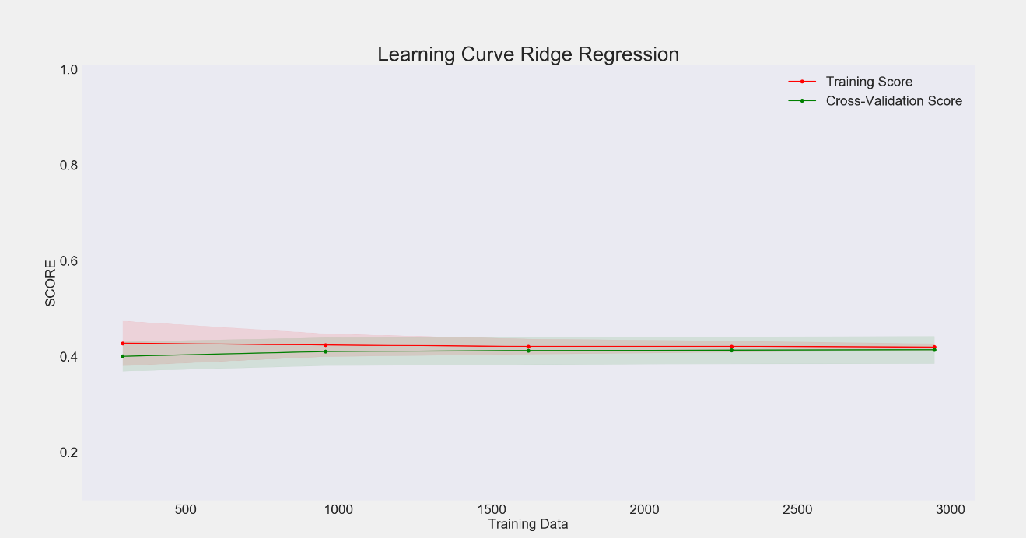

*“K-Nearest Neighbors”*

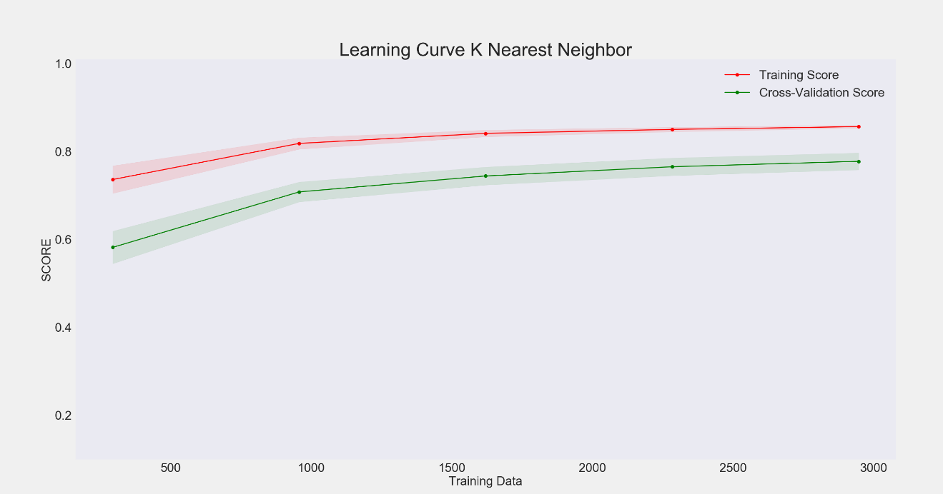

*“Support Vector Machine”*

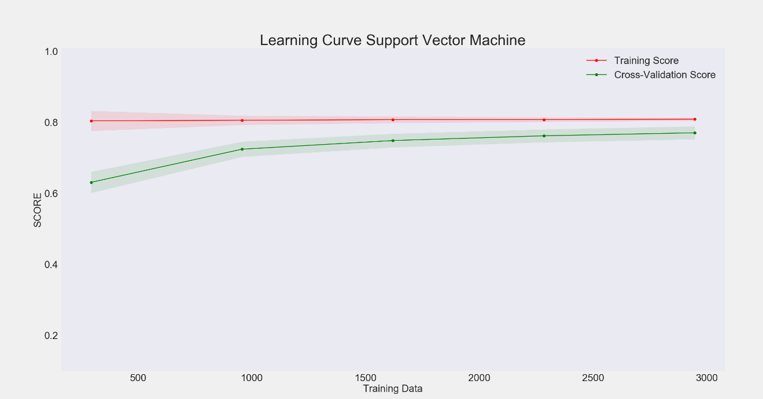

*“Nu-Support Vector Machine”*

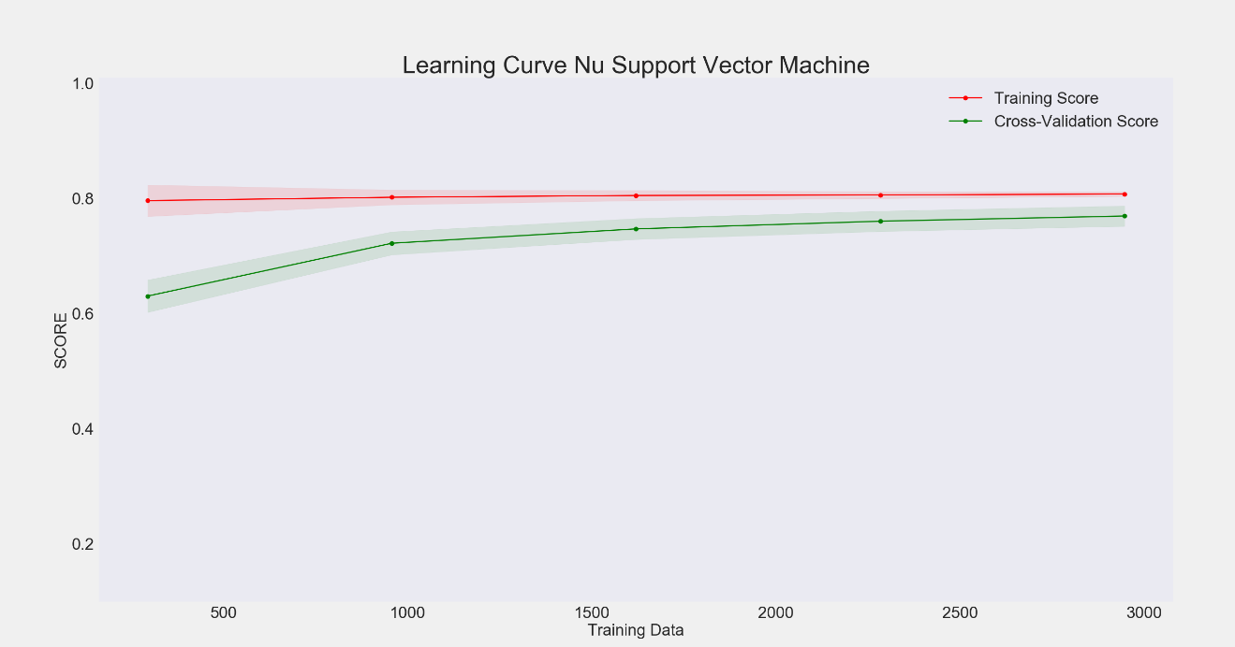

*“Neural Network”*

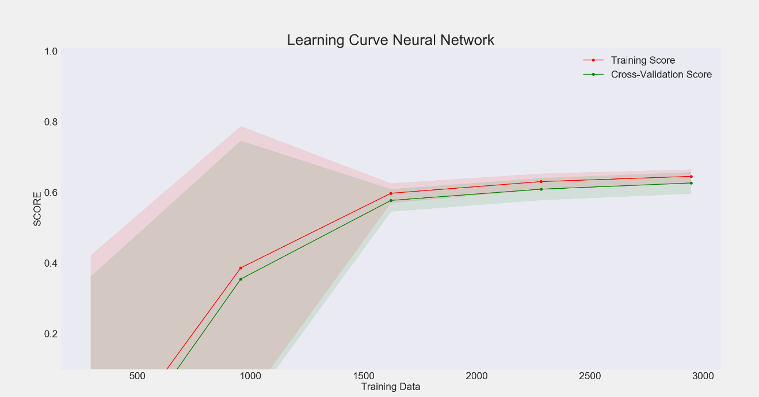

*“RANSAC”*

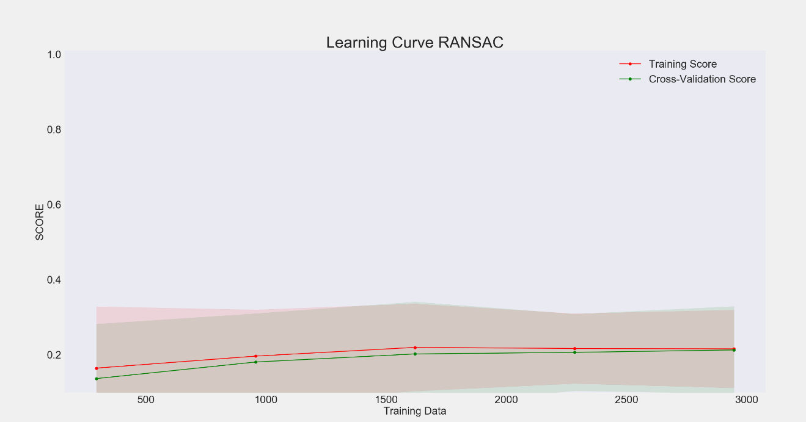

*“Gradient Booster”*

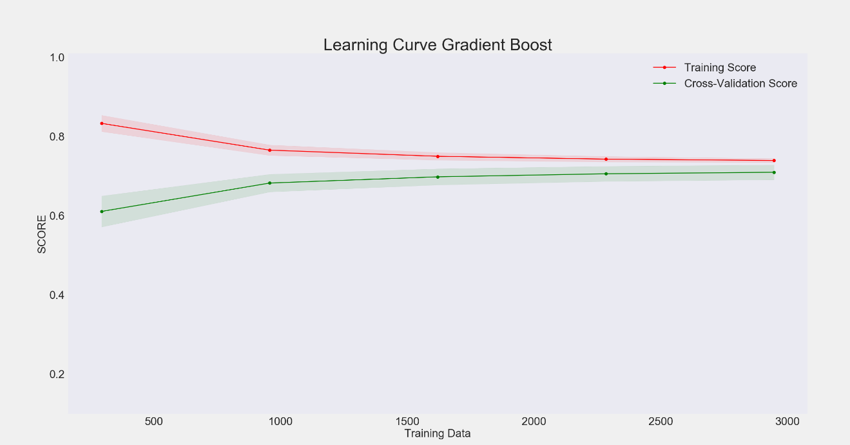

*“Random Forest”*

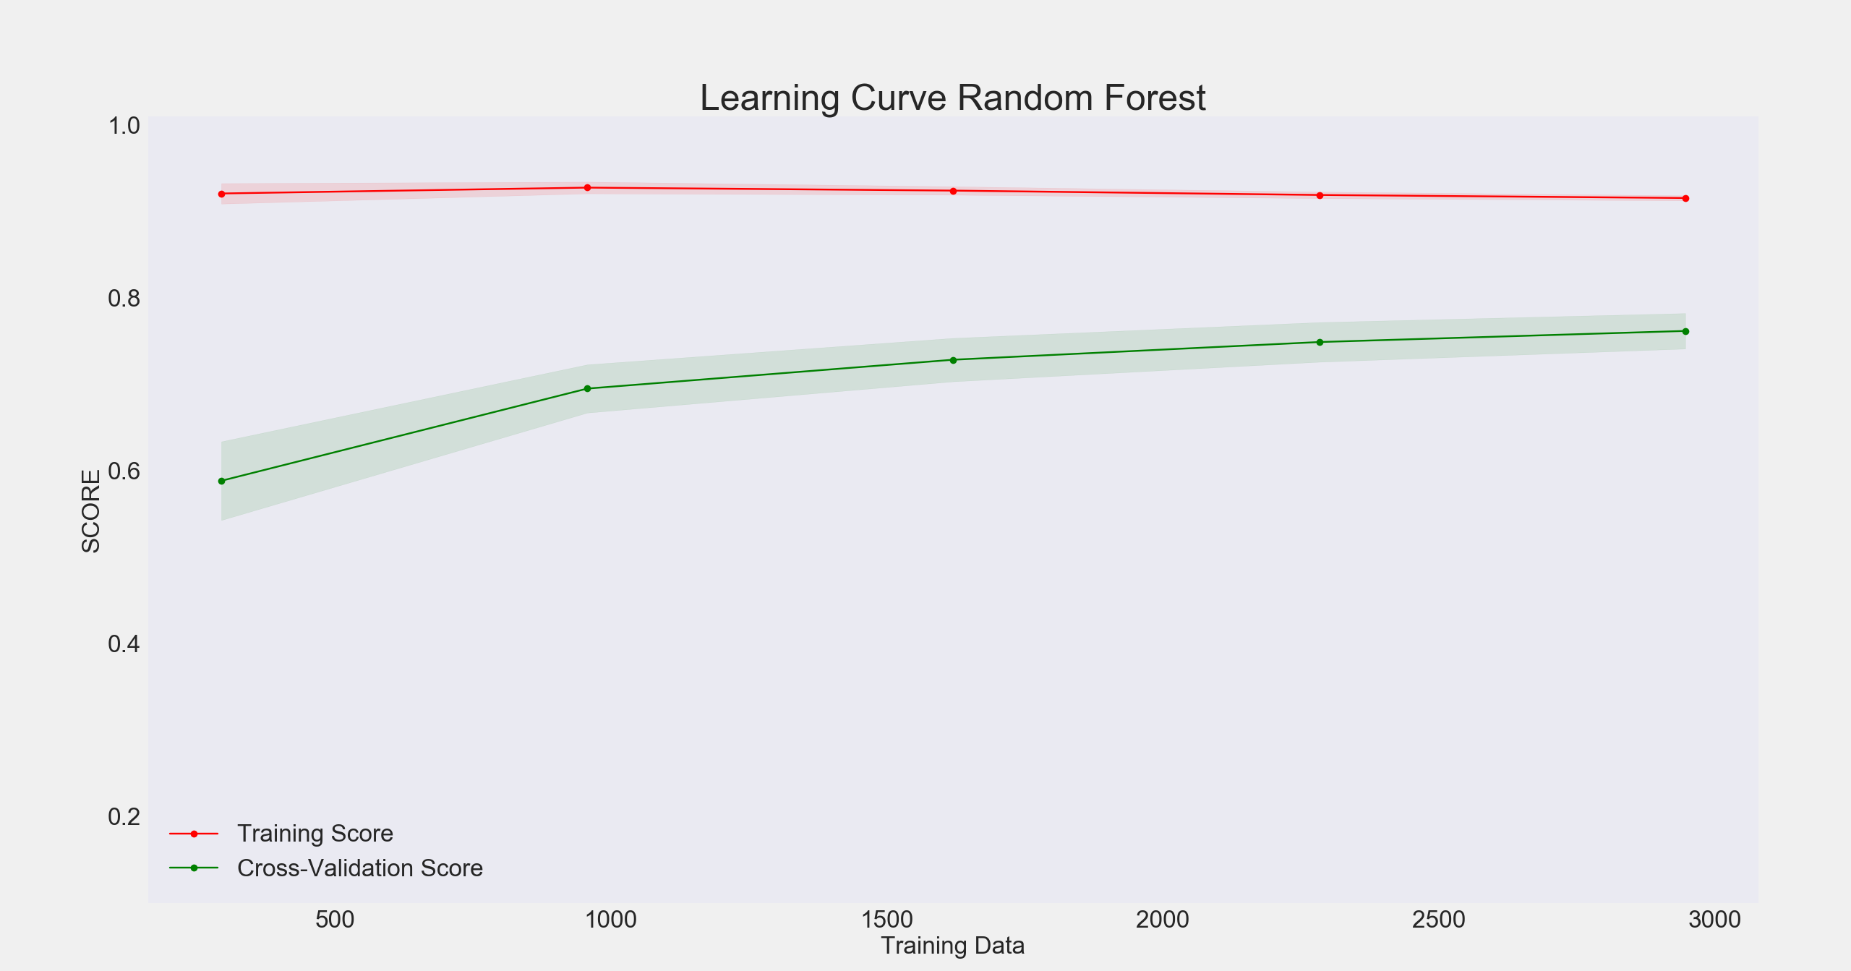

## Appendix G: Terminology

*“Water Treatment Terminology”*

* *Accelator* – Primary mixing element located in the clarifiers center well and consisting of a disc with long fan like protrusions to reach into the secondary mixing zone
* *Coagulation* – The process of chemically treating incoming clarifier influent to neutralize charged particles and form gelatinous masses from the bridged connection of these particles for easier separation and removal
* *Colloidal* – Solution with evenly dispersed particles that do not settle
* *Flocculation* – The process of slowly mixing coagulated influent to promote the collision of particles and further the bonding of particles to create floc and increase the removal of solids
* *Launderer* – Tray system located at effluent surface on clarifier and used to take in the effluent and transfer it to the clear well for use in process systems
* *Turbidity* – Quantity of suspended particles in a liquid measured in NTU
* *Zeta Potential* – Test to quantify the charge of colloidal in the clarifier influent
* *PLC* – Programmable Logic Controller
* *SCADA* – Supervisory Control and Data Acquisition